West Cornforth Primary School

Low Level Concerns Policy and Guidance



September 2026

Date: September 2026
Date for review: September 2027

Contents

1. Introduction
2. Summary
3. Keeping Children Safe in Education September 2026
4. Clarity around Allegation vs Low-Level Concern vs Appropriate Conduct
5. Storing and use of Low-Level Concerns and follow-up information
6. Process to follow when a Low-Level Concern is raised
7. Low Level Concern Form

1. Introduction

At West Cornforth Primary School, we aim to create an open and transparent culture where all concerns about all adults involved with our school are dealt with promptly and appropriately. We aim to identify any concerning, problematic or inappropriate behaviour early; minimise the risk of abuse; and ensure that adults working in or on behalf of our school (including supply staff, volunteers and contractors) are clear about professional boundaries and act within these boundaries, and in accordance with our school ethos.
This policy should be read alongside our Safeguarding and Child Protection and Staff Code of Conduct Policies.

2. Summary

It may be possible that a member of staff acts in a way that does not cause risk to children, but is however inappropriate. A member of staff who has a concern about another adult or who, on reflection, recognises that their actions could have been viewed as a risk should inform the Head Teacher about their concern using a Low-Level Record of Concern Form. If the Head Teacher cannot be contacted, the Chair of Governors should be contacted instead.

3. Keeping Children Safe in Education September 2026

This policy reflects the guidance in Part 4 (Section 2) of Keeping Children Safe in Education 2026 (p.118) which states:

503. Governing bodies and proprietors should have policies and processes to deal with any concerns or allegations which do not meet the harm threshold, referred to in this guidance as ‘low-level’ concerns. It is important that schools and colleges have appropriate policies and processes in place to manage and record any such concerns and take appropriate action to safeguard children. Low-level concerns

504. As part of their whole school or college approach to safeguarding, schools and colleges should ensure that they promote an open and transparent culture in which all concerns about all adults working in or on behalf of the school or college (including supply teachers, volunteers and contractors) are dealt with promptly and appropriately.

505. Creating a culture in which all concerns about adults are shared responsibly and with the right person, recorded and dealt with appropriately, is critical. If implemented correctly, this should:
• enable schools and colleges to identify inappropriate, problematic or concerning behaviour early
• minimise the risk of abuse, and
• ensure that adults working in or on behalf of the school or college are clear about professional boundaries and act within these boundaries, and in accordance with the ethos and values of the institution.

What a low-level concern is

506. The term ‘low-level’ concern does not mean that it is insignificant. A low-level concern is any concern – no matter how small, and even if no more than causing a sense of unease or a ‘nagging doubt’ - that an adult working in or on behalf of the school or college may have acted in a way that:
• is inconsistent with the staff code of conduct, including inappropriate conduct outside of work, and
• does not meet the harm threshold or is otherwise not serious enough to consider a referral to the LADO.
Examples of such behaviour could include, but are not limited to:
• being overfriendly with children,
• having favourites,
• taking photographs of children on their mobile phone, contrary to school policy,
• engaging with a child on a one-to-one basis in a secluded area or behind a closed door, or
• humiliating children.

507. Such behaviour can exist on a wide spectrum, from the inadvertent or thoughtless, or behaviour that may look to be inappropriate, but might not be in specific circumstances, through to that which is ultimately intended to enable abuse.

508. Low-level concerns may arise in several ways and from a number of sources. For example: suspicion; complaint; or disclosure made by a child, parent or other adult within or outside of the organisation; or as a result of vetting checks undertaken.

509. It is crucial that all low-level concerns are shared responsibly with the right person and recorded and dealt with appropriately. Ensuring they are dealt with effectively should also protect those working in or on behalf of schools and colleges from becoming the subject of potential false low-level concerns or misunderstandings.

4. Clarity around Allegation vs Low-Level Concern vs Appropriate Conduct

Allegation:
Any adult linked to our school who has:
- behaved in a way that has harmed a child, or may have harmed a child and/or;
- possibly committed a criminal offence against or related to a child and/or;
- behaved towards a child or children in a way that indicates he or she may pose a risk of harm to children; and/or
- behaved or may have behaved in a way that indicates they may not be suitable to work with children.

Low Level Concern:
Any adult linked to our school who has behaved in a way that:
- is inconsistent with the staff code of conduct, including inappropriate conduct outside of work; and
- does not meet the allegations threshold or is otherwise not considered serious enough to consider a referral to the LADO.
Appropriate:
- Behaviour which is entirely consistent with our school’s Code of Conduct, and the Law.

5. Storing and use of Low-Level Concerns and follow-up information

LLC forms and follow-up information will be stored securely within the schools safeguarding systems, with access only by the leadership team. This will be stored in accordance with the school’s GDPR and data protection policies.
The staff member(s) reporting the concern must keep the information confidential and not share the concern with others apart from the Head Teacher or those aware in the senior leadership team.

Low-Level Concerns will not be referred to in references unless they have been formalised into more significant concerns resulting in disciplinary or misconduct procedures.
Whenever staff leave West Cornforth Primary School, any record of low-level concerns which are stored about them will be reviewed as to whether or not that information needs to be kept.

Consideration will be given to:
(a) whether some or all of the information contained within any record may have any reasonably likely value in terms of any potential historic employment or abuse claim so as to justify keeping it, in line with normal safeguarding records practice; or
(b) if, on balance, any record is not considered to have any reasonably likely value, still less actionable concern, and ought to be deleted accordingly

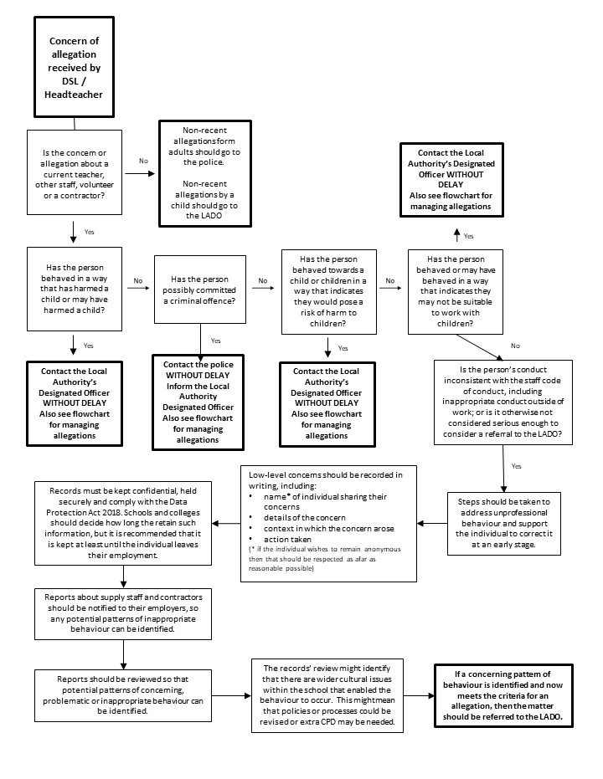
6. Process to follow when a Low-Level Concern is raised
See Appendix A
*NB – if the concern is about the Headteacher, then the Chair of Governors should be informed.

7. Low level Concerns Reporting Form – West Cornforth Primary School
Your details
Name (optional)

Role

Date and time of completing this form
Details of individual (including yourself for self-reporting) whom the concern is about
Name

Role

Relationship to the individual reporting eg manager, colleague
Details of concern
Please include as much detail as possible. Think about the following: What behaviour and/or incident are you reporting? What exactly happened? Why does the behaviour and/or incident worry you? Why do you believe the behaviour and/or incident is not consistent with our Staff Code of Conduct?

Details of any children or young people involved
Name(s)

Next Steps
Are you willing to meet with the  headteacher and DSL to discuss your concern? Please circle as appropriate. | Yes | No
Please state any other information that you feel is relevant to the processing
of this concern.
Signature

For use by HT/safeguarding team upon receipt of the concern
Date and time concern received
Signature

Role

Actions to be taken and follow-up.

Appendix A - Fact Finding Advice
Before contacting the LADO, schools and colleges should conduct basic enquiries in line with local procedures to establish the facts and to help them determine whether there is any foundation to the allegation, being careful not to jeopardise any future police investigation. Please liaise with HR as necessary.
Basic enquiries could include the following:
- was the individual in the school or college at the time of the allegations
- did the individual, or could the individual have come into contact with the child
- Are there any witnesses, any CCTV footage?
When fact finding you may find it helpful to use the 5 WH model of open questions:
- Who
- What
- Where
- When
- Why (context/ events leading up to incident)
Examples include:
“What did you see/hear/experience?” “When did the situation occur?” “Where did the situation occur?” “Who was involved?” “How were you impacted by what occurred?” or “How do you see the situation?” “Was anyone else present?” “What was their involvement?” “Can you tell me more?”
If your initial fact finding indicates the allegation could not have happened (e.g. child/ individual to whom the allegation relates was not in school, or physically the incident could not have happened (e.g. slamming a soft closed door) this does not need to be reported to LADO. You will need to keep a record of your allegations management decision making within school/ college. Please ensure any statements from students are signed and dated by the student.
You should advise parent/ child of the outcome of your fact finding (e.g. referral to LADO, dealing with incident as a low-level concern or that the allegation could not have happened and explain why)
Threshold for LADO: (Please ensure you are familiar with Durham Safeguarding Children Partnership procedures for managing allegations against staff and volunteers who work with children.)
• behaved in a way that has harmed a child, or may have harmed a child
• possibly committed a criminal offence against or related to a child
• behaved towards a child or children in a way that indicates he or she may pose a risk of harm to children
• behaved or may have behaved in a way that indicates they may not be suitable to work with children.
If you consider that any of the above points are met, a referral needs to be made to LADO within 1 working day – 03000 268835.

A referral to LADO does not negate your safeguarding responsibilities. If a child is at risk of imminent harm and/ or you suspect a criminal offence may have occurred, you MUST follow safeguarding procedures and liaise with Children’s Services (First Contact) and/or Police before making a referral to LADO.

Low level concerns (Keeping Children Safe In Education)
Governing bodies and proprietors should have policies and processes to deal with any concerns or allegations which do not meet the harm threshold. This is referred to in KCSIE as ‘low-level’ concerns. It is important that schools and colleges have appropriate policies and processes in place to manage and record any such concerns and take appropriate action to safeguard children.
The term ‘low-level’ concern does not mean that it is insignificant. A low-level concern is any concern (no matter how small, and even if no more than causing a sense of unease or a nagging doubt) that an adult working in or on behalf of the school or college may have acted in a way that is inconsistent with the staff code of conduct, including inappropriate conduct outside of work and does not meet the harm threshold or is otherwise not serious enough to consider a referral to the LADO.
Examples of such behaviour could include, but are not limited to:
• being over friendly with children
• having favourites
• engaging with a child on a one-to-one basis in a secluded area or behind a closed door when it is not part of their role
• humiliating children.
Such behaviour can exist on a wide spectrum, from the inadvertent or thoughtless, or behaviour that may look to be inappropriate, but might not be in specific circumstances, through to that which is ultimately intended to enable abuse.
Low-level concerns may arise in several ways and from a number of sources. For example: suspicion; complaint; or disclosure made by a child, parent or other adult within or outside of the organisation; or as a result of vetting checks undertaken.
It is crucial that all low-level concerns are shared responsibly with the right person and recorded and dealt with appropriately. Ensuring they are dealt with effectively should also protect those working in or on behalf of schools and colleges from becoming the subject of potential false low-level concerns or misunderstandings.
If threshold for LADO is not met:
- Follow your low-level concerns policy
- Log your decision making internally – this does not need to be reported/ logged with LADO

DCC LADO TEAM

