Online Learning Acceptable Use Policy
Videoconference Lessons
During video calls with your teachers it is really important that you stick to these rules:
- An adult is with you to set up the video call, and available throughout.
- You are in either your dining room, living room or kitchen, and not your bedroom.
- You must be dressed and ready – not in pyjamas.
- Please remember that the video conference is part of school. You must be respectful to staff and other pupils. School rules still apply!

If you have any questions your teacher can be contacted via Class Dojo.

In an emergency there are some staff in school. They can be contacted on 01740 654315.

Joining the video call
- Your teacher will send you an invitation to join a meeting on Teams. Which will come through in an email.
- Open the invitation and click on yes.
- Go onto the calendar, you should be able to see the meeting on the calendar.
- Click on Join.
- You will have the option to join in the app or to join using the browser. If you can download the Teams app it works better.
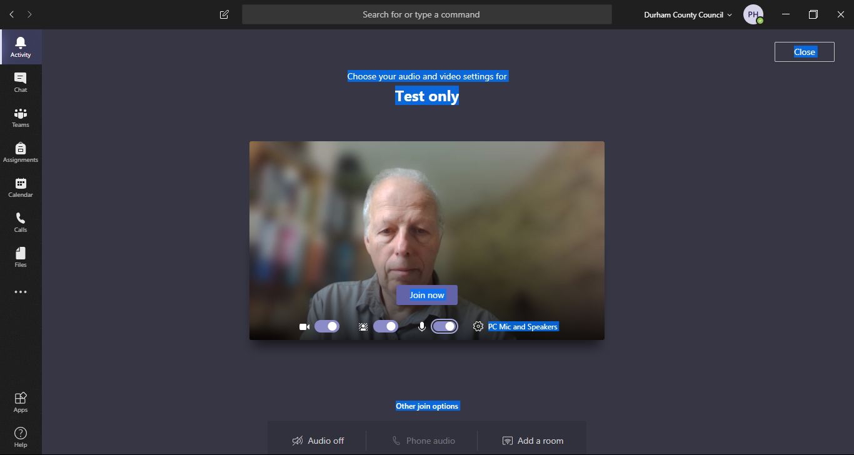
Start with your microphone muted (turned off) otherwise it gets very noisy!

It is a good idea to blur the background so everyone in your class can’t see all of your house.

- Then click join now.
- You can still join if you are late.

There will be two members of staff on each video call.

