English Home Learning Pack

Year 5/6

Miss Reed

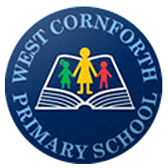

Monday - English

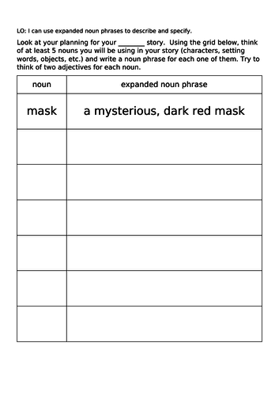Write a single noun in the noun column. Make it more interesting by turning it into an expanded noun phrase.

Tuesday – English

Thinking about the Boy in the Tower story we have been reading in school, write a letter from Ade to Gaia, think about how he is feeling.

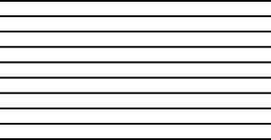

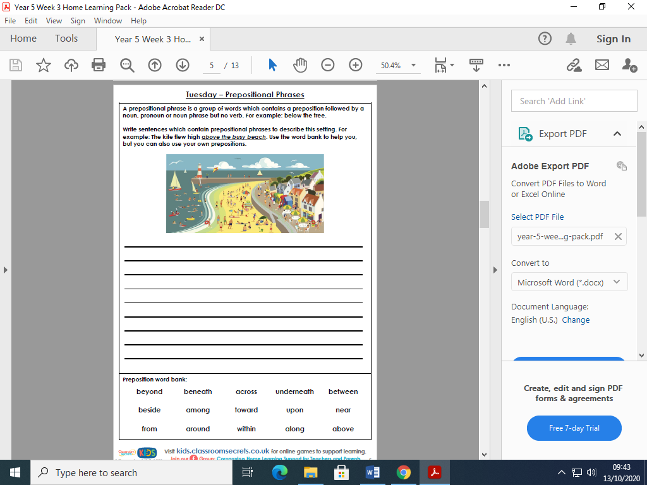Wednesday – English

Thursday – English

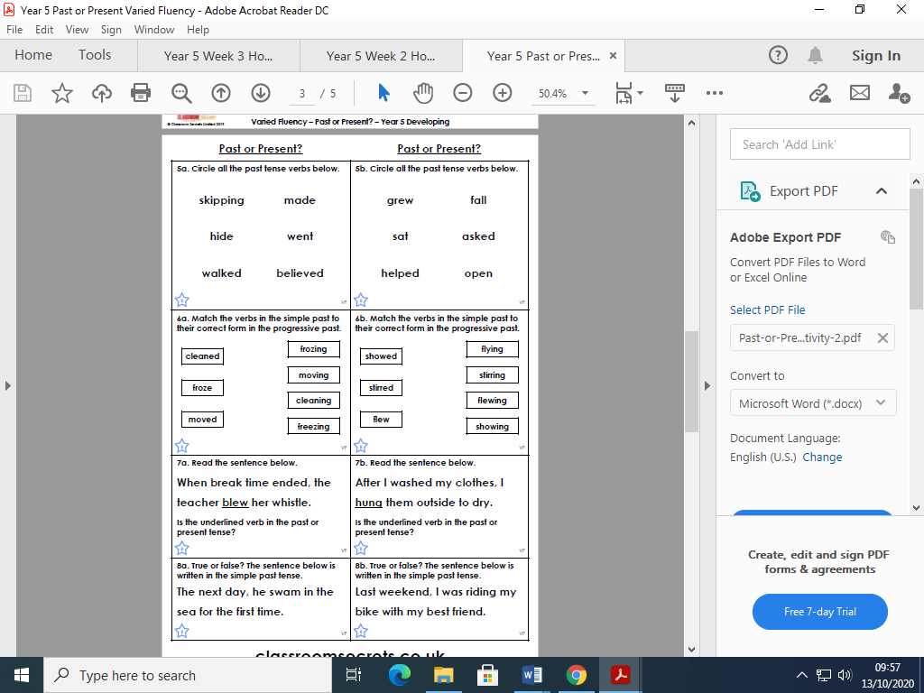

Friday – English

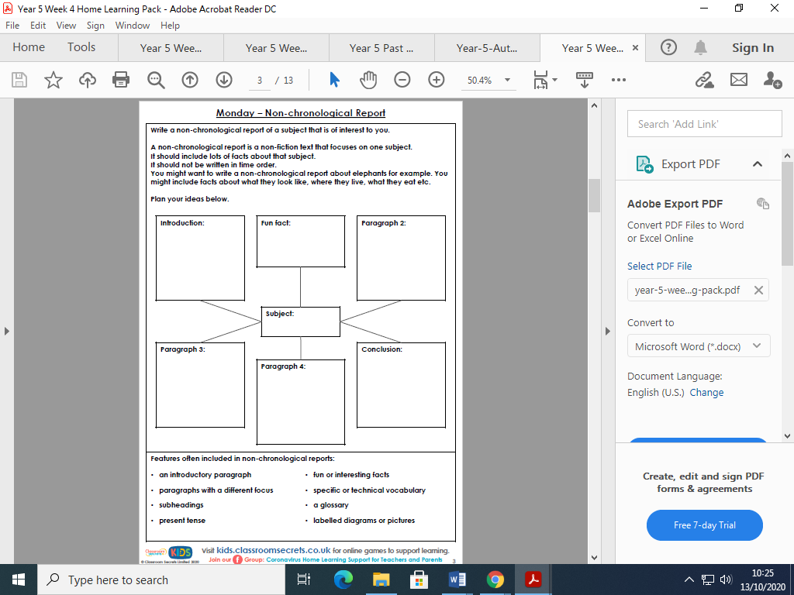

Monday - English

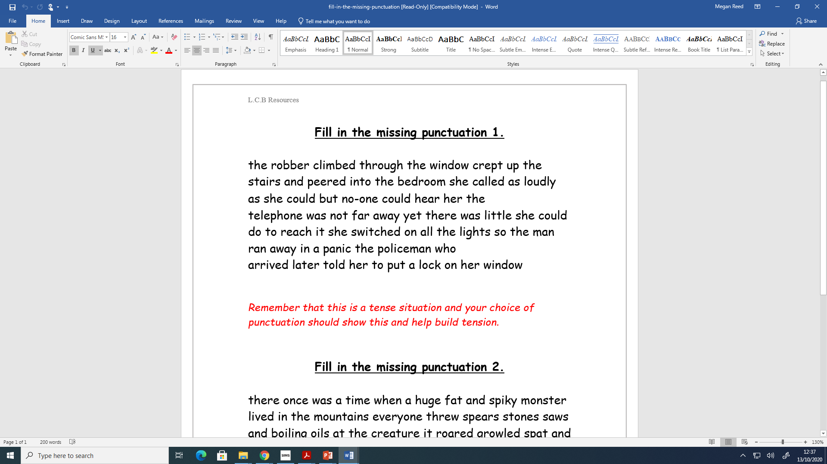

Tuesday

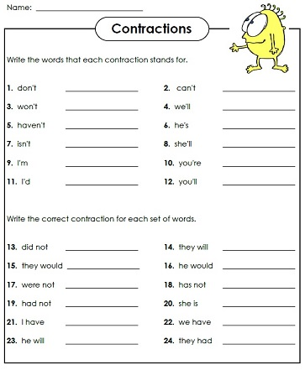

Wednesday

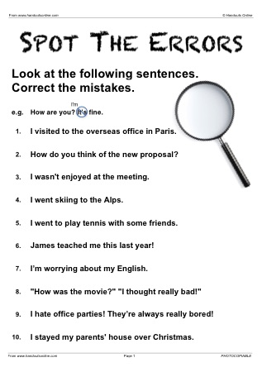

Thursday

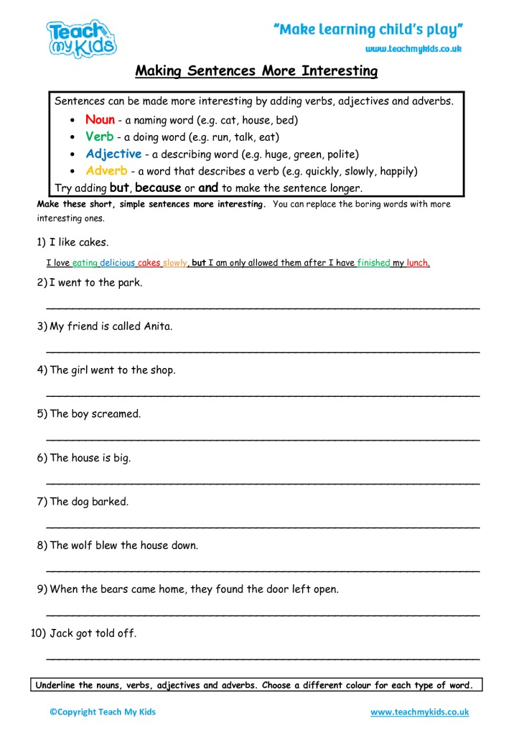

Friday

