West Cornforth Primary School
Home/School Learning Pack

Summer 2 Week 7
WB: 13.7.20

Note: Remember to refer to the Year 1 weekly overview plan for further details on each task. As always, the plan will be sent via class dojo and shared on the school website.

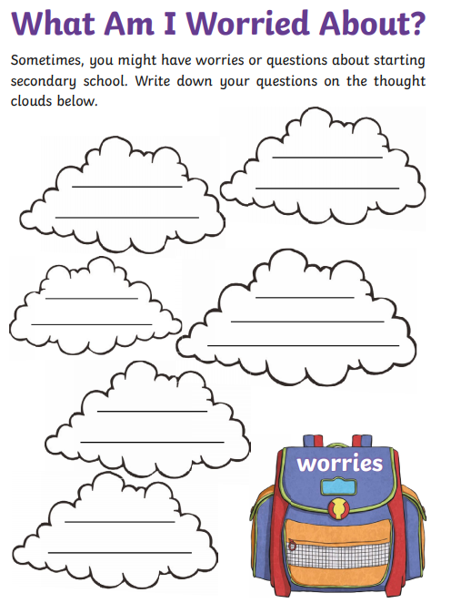
English Monday- Read the story, ‘Jake’s First Day.’ How are we feelings about our first day in Year 2? Read and discuss the story together. Complete the worry cloud
Monday Maths
Star Starter Task
- Count to 100. Write random numbers between 1-100 as they are said by an adult.

Learning Reminders- Bonds to 10.
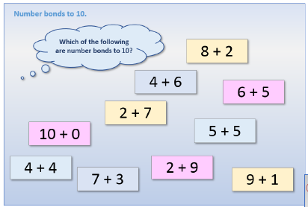

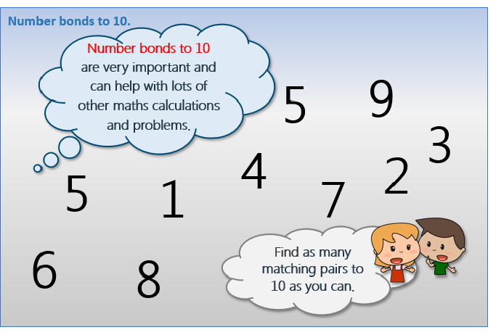

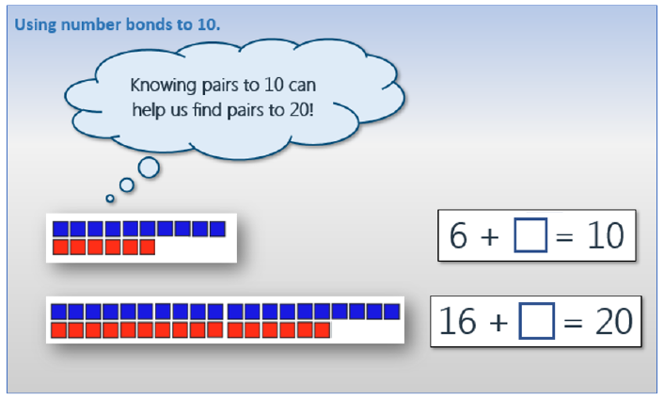

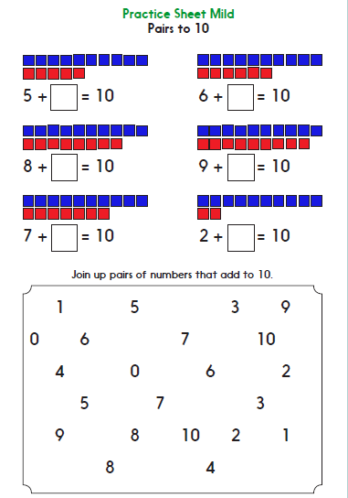
Main Tasks
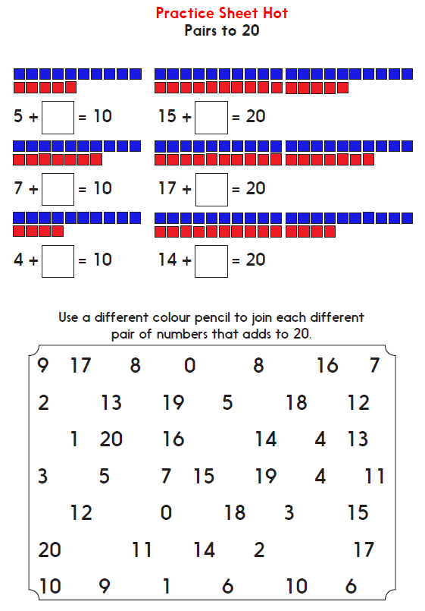
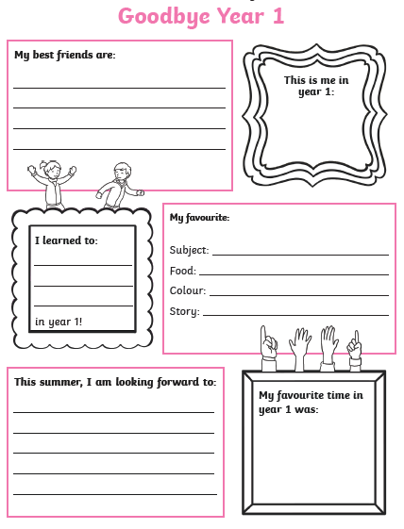
English Tuesday- Reflecting on Year 1. Complete the ‘Goodbye Year 1’ sheet.
Tuesday Maths
Star Starter Task
- Count in 2’s, 5’s 10’s. Count to a certain number and stop. Count back.

Learning Reminders- How many to the next ten?
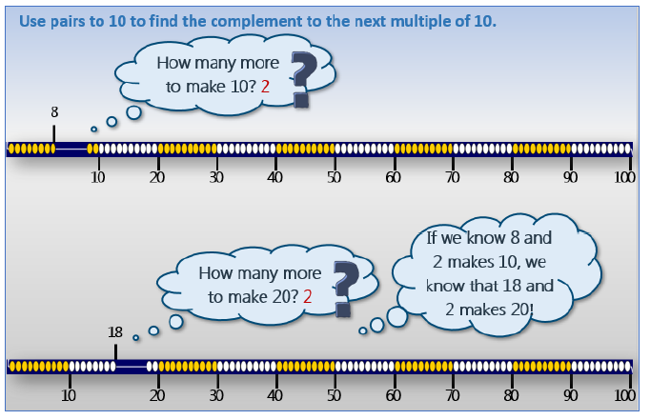

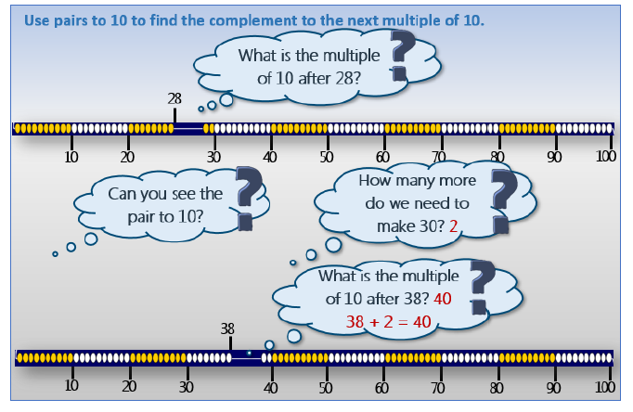

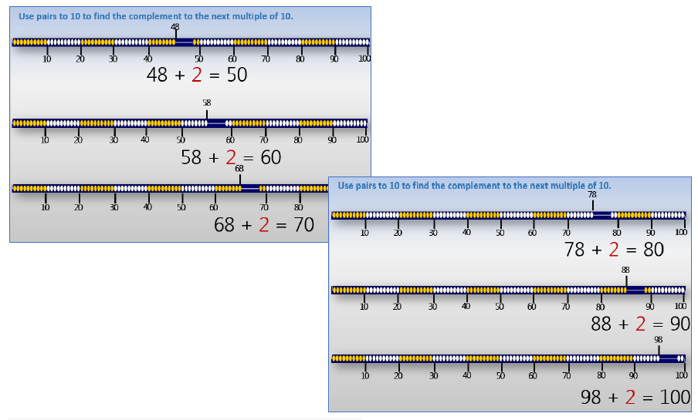

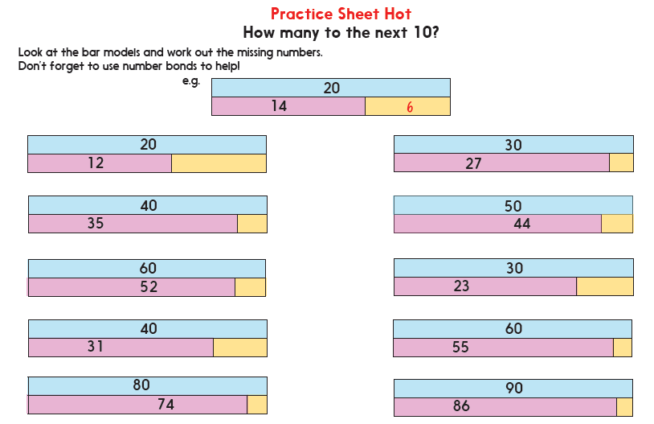
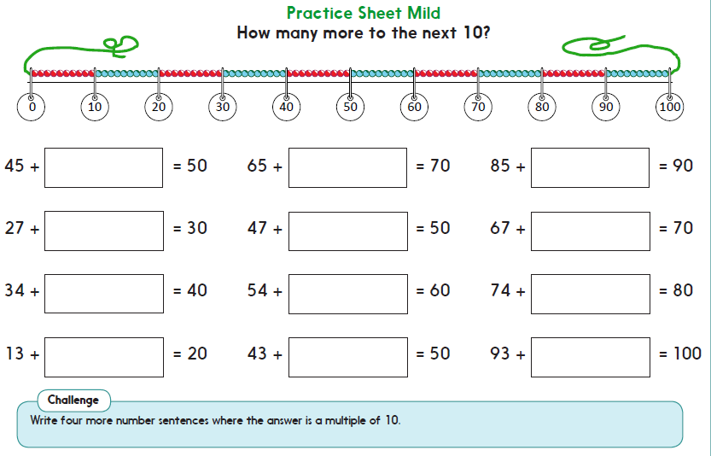
Main Tasks
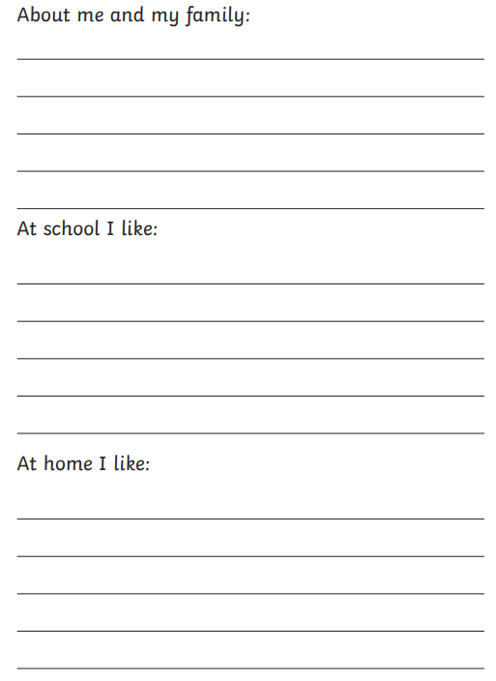
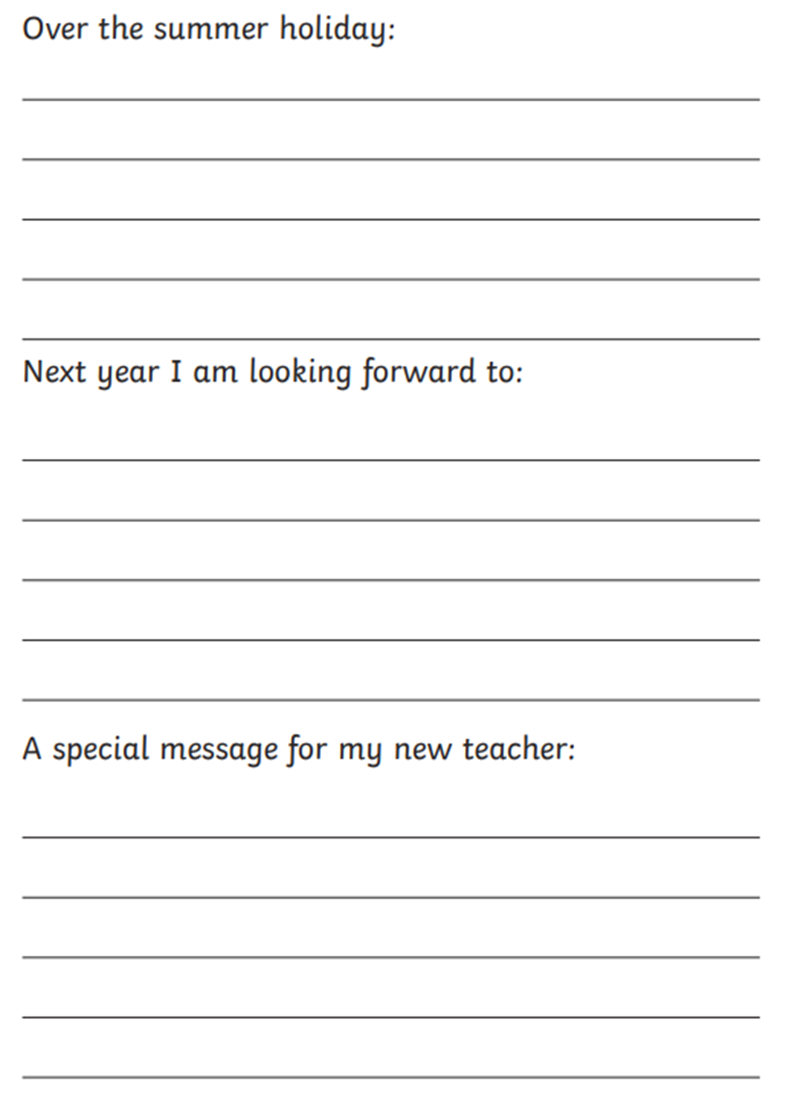
English Wednesday- All about me! Complete the ‘All About Me’ transition information for your new class teacher. Think carefully about each subheading.
Wednesday Maths
Star Starter Task
- Practise making number bonds to 20 with numicon. Write as number sentences on a whitebeard.

Learning Reminders- Bridging to 10.
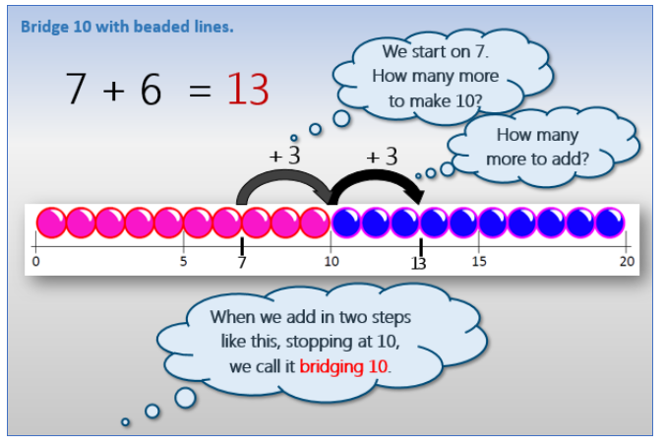

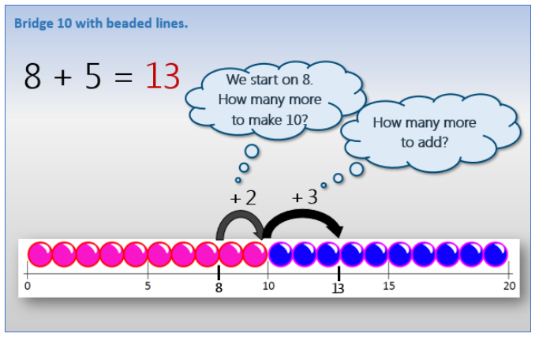

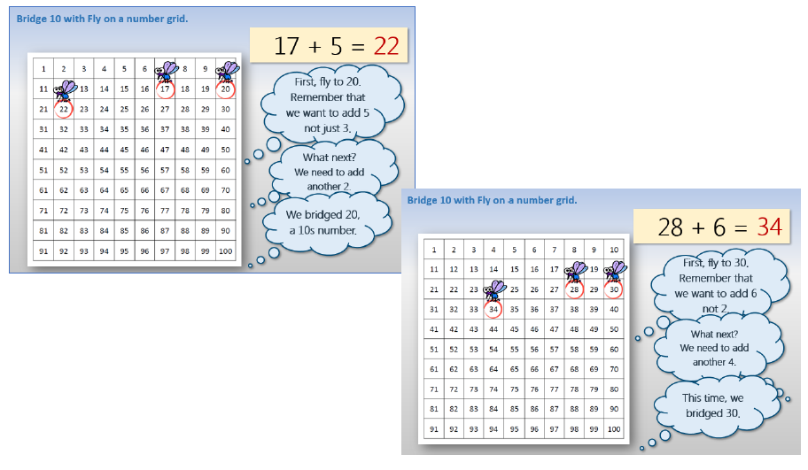
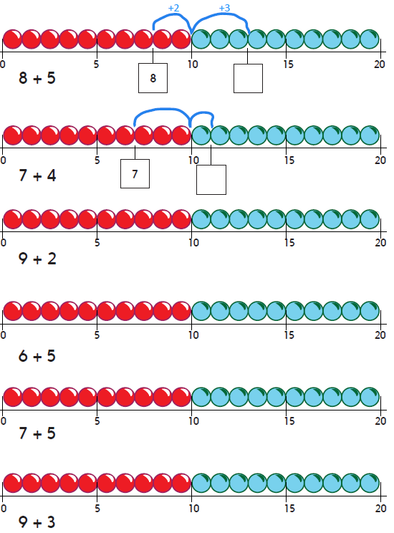
Main Tasks

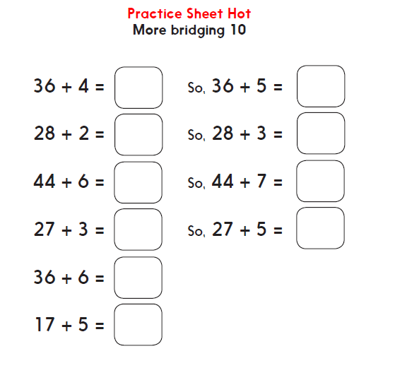
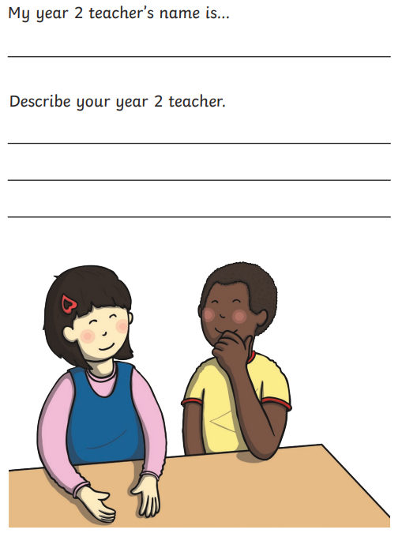
English Thursday- Preparing for Year 2. Complete the information.
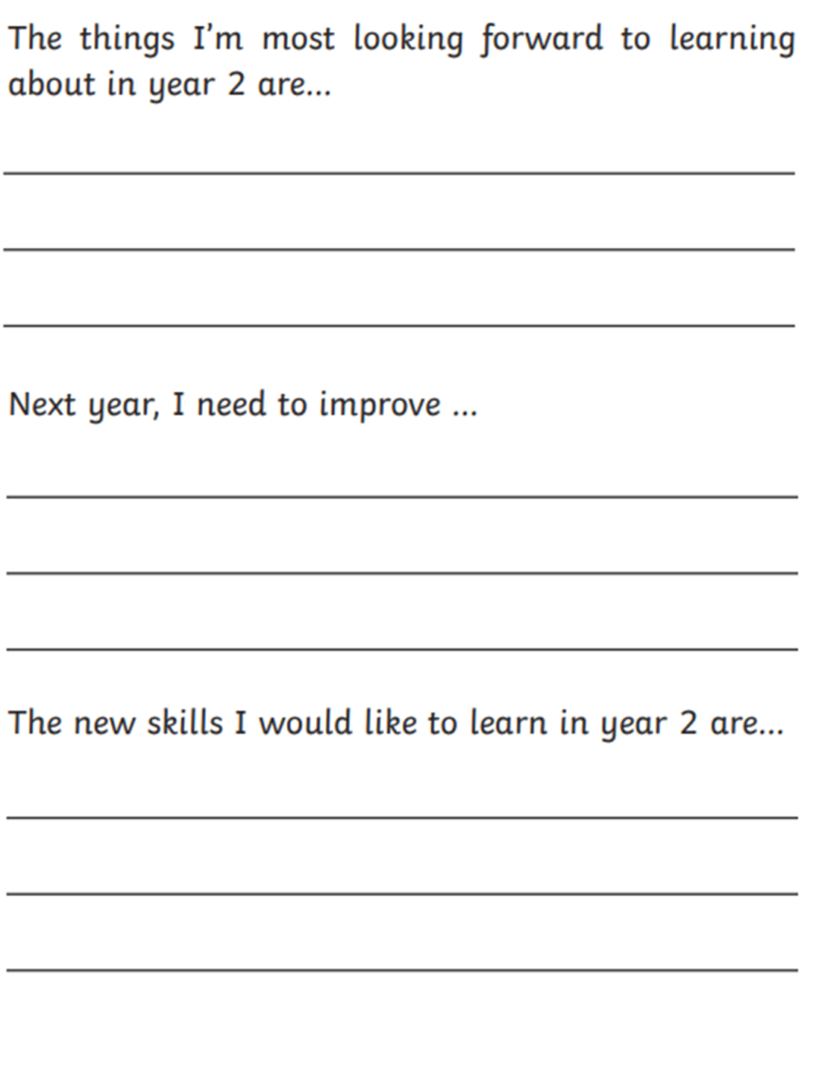
Thursday Maths
Star Starter Task
- Number bond song- https://www.youtube.com/watch?v=lD9tjBUiXs0
- 3-D shape song- https://www.youtube.com/watch?v=2cg-Uc556-Q
Learning Reminders- 3-D shapes and position.

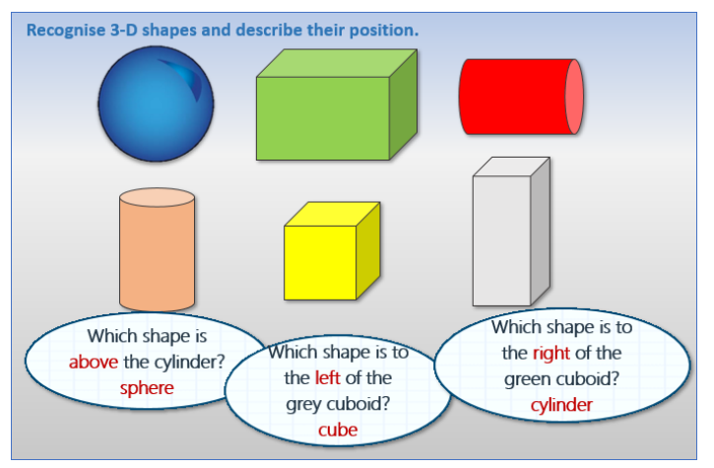

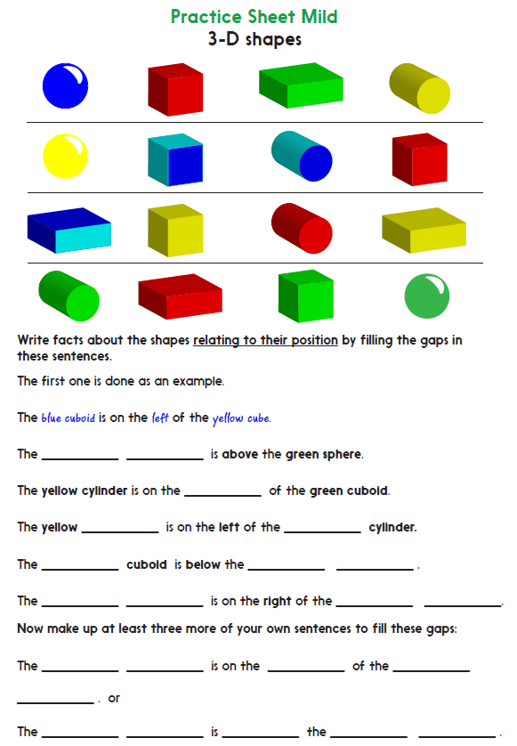
Main Tasks
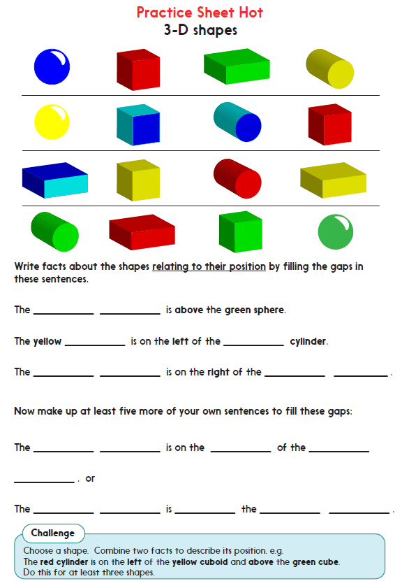
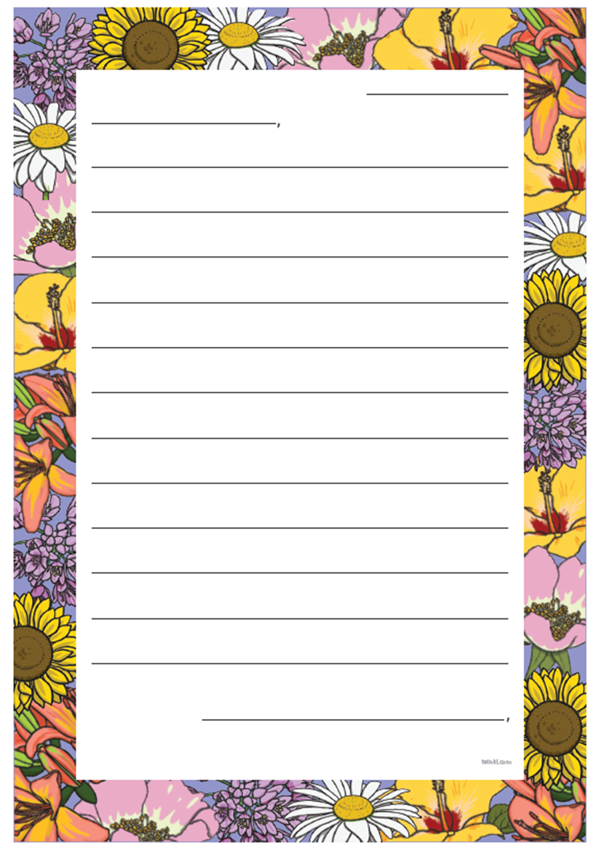
English Friday- Write a letter to your new teacher. What would you like to tell them about yourself? What would you like to ask them? Remember to use the correct punctuation
Friday Maths
Star Starter Task
- Practise your 2, 5, and 10 times tables, link to counting.

Learning Reminders- 3-D shapes and ½ and ¼ turns.
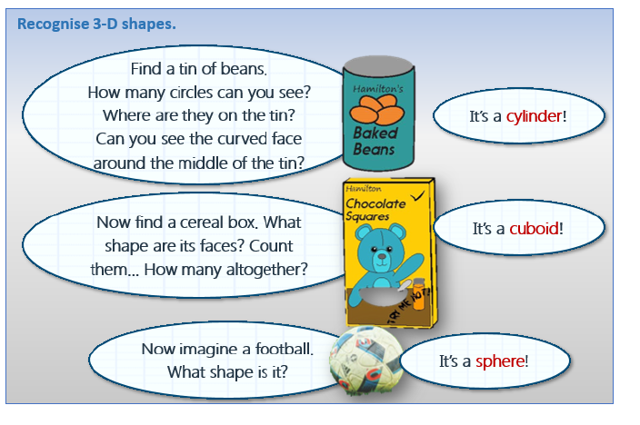

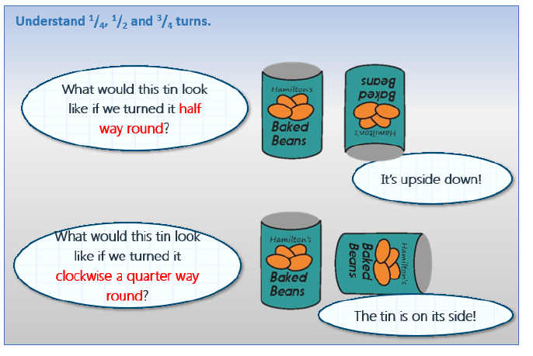

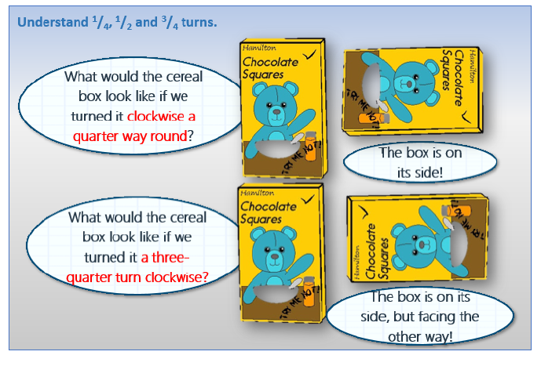

Main Tasks
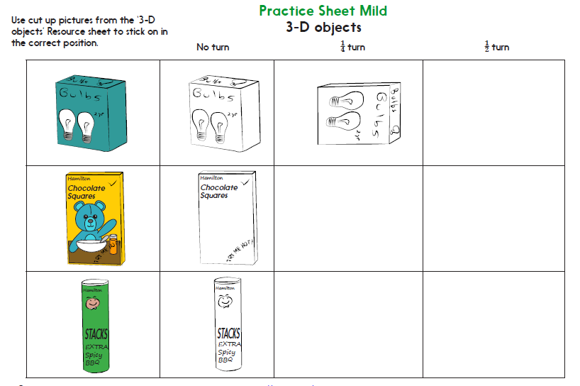
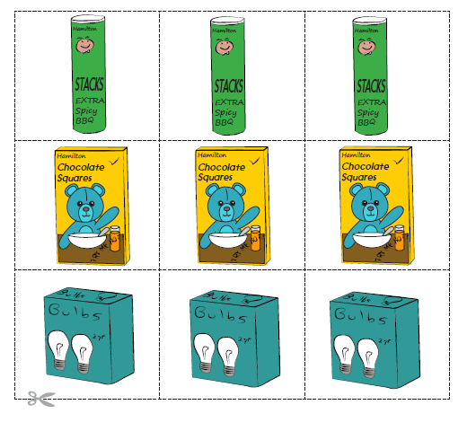

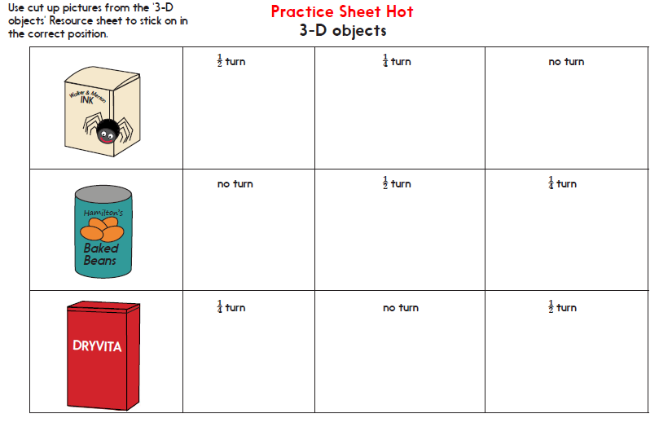
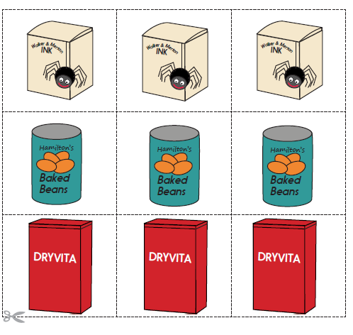
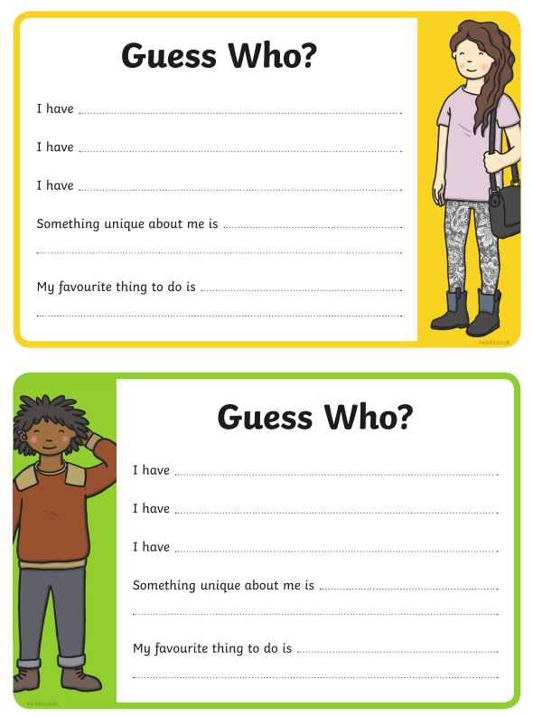
PM Tasks/Activities- Complete the ‘Guess who?’ task. Complete the guess who card and this will be passed onto your new teacher. Will your new teacher guess whose card is who’s?
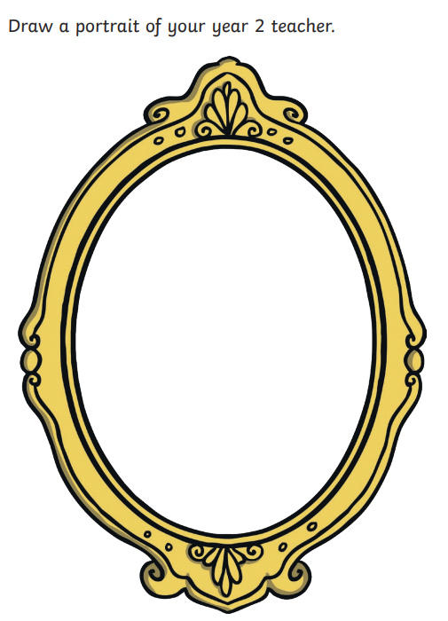
PM Tasks/Activities- Create a self-portrait for your Year 2 teacher. Write adjectives to describe yourself around the frame.
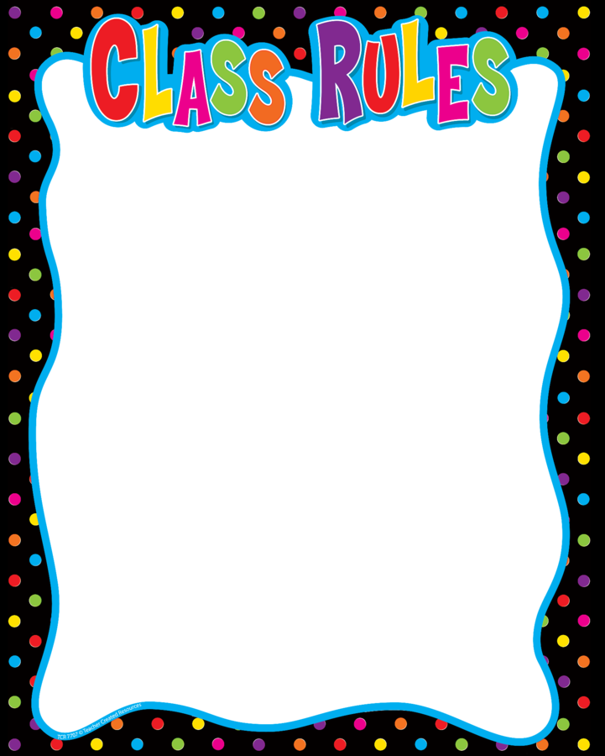
PM Tasks/Activities- Begin to think about class rules and expectations for Year2. What will my new teacher expect? Share ideas and then children write same ideas down on template provided

