West Cornforth Primary School
Home/School Learning Pack

Summer 2 Week 6
WB: 6.7.20

Note: Remember to refer to the Year 1 weekly overview plan for further details on each task. As always, the plan will be sent via class dojo and shared on the school website.

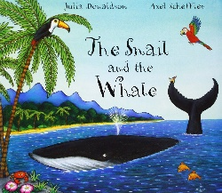
English Monday- Recall and sequence key events from a story. Can you recall key events from the story of ‘The Snail and the Whale’ by Julia Dodson? Show your understanding by cutting out and sequencing the images into the correct order and then writing about each part.
__________________________________________________________________________________________________________________________________________________________________________________________________________________________________________________________

__________________________________________________________________________________________________________________________________________________________________________________________________________________________________________________________

__________________________________________________________________________________________________________________________________________________________________________________________________________________________________________________________

__________________________________________________________________________________________________________________________________________________________________________________________________________________________________________________________

__________________________________________________________________________________________________________________________________________________________________________________________________________________________________________________________

__________________________________________________________________________________________________________________________________________________________________________________________________________________________________________________________

__________________________________________________________________________________________________________________________________________________________________________________________________________________________________________________________

__________________________________________________________________________________________________________________________________________________________________________________________________________________________________________________________

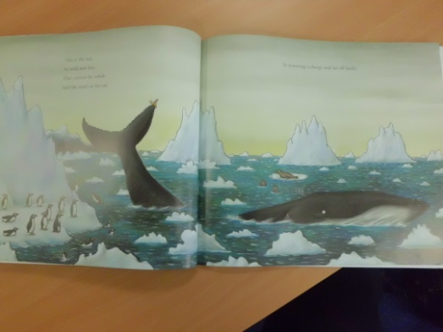
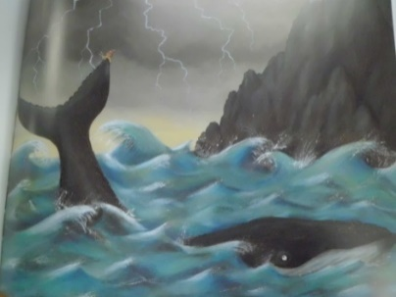

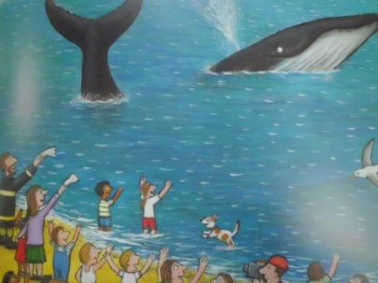
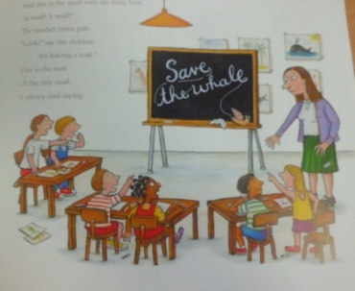
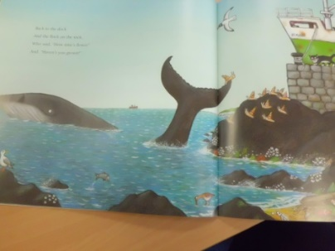
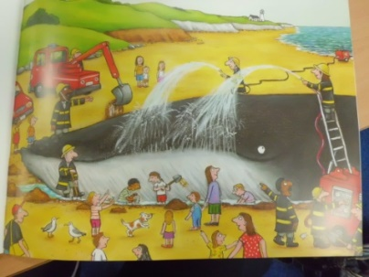
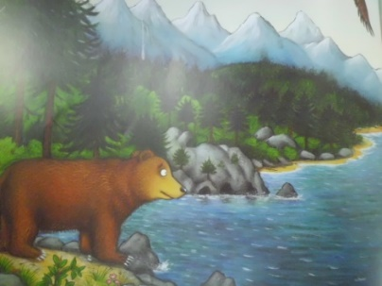
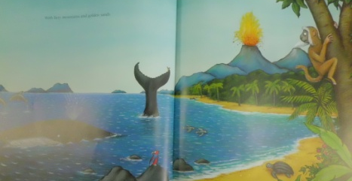
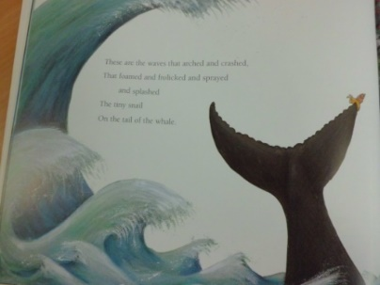
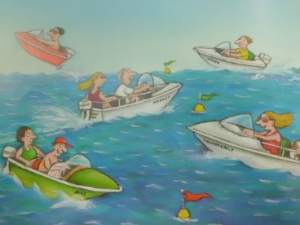
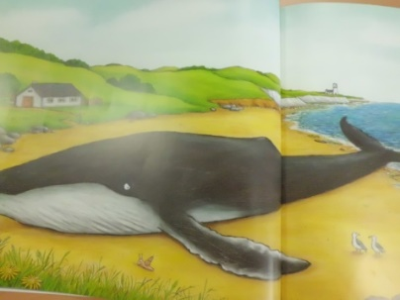
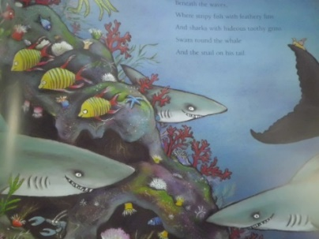

Monday Maths
Star Starter Tasks
Remember that you can use different manipulatives and methods to help you work out the answers. Record notes on your whiteboard.

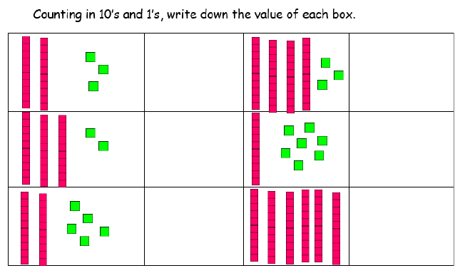

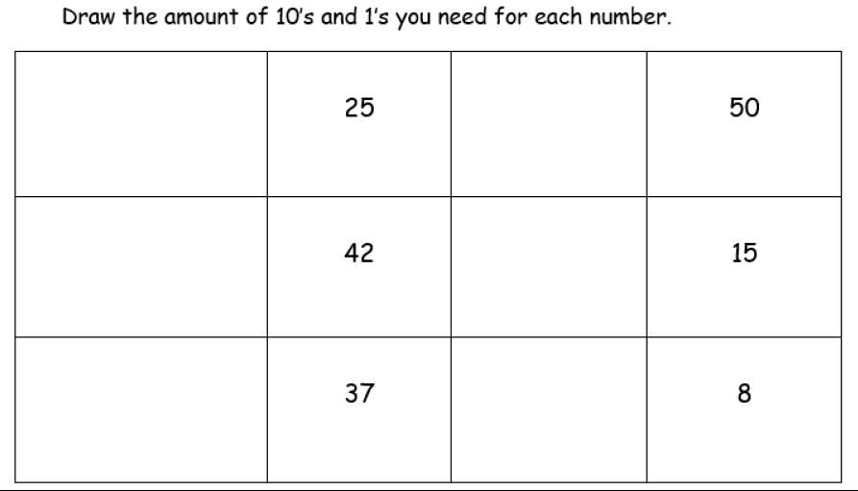

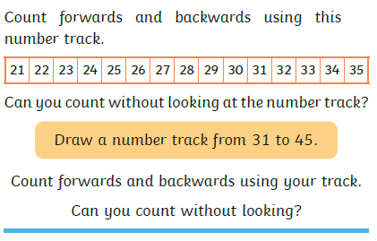

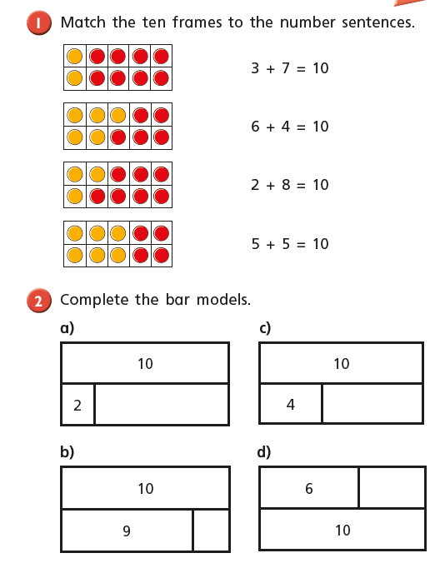
Main Tasks

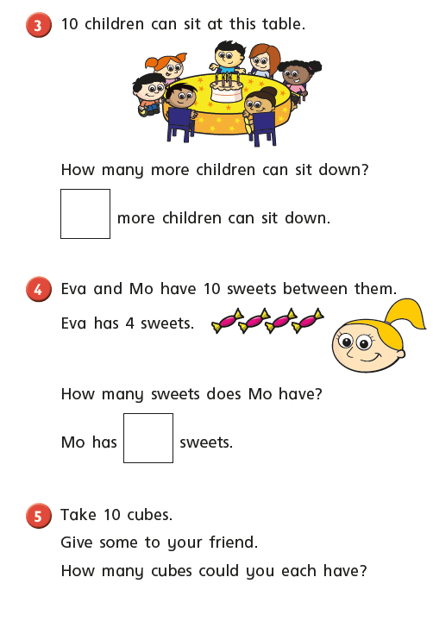

Monday PM – Healthy me- Handwashing- Can you create your own poster to encourage others to always wash their hands? Look at examples to help

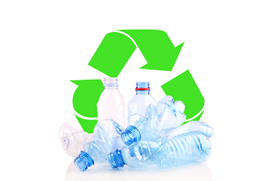
Monday – Healthy Me! - Looking after ourselves. Go through the

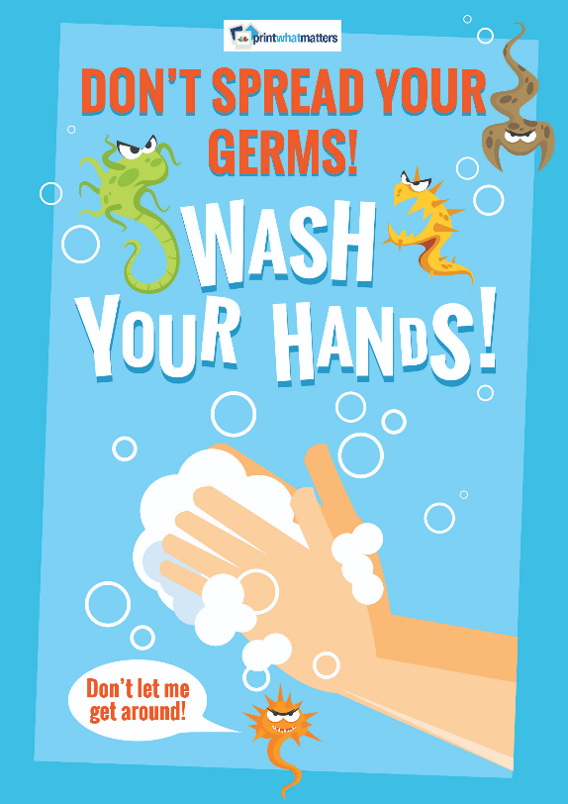
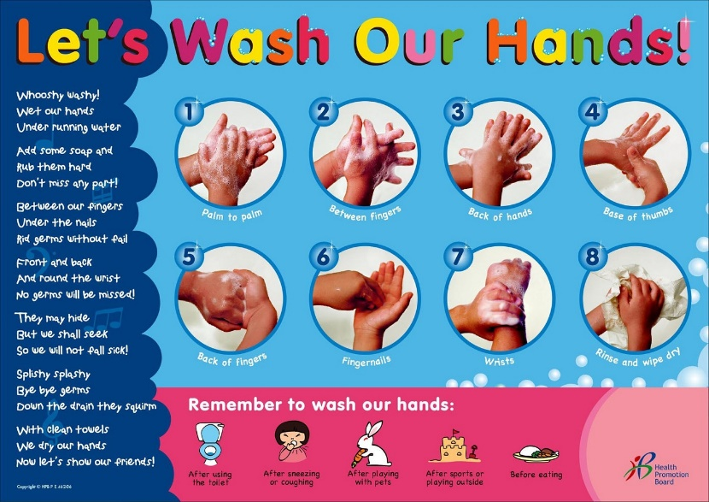

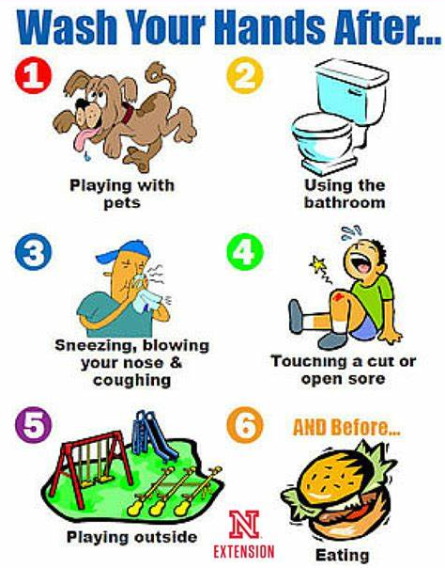

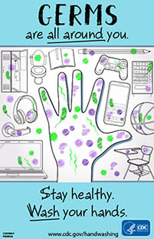

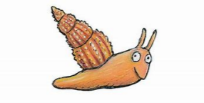
English Tuesday- Recall key events from a story. Can you write about what the snail saw/discovered during his adventure on the tail of the whale?
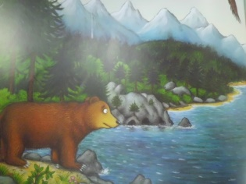
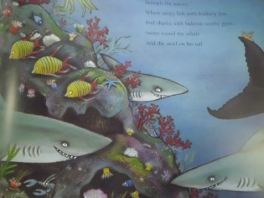

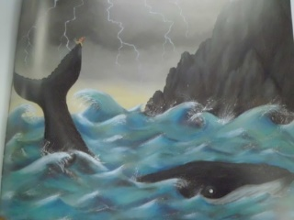

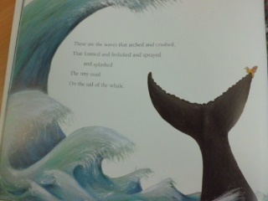
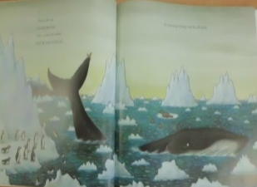

_____________________________________________________________________________________________________________________________________________________________________________________________________________________________________________________________________________________________________________________________________________________________________________________________________________________________________________________________________________________________________________________________________________________________________________________________________________________________________________________________________________________________________________________________________________________________________________

Tuesday Maths
Star Starter Tasks
Remember that you can use different manipulatives and methods to help you work out the answers. Record notes on your whiteboard.
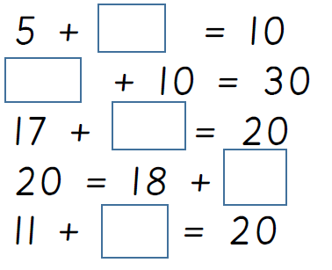
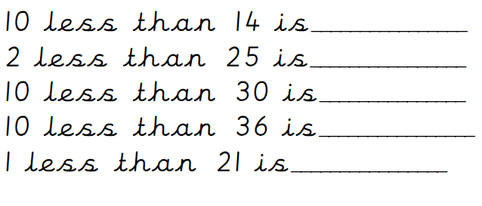

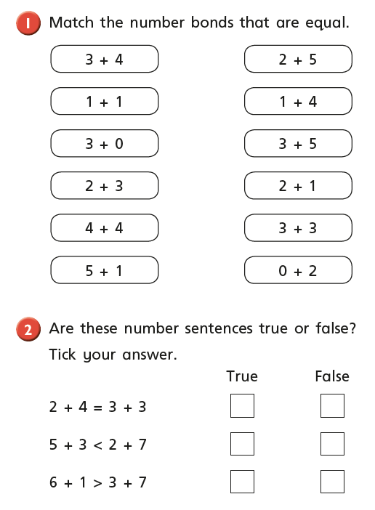
Main Tasks

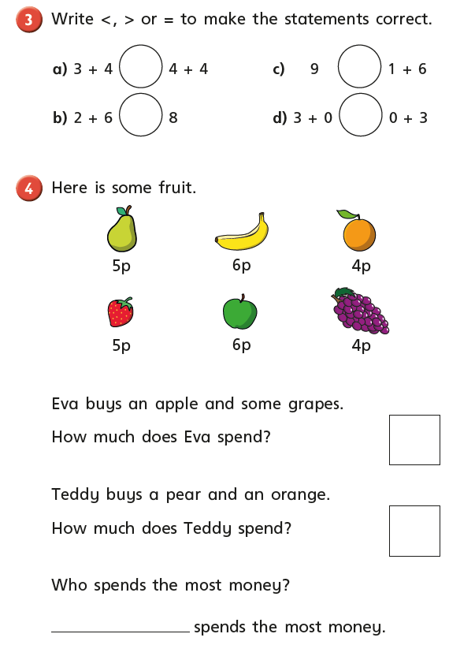

Tuesday PM Music – Sing along with Julia Donaldson. Learn ‘The Snail and the Whale Song.’
https://www.youtube.com/watch?v=a9hmHFQlXXs]

This is the tale, the incredible tale of a snail and a whale,
This is the tale, the incredible tale of a snail, who sailed all round the world on the tail of a whale.
Land, sea and sky, it was all so enormous it made the snail cry.
Land, sea and sky, "Oh, how terribly tiny am I, Oh, how tiny am I!" said the snail with a sigh.
Then came the day, when the whale lost his way and was beached in a bay,
Then came the day, when the water was slipping away,
And he heavily, helplessly lay in the bay.
Here comes the snail! Keep your eyes on the blackboard, she's leaving a trail.
Here comes the snail, and she writes on the board, "Save the Whale!"
"Save the Whale!" wrote the snail with her silvery trail.
Dig, squirt and spray, all the children and firemen are working away,
Dig, squirt and spray, till the tide rolls back into the bay,
And the whale and the snail travel safely away.
Snail after snail after snail slithers onto the tail of the whale,
Snail after snail, and they sing to the sea as they sail,
Yes they sing as they sail on the tail of the whale.

English Wednesday- Recall key events from the end of a story. Can you write about who helped the whale at the end of the story? What exactly happened? Write a simple recount of the ending.

____________________________________________________________________________________________________________________________________________________________________________________________________________________________________________________________________________________________________________________________________________________________________________________________________________________________________________________________________________________________________________________________________________________________________________________________________________________________________________________________________________________________________________________________________________________________________________________________________________________________________________________________________________________________________________________________________
Wednesday Maths
Star Starter Tasks
Remember that you can use different manipulatives and methods to help you work out the answers. Record notes on your whiteboard.

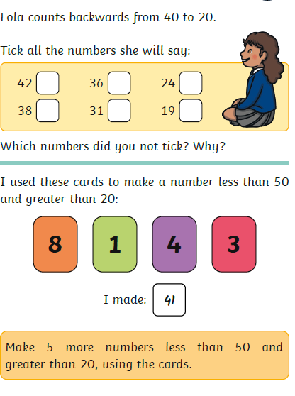

Main Tasks
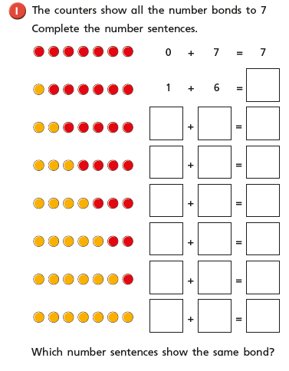

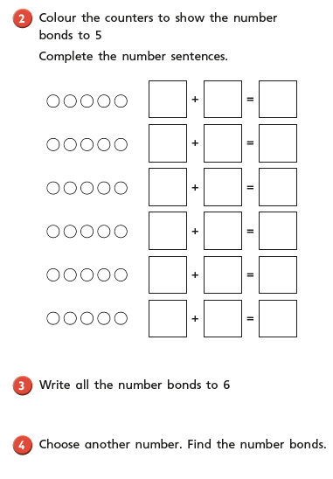

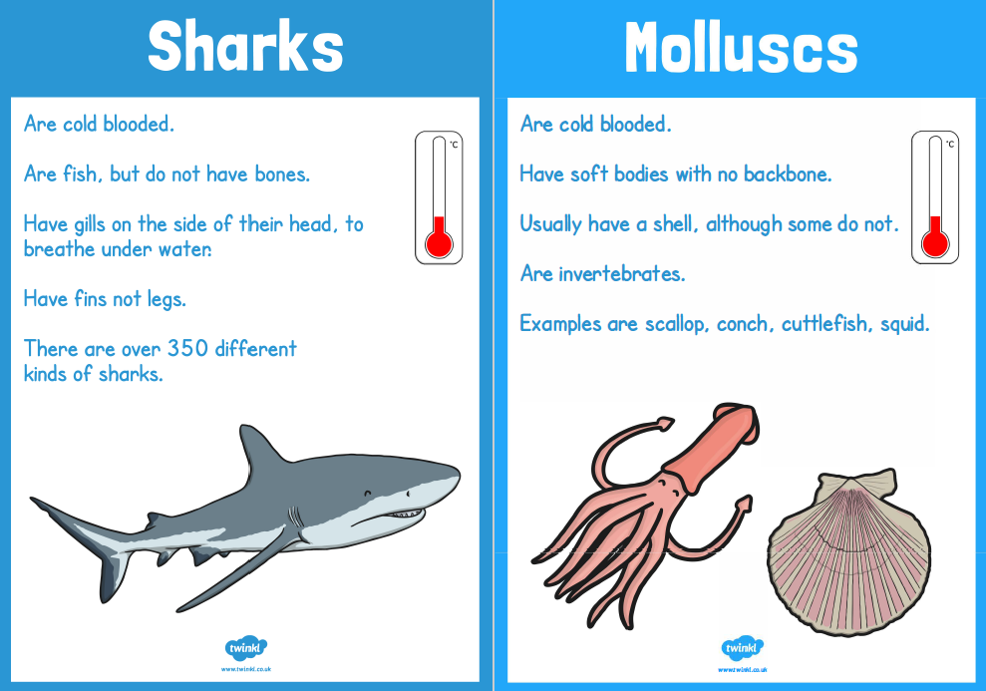
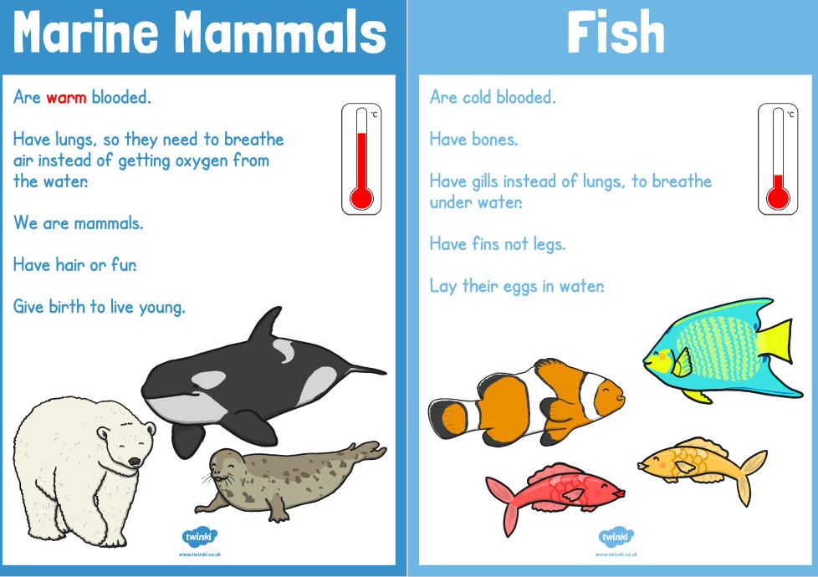
Wednesday PM- Can you find out about the different groups that sea and sea/land creatures and animals come into? Discuss the similarities and differences between the groups. Which ocean layer would you expect to find these animals/creatures?
Using your knowledge of the groups. Can you cut out and sort the images into groups? Create your own table on a large sheet out paper.
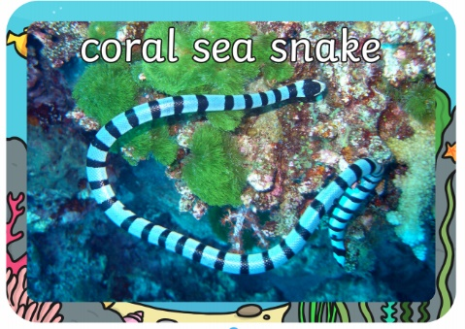
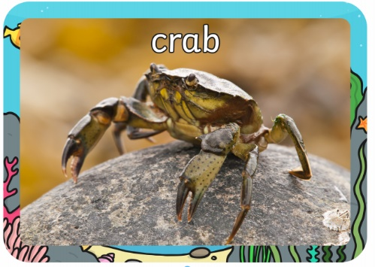
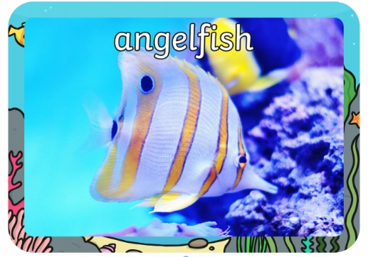
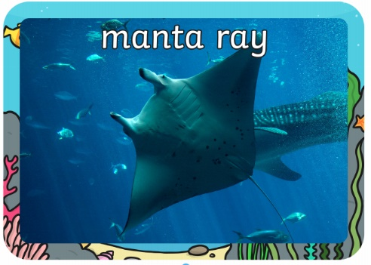
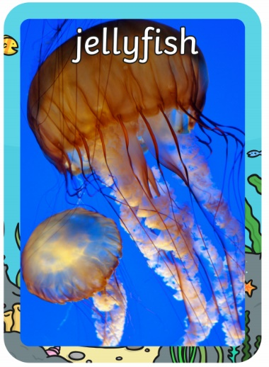
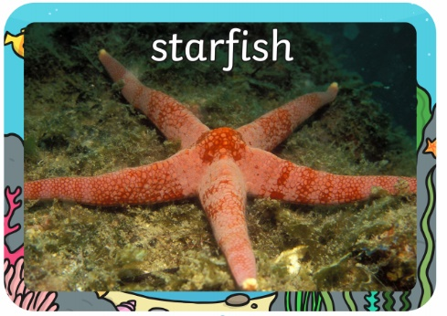
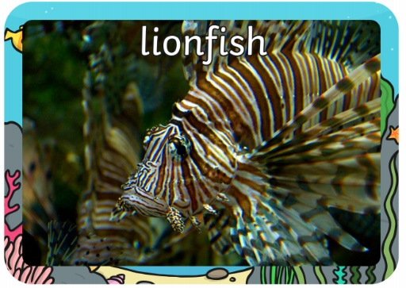
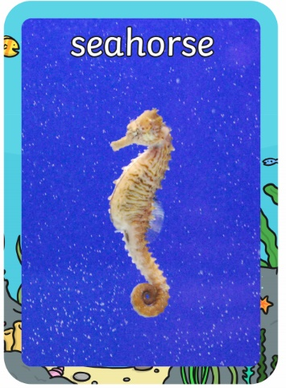
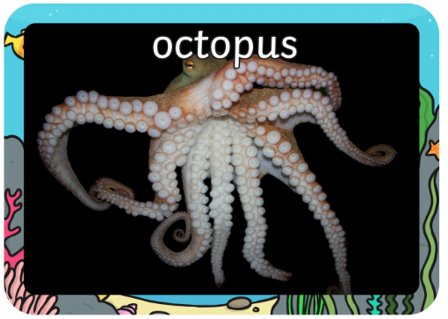

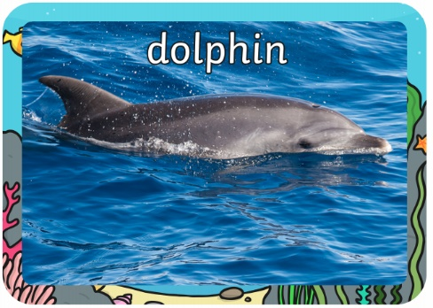
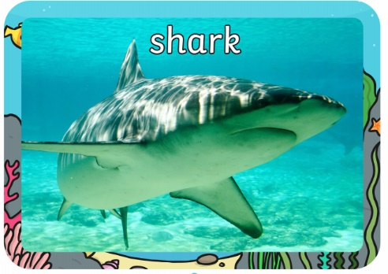

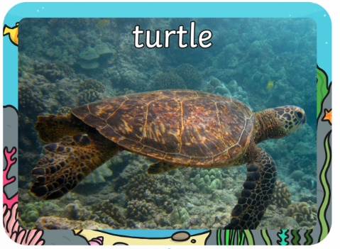
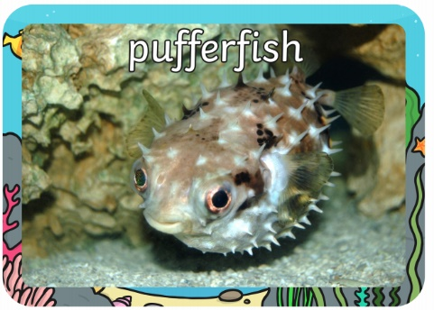

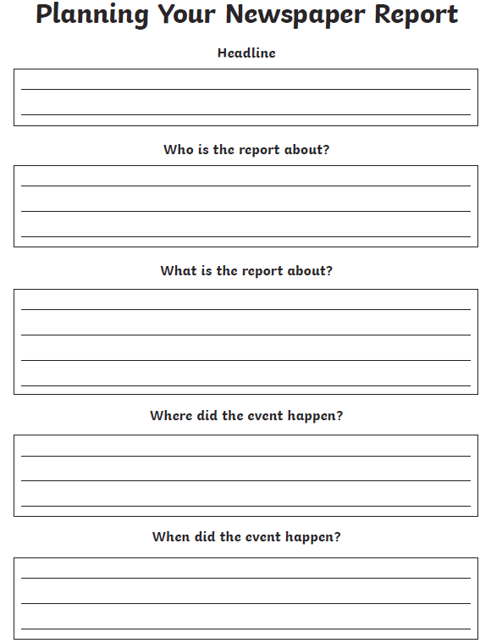
English Thursday- Imagine that you are a newspaper reporter. You are going to write a newspaper report all about the adventures of the snail and the whale. Use your knowledge of the story and the events that occur to plan your newspaper report using the template provide
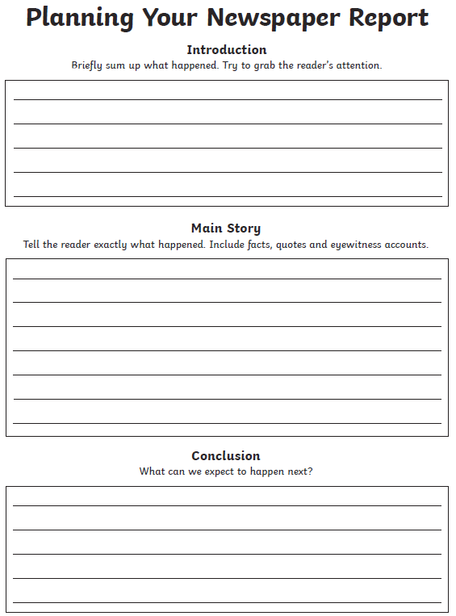
Thursday Maths
Star Starter Tasks
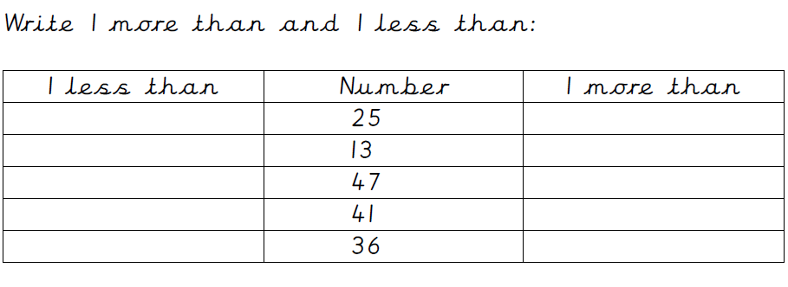
Remember that you can use different manipulatives and methods to help you work out the answers. Record notes on your whiteboard.
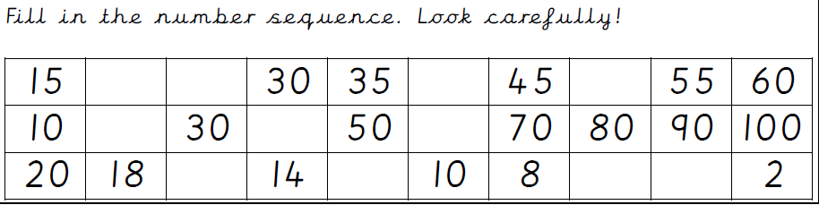

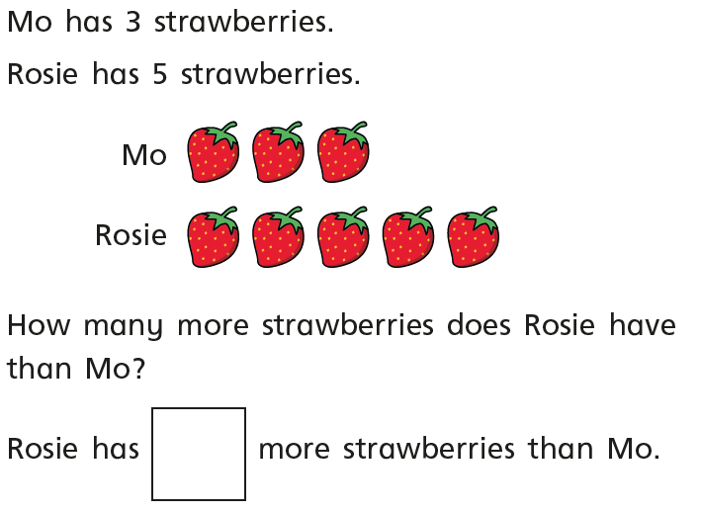

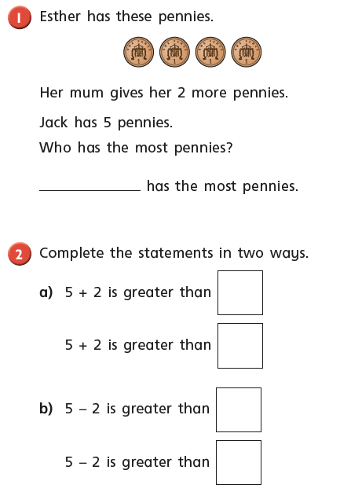
Main Tasks

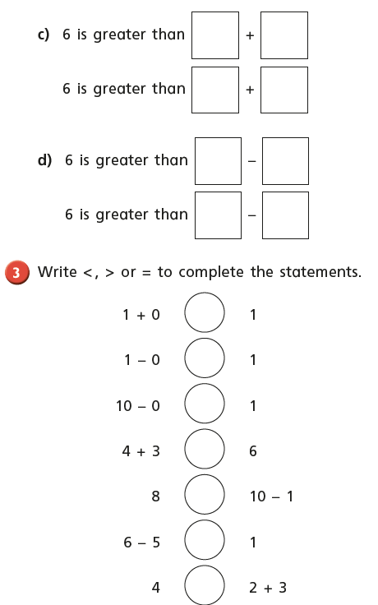

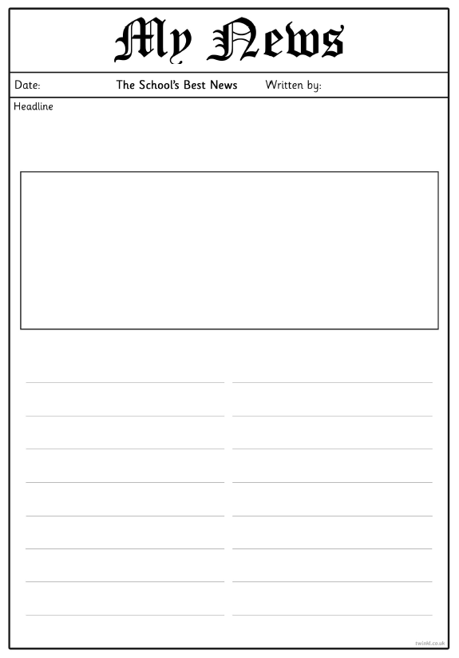
English Friday- Use your newspaper report plan to help complete your own newspaper report all about the adventures of the snail and the whale.
Thursday Maths
Star Starter Tasks
Remember that you can use different manipulatives and methods to help you work out the answers. Record notes on your whiteboard.

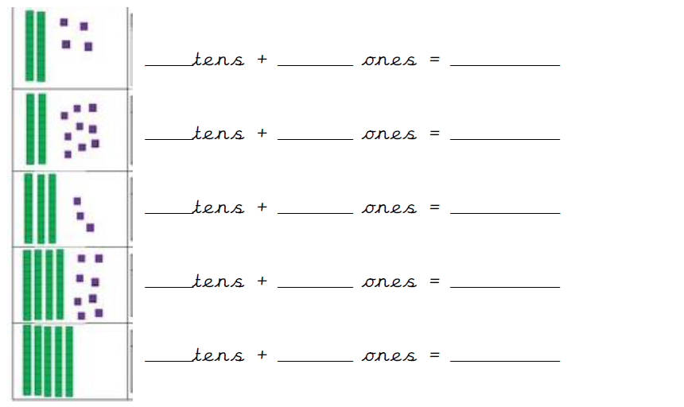

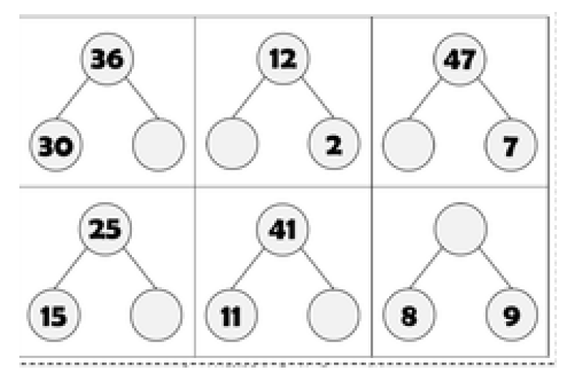

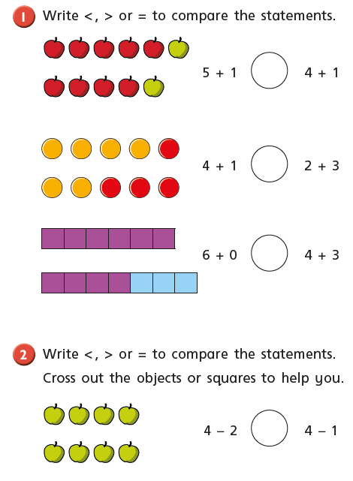
Main Tasks

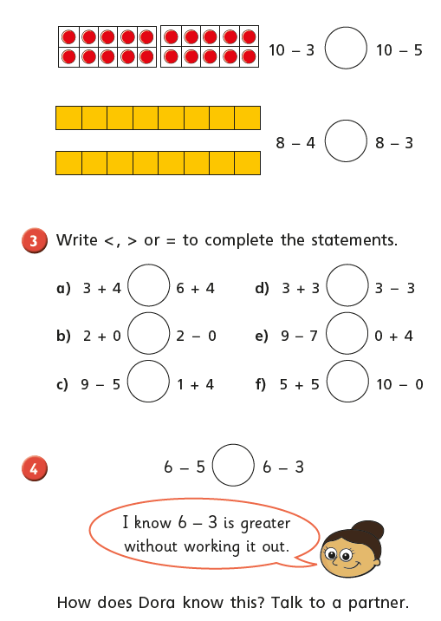

Friday PM Science- Experiment
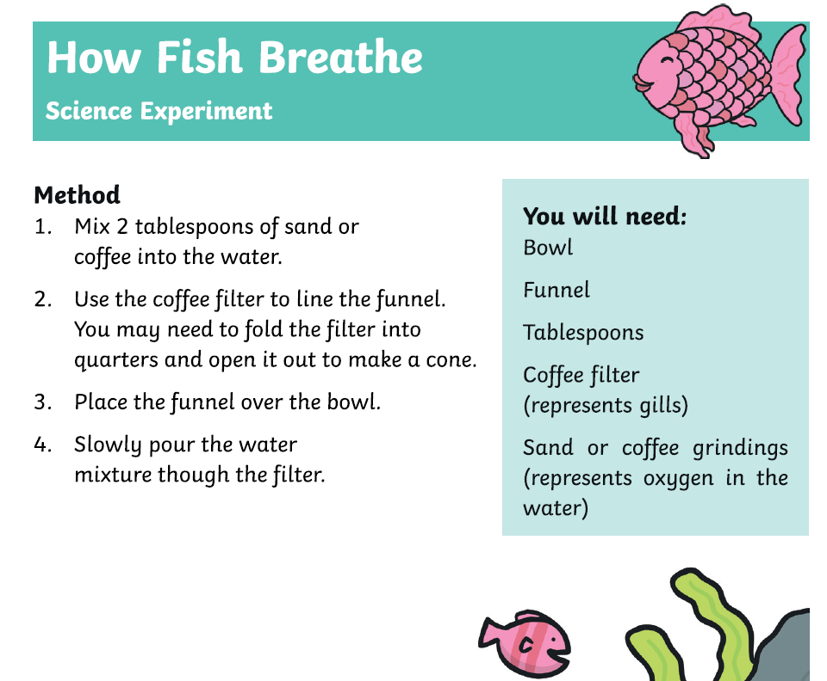
How do fish breath under water?

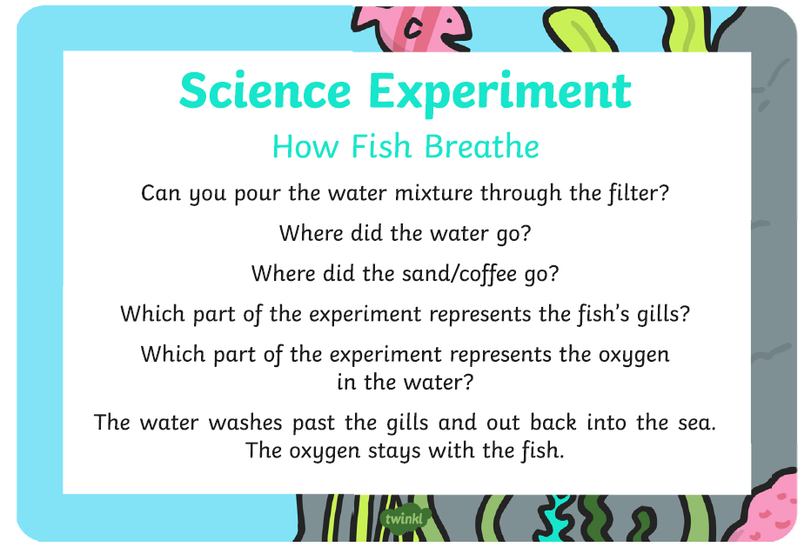

Tell me about what you have learnt from the science experiment!

__________

.
__________

