Day | Daily English Task  Weekly Focus:  Oceans | Daily Maths Task  Weekly Focus:  Volume, Temperature and Time.  Each day, try to complete a Fluency task from the booklet | Music Events  DURHAM MUSIC LIVE! | 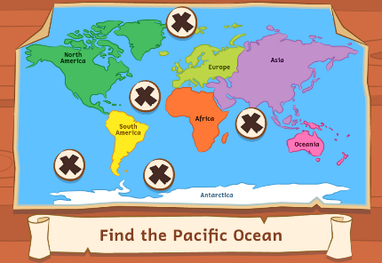  Other Subjects  Y2 under the Sea
Monday | Daily Reading. Read online and complete your Accelerated Reader quizzes https://www.myon.co.uk/login/index.html  Spellings : Week 2 Summer Spelling 2 Booklet spelling booklet. Days 1-5 (Spelling list is on back page.)  This week we will continue with the MyOn Project as mentioned on Class Dojo. | TTRockstars: https://ttrockstars.com/  Topmarks:  Daily 10 Mixed Tables 2, 3, 5 and 10  Mathletics Multiplication: www.mathletics.co.uk  Link  - Litres  Complete sheets | Whole Class Singing – 13:30 | 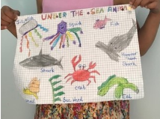  Science:  During our recent Science lessons, we found out about food chains. Do some more work on Ocean food chains.  Ocean Food Chain Song  Ocean Food Chains and Food Webs  Read the PDF “Under the Sea Foodchains”  Complete the separate activity  Research the food chain or food web of some sea creatures of your choice
Tuesday | Spellings : Week 2 Summer Spelling 2 Booklet spelling booklet. Days 1-5 (Spelling list is on back page.)  This week we will continue with the MyOn Project as mentioned on Class Dojo. | TTRockstars:  https://ttrockstars.com/  Topmarks:  Daily 10 Mixed Tables 2, 3, 5 and 10  Mathletics: www.mathletics.co.uk  Link  2. Temperature  Complete sheets | Tiny Fingers – 13:30  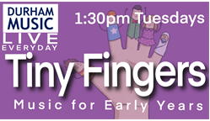 | 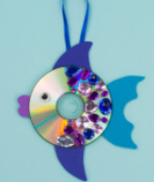  Art:  Have some fun making your own sea creature by recycling old things from your home that you don’t need any more (Ask an adult first!!)  You could follow the instructions to make a fish from an old CD – or adapt this idea to create your own Shark or other creature!
Wednesday | Spellings : Week 2 Summer Spelling 2 Booklet spelling booklet. Days 1-5 (Spelling list is on back page.)  This week we will continue with the MyOn Project as mentioned on Class Dojo. | TTRockstars: https://ttrockstars.com/  Topmarks:  Daily 10 Mixed Tables 2,5 and 10  Mathletics: www.mathletics.co.uk  Link  3.O'Clock and half past  Complete sheets | Ukulele and Singing – 13:30  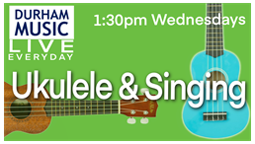 | Mindfulness  Have a relaxing time colouring some of the ocean pictures or completing the word search.
Thursday | Spellings : Week 2 Summer Spelling 2 Booklet spelling booklet. Days 1-5 (Spelling list is on back page.)  This week we will continue with the MyOn Project as mentioned on Class Dojo. | Daily 10 Division 2,5, 10 Extension- choose 3 x tables  Mathletics: www.mathletics.co.uk  Link  4. Quarter to and Quarter Past  Complete sheets | Rhythm and Musicianship 13:30  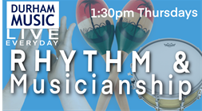 | Computing  Link : Think U Know PACK 6  Try some activities from the 6th pack  Upload any work you’ve done to Class Dojo if you can  Use this time to type up any work you’d like to show me on Class Dojo, if you want to.
Friday | Spelling Test.  This week we will continue with the MyOn Project as mentioned on Class Dojo. | Daily 10 Division 2,3, 5, 10  Mathletics:  Link  www.mathletics.co.uk  Friday Challenge | Little Fingers (for EYFS and KS1) – 13:30  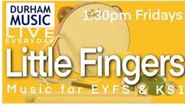 | PE  Get outdoors in the fresh air! Go for a drive or a walk. Go to the sea if you can!  Les Mills BORN TO MOVE™ https://www.youtube.com/channel/UCJIZkpEAHfJ4kSkbkB8krDg  Go Noodle https://www.youtube.com/user/GoNoodleGames  Zumba with Dovydas https://www.youtube.com/channel/UCOjZigyo_fg2V7JdGwePSwg  Super Movers https://www.bbc.co.uk/teach/supermovers  Andy’s Wild Workouts (EYFS) https://www.bbc.co.uk/iplayer/episodes/p06tmmvz/andys-wild-workouts

