Day | Daily English Task | Daily Maths Task | Other Things that you could do
Monday | This week we are looking back over our time in Reception. Look at the different topics that we covered and think about the books that we read. Which book did you like best in each topic? Can you write what happened in the story? | This week we are going to revise some of the things that we have been doing this year. Can you look at the pictures of the 3D shapes? Can you remember the names of the shapes? Which objects can you remember are which shape? Fill in the chart of information. | - Fill in the information sheet about yourself.  - Draw a picture of your favourite book from this year.  - Make a list of the things that you would like in your new classroom.  - Write a list of your best friends.  - Draw a picture of a special moment from the year.  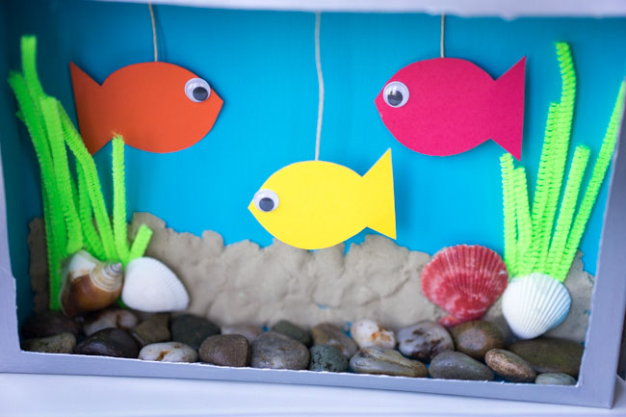  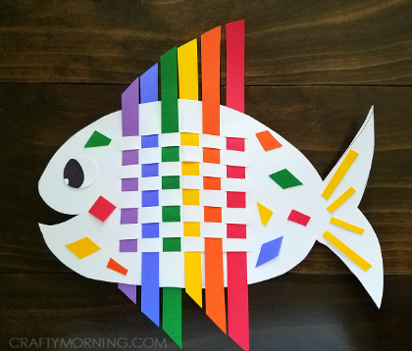  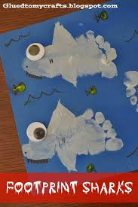
Tuesday | Think about the different topics that we have covered this year. What did you enjoy learning about the most? Can you think of a piece of information that you have learned this year or something that you have learned to do? Write some sentences about your learning. | Today we will be revising more and less. For each number can you write the number that is one more and one less? Can you write the number that is two more and two less. Use the number line to help you. Can you also find out which number is bigger and which is smaller using the numberline.
Wednesday | Think of all that you have done this year and the times that you have spent with your friends. Can you think of your favourite memory from the year? It might have been something that we have learned, something that you did with your friends or a moment that made you smile. | Today we are going to practise addition. Can you use all that you have learned to work out the answers to these addition questions? You can count out objects to help you, count on using your fingers or you can use Numicon to help you.
Thursday  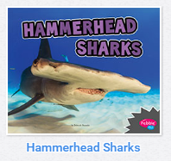  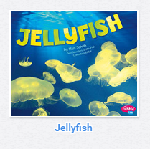 | Think to next year in your new class. What would you like your new teacher to know about you? Write a letter to Miss Cameron to tell them who you are and some information about yourself. What are you good at? What do you find hard? | Today we are going to practise subtraction. Can you use all that you have learned to work out the answers to these addition questions? You can use objects to help you, count back using your fingers or you can use Numicon to help you.
Friday | Think of what you are looking forward to about next year. What would you like to learn about? What do you want to learn how to do? Write a list of things that you are excited about next year. | Today we are going to practise adding money. Can you add the coins in the purse to see how much there is there altogether. Can you look at the different coins and say how much they are worth?

