Day | Daily English Task | Daily Maths Task | Other Things that you could do
Monday | This week we are reading the story Tiddler the storytelling fish by Julia Donaldson. Can you listen to the story on YouTube? Can you look back through the story and write a list of the different characters that you can see in the story? Can you remember the different types of fish? | This week we are going to think about tiddler from the story and we are going to do some measuring. Can you look at the different fish and put them into size order from the shortest fish to the longest fish? Can you remember to put the fish next to each other when you are comparing them? | - Think about what you have learned about telling tales from this story. Make a poster to tell people why they shouldn’t make up tales.  - Try to make the different fish from the story.  - Look at the Gruffalo fish in the story, can you design your own fish?  - Research other sea animals on MyON  - Make an under the sea dance where you pretend to be different sea creatures.  - Make a home aquarium.  - Colour in the scales on a fish in a repeating pattern.  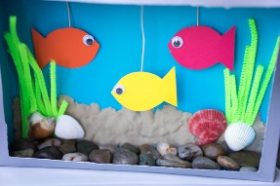  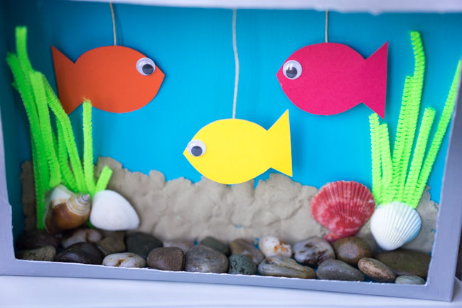  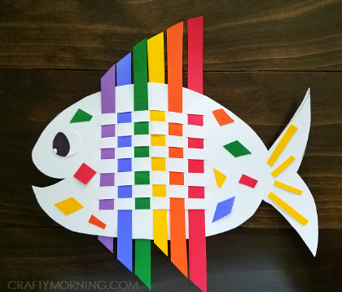  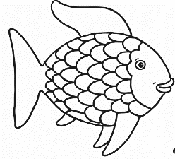  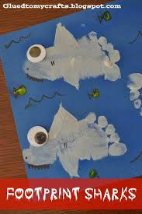
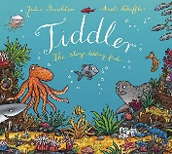  Tuesday | Think about the story that we read yesterday. Listen to it again. Look at the pictures of the parts of the story. Can you cut out these pictures and stick them into the right order. If you can’t print them, tell your adult what is happening in each picture and point to the pictures in the right order. | Cut out or make your own fish shape to be Tiddler. Use this fish to compare sizes of things around your house/ the classroom. Can you write a list of things that you can find in your house that are longer than Tiddler? Remember to put Tiddler at the very end of the object as you measure. Can you find anything that is the same size as Tiddler?
Wednesday | Listen to the story again. Look at the pictures of the different tales that Tiddler told. Can you think about what is happening in each picture and think of a sentence to write to say what is happening in the picture? | Using your fish from yesterday, today look for things that are shorter than Tiddler. Compare the different things that you have found. Which is the shortest thing that you have found in your house/ classroom? Which is the object that is the closest to the size of Tiddler without being longer?
Thursday  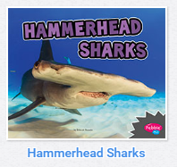  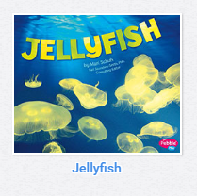 | Imagine that you are Tiddler. Can you fill in this speech bubble to write what happened in the story from Tiddlers point of view? Remember to use ‘I’ when you are writing instead of ‘he’ because you are pretending to be Tiddler. | Look at the fish template from the school website or make your own roughly A4 size. Can you find objects around you to use to measure this fish e.g. sweets, buttons, coins? Can you carefully lay these objects from one side of the fish to the other? How many of each object does it take to go from one side to the other?
Friday | Think of all of the tales that Tiddler told in the story. Can you write a letter to the other fish to tell them that Tiddler really did get caught in the fisherman’s net and that this is not one of Tiddler’s tall tales. | Use your Tiddler cut out from earlier in the week. Can you use the cut out to measure different things around you? How many Tiddlers does it take to measure from one side of the object to the other? E.g. how many can you fit across your TV/ whiteboard.

