Complete daily | Name recognition  Find your name. Match your name. Find the letters in your name. Attempt to write your name.  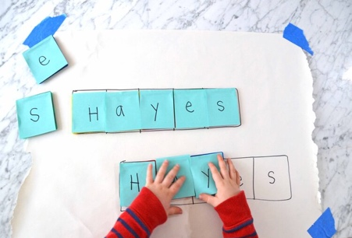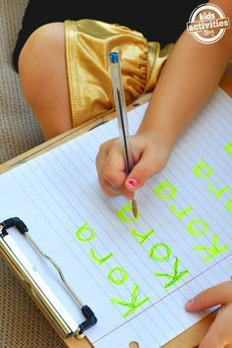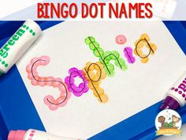
Focus tasks | 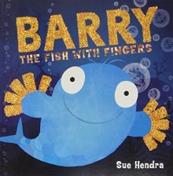  https://www.youtube.com/watch?v=Ewsgwj-wM4w  Teaching Ideas and Resources:  English  - Puffy, the puffer fish, blows bubbles. Think of different words to describe bubbles. You might try blowing bubbles to help you think of some new vocabulary.  - 'Barry was no ordinary fish'. What does 'ordinary' mean?  - Barry is described as 'amazing' in the story. Write a story about another amazing creature.  - Use finger puppets to tell a story that Barry might perform to his friends.  Maths  - Design a new scarf for Puffy which has repeating patterns on it.  Science  - Think about the bubbles that Puffy blows. What are bubbles? Can you make your own?  Computing  - Use a paint package to design a new creature that lives under the sea with Barry and his friends.  Design Technology  - Design and make some new finger puppets for Barry to use.  - Practise your cutting skills by making your own paper chain fish.  Art  - Look at the illustrations in the book and create a new fish friend for Barry.  - Design a new animal that has some body parts from different creatures.  - Try some finger painting like Barry does!  PSHE  - Puffy, the puffer fish, can blow the best bubbles. Think about your talents... what are you good at doing? What are your friends' talents?  - Look at the expressions on the faces of the characters in the story. How are they feeling? How do you know?  - Puffy gets upset when everyone wants to play with Barry. What could he do to make himself feel better? How could the other fish cheer him up?  - Puffy explains that he was a 'grumpy spoilsport'. What is a spoilsport

Complete daily | Watch the jolly phonics phase 2 song on Youtube. Join in with the words and actions. https://www.youtube.com/watch?v=1Qpn2839Kro  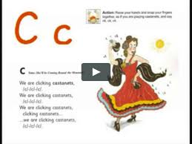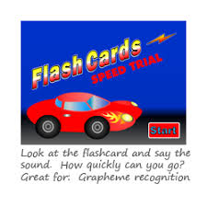  Go on Phonicsplay.co.uk or use the app Username: march20Password: home. Flashcards- speed trials- phase 2  Recap phase 2 sounds  Recap all phase 2 sounds. Attempt to form the letters for each sound whist saying the rhyme. Use additional resources provided to attempt CVC words.  Attempt to use and blend these sounds into words that make simple sentences.
Focus tasks | 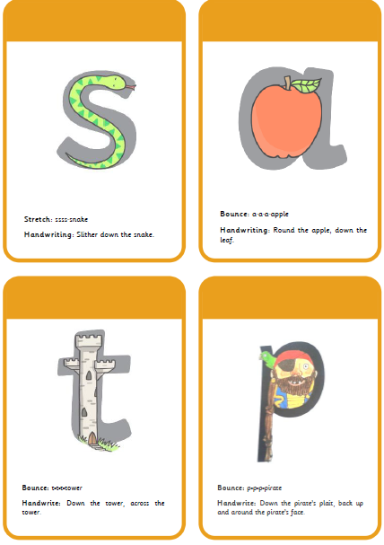  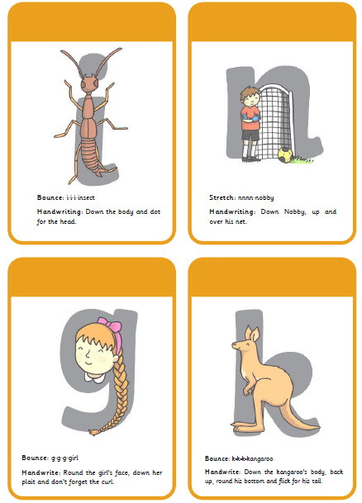  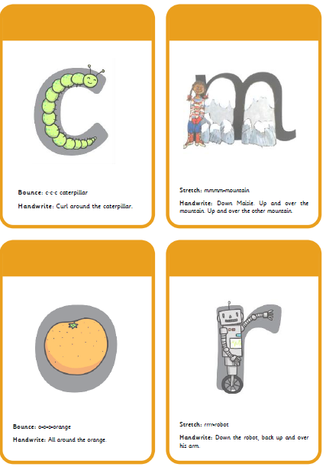  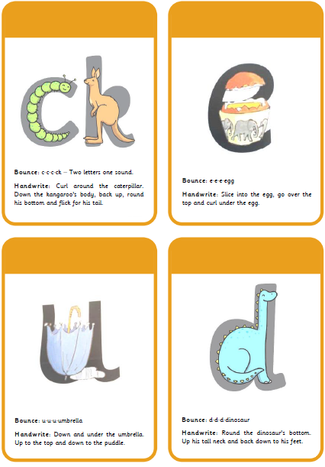  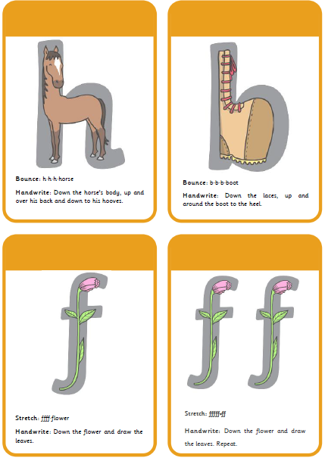  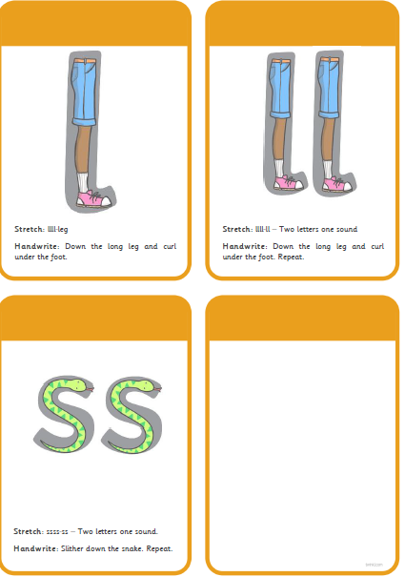

Complete daily | Watch the ‘Our favourite number songs’ video on Youtube on the Super Simple Songs channel. Sing along and remember to hold up the correct fingers when counting.  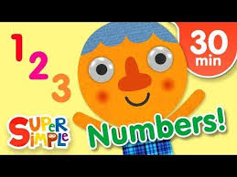

Other activities.
- Go over the date and weather daily. Go outside to check the weather and discuss. What season are we in? What happens during this season? Make a weather chart or use an online one. https://www.ictgames.com/mobilePage/dateChart/index.html
Jack Hartmann on YouTube has some great days of the week and months of the year songs and dances.

- Encourage children to dress themselves. Putting on their own clothes, coats and shoes makes them more independent and ready for starting their Reception class.

Pencil control
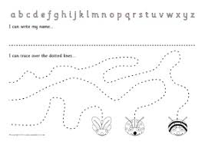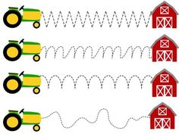
- You can make your own pencil control sheet by drawing lines for your child to follow. Make these however you like. Using , straight, circular, and zig zag lines.
- Have your child join the dots, number the dots to incorporate a bit of maths.
- Placing objects inside lines.
- Highlighter Tracing, draw a picture with a highlighter for your child to trace
See additional file for new pencil control sheets.

Tommy thumb songs

https://www.youtube.com/watch?v=yGJvH-KnFJE

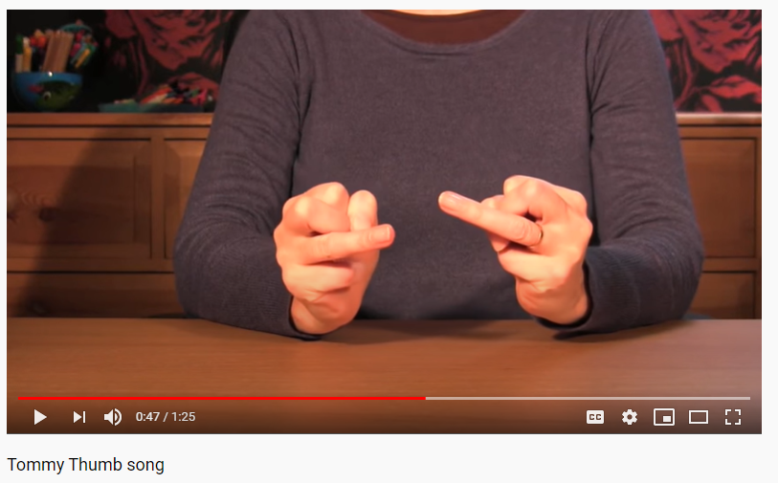
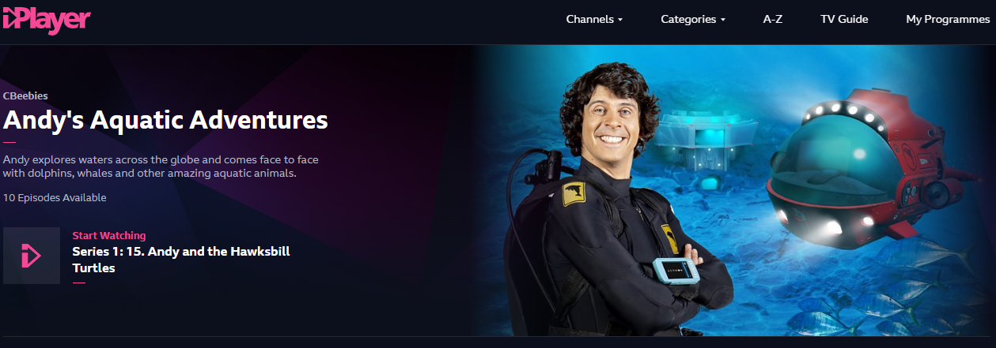
https://www.bbc.co.uk/iplayer/episodes/m000fbs2/andys-aquatic-adventures

Use your log in on myon.co.uk to access a range of ‘Under the Sea’ books.
