Complete daily | Name recognition  Find your name. Match your name. Find the letters in your name. Attempt to write your name.  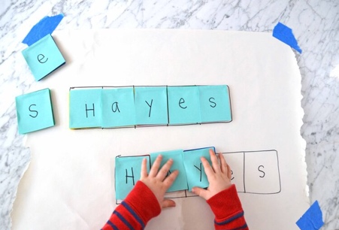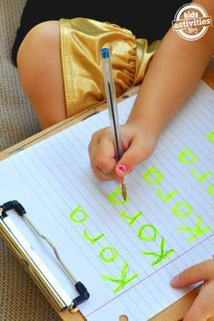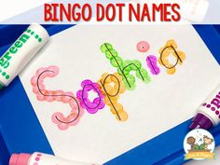
Focus tasks | 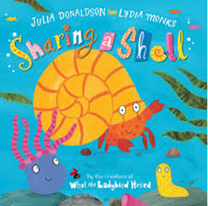  Learning Intention: To listen and respond to stories  Activity: Read ‘Sharing a Shell’.  Read the story with lots of rhythm and expression. Encourage your child to listen to the story and join in with repeated or remembered parts.  Encourage them to discuss what might happen next.  When reading the story, encourage your child to listen to the rhyming words. Encourage them to identify missing rhyming words based on rhyme and context of the story. Together label some of the characters from the book. Who is this character? What sound does crab begin with? How do we form a ‘c’?  Activity:  Together sequence the ‘Sharing a Shell’ story pictures. Have them spread on the board for your child to lay into order. See if your child can remember what happened in the beginning, middle and end. Study the pictures carefully and ask what happened next.  Use some of the character pictures, stick these on the board and discuss what the character could be saying. Share ideas, and why they might be saying this. As a group write a speech bubble for the character. Discuss sounds as you write words.  Learning Intention: Beginning to think of describing words.  Use some real shells and use these as a writing prompt. Encourage children to think of and write words to describe the shells, such as bumpy, smooth, flat, round and pointy (talk about sounds and letter formation). Together write these on the board. Gave children some shells each for them to look at and describe see if they can use the playdough to create scenes from the story using the shells

Complete daily | Watch the jolly phonics phase 2 song on Youtube. Join in with the words and actions. https://www.youtube.com/watch?v=1Qpn2839Kro  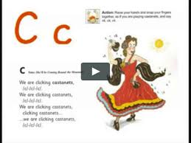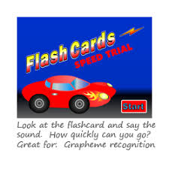  Go on Phonicsplay.co.uk or use the app Username: march20Password: home. Flashcards- speed trials- phase 2
Focus tasks | Introduce the ‘a ’sound.  Form the letter ‘’ saying, “ Around the apple and down the leaf” ,as you form the letter.  How many things around the house can you find begging with the ‘ma’ sound?  Practise forming the letter ‘’. Remember to start and finish in the correct place. Say “ Around the apple and down the leaf”, as you form the letter.  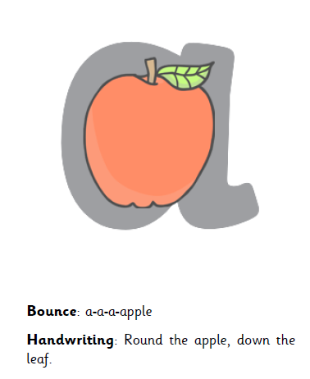  If you wish to practise a new sound the cards are available to download on the class dojo.  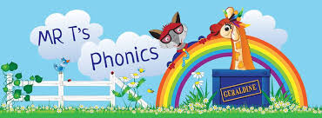  https://www.youtube.com/watch?v=H6fxDt4nV64  Watch Mr Thorne does phonics on YouTube- episode ‘a’  Write some words with the initial sound ‘a’.  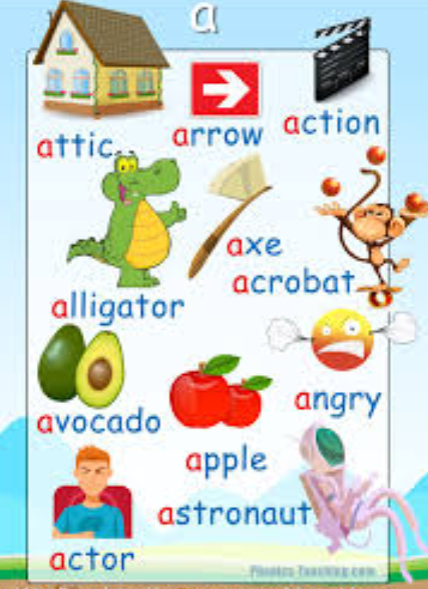  Watch the Letter, Song with bounce patrol. https://www.youtube.com/watch?v=gsb999VSvh8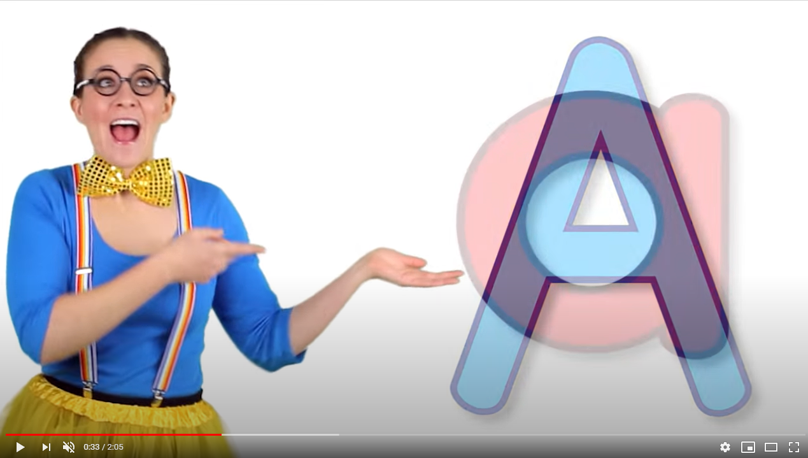

Complete daily | Watch the ‘Our favourite number songs’ video on Youtube on the Super Simple Songs channel. Sing along and remember to hold up the correct fingers when counting.  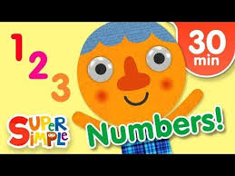
Focus tasks | Hide some of the characters from the story on 2d shapes ( Use outside if the weather is nice) When you discover each shape, see if we know what shape it is. How can we tell? Talk about the properties together. Does it have corners/ points? How many sides does it have? Are they straight or curved?  Resources- Characters on 2D shapes  Have a selection of shapes. Draw a grid and write- Squares, Rectangles, Triangles, Circles  Can we find all of the X . Take turns getting up and selecting a shape and putting it into the correct place. How many X do we have, count all together and write the number on the board in each section. Include some new shapes to discuss.  Resources- Selection of 2D shapes  Under the sea shape pictures.  Use shapes to create under the sea pictures. Model one on the board. Make sure lots of 2D shapes are being discussed. Which shape shall I use for the rock? Which shape would make a good fish?  Sea creatures’ shapes  Talk about the shapes they can see on each picture. Which shapes do we have to make the star fish? Go through each one. Give your child time to make each sea creature. Cutting their own shapes and placing them correctly. Include lots of discussion of shapes as you complete the activity.

Other activities.
- Go over the date and weather daily. Go outside to check the weather and discuss. What season are we in? What happens during this season? Make a weather chart or use an online one. https://www.ictgames.com/mobilePage/dateChart/index.html
Jack Hartmann on YouTube has some great days of the week and months of the year songs and dances.

- Encourage children to dress themselves. Putting on their own clothes, coats and shoes makes them more independent and ready for starting their Reception class.

Pencil control
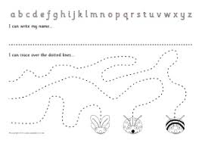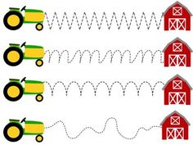
- You can make your own pencil control sheet by drawing lines for your child to follow. Make these however you like. Using , straight, circular, and zig zag lines.
- Have your child join the dots, number the dots to incorporate a bit of maths.
- Placing objects inside lines.
- Highlighter Tracing, draw a picture with a highlighter for your child to trace
See additional file for new pencil control sheets.
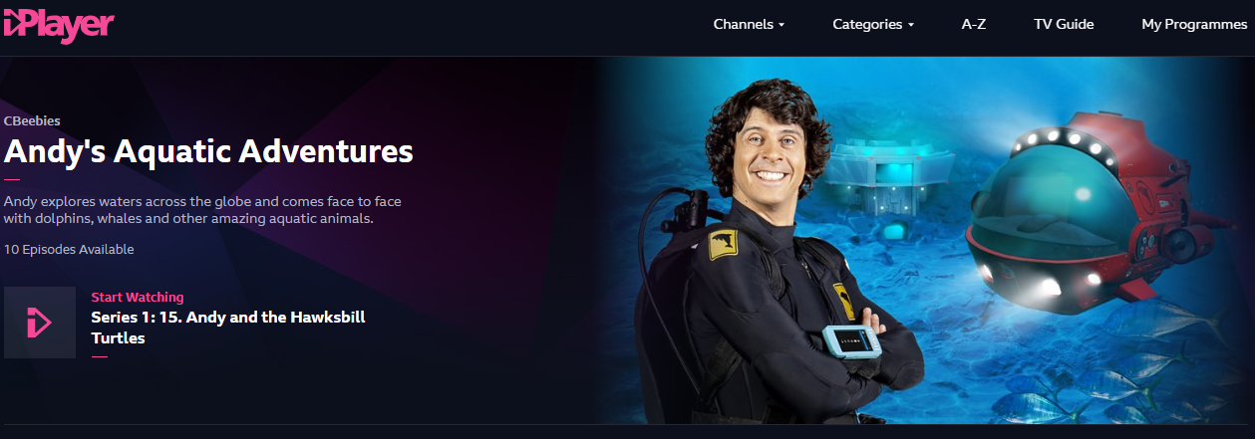
https://www.bbc.co.uk/iplayer/episodes/m000fbs2/andys-aquatic-adventures

Use your log in on myon.co.uk to access a range of ‘Under the Sea’ books.
