Geography Year 5/6 Tsunamis
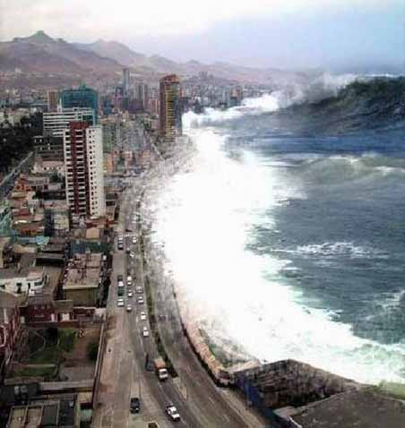
What is a tsunami?
______________________________________
______________________________________
______________________________________

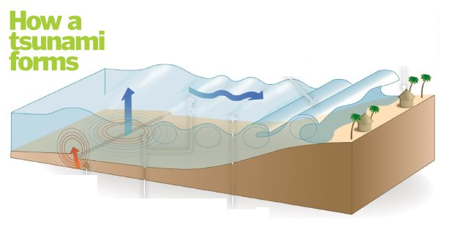

Use the diagram and the video
clip you have just seen to put the following sentences into the correct order to describe how a tsunami forms. Put a 1 in the box next to the sentence you think comes first.

Order of Sentences
Pressure builds under the surface at a tectonic plate boundary for a very long time until it is released in an earthquake or volcanic eruption.
Waves out at sea are often small, but travel at hundreds of miles an hour.
The back of the wave is still moving faster than the front, so the back rises causing a massive wave to form (often as high as 50ft).
The rock is pushed upwards after the earthquake, shifting the ocean water and causing a wave to form.
The massive wave hits the shore and travels inland, destroying objects and buildings in its path.
As waves move into shallow water they slow down.

The South East Asia Tsunami
Countries affected by the tsunami
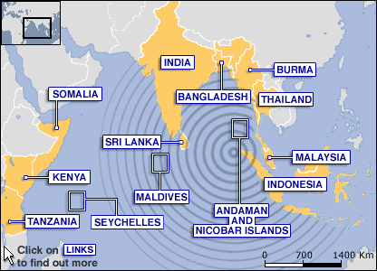
On December 26th 2004, an earthquake measuring 9.1 on the Richter Scale happened under the Indian Ocean. The epicentre of this earthquake was near Sumatra in Indonesia.
This earthquake lifted a 750 mile stretch of sea bed 40 metres higher than it had been. This then shifted the ocean water, forming a 1m tall wave at sea that was 100 miles long. This wave travelled at 500 mph until it hit shallower water and slowed down. As the wave slowed, it reached a height of 115 foot.
Eleven countries were hit by the tsunami waves, but the energy of the earthquake and tsunami was felt around the world.
Fact File
Use the information above to fill in the boxes to make your own fact file about the 2004 tsunami.
DATE

TIME

CAUSE OF TSUNAMI

MAGNITUDE OF EARTHQUAKE

LENGTH OF SEA BED LIFTED

MAXIMUM WAVE SPEED

TALLEST WAVE HEIGHT

NUMBER OF COUNTRIES AFFECTED

EXAMPLES OF THREE COUNTRIES AFFECTED

Effects of the South East Asia Tsunami
Effects on Businesses, Jobs or Money
Effects on People

220,000 people dead or missing.
Millions of people left homeless as houses
were destroyed.
Businesses damaged and destroyed.
No food or clean water.
Higher chance of illness and starvation.
Fishermen’s boats are damaged so they
can’t go out to work and can’t earn money.
Hotels damaged, so there will be less money from
tourism.
Roads and bridges are damaged, so goods
can’t be moved around the country.

220,000 people dead or missing.
Millions of people left homeless as houses
were destroyed.
Businesses damaged and destroyed.
No food or clean water.
Higher chance of illness and starvation.
Fishermen’s boats are damaged so they
can’t go out to work and can’t earn money.
Hotels damaged, so there will be less money from
tourism.
Roads and bridges are damaged, so goods
can’t be moved around the country.

