Please note- Please try to ensure you complete your daily reading via MyON. You can also complete the quiz related to the book you have been reading.
 | Maths- AM | Literacy- AM | Other Activities/Tasks- PM
Monday | Starter-Complete ‘Star Starter Task.’- Please see the resource booklet.  Main Activity- Number bonds to 10.  Look at, discuss and complete the learning reminder cards. Discuss the key questions and thought bubbles on each card.  Complete the main tasks. Ensure the mild and hot tasks are completed. | Phonics- Please ensure a phonics session is carried out daily. Flash card hunt. Reading and writing given words with chalk.  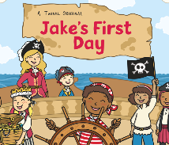  Literacy- Read the story, ‘Jake’s First Day.’ How are we feelings about our first day in Year 2?  Discuss any worries of questions that we may have. Discuss why it is important to share of worries. Any questions the children have can be asked in class or sent via class dojo for children working from home.  Complete the worry clouds on the template provided. These can be anything and any worry should be valued. For example: being alone or getting the question wrong. | 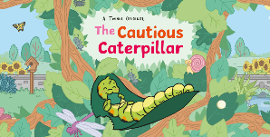  - Read ‘The Cautious Caterpillar’ story. Discuss change. Link to transition and moving to our new class.  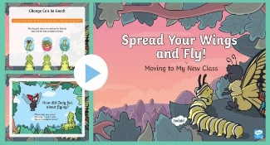  - Share the ‘Spread your wings- Cautious Caterpillar’ PowerPoint together. Discuss moving to Year 2. Discuss all of the questions and concepts mentioned in the PowerPoint.  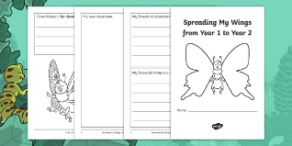  - Compete the ‘Spreading my wings from Year 1 to Year 1’ booklet. Explain why we might want to pass this onto our new teacher.  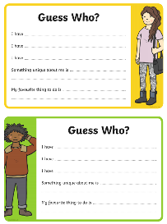  - Complete the ‘Guess who?’ task. Complete the guess who card and this will be passed onto your new teacher. Will your new teacher guess whose card is who’s?  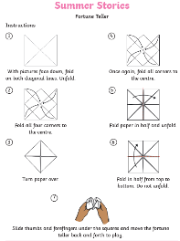  - Create your own ‘Summer Stories’ fortune teller. Work with an adult.  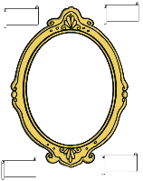  - Create a self-portrait for your Year 2 teacher. Write adjectives to describe yourself around the frame.  - Begin to think about class rules and expectations for Year2. What will my new teacher expect? Share ideas and then children write same ideas down on template provided.  - https://www.brassfestival.co.uk/brass-whats-on/ Join in with the ‘Brass Festival’ online. There will be 5 workshops, one each day. Monday 13 – Friday 17 July and each workshop will be broadcast on the BRASS website at 1pm.  - https://www.youtube.com/user/thebodycoach1- Join in with Joe Wicks daily PE session on his YouTube- The Body Coach.
Tuesday | Maths  Starter- Complete ‘Star Starter Task.’- Please see the resource booklet.  Main Activity- How many to the next 10?  Look at, discuss and complete the learning reminder cards. Discuss the key questions and thought bubbles on each card.  Complete the main tasks. Ensure the mild and hot tasks are completed. | Literacy  Phonics- Sounds- Can you hit a sound card with a beanbag? Say the sound as you aim. Buried treasure, blending for reading. Can you find the coins hidden in the year 1 outdoor space?  Literacy- Discuss the importance of preparing for moving to Year 2 as well as the importance of reflecting on our time spent in Year 1.  Talk about all of the positive memories from Year 1. What did you enjoy? What did you find hard? What have you learnt? What will you miss?  Complete the ‘Goodbye Year 1’ sheet.
Wednesday | Maths  Starter- Complete ‘Star Starter Task.’- Please see the resource booklet.  Main Activity- Bridging to 10.  Look at, discuss and complete the learning reminder cards. Discuss the key questions and thought bubbles on each card.  Complete the main tasks. Ensure the mild and hot tasks are completed. | Literacy  Phonics- Sounds- Teacher shouts a sound, children write on the yard with chalk. Word hunt- Hunt for words, read these and then sort into real or nonsense.  Literacy- All about me! Complete the ‘All About Me’ transition information for your new class teacher.  Think carefully about each subheading.
Thursday | Maths  Starter- Complete ‘Star Starter Task.’- Please see the resource booklet.  Main Activity- New- 3-D shapes and position.  Look at, discuss and complete the learning reminder cards. Discuss the key questions and thought bubbles on each card.  Complete the main tasks. Ensure the mild and hot tasks are completed. | Literacy  Phonics- Flash cards (Phase 3&5) Phonics play- Tricky word trucks.  Literacy- Preparing for our move into Year 2.  Adults to discuss differences between Year 1 and Year 2. What should the children expect? Who will their teacher be?  Complete the information on the template provided, all about preparing for Year 2.
Friday | Maths  Starter- Complete ‘Star Starter Task.’- Please see the resource booklet.  Main Activity- New- 3-D shapes and ½ and ¼ turns.  Look at, discuss and complete the learning reminder cards. Discuss the key questions and thought bubbles on each card.  Complete the main tasks. Ensure the mild and hot tasks are completed. | Phonics- Flash cards (Phase 3&5) Phonics play- Sentence level game.  Literacy- Write a letter to your new teacher.  What would you like to tell them about yourself? What would you like to ask them?  Remember to use the correct punctuation when writing questions.

Useful Websites for Extra Tasks/Activities
Phonics  https://www.phonicsplay.co.uk/  Username – march20 Password – home  https://www.teachyourmonstertoread.com/games/tm1/demo  https://www.phonicsbloom.com/  https://www.topmarks.co.uk/english-gam…/…/letters-and-sounds | Maths  www.mathletics.com  www.ttrs.com  www.topmarks.co.uk  https://www.oxfordowl.co.uk/for-home/  https://www.bbc.co.uk/iplayer/episodes/b08bzfnh/numberblocks  www.whiterosemaths.com/homelearning/
English  https://www.topmarks.co.uk/…/7-11-years/spelling-and-grammar  www.sooperbooks.com  https://www.oxfordowl.co.uk/for-home/  www.spellingframe.co.uk  http://www.funenglishgames.com/games.html  https://www.eslgamesplus.com/  www.pobble365.com  www.readtheory.org  https://www.scholastic.com/…/scholastic-learn-at-home--free…# | Other  https://www.si.edu/kids - Fun lessons on geography, history and science  https://www.shaunsgameacademy.co.uk/ - Computing  https://scratch.mit.edu/ - Computing – click ‘create’  https://www.duolingo.com/register - Languages  https://mrnussbaum.com/science - Science  https://www.gonoodle.com/good-energy-at-home-kids-games-an…/ - Free exercise videos  https://www.virtualmusicalinstruments.com/ - Music

