Please note- Please try to ensure you complete your daily reading via MyON. You can also complete the quiz related to the book you have been reading.
 | Maths- AM | Literacy- AM | Other Subjects- PM
Monday | Starter- Count to 100. Stopping at different numbers. What is one more than that number? What is one less than that number?  Complete ‘Star Starter Tasks’ within the resource pack-Remember that you can use different manipulatives and methods to help you work out the answers. Record notes on your whiteboard.  Main Activity- Number bonds.  Complete each of the tasks in turn. Adult to discuss each question. | Phonics- Please ensure a phonics session is carried out daily. Flash card hunt. Reading and writing given words with chalk.  Literacy- Listen to the story ‘The Snail and the Whale’ by Julia Donaldson. https://www.youtube.com/watch?v=hheolVGZVvs  Recall and sequence key events from a story. Can you recall key events from the story of ‘The Snail and the Whale’ by Julia Dodson?  Show your understanding by cutting out and sequencing the images into the correct order and then writing about each part. | Healthy Me- Handwashing  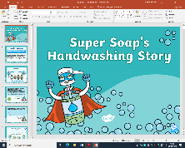  Go through the PowerPoint all about handwashing. Talk about the importance. Look at and discuss the different situations where the children need to wash their hands. Discuss this.  Children create their own poster to encourage others to always wash their hands. Look at examples within the resource booklet for ideas. | Under the Sea Facts-  Look at the PowerPoint- Sea Creature Facts. Go through the PowerPoint and discuss information. Discuss similarities and differences between the sea creatures.  Create large A3 posters about the sea creatures using given images and learnt information.  You will need to remember some of this information for a task later in the week.
Tuesday | Maths  Starter- Count in 2’s 5’s and 10’s. Use interactive hundred square.  Complete ‘Star Starter Tasks’ within the resource pack-Remember that you can use different manipulatives and methods to help you work out the answers. Record notes on your whiteboard.  Main Activity- Number bonds. Compare.  Complete each of the tasks in turn. Adult to discuss each question. | Literacy  Phonics- Sounds- Can you hit a sound card with a beanbag? Say the sound as you aim. Buried treasure, blending for reading. Can you find the coins hidden in the year 1 outdoor space?  Literacy- Recall key events from a story.  Can you write about what the snail saw/discovered during his adventure on the tail of the whale?  Use the images provided to support with this. Adult to discuss and model some sentence ideas. | Can you sing along with Julia Donaldson?  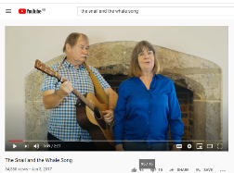  Learn ‘The  Snail and the Whale Song.’  https://www.youtube.com/watch?v=a9hmHFQlXXs] | https://www.youtube.com  /user/thebodycoach1  Join in with Joe Wicks daily PE session on his YouTube- The Body Coach.
Wednesday | Maths  Starter- Number bond song- https://www.youtube.com/watch?v=lD9tjBUiXs0  Complete ‘Star Starter Tasks’ within the resource pack-Remember that you can use different manipulatives and methods to help you work out the answers. Record notes on your whiteboard.  Main Activity- Systematic number bonds.  Complete each of the tasks in turn. Adult to discuss each question. | Literacy  Phonics- Sounds- Teacher shouts a sound, children write on the yard with chalk. Word hunt- Hunt for words, read these and then sort into real or nonsense.  Literacy- Recall key events from the end of a story.  Can you write about who helped the whale at the end of the story? What exactly happened?  Write a simple recount of the ending.  Use the images provided to support with this. Adult to discuss and model some sentence ideas. | Can you find out about the different groups that sea and sea/land creatures and animals come into?  Discuss the similarities and differences between the groups. Which ocean layer would you expect to find these animals/creatures?  Using your knowledge of the groups. Can you cut out and sort the images into groups? Create your own table on a large sheet out paper.
Thursday | Maths  Starter- Count in 2’s, 5’s and 10’s on interactive hundred square. Practise your 2, 5, and 10 times tables, link to counting.  Complete ‘Star Starter Tasks’ within the resource pack-Remember that you can use different manipulatives and methods to help you work out the answers. Record notes on your whiteboard.  Main Activity- Comparing statements.  Complete each of the tasks in turn. Adult to discuss each question. | Literacy  Phonics- Flash cards (Phase 3&5) Phonics play- Tricky word trucks.  Literacy- Imagine that you are a newspaper reporter. Lots of people would love to find out all about the adventures of the snail and the whale. Not many people will believe it!  Adult to show the children some examples of age appropriate newspaper articles. Why are they important? What do they give people?  Explain that they are going to write a newspaper report all about the adventures of the snail and the whale. Use your knowledge of the story and the events that occur to plan your newspaper report using the template provide | Can you create your ‘Snail and the Whale’ picture using tissue paper?  Discuss the items/resources that you are going to need.  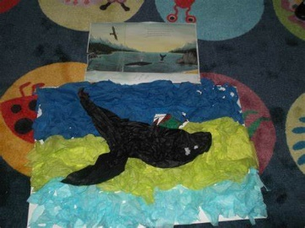 | 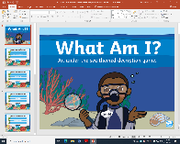  Can you complete the ‘Who am I?’ under the Sea description game?  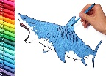  Using your knowledge of under the sea creatures complete the description game. Listen and think carefully about the clues provided. Draw the sea creature that you think is being described. Think about the features of the sea creature as you draw it! Reveal and see if you were correct.
Friday | Maths  Starter- Complete ‘Star Starter Tasks’ within the resource pack-Remember that you can use different manipulatives and methods to help you work out the answers. Record notes on your whiteboard.  Main Activity- Comparing statements 2.  Complete each of the tasks in turn. Adult to discuss each question. | Phonics- Flash cards (Phase 3&5) Phonics play- Sentence level game.  Literacy- Use your newspaper report plan to help complete your own newspaper report all about the adventures of the snail and the whale.  Think about the key features of your newspaper report. Remember to include your title and some images.  Read, check and edit your own work. | 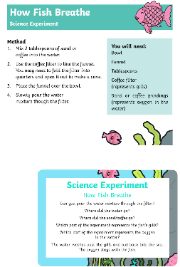  Science- Experiment- How do fish breath under water?  Write about what you have learnt from the science experiment!

Useful Websites for Extra Tasks/Activities
Phonics  https://www.phonicsplay.co.uk/  Username – march20 Password – home  https://www.teachyourmonstertoread.com/games/tm1/demo  https://www.phonicsbloom.com/  https://www.topmarks.co.uk/english-gam…/…/letters-and-sounds | Maths  www.mathletics.com  www.ttrs.com  www.topmarks.co.uk  https://www.oxfordowl.co.uk/for-home/  https://www.bbc.co.uk/iplayer/episodes/b08bzfnh/numberblocks  www.whiterosemaths.com/homelearning/
English  https://www.topmarks.co.uk/…/7-11-years/spelling-and-grammar  www.sooperbooks.com  https://www.oxfordowl.co.uk/for-home/  www.spellingframe.co.uk  http://www.funenglishgames.com/games.html  https://www.eslgamesplus.com/  www.pobble365.com  www.readtheory.org  https://www.scholastic.com/…/scholastic-learn-at-home--free…# | Other  https://www.si.edu/kids - Fun lessons on geography, history and science  https://www.shaunsgameacademy.co.uk/ - Computing  https://scratch.mit.edu/ - Computing – click ‘create’  https://www.duolingo.com/register - Languages  https://mrnussbaum.com/science - Science  https://www.gonoodle.com/good-energy-at-home-kids-games-an…/ - Free exercise videos  https://www.virtualmusicalinstruments.com/ - Music

