**West Cornforth Primary School**

**Home/School Learning Pack**



**Summer 2 Week 4**

**WB: 22.6.20**

*Note: Remember to refer to the Year 1 weekly overview plan for further details on each task. As always, the plan will be sent via class dojo and shared on the school website.*

**English Monday-** Complete the name labels for the sea creatures/animals and then add descriptive labels to the images using your senses.

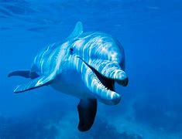

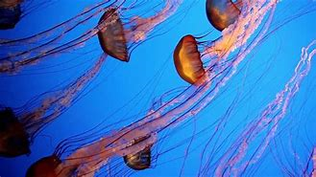

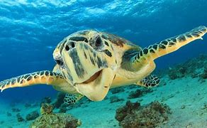

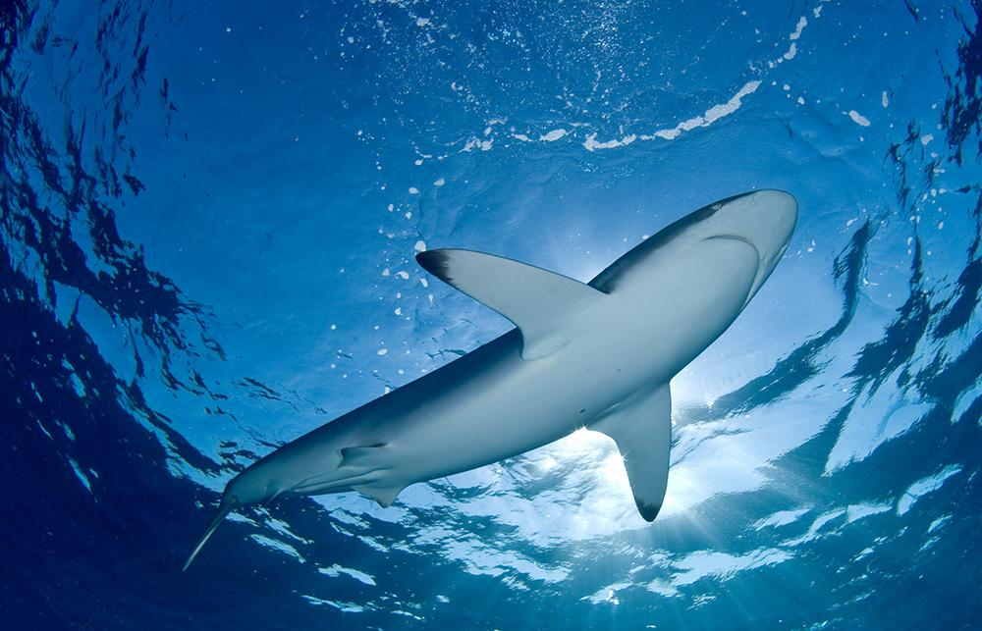

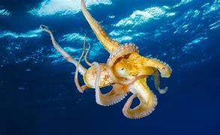

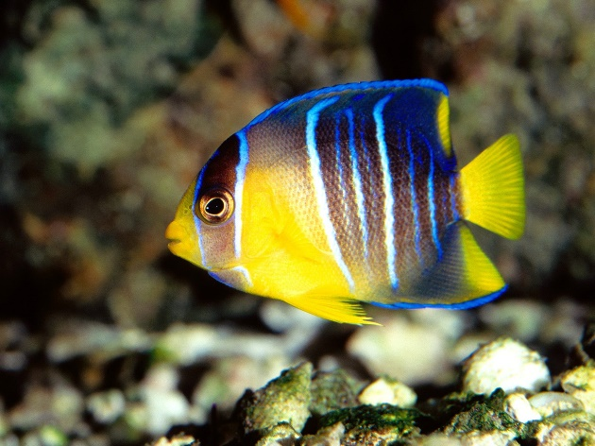

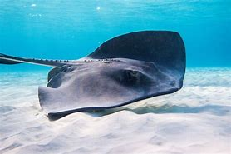

**Monday Maths -** Starter

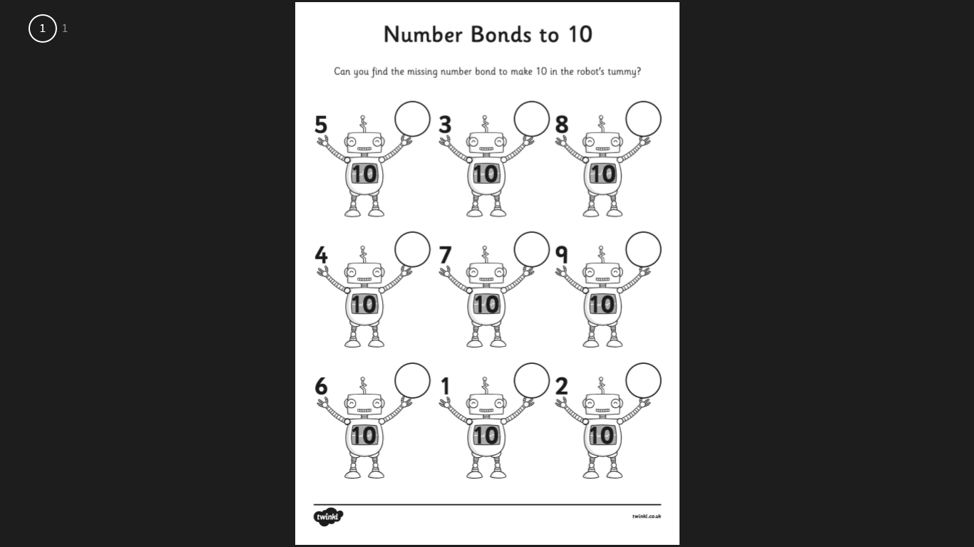

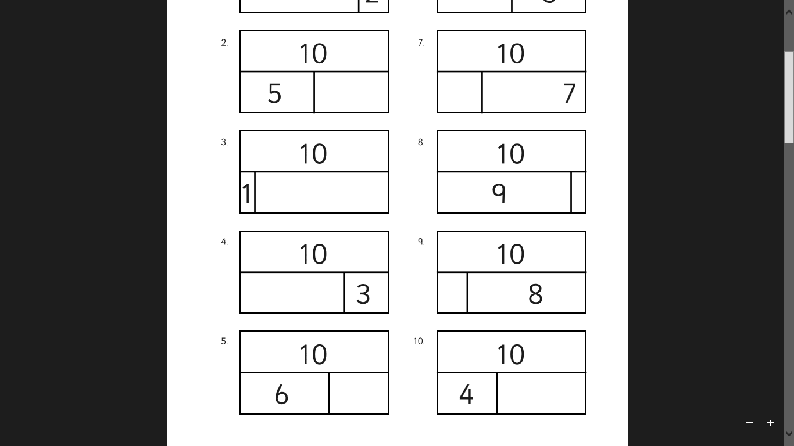

**Monday Maths -** 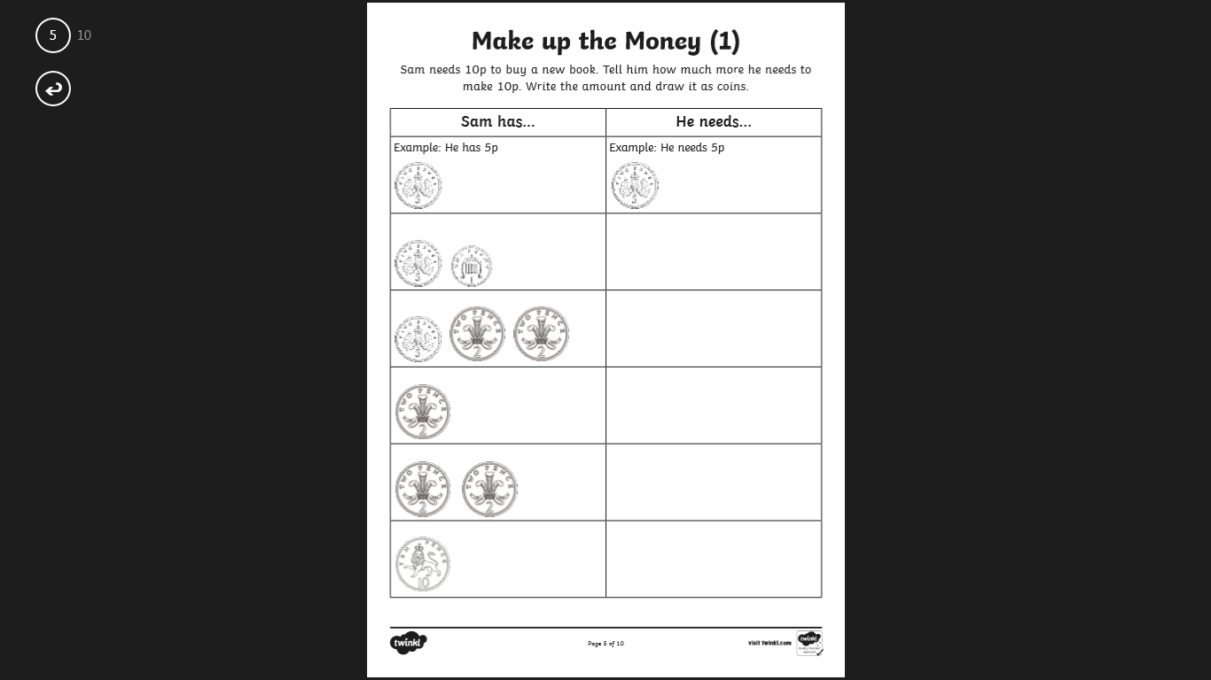Main task

**Monday –** Plastic pollution poster. Use some of the images below or find and print or draw your own.

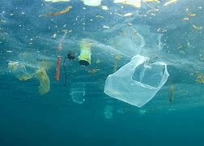

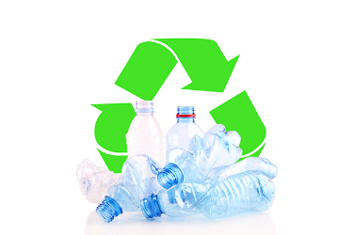

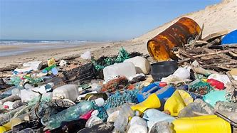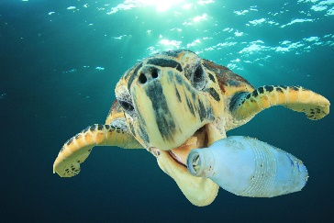

**English Tuesday-** Write detailed, describe sentences about the sea creatures. Use your descriptive labels from yesterday to help with ideas. Look at the weekly plan or examples.



__________________________________________________________________________________________________________________________________________________________________________________________________________________________________________________________

_______________________________________________________________________________________________________________________



__________________________________________________________________________________________________________________________________________________________________________________________________________________________________________________________

_______________________________________________________________________________________________________________________



__________________________________________________________________________________________________________________________________________________________________________________________________________________________________________________________

_______________________________________________________________________________________________________________________

__________________________________________________________________________________________________________________________________________________________________________________________________________________________________________________________

_______________________________________________________________________________________________________________________

**Tuesday Maths Task-** Go through the PowerPoint alongside the children. Children only record and complete tasks shown on this sheet. Discuss others together. Use the squares to record. Use manipulatives to show understanding.

|  |  |  |  |  |  |  |  |  |  |
| --- | --- | --- | --- | --- | --- | --- | --- | --- | --- |
|  |  |  |  |  |  |  |  |  |  |
|  |  |  |  |  |  |  |  |  |  |
|  |  |  |  |  |  |  |  |  |  |
|  |  |  |  |  |  |  |  |  |  |
|  |  |  |  |  |  |  |  |  |  |

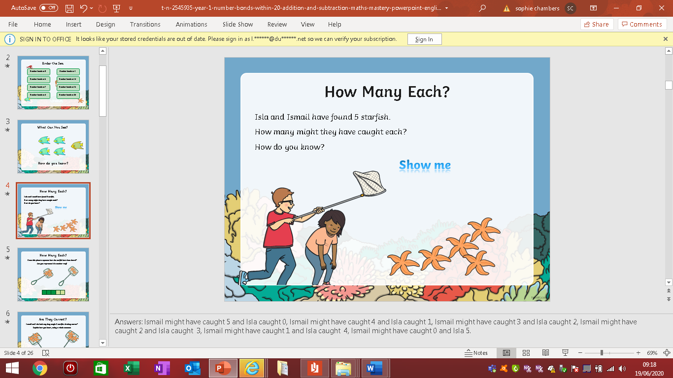

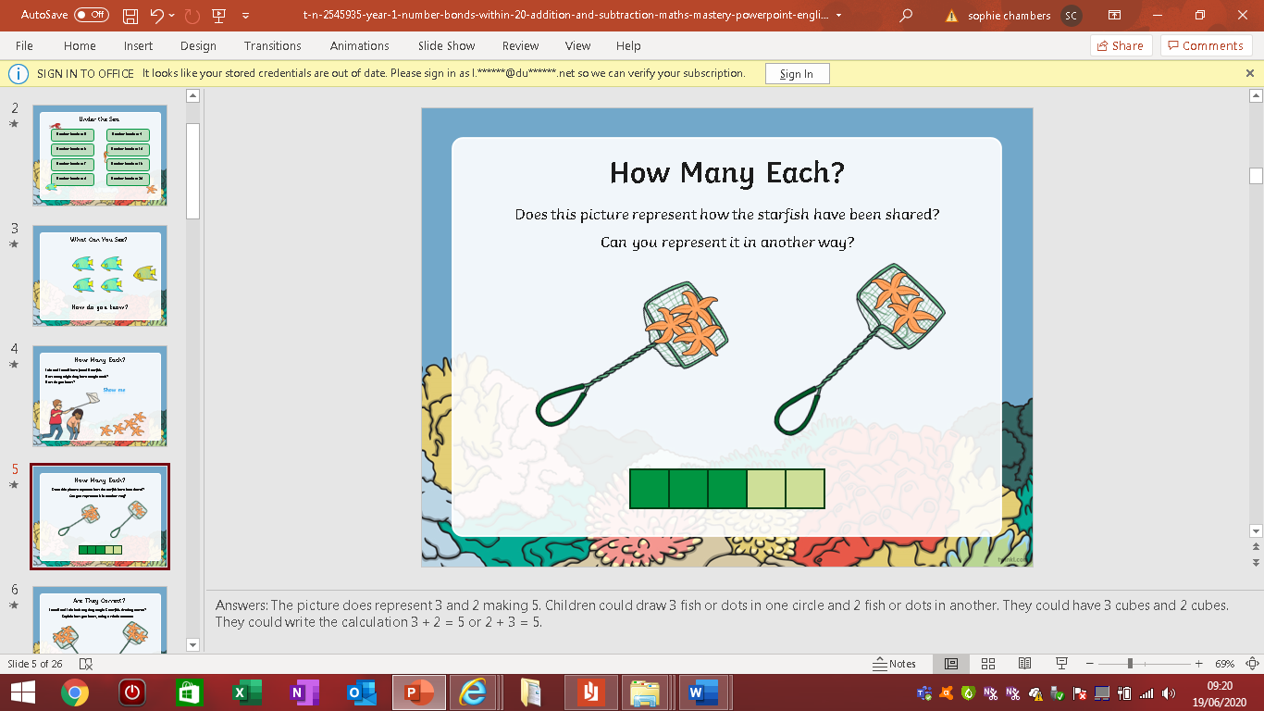

|  |  |  |  |  |  |  |  |  |  |
| --- | --- | --- | --- | --- | --- | --- | --- | --- | --- |
|  |  |  |  |  |  |  |  |  |  |
|  |  |  |  |  |  |  |  |  |  |
|  |  |  |  |  |  |  |  |  |  |
|  |  |  |  |  |  |  |  |  |  |
|  |  |  |  |  |  |  |  |  |  |

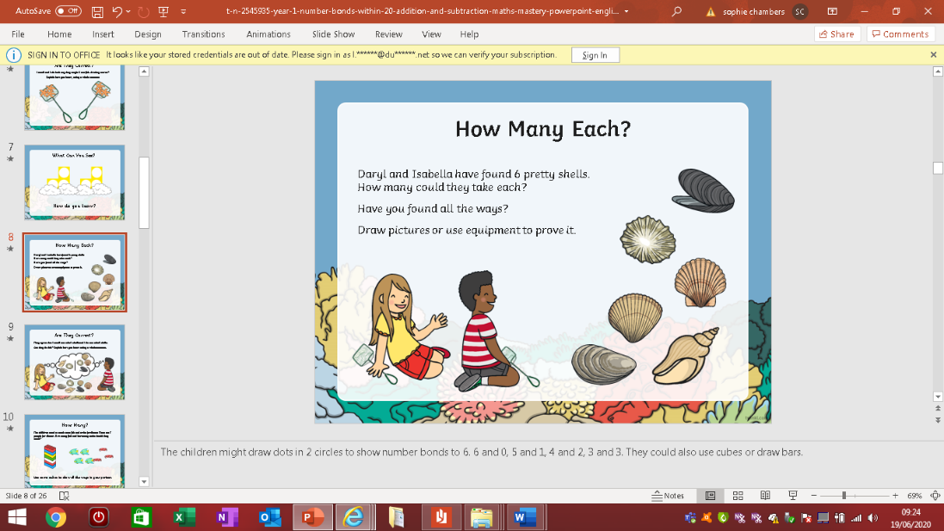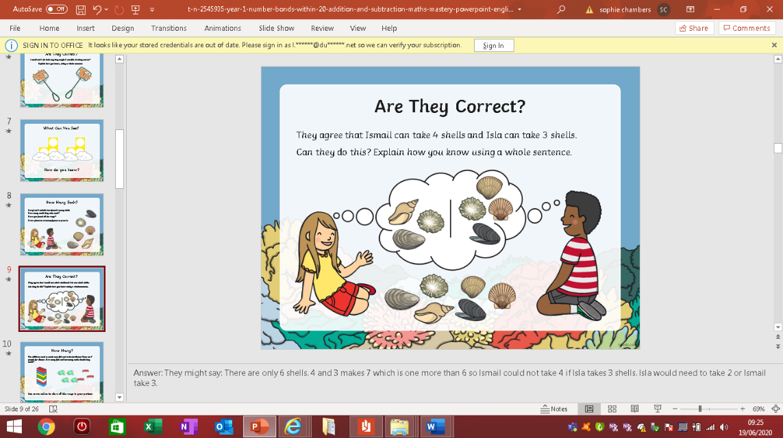

|  |  |  |  |  |  |  |  |  |  |  |  |
| --- | --- | --- | --- | --- | --- | --- | --- | --- | --- | --- | --- |
|  |  |  |  |  |  |  |  |  |  |  |  |
|  |  |  |  |  |  |  |  |  |  |  |  |
|  |  |  |  |  |  |  |  |  |  |  |  |
|  |  |  |  |  |  |  |  |  |  |  |  |
|  |  |  |  |  |  |  |  |  |  |  |  |

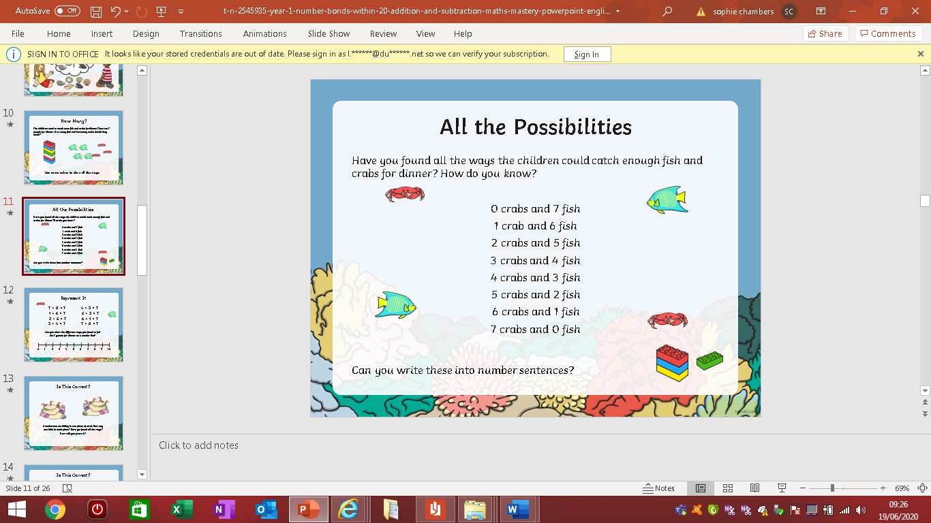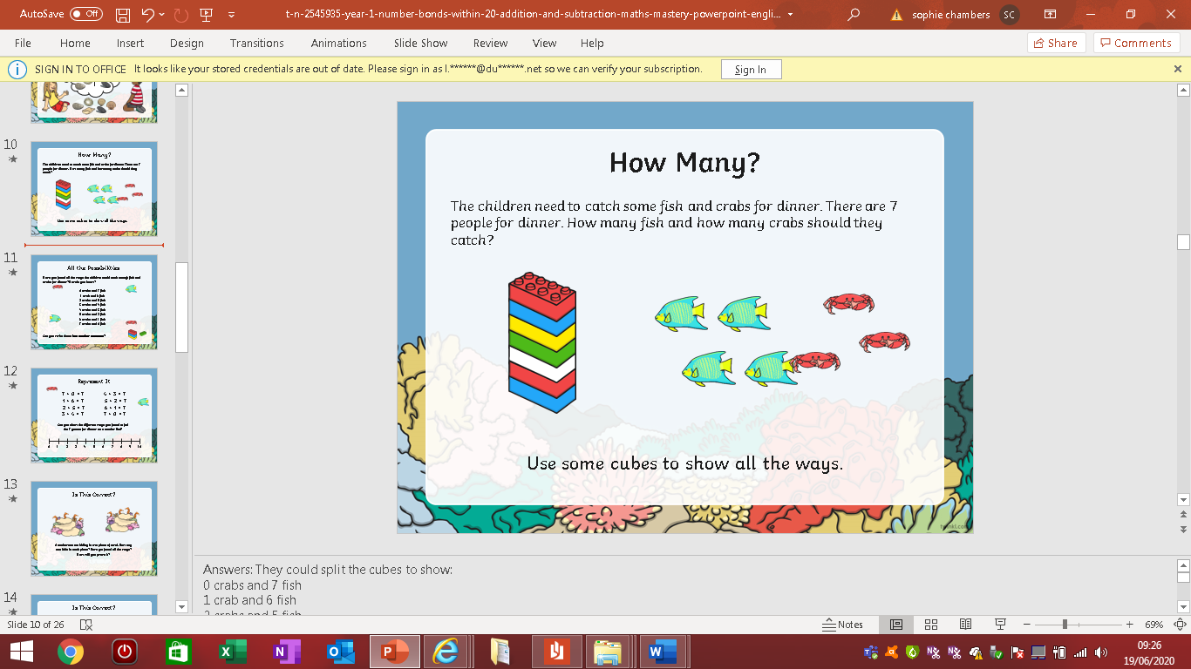

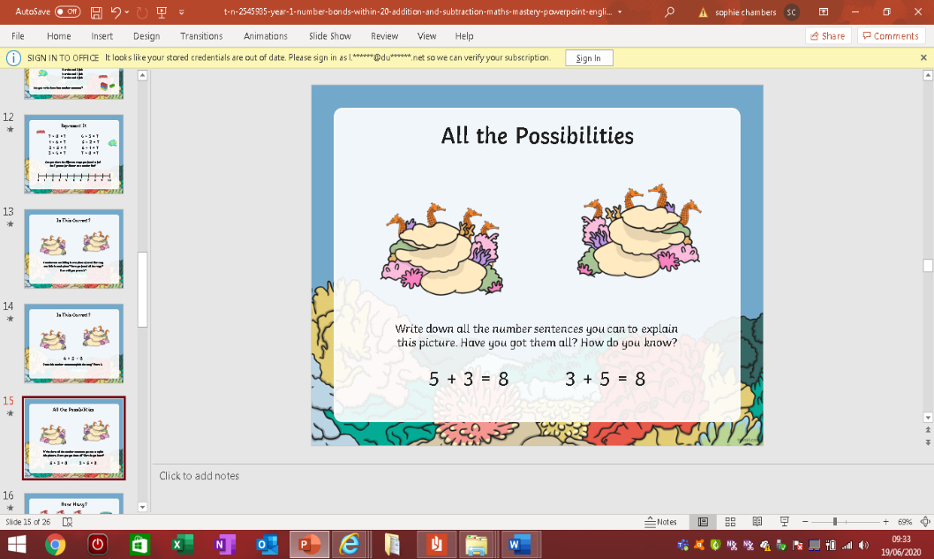

|  |  |  |  |  |  |  |  |  |  |  |  |  |  |  |
| --- | --- | --- | --- | --- | --- | --- | --- | --- | --- | --- | --- | --- | --- | --- |
|  |  |  |  |  |  |  |  |  |  |  |  |  |  |  |
|  |  |  |  |  |  |  |  |  |  |  |  |  |  |  |
|  |  |  |  |  |  |  |  |  |  |  |  |  |  |  |
|  |  |  |  |  |  |  |  |  |  |  |  |  |  |  |
|  |  |  |  |  |  |  |  |  |  |  |  |  |  |  |

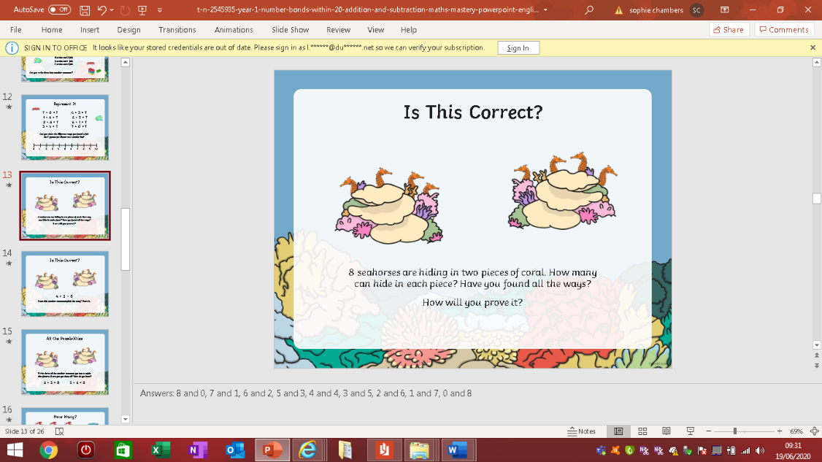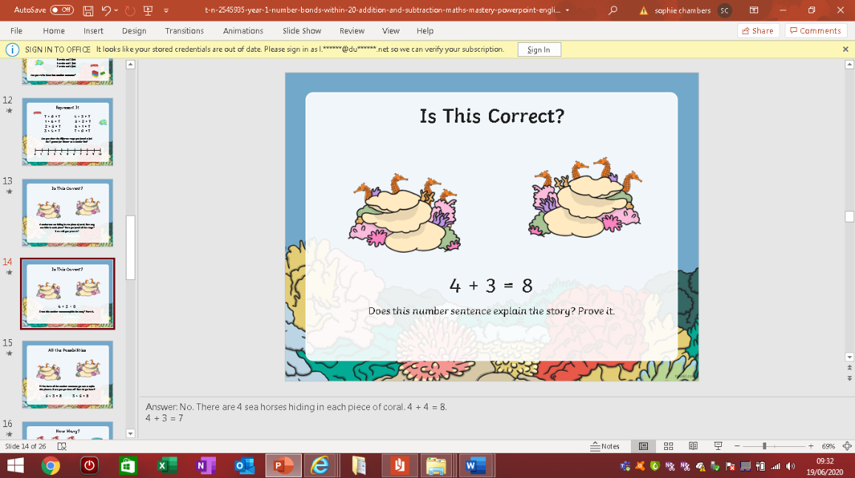

|  |  |  |  |  |  |  |  |  |  |  |  |  |  |  |
| --- | --- | --- | --- | --- | --- | --- | --- | --- | --- | --- | --- | --- | --- | --- |
|  |  |  |  |  |  |  |  |  |  |  |  |  |  |  |
|  |  |  |  |  |  |  |  |  |  |  |  |  |  |  |
|  |  |  |  |  |  |  |  |  |  |  |  |  |  |  |
|  |  |  |  |  |  |  |  |  |  |  |  |  |  |  |
|  |  |  |  |  |  |  |  |  |  |  |  |  |  |  |

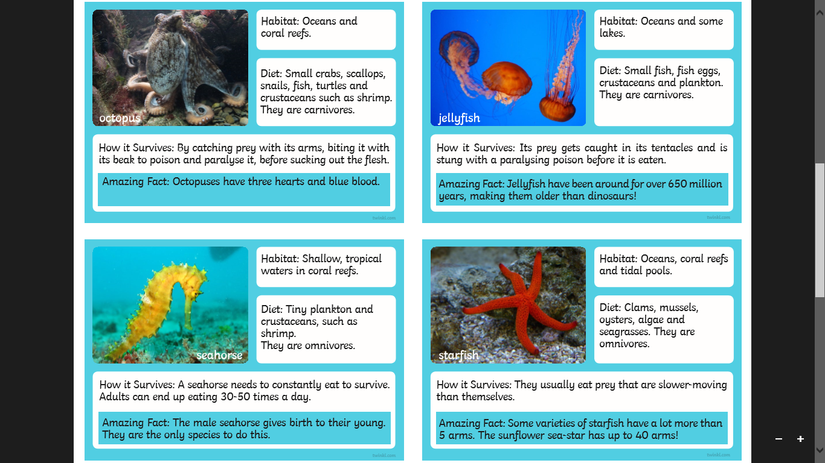**English Wednesday-** Complete the reading comprehension task to find out more about the under the sea creatures and animals.

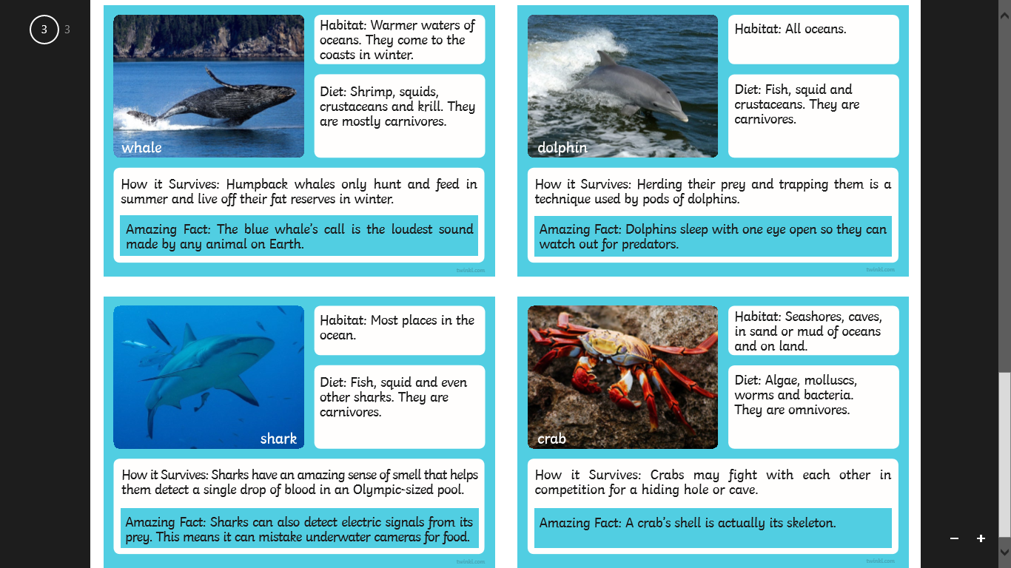

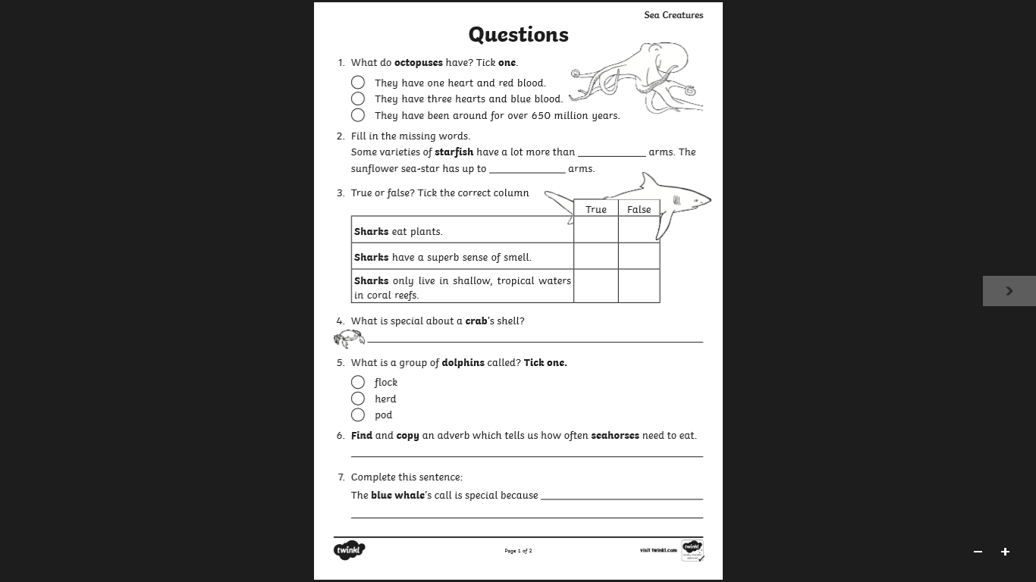

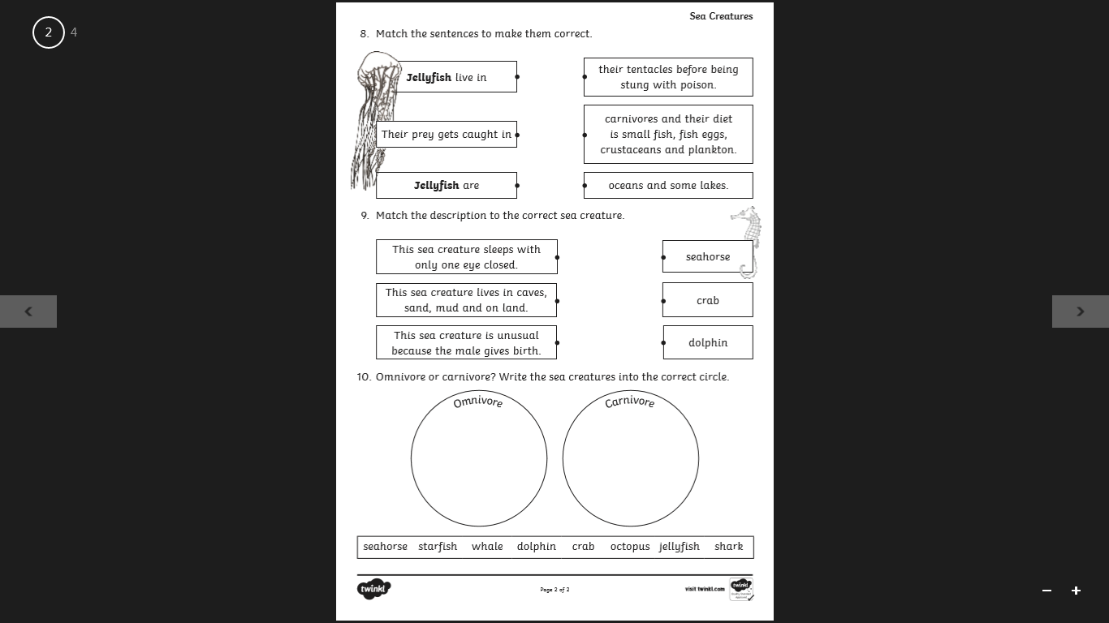

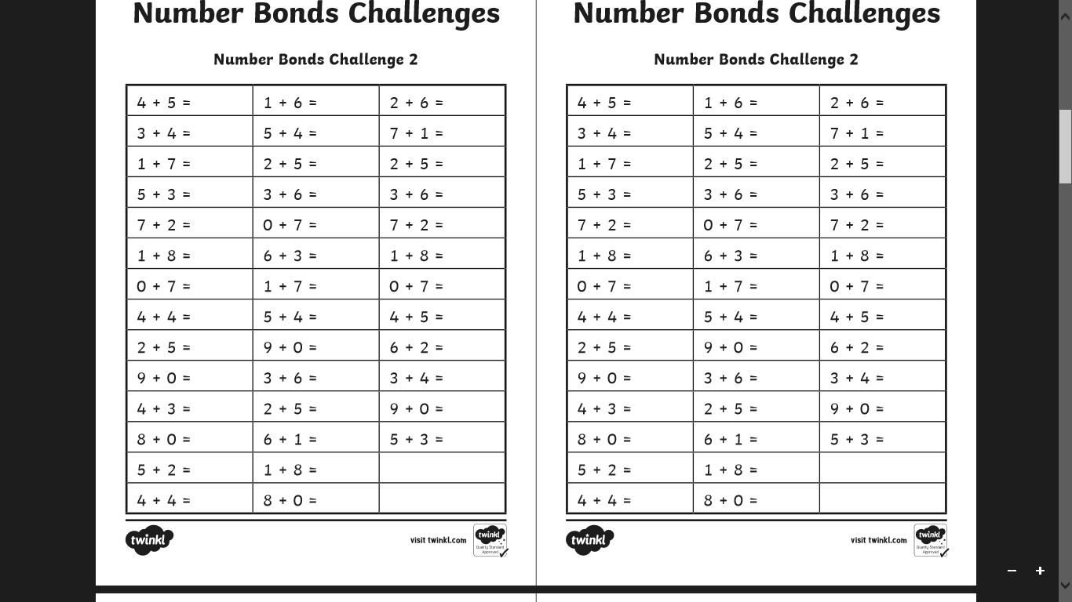**Wednesday Maths –** Starter- The number bond challenge. How many can you complete in 2 minutes?

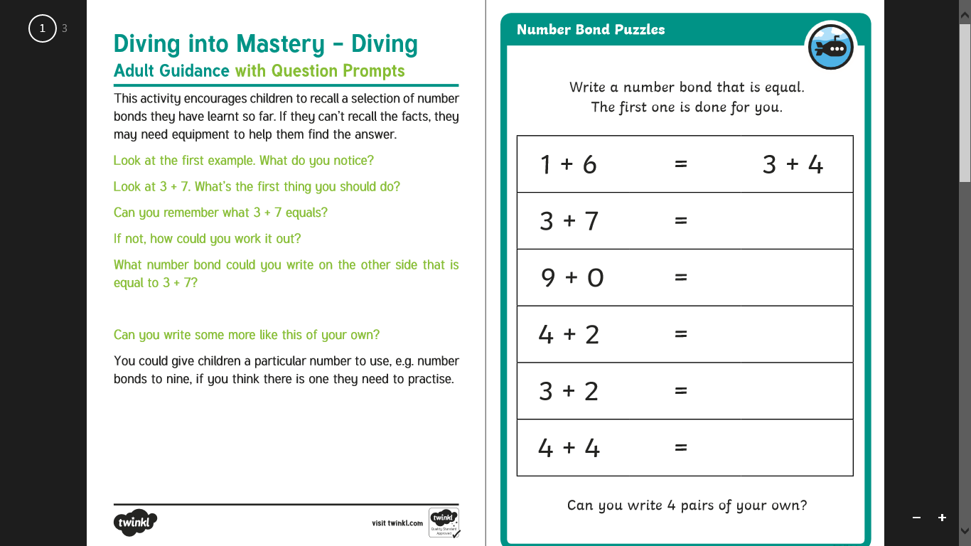**Wednesday Maths –** Main task- Complete the challenges. Use numicon and other resources as needed.

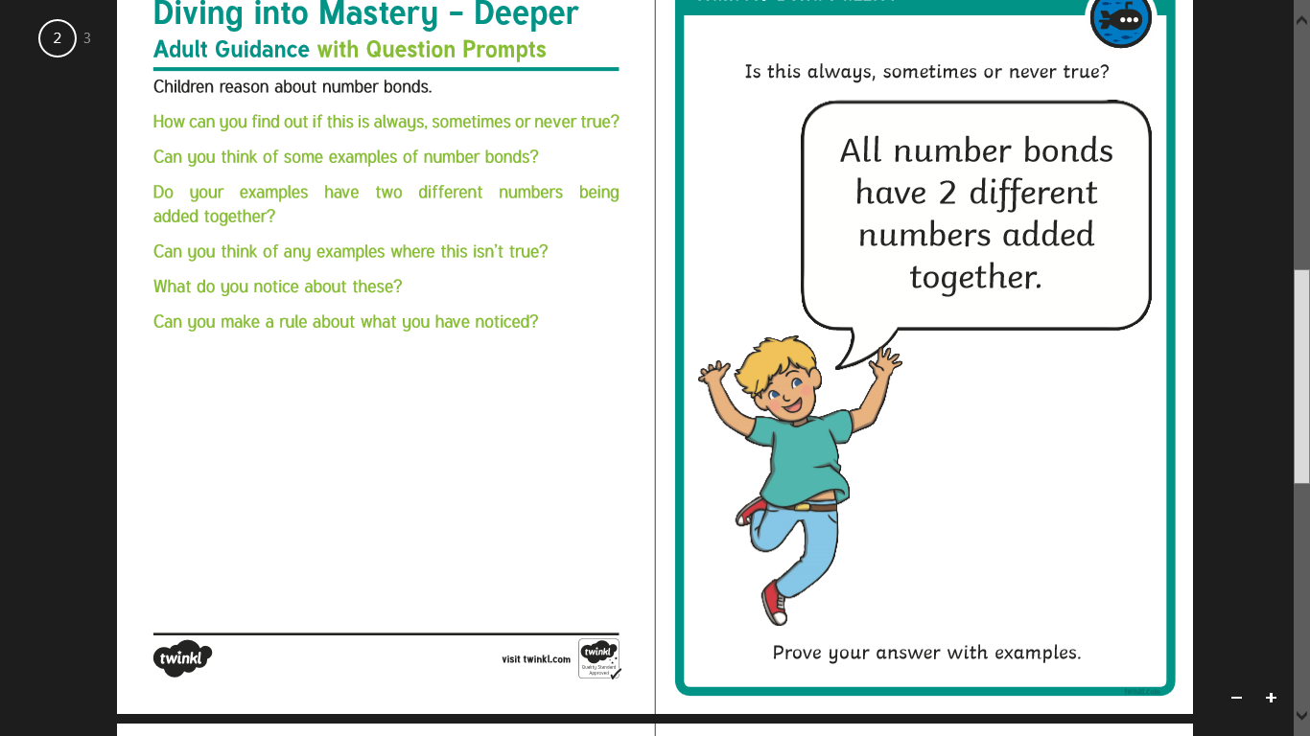

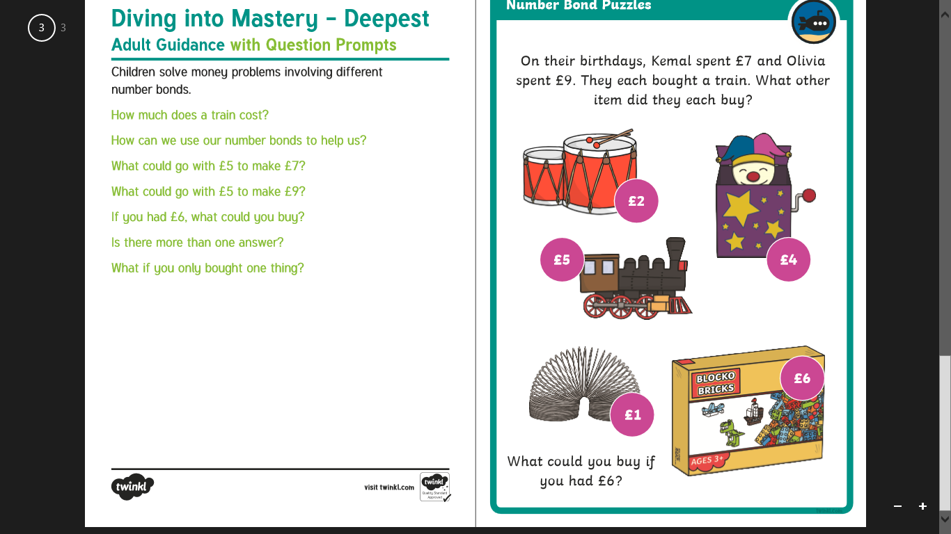

**Science/Geography -** Can you find out about the different layers of the ocean and what lives there? Label the parts of the ocean and draw and label some of the animals/sea creatures that you might find there.

**English Thursday-** Complete some simple fact cards about your favourite under the sea creatures/animals. Use the information you have learnt. Add your own images.



My Under the Sea

Fact Card

________________________________________________________________________________________________________________________________________________________________________________________________________________________________________________________________________________________________________________________________________________________________________________________________________________________________________________________________________________________________________



My Under the Sea

Fact Card

________________________________________________________________________________________________________________________________________________________________________________________________________________________________________________________________________________________________________________________________________________________________________________________________________________________________________________________________________________________________________

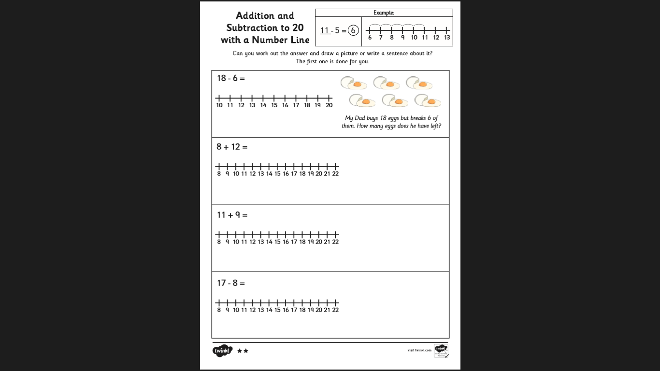**Thursday Maths Task-**

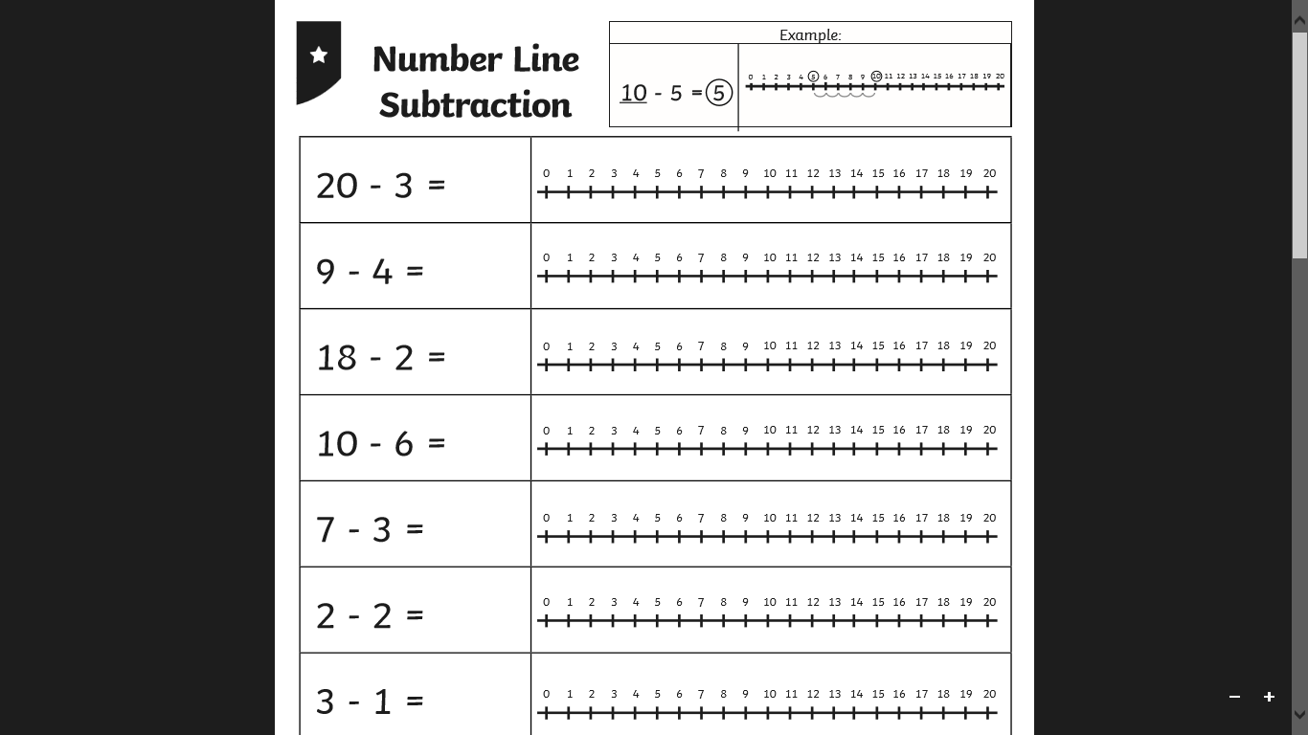

Can you use your knowledge of number bonds to explain how you know your answers are correct?

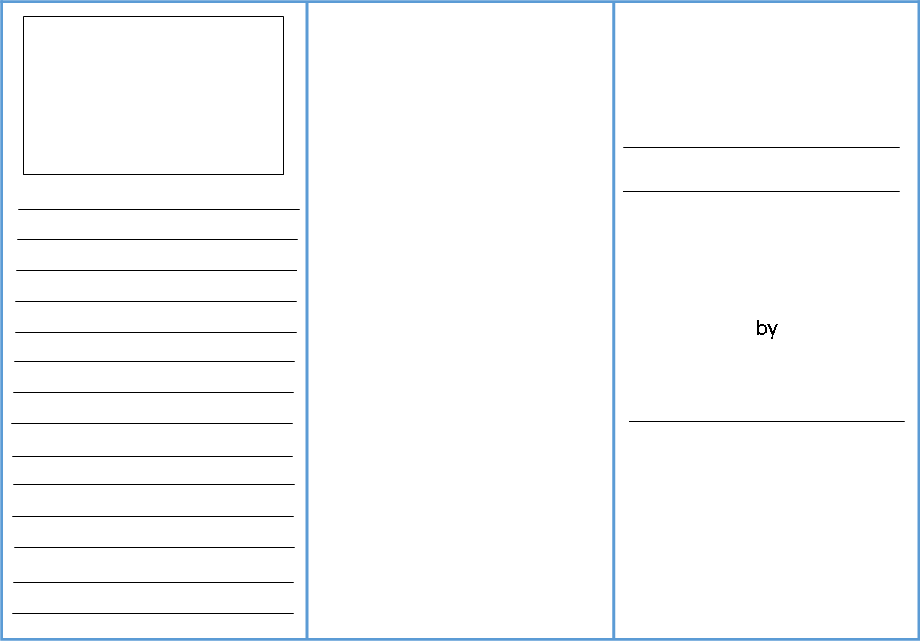**English Friday-** Using all the information you have learnt this week. Create your own leaflet all about under the sea animals/ creatures. Add lots of information, imagine this could be given out at an aquarium.

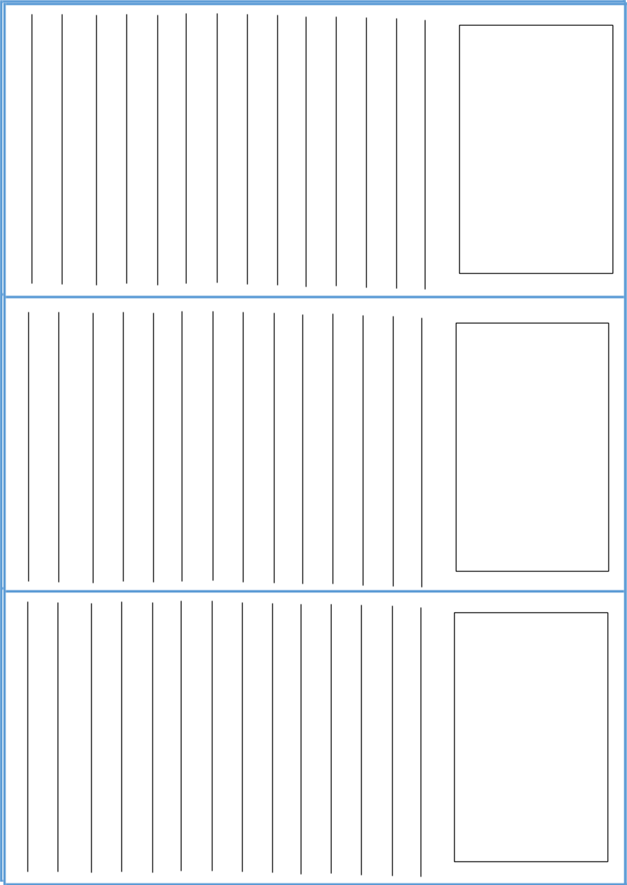

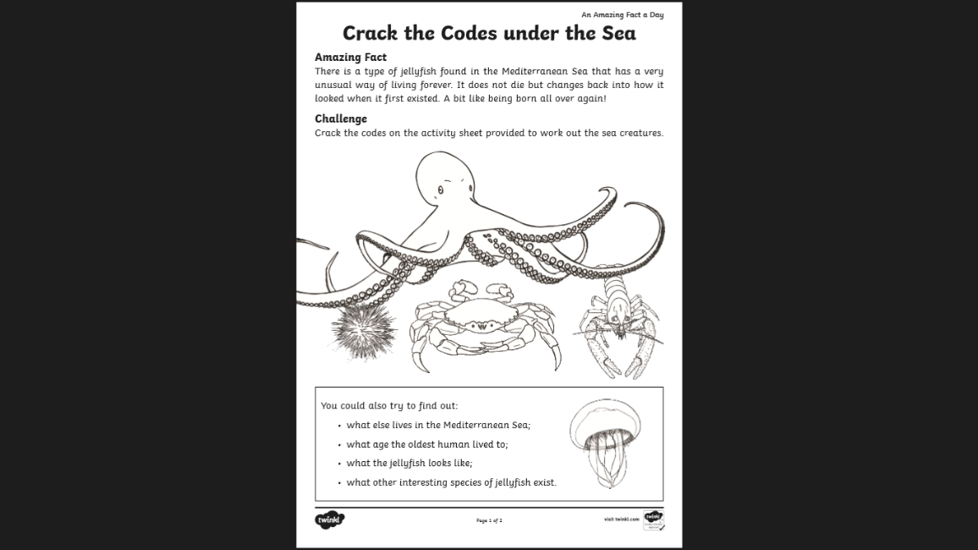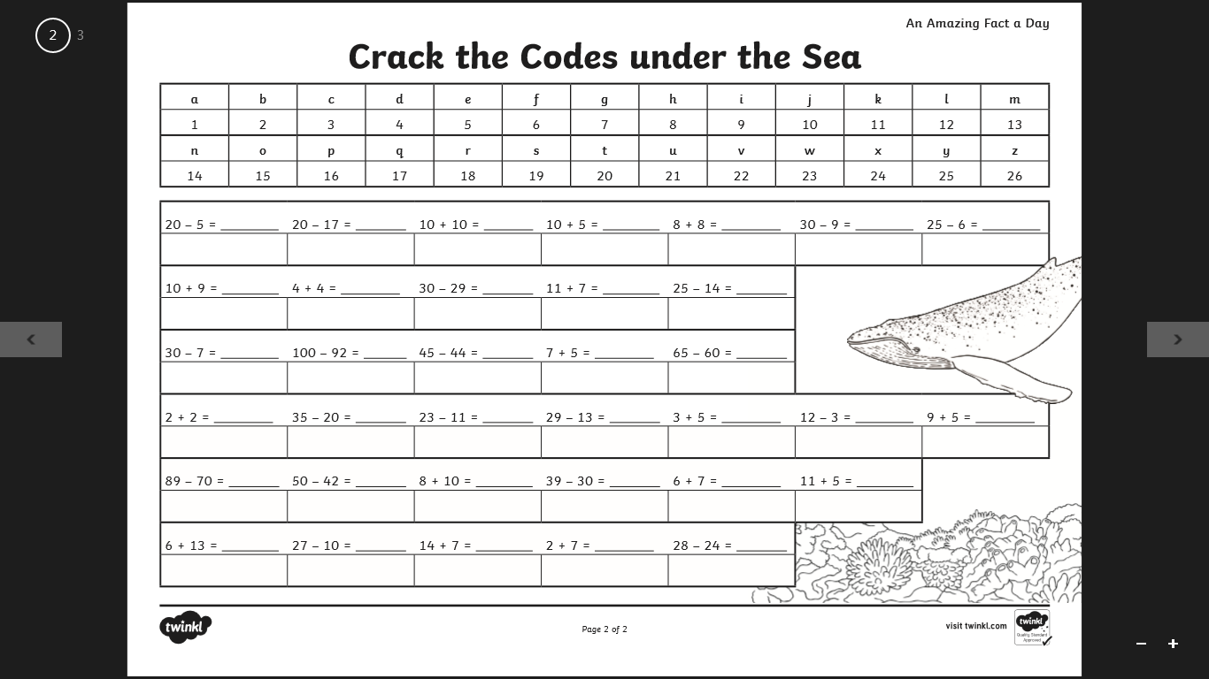**Friday Maths Task-** Use a number line to work out the answers and crack the under the sea code. **Which under the sea words will you reveal?**

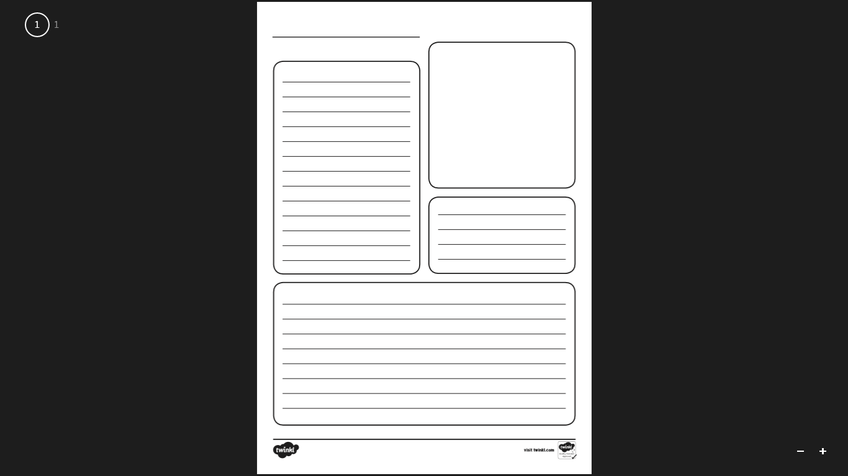**Friday Science-** Can you find out about different under the sea creatures and create your own fact file about a chosen sea creature?