**West Cornforth Primary School**

**Home/School Learning Pack**



**Summer 2 Week 3**

**WB: 15.6.20**

*Note: Remember to refer to the Year 1 weekly overview plan for further details on each task. As always, the plan will be sent via class dojo and shared on the school website.*

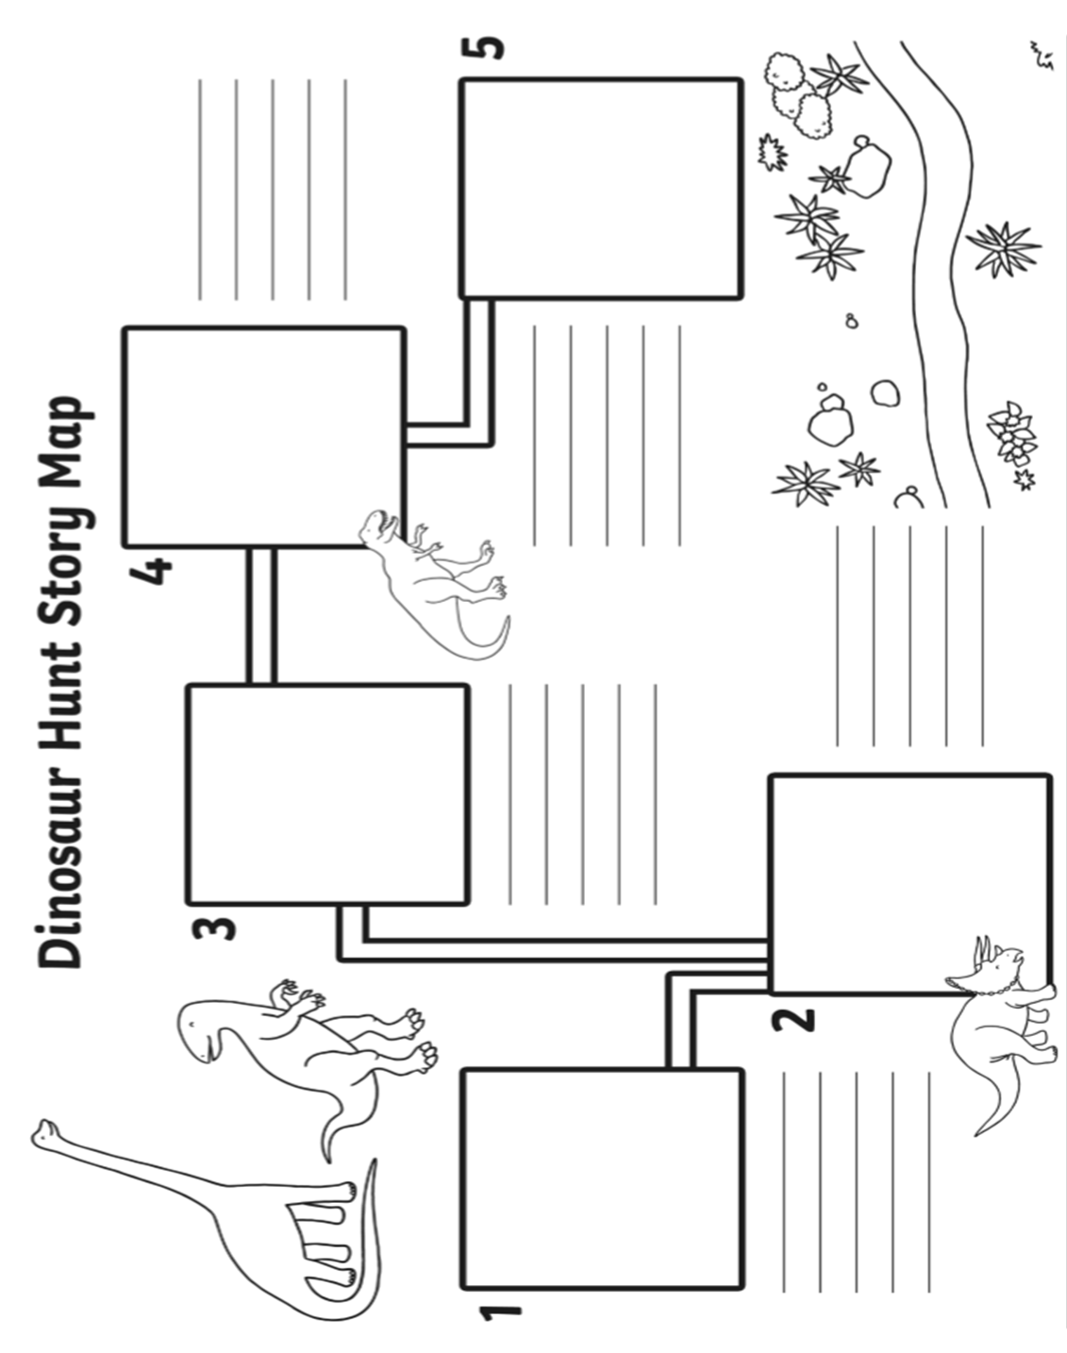**English- Monday First Task-** Recap the key parts of your story by looking back at the story map/plan you completed last week. Add any detail needed. Think about recreating a more detailed map/plan on a large sheet of paper.

**English Tuesday to Thursday -Dinosaur adventure story writing template.** This is an ongoing weekly task. Please take your time to make your story as detailed and interesting as possible.

**Friday Task-** Take the time to read through and edit and improve your dinosaur adventure story. Use the blank pages to make a front and back cover for your story and attach your pages together to make a ‘real’ story book. **What will your front cover include? What will the title of your adventure story be? Who is the author?**

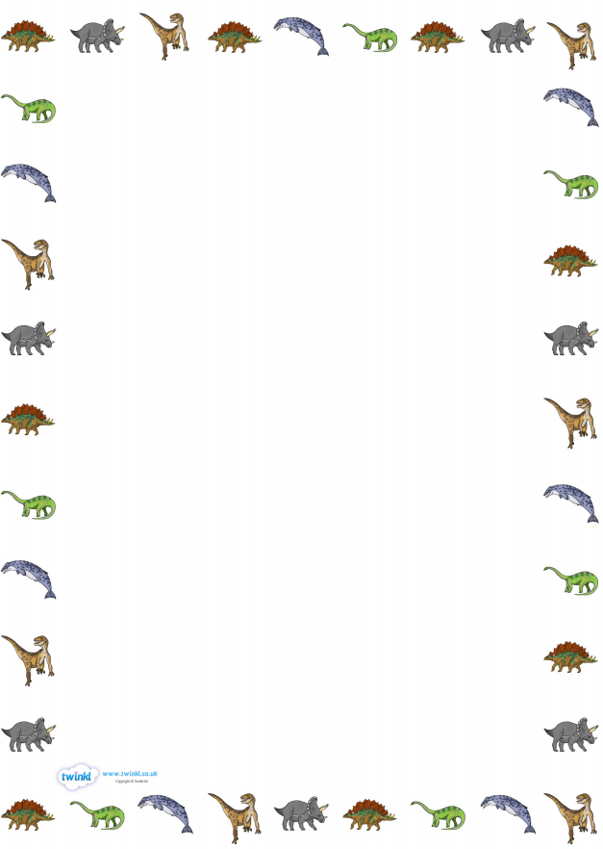



**__________________________________________________________________________________________________________________________________________________________________________________________________________________________________________________________________________________________________________________________________________________________________________________________________________________________________________________________________________________________________________________________________________________________________________________________________________________________________________________________________________________________________________________________________________________________________________________________________________________________________________________________________________________________________________________________________________________________________________________________________________________________________________________________________________________________________________________________________**

**__________________________________________________________________________________________________________________________________________________________________________________________________________________**



**__________________________________________________________________________________________________________________________________________________________________________________________________________________________________________________________________________________________________________________________________________________________________________________________________________________________________________________________________________________________________________________________________________________________________________________________________________________________________________________________________________________________________________________________________________________________________________________________________________________________________________________________________________________________________________________________________________________________________________________________________________________________________________________________________________________________________________________________________**

**__________________________________________________________________________________________________________________________________________________________________________________________________________________**



**__________________________________________________________________________________________________________________________________________________________________________________________________________________________________________________________________________________________________________________________________________________________________________________________________________________________________________________________________________________________________________________________________________________________________________________________________________________________________________________________________________________________________________________________________________________________________________________________________________________________________________________________________________________________________________________________________________________________________________________________________________________________________________________________________________________________________________________________________**

**__________________________________________________________________________________________________________________________________________________________________________________________________________________**



**__________________________________________________________________________________________________________________________________________________________________________________________________________________________________________________________________________________________________________________________________________________________________________________________________________________________________________________________________________________________________________________________________________________________________________________________________________________________________________________________________________________________________________________________________________________________________________________________________________________________________________________________________________________________________________________________________________________________________________________________________________________________________________________________________________________________________________________________________**

**__________________________________________________________________________________________________________________________________________________________________________________________________________________**

**Monday Maths Task-** Recap- Recognising and exploring the value of notes and coins.

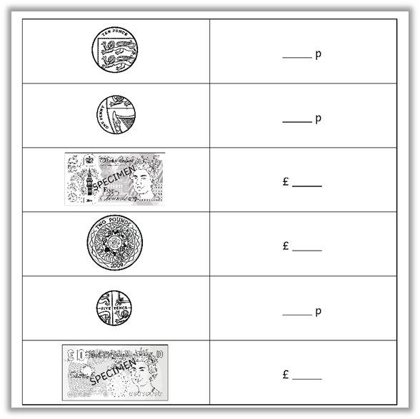

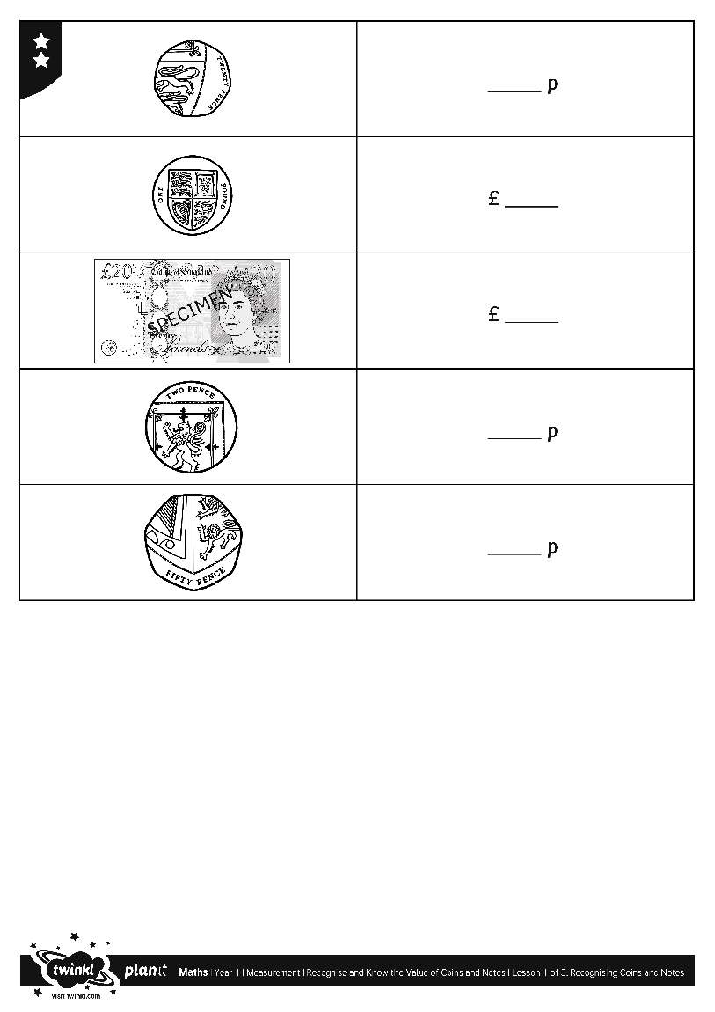

**Monday Maths Extension-** Use real money/imitation money for sorting.

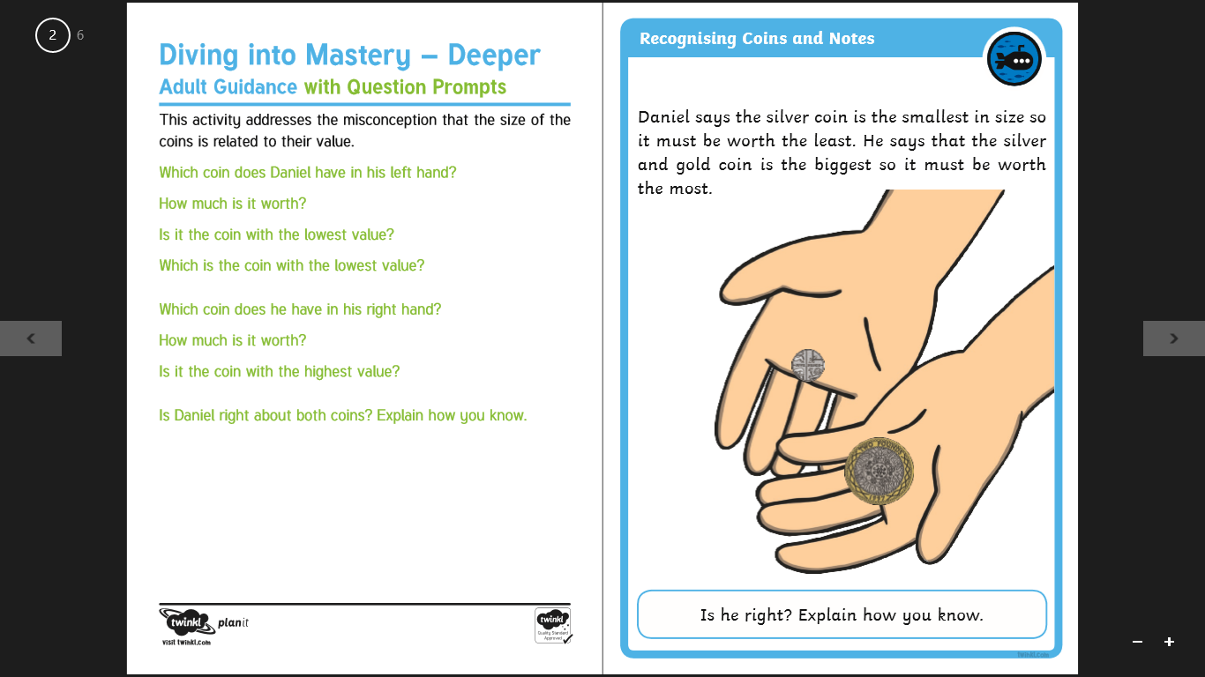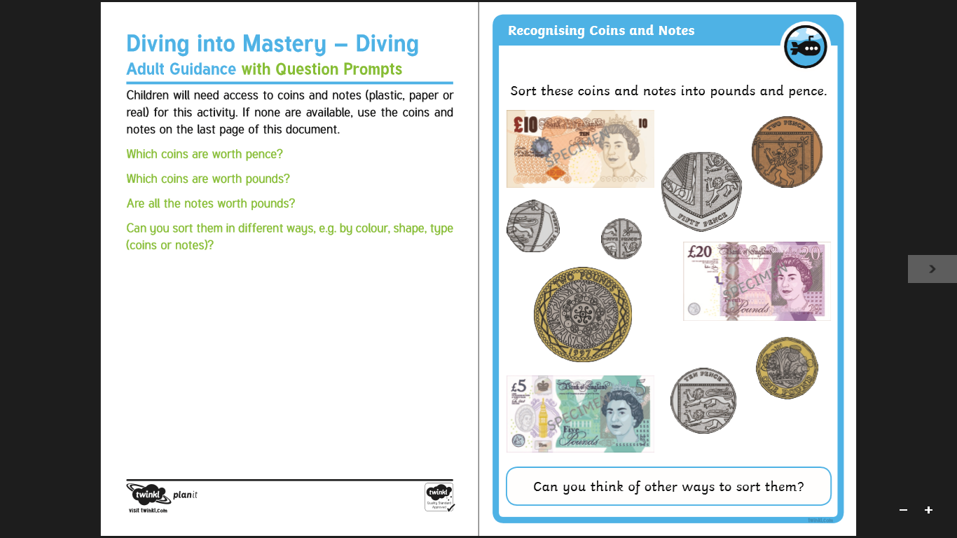

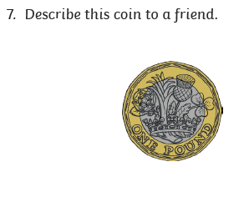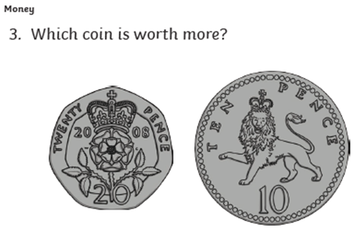

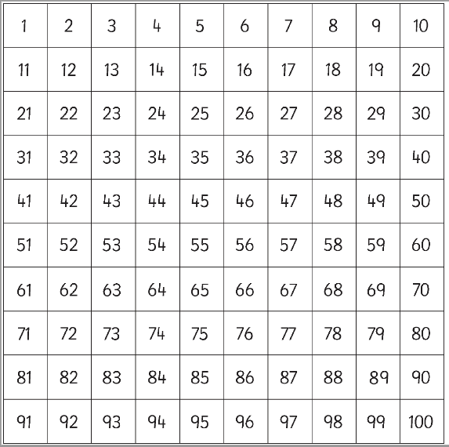**Tuesday Maths Task-** Recognise different coins. Add groups of coins to find the total amount. Compare the value of different groups of coins.

**Add the coins in each purse. Write the addition number sentence on the line provided, e.g. 20p + 10p + 10p + 5p =**

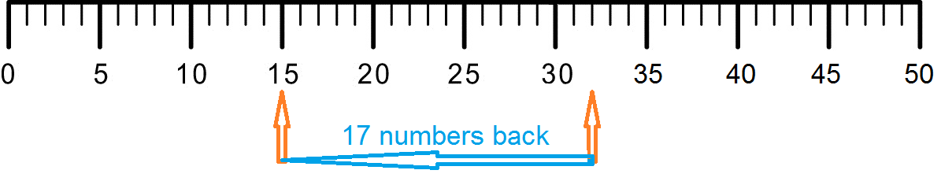***Tip- Start with the largest coin. Try using a hundred square or number line when adding. Think about using any addition facts that you already know e.g. 10+10= 20. Create your own number line.*** 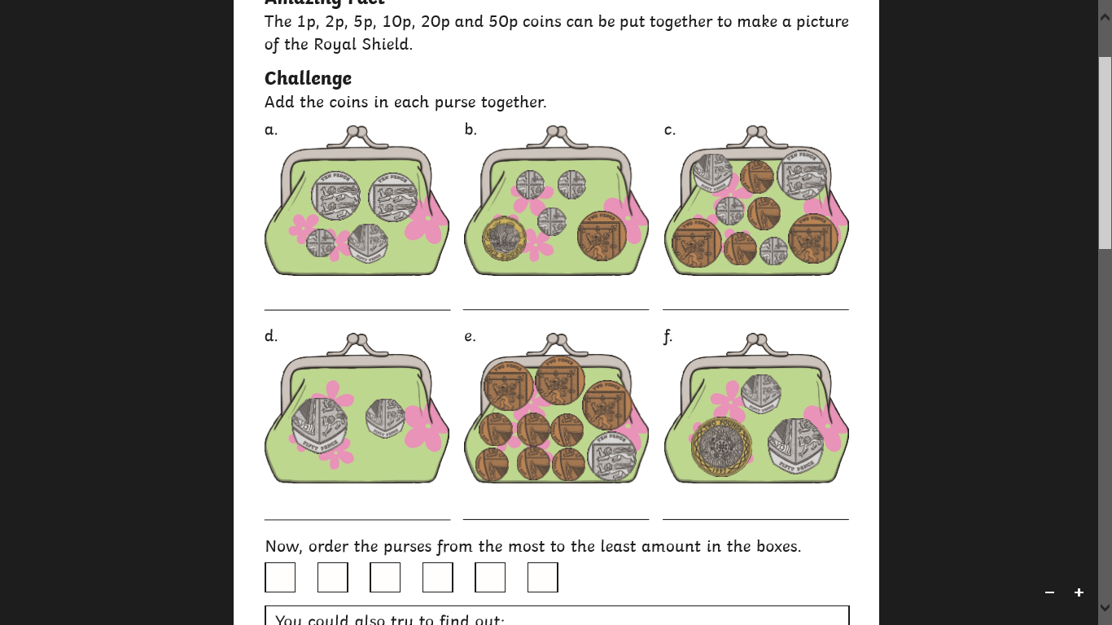

Can you order the purses from the purse that has the most money to the purse that has the least amount of money?

­­­­­­­­­­­­­­­­­­­­**Wednesday Maths Starter Task-**

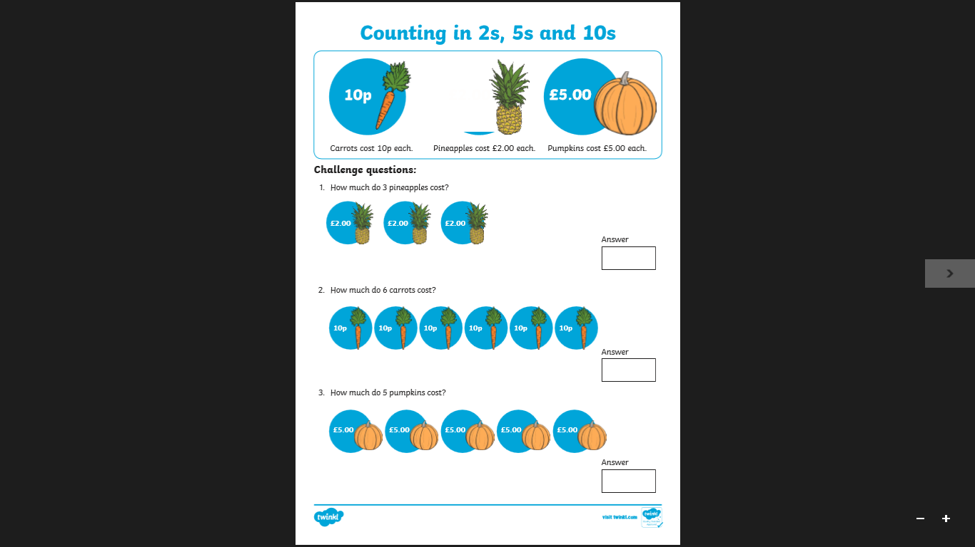

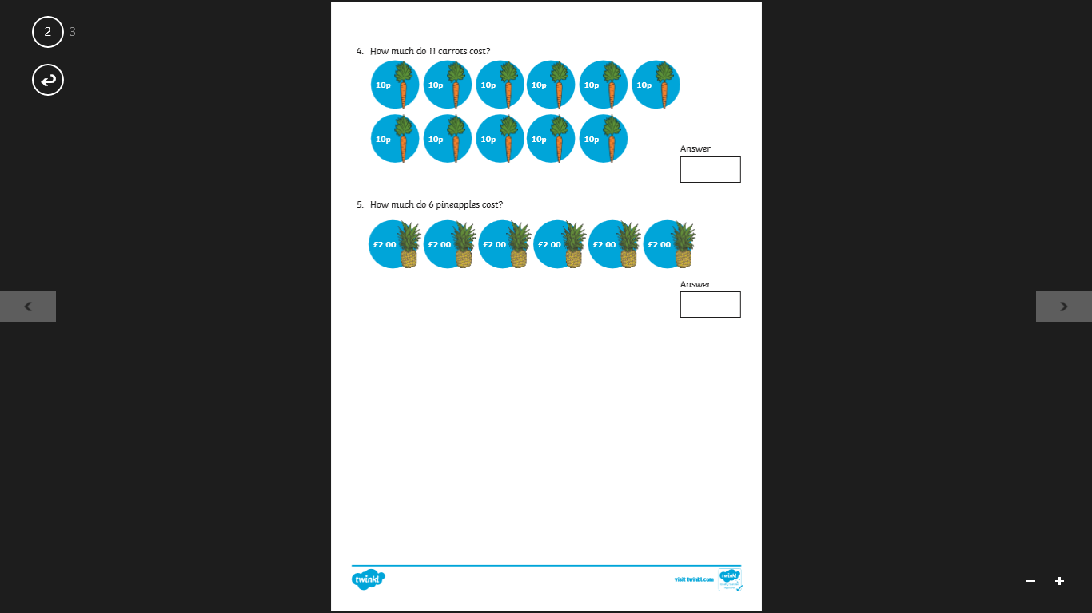

**Wednesday Maths Task-** Shopping. Add amounts and find the total. 

30p

50p

8p

20p

25p

11p

C:\Users\Claire\AppData\Local\Microsoft\Windows\Temporary Internet Files\Content.IE5\OLA1CTGA\MC900234008[1].wmf

10p

C:\Users\Claire\AppData\Local\Microsoft\Windows\Temporary Internet Files\Content.IE5\KOMNUVQJ\MC900112658[1].wmfC:\Users\Claire\AppData\Local\Microsoft\Windows\Temporary Internet Files\Content.IE5\OLA1CTGA\MC900234008[1].wmfC:\Users\Claire\AppData\Local\Microsoft\Windows\Temporary Internet Files\Content.IE5\JTOS528P\MC900331495[1].wmfC:\Users\Claire\AppData\Local\Microsoft\Windows\Temporary Internet Files\Content.IE5\KOMNUVQJ\MC900112658[1].wmfC:\Users\Claire\AppData\Local\Microsoft\Windows\Temporary Internet Files\Content.IE5\TY6NH2TH\MC900112670[1].wmfC:\Users\Claire\AppData\Local\Microsoft\Windows\Temporary Internet Files\Content.IE5\KOMNUVQJ\MC900234380[1].wmfC:\Users\Claire\AppData\Local\Microsoft\Windows\Temporary Internet Files\Content.IE5\KOMNUVQJ\MC900234380[1].wmfC:\Users\Claire\AppData\Local\Microsoft\Windows\Temporary Internet Files\Content.IE5\KOMNUVQJ\MC900290250[1].wmfC:\Users\Claire\AppData\Local\Microsoft\Windows\Temporary Internet Files\Content.IE5\OLA1CTGA\MC900234008[1].wmf

+

+

costs ______ p altogether.

­­­­­­______________________

costs ______ p altogether.

­­­­­­______________________

C:\Users\Claire\AppData\Local\Microsoft\Windows\Temporary Internet Files\Content.IE5\KOMNUVQJ\MC900290250[1].wmf

+

C:\Users\Claire\AppData\Local\Microsoft\Windows\Temporary Internet Files\Content.IE5\JTOS528P\MC900331495[1].wmf

+

+

costs ______ p altogether.

­­­­­­______________________

costs ______ p altogether.

­­­­­­______________________

+

+

costs ______ p altogether.

­­­­­­______________________

costs ______ p altogether.

­­­­­­______________________

**Thursday Maths Task-** Money word problems. Addition and subtraction.

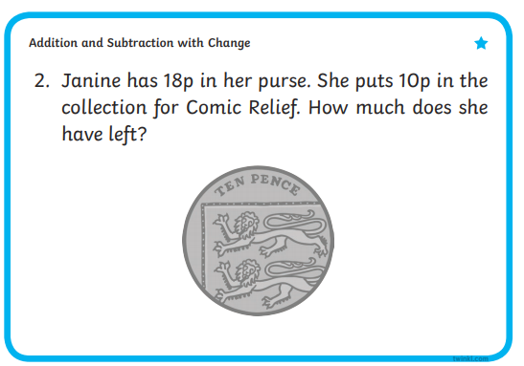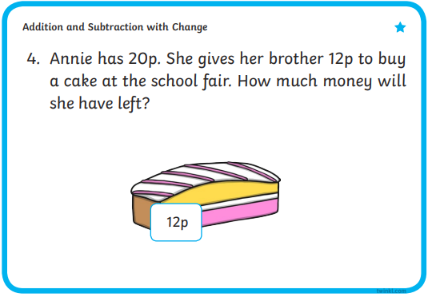

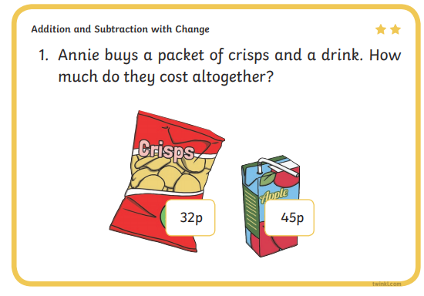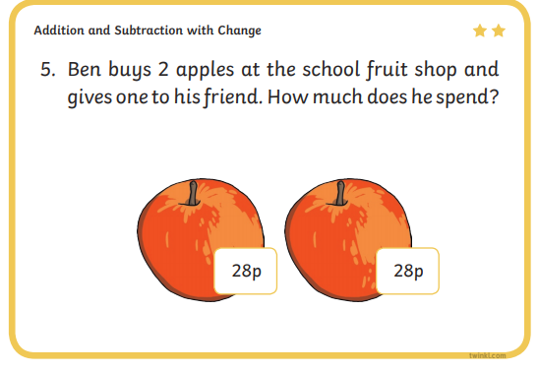

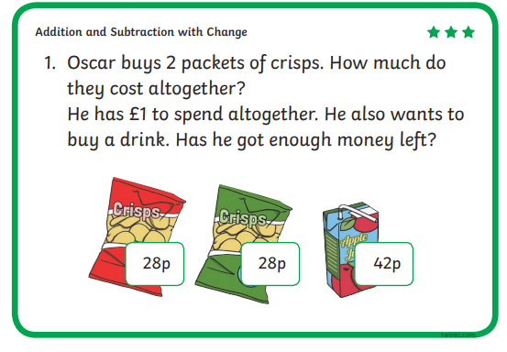

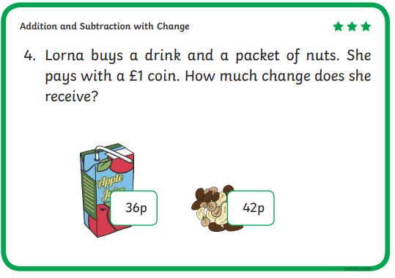

**Thursday Maths Task-** Money. Exploring the concept of change.

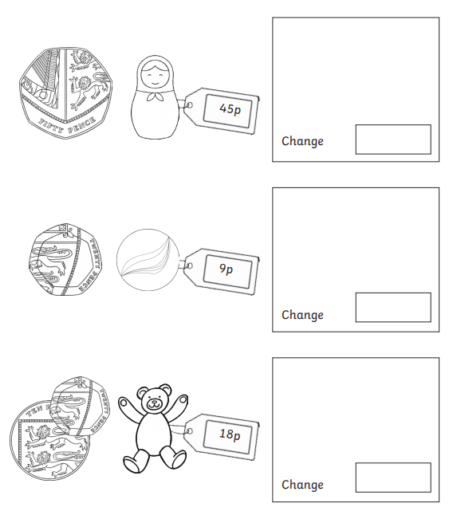

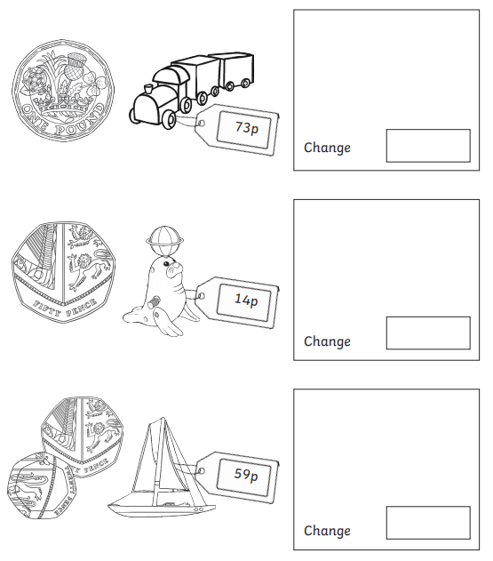

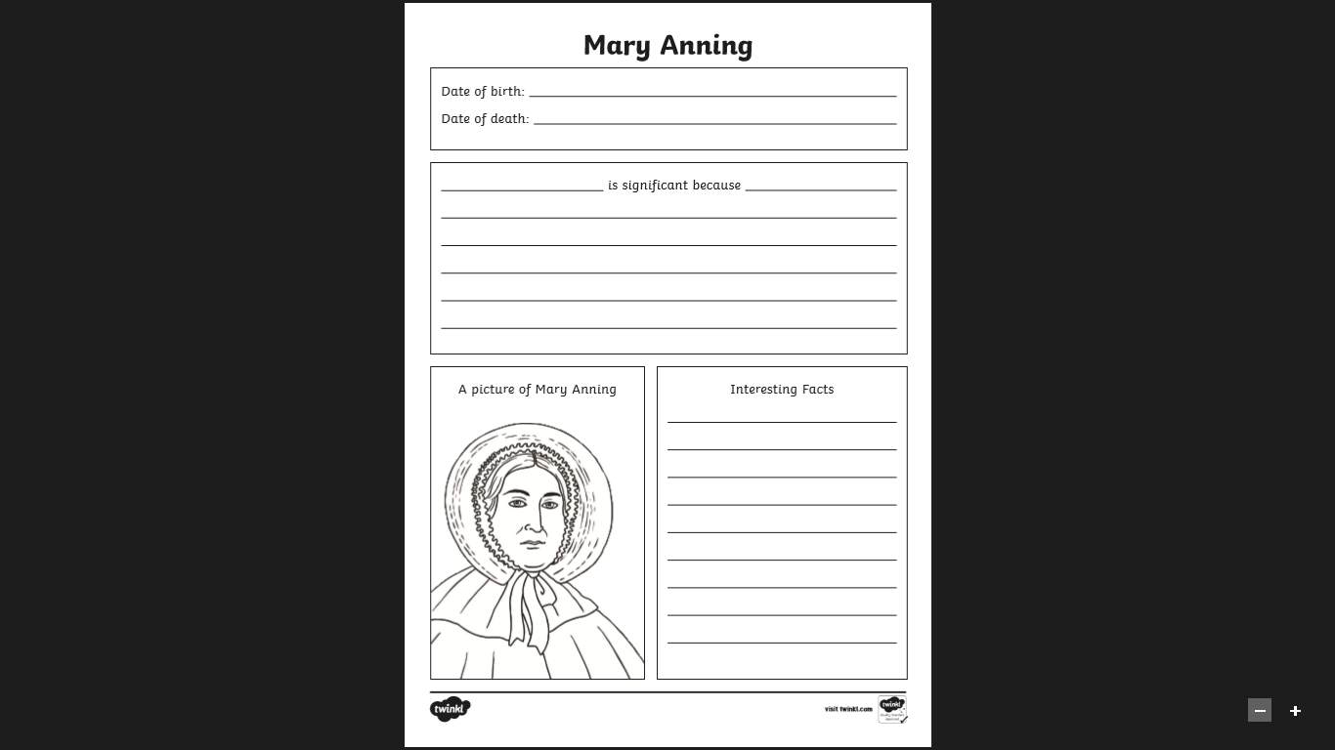**History-** Significant people in history.

**Art-** Create your own dinosaur skeleton art using cotton buds.



