Day | 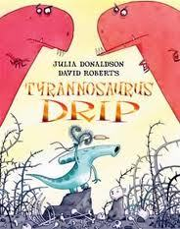  Daily English Task  Weekly Focus:  Tyrannousarus Drip –  Week 1: Comprehension  Week 2: Fiction writing  Week 3: Non Fiction writing – Dinosaurs. | Daily Maths Task  Weekly Focus:Fractions  Week 7 | 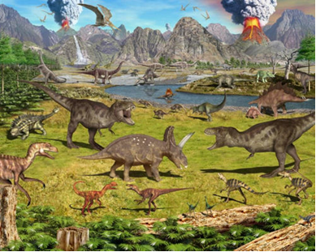  Other Subjects  Y2 Dinosaur Topic
Monday | Daily Reading. Read online and complete your Accelerated Reader quizzes https://www.myon.co.uk/login/index.html  Spellings : Week 4 spelling booklet. Days 1-5 (Spelling list is on back page.)  Re read the story of Tyrannosarus Drip.  Write a character profile of Drip- what is he like? What does he look like? Use expanded noun phrases to help you to really describe him to someone who may have never seen him before.  Use the sheet provided or make one of your own If you would like to. | TTRockstars: https://ttrockstars.com/  Topmarks:  Daily 10 Mixed Tables 2, 3, 5 and 10  Mathletics Multiplication: www.mathletics.co.uk  LESSON 1: FRACTIONS | More Fossils! What can we find out about dinosaurs?  Research where dinosaurs have been found and identify places on a map.  Use a map or globe and identify where some dinosaurs came from.  Discuss where the dinosaurs have been found. Where do you think they lived? What conditions do you think dinosaurs needed to survive? Think about what we know about them so far, especially the 4 dinosaurs we have studied in detail.  Look at some websites including  STEM- FOSSILS VIDEO  Find out about dinosaur fossils and what we know today. Make a fact sheet or poster.  How dinosaur fossils are formed. Natural History Museum
Tuesday | Spellings : Week 4 spelling booklet. Days 1-5 (Spelling list is on back page.)  Sequence the story of Tyrannosaurus Drip and then tell the story to someone younger – or someone who has never heard the story before. Use the pictures to help you to remember.  Use the sheets and pictures provided.  ‘Retelling’ Extension sheet. | TTRockstars: | Read “How to look after a Dinosaur Egg” and answer the questions.  - Research different dinosaur eggs on the internet.  - Colour some of the dinosaur pictures and relax! | PSHE  Look at the Booklet and Parent info – Making a Difference from home.  Try some activities from there and start a little project if you wish!
https://ttrockstars.com/
Topmarks:
Daily 10 Mixed Tables 2, 3, 5 and 10

Mathletics: www.mathletics.co.uk

LESSON 2: NON UNIT FRACTIONS

Wednesday | Spellings : Week 4 spelling booklet. Days 1-5 (Spelling list is on back page.)  Planning your own story based on Tyrannosaurus Drip.  Which dinosaurs would live on each side? What would be in the middle of them? Who is your main character and what are they called? What do they look like? Are they a herbivore of a carnivore? Who steals the eggs?  See sheet: ‘New Character’ | TTRockstars: https://ttrockstars.com/  Topmarks:  Daily 10 Mixed Tables 2,5 and 10  Mathletics: www.mathletics.co.uk  LESSON 3: FIND A HALF | - Continue to research Mary Anning if needed – see last week’s overview.  - Why don’t you build your own Dinosaur this afternoon… see the sheets provided.  Write a description of the dinosaur you have made. What can it do? How has it been adapted?
Thursday | Spellings : Week 4 spelling booklet. Days 1-5 (Spelling list is on back page.)  Plan your story today. Include the new characters and ideas you thought of yesterday!  Try some illustration ideas if you have time.  See sheet: ‘Planning Boxes’ | Daily 10 Division 2,5, 10 Extension- choose 3 x tables | Computing  Think U Know pack 4  Upload any work done to Class Dojo if you can  Use this time to type up any work you’d like to show me on Class Dojo, if you want to.
Mathletics: www.mathletics.co.uk

LESSON 4: FIND A QUARTER

Friday | Spelling Test.  Discuss your planning from yesterday and the characters that you created.  How are you going to start your story? What could your first sentence be?  Now, using your planning and ideas, write your very own new version of the story and illustrate it. Write it in a booklet, or on paper or type it up on the computer and add pictures. | Daily 10 Division 2,3, 5, 10  Mathletics: www.mathletics.co.uk  Friday Challenge | PE/ Movement  Try some Yoga! YOGA!  See the attached Daily Live Activities sheet for ideas.

