Day | Daily English Task  Weekly Focus:  Oceans | Daily Maths Task  Weekly Focus:  Measuring Mass and Volume.  Each day, try to complete a Fluency task from the booklet | 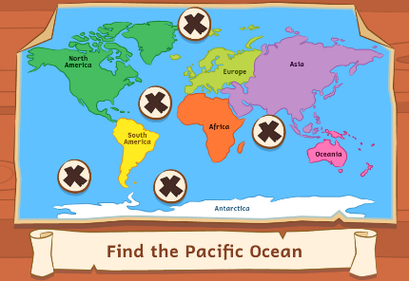  Other Subjects  Y2 under the Sea
Monday | Daily Reading. Read online and complete your Accelerated Reader quizzes https://www.myon.co.uk/login/index.html  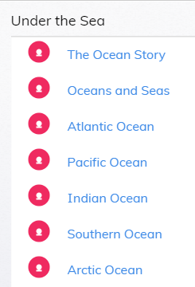  Spellings : Week 1 Summer Spelling 2 Booklet spelling booklet. Days 1-5 (Spelling list is on back page.)  Look at the MyOn project and find out about creatures of the oceans  Make some notes about some of the creatures you have found out about. | TTRockstars: https://ttrockstars.com/  Topmarks:  Daily 10 Mixed Tables 2, 3, 5 and 10  Mathletics Multiplication: www.mathletics.co.uk  Link  1. Measuring Mass in grams  Complete sheets | Look at the PDF Parts of Ocean Animals and complete the separate sheets.
Tuesday | Spellings : Week 1 Summer Spelling 2 Booklet spelling booklet. Days 1-5 (Spelling list is on back page.)  Look at the MyOn project and find out about creatures of the oceans  Make your first fact sheet about animals of the oceans Use optional sheets if you wish. | TTRockstars:  https://ttrockstars.com/  Topmarks:  Daily 10 Mixed Tables 2, 3, 5 and 10  Mathletics: www.mathletics.co.uk  Link  2. Measuring Mass in kilograms  Complete sheets | Look at the PDF Ocean Animals Suited to their Habitats and complete the separate sheets.
Wednesday | Spellings : Week 1 Summer Spelling 2 Booklet spelling booklet. Days 1-5 (Spelling list is on back page.)  Look at the MyOn project and find out about creatures of the oceans  Make your second fact sheet about animals of the oceans | TTRockstars: https://ttrockstars.com/  Topmarks:  Daily 10 Mixed Tables 2,5 and 10  Mathletics: www.mathletics.co.uk  Link  3.Compare Volume  Complete sheets | 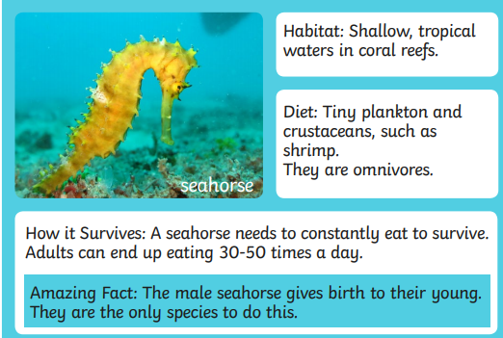  Choose one OCEAN and try to find out which creatures live in it. Make an information sheet or booklet to tell someone all about this ocean and the creatures that live there.  Example
Thursday | Spellings : Week 1 Summer Spelling 2 Booklet spelling booklet. Days 1-5 (Spelling list is on back page.)  Look at the MyOn project and find out about creatures of the oceans | Daily 10 Division 2,5, 10 Extension- choose 3 x tables | Computing  Link : Think U Know PACK 6  Try some activities from the 6th pack  Upload any work you’ve done to Class Dojo if you can  Use this time to type up any work you’d like to show me on Class Dojo, if you want to.
Mathletics: www.mathletics.co.uk

Link
4. Millilitres
Complete sheets
Friday | Spelling Test.  Look at the MyOn project and find out about creatures of the oceans | Daily 10 Division 2,3, 5, 10  Mathletics:  Link  www.mathletics.co.uk  Friday Challenge | PE  Get outdoors in the fresh air! Go for a drive or a walk. Go to the sea if you can!  Les Mills BORN TO MOVE™ https://www.youtube.com/channel/UCJIZkpEAHfJ4kSkbkB8krDg  Go Noodle https://www.youtube.com/user/GoNoodleGames  Zumba with Dovydas https://www.youtube.com/channel/UCOjZigyo_fg2V7JdGwePSwg  Super Movers https://www.bbc.co.uk/teach/supermovers  Andy’s Wild Workouts (EYFS) https://www.bbc.co.uk/iplayer/episodes/p06tmmvz/andys-wild-workouts

