Day | Daily English Task  Weekly Focus:  Oceans | Daily Maths Task  Weekly Focus: Movement  (This is the alternative Y2 Home learning Task from White Rose)  Each day, try to complete a Fluency task from the booklet | 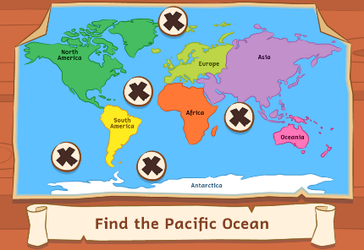  Other Subjects  Y2 under the Sea
Monday | Daily Reading. Read online and complete your Accelerated Reader quizzes https://www.myon.co.uk/login/index.html  Spellings : Week 6 spelling booklet. Days 1-5 (Spelling list is on back page.)  Oceans of the World Video  The Oceans Song! (Parents, thank me later!) See if you can learn the song, just like we did with the Continents song!  Discuss with an adult / sibling what you have found out about the oceans of the world. | TTRockstars: https://ttrockstars.com/  Topmarks:  Daily 10 Mixed Tables 2, 3, 5 and 10  Mathletics Multiplication: www.mathletics.co.uk  Link  Describe Movement | Look at “Oceans of the World Facts”  Make a poster about your favourite Ocean. Have a look online to see if you can find any more facts out about the oceans.  Here’s some links to get you started.  Ocean facts for Kids  Oceans BBC Bitesize  Nat Geo Ocean Facts for Kids
Tuesday | Spellings : Week 6 spelling booklet. Days 1-5 (Spelling list is on back page.)  - Look at “Oceans Text” look at the information on the map and answer the separate questions.  - Look at An Unexpected Adventure Pack. Discuss the picture. On Friday you will be writing a story about what happened. You can try to include some facts about oceans/ seas too.  - Complete some of the activities today. | TTRockstars:  https://ttrockstars.com/  Topmarks:  Daily 10 Mixed Tables 2, 3, 5 and 10  Mathletics: www.mathletics.co.uk  Link  Describing Turns | Look at the “Match up the Oceans” sheet.  Match the Oceans to the correct part of the map .  Play Bitesize Ocean Voyage and other games  Online matching of the oceans. | PSHE  Watch  Billy's Bucket  What questions does it make you think of?  Discuss them with someone else.  Write some of your questions and thoughts and send them to Miss Hird on Class Dojo!
Wednesday | Spellings : Week 6 spelling booklet. Days 1-5 (Spelling list is on back page.)  - Look at “Collect the Punctuation Game” Play it with an adult/ sibling.  - Look at: An Unexpected Adventure Pack again. Complete some more of the activities today. Gather your ideas for your writing. | TTRockstars: https://ttrockstars.com/  Topmarks:  Daily 10 Mixed Tables 2,5 and 10  Mathletics: www.mathletics.co.uk  link  Describing Movement and Turns | - Look at the sheet “Match Up the Seas”  Match the seas to their correct locations on the map. Look at an atlas at home or online to help you.  - Complete the sheet “Oceans and Seas” word search.
Thursday | Spellings : Week 6 spelling booklet. Days 1-5 (Spelling list is on back page.)  - Look at “Layers of the Ocean” Comprehension. Read and answer the questions.  - Look at: An Unexpected Adventure Pack again. Complete some more of the activities today. Gather your ideas for your writing. | Daily 10 Division 2,5, 10 Extension- choose 3 x tables | Computing  Link : Think U Know PACK 5  Try some activities from the 5th pack  Upload any work you’ve done to Class Dojo if you can  Use this time to type up any work you’d like to show me on Class Dojo, if you want to.
Mathletics: www.mathletics.co.uk

Link
Making patterns with shapes – see sheet.

Friday | Spelling Test.  An Unexpected Adventure Pack  Have a look at the picture again and discuss think about what is happening. Finish off your activities.  Write your own story all about what happened! | Daily 10 Division 2,3, 5, 10  Mathletics:  Link  www.mathletics.co.uk  Friday Challenge | PE  Get outdoors in the fresh air! Go for a drive or a walk. Go to the sea if you can!

