Day | Daily English Task | Daily Maths Task | Other Things that you could do
Monday  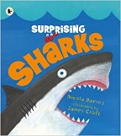 | This week we are looking at sharks! Look on YouTube for the book ‘Surprising sharks’ by Nicola Davies. Can you write a list of the different types of shark that can be found? Can you draw a picture of the different sharks? Which sharks are dangerous to humans? | This week we are looking at taking away numbers by crossing out the right amount and counting to see how many are left. Can you count how many are in the first group and write the answer, then see how many you need to take away. Cross this many fish out and see how many are left. | - Look on the internet for as much information on different sharks as you can find.  - Make shark silhouettes  - Make a plate shark  - Make a footprint shark  - Read under the sea books on MyON  - Sing ‘Baby shark’ and make up a dance.  - Find out which creatures we are likely to see in the seas around Britain  - Make a poster to tell people that not all sharks are dangerous.  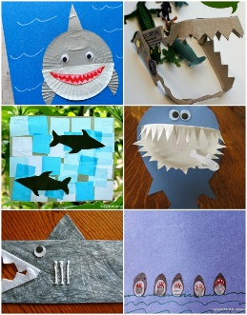  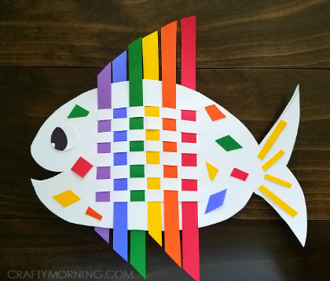  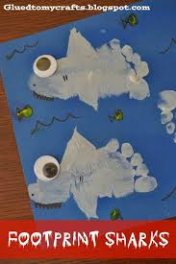
Tuesday | Look at the diagram of the shark. Can you label the parts of the shark’s body? Can you write a sentence about the different parts of the shark? What do they do? Write a sentence to tell me some other facts about the body of a shark- what does it feel like? What about its skeleton? | Remember how we are taking away by crossing out numbers. When we use Numicon we can cover the holes with our fingers and count how many are left. Look at the pieces of Numicon. Can you say which number they represent? Cover the right number of holes to see how many are left.
Wednesday  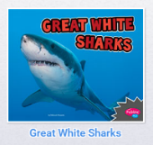 | Look at the book ‘Great white sharks’ on MyOn. Can you listen to the information about the Great White shark? Think of some sentences to write about the Great White shark. Can you write these sentences to tell people some facts about them? | Look at the group of sharks. Can you count to see how many there are? Count and write the total. Look to see how many you need to take away. Cross out that number of sharks. Can you count to see how many are left?
Thursday  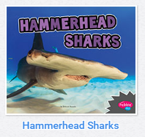  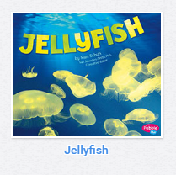 | Look at the non-fiction book ‘Hammerhead sharks’ on MyOn. Can you listen to the information about the Hammerhead shark. Think of some sentences to write about the shark. Can you write these sentences to tell people some facts about Hammerhead sharks? | Look at the group of sharks. Count to see how many have been crossed out and write this number in the box. Can you count to see how many sharks are left without lines through them? Write this answer in the total box.
Friday  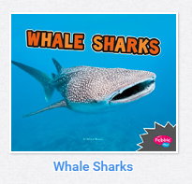 | Look at the non-fiction book ‘Whale sharks’ on MyOn. Can you listen to the information about the whale shark? Think of some sentences to write about the shark. Can you write these sentences to tell people some facts about whale sharks? | Look at the number sentences and have some objects ready to help you to solve the problem. Look at the first number in the number sentence and put that many objects in a line. Then look at the second number in the number sentence and take that many objects away from your line. How many are left?

