Day | Daily English Task | Daily Maths Task | Other Things that you could do
Monday | This week we are looking at the topic of ‘Under the sea’. There are a range of books on MyON. Have a look at a book that interests you. Can you write a list of animals that you might find under the sea? Can you draw pictures of them? | This week we are looking at adding two numbers by keeping one number in your head and counting on. Can you count how many are in the first group, keep that number in your head and count on to see how many there are altogether? | - Look on the internet for as much information on different sea creatures as you can find.  - Make fish pictures  - Make a plate jellyfish  - Make an under the sea collage picture.  - Read under the sea books on MyON  - Look at a map of the world to see where the different seas are.  - Find out which creatures we are likely to see in the seas around Britain  - Make a fish weaving picture  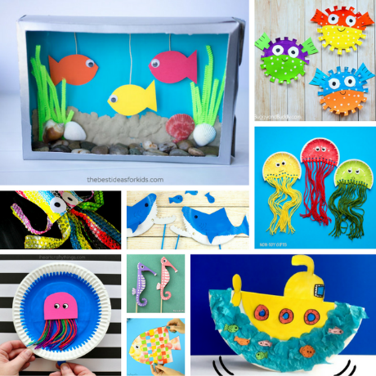  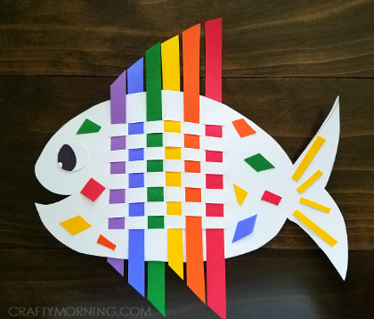
Tuesday  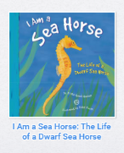 | Look at the book ‘I am a seahorse’ on MyOn. Can you listen to the information about the seahorse. Think of some sentences to write about the seahorse. Can you write these sentences to tell people some facts about seahorses? | Remember how we are adding two numbers by keeping one number in our head and counting on. Look at the pieces of Numicon. Can you say which number they represent? Keep one number in your head and then use your fingers to help you count on to find the answer.
Wednesday  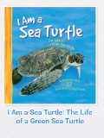 | Look at the book ‘I am a sea turtle’ on MyOn. Can you listen to the information about the turtle. Think of some sentences to write about the turtle. Can you write these sentences to tell people some facts about turtles? | Look at the group of turtles. Can you count to see how many there are? Count and write the total. Keep this number in your head. Which number is written in the number sentence? Show this number on your fingers and then count on from the number in your head. How many do you have altogether?
Thursday  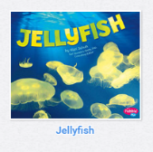  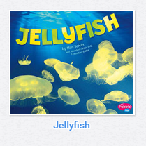 | Look at the non-fiction book ‘Jellyfish’ on MyOn. Can you listen to the information about the jellyfish. Think of some sentences to write about the jellyfish. Can you write these sentences to tell people some facts about jellyfish? | Look at the group of jellyfish. Can you count to see how many there are? Count and write the total. Keep this number in your head. Which number is written in the number sentence? Show this number on your fingers and then count on from the number in your head. How many do you have altogether?
Friday  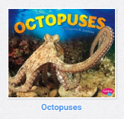  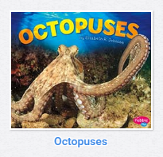 | Look at the non-fiction book ‘Octopus’ on MyOn. Can you listen to the information about the octopus. Think of some sentences to write about the octopus. Can you write these sentences to tell people some facts about an octopus? | Look at the number in the number sentence. Show this many on your fingers. Can you keep this number in your head and then count how many octopuses you can see in the picture. How many do you have altogether?  Write the number on your sheet.

