Complete daily | Name recognition  Find your name. Match your name. Find the letters in your name. Attempt to write your name.  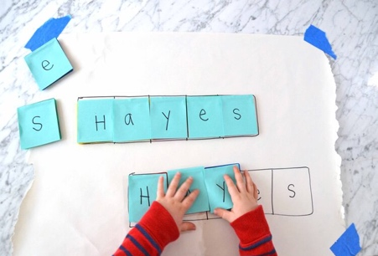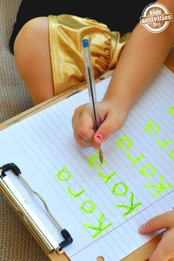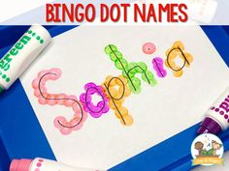
Focus tasks | 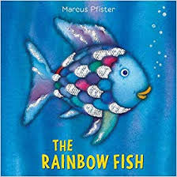  Learning Intention: To listen and respond to stories  Activity: Discuss the different characters throughout the story (e.g. Rainbow Fish, Little Blue Fish, the octopus). How are they feeling? Why? Why might Rainbow Fish not want to give away his sparkly scales?  Discuss sharing and different ways of sharing resources e.g. completing a jigsaw puzzle together, making pictures for someone, building models together using construction toys.  Learning Intention:  Activity:  Discuss Rainbow Fish. What was special about him? Was he nice fish at the beginning? What happened at the end?  Write a list of things that make someone a nice person.  Kind, sharing, play together, friendly, taking turns, laughing together, making sure people are not left out, listening to others.  Learning Intention: To speak in a group and share ideas. To understand what makes a good friend.  Can you think of your own rainbow Character. Model on the board a Rainbow animal eg Rainbow Dog. Then tell the children about your animal. Make sure you tell them what makes them special and how they are a good friend to others. (Kind, sharing, play together, friendly, taking turns, laughing together, making sure people are not left out, listening to others)  Give children time to make their own Rainbow animal, ask them to think about what makes their Rainbow animal good.  Take turns standing up and sharing with others why their Rainbow animal in  Activity: Resources – paper pens

Complete daily | Watch the jolly phonics phase 2 song on Youtube. Join in with the words and actions. https://www.youtube.com/watch?v=1Qpn2839Kro  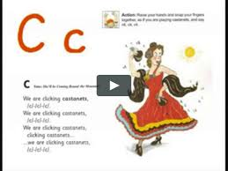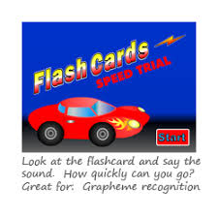  Go on Phonicsplay.co.uk or use the app Username: march20Password: home. Flashcards- speed trials- phase 2
Focus tasks | Introduce the ‘m ’sound.  Form the letter ‘’ saying, ““Down Maisie, over the Mountain, over the mountain””. as you form the letter.  How many things around the house can you find begging with the ‘m’ sound?  Practise forming the letter ‘’. Remember to start and finish in the correct place. Say “Down Maisie, over the Mountain, over the mountain”, as you form the letter.  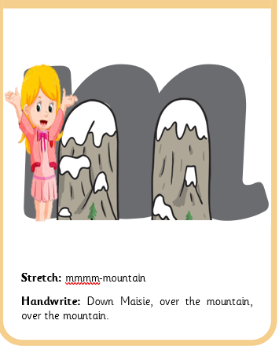  If you wish to practise a new sound the cards are available to download on the class dojo.  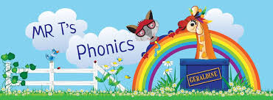  https://www.youtube.com/watch?v=Xh6Ux5D2D84  https://www.youtube.com/watch?v=3IsTdhma4DU  https://www.youtube.com/watch?v=QI_3IFdqFKI  Watch Mr Thorne does phonics on YouTube- episode ‘M’  Write some words with the initial sound ‘M’.  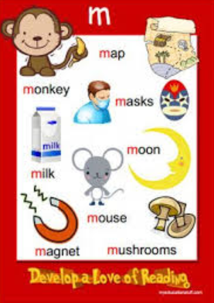  Watch the Letter , Song with bounce patrol. https://www.youtube.com/watch?v=Nvn9QvV7Aqk  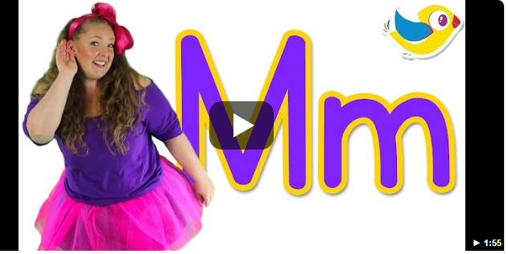

Complete daily | Watch the ‘Our favourite number songs’ video on Youtube on the Super Simple Songs channel. Sing along and remember to hold up the correct fingers when counting.  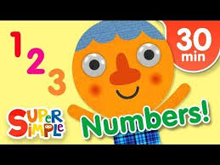
Focus tasks | Model a repeating pattern using coloured fish. See if they can pick the fish that comes next.  Make new repeating patterns, maming sure your child joins in  Resources- Coloured fish cut out from coloured paper  Clap and count, attempt beyond ten taking turns.  Hand out some repeating pattern examples. See if your child can copy these using blocks (independently)  Challenge- attempt your own repeating pattern.  Resources- repeating pattern block examples - blocks  Hand out some fish templates. Pin one to the board to model with your child to begin them off. Each child needs pile of different coloured scales. Model sticking the scales in a repeating pattern. Your child can follow on and see if they can continue the repeating pattern. Leave to work independently.  Resources- Rainbow fish templates. Coloured circles for scales.  Hand out repeating pattern sheet 1. Give each child a small plate with different coloured paints on ( see the sheet for colours) . Complete the finger painting worms ( One colour per hand). Do the first one as a group. Se if they can complete some independently. Wipe fingers between use with baby wipe.  Repeating pattern sheet 1. Using pens, finish the repeating patter. Give out sheet 2 if they are finished as a challenge. They may need support.  .

Other activities.
- Go over the date and weather daily. Go outside to check the weather and discuss. What season are we in? What happens during this season? Make a weather chart or use an online one. https://www.ictgames.com/mobilePage/dateChart/index.html
Jack Hartmann on YouTube has some great days of the week and months of the year songs and dances.

- Encourage children to dress themselves. Putting on their own clothes, coats and shoes makes them more independent and ready for starting their Reception class.

Pencil control
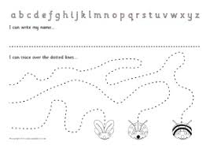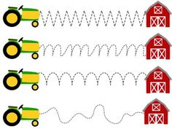
- You can make your own pencil control sheet by drawing lines for your child to follow. Make these however you like. Using , straight, circular, and zig zag lines.
- Have your child join the dots, number the dots to incorporate a bit of maths.
- Placing objects inside lines.
- Highlighter Tracing, draw a picture with a highlighter for your child to trace
See additional file for new pencil control sheets.
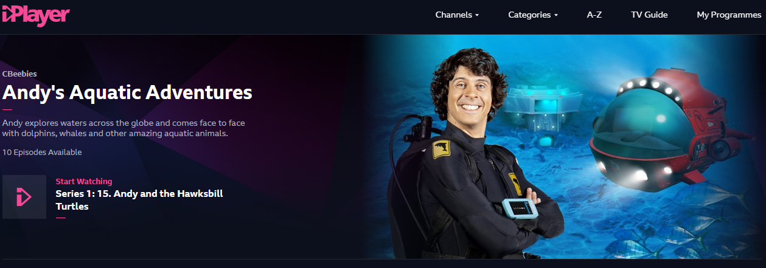
https://www.bbc.co.uk/iplayer/episodes/m000fbs2/andys-aquatic-adventures

Use your log in on myon.co.uk to access a range of ‘Under the Sea’ books.
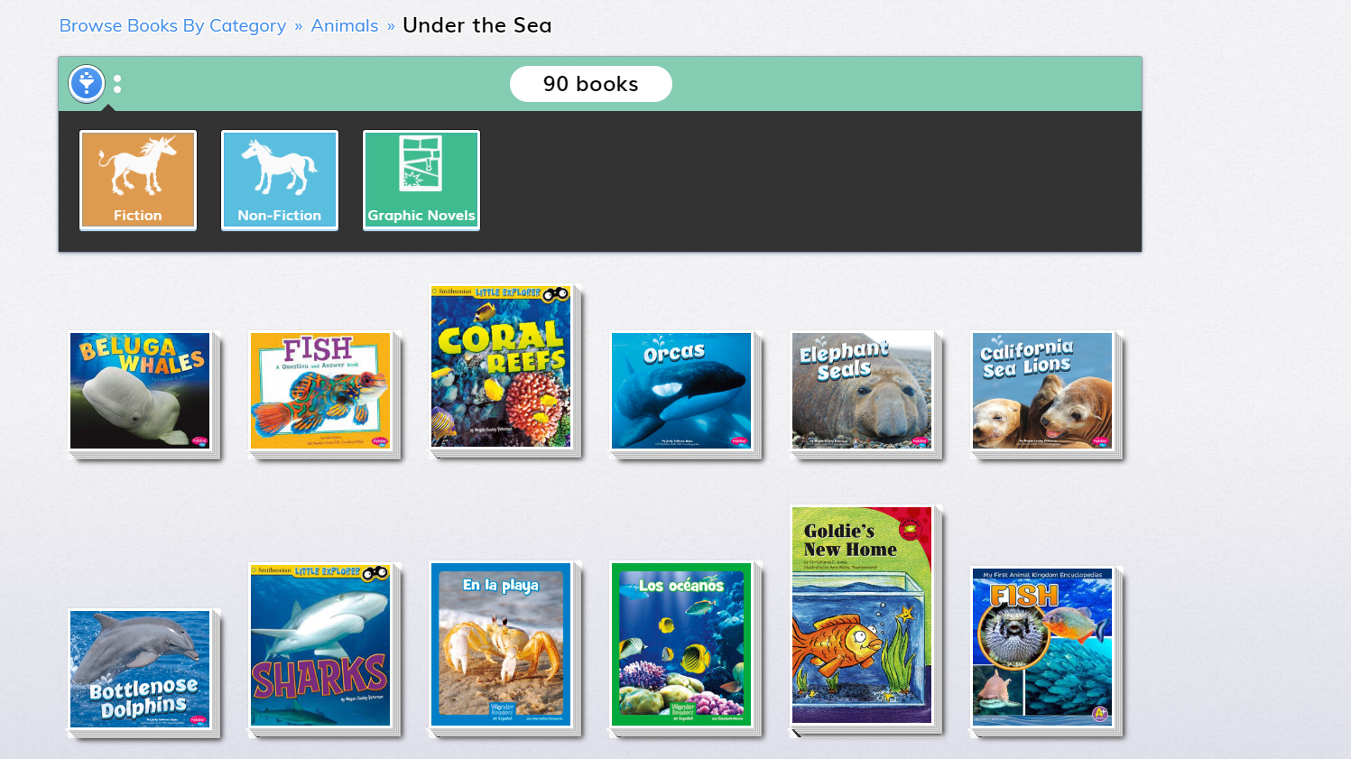

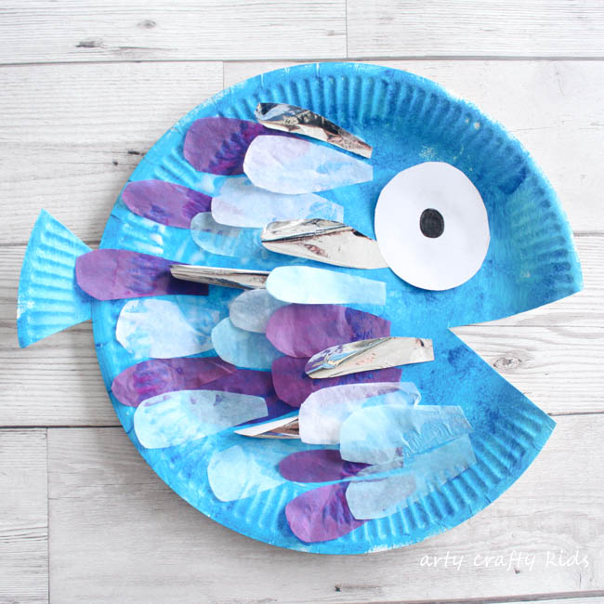
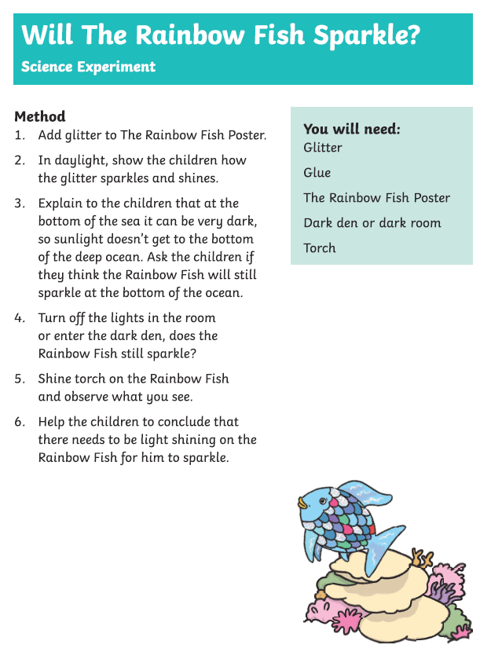

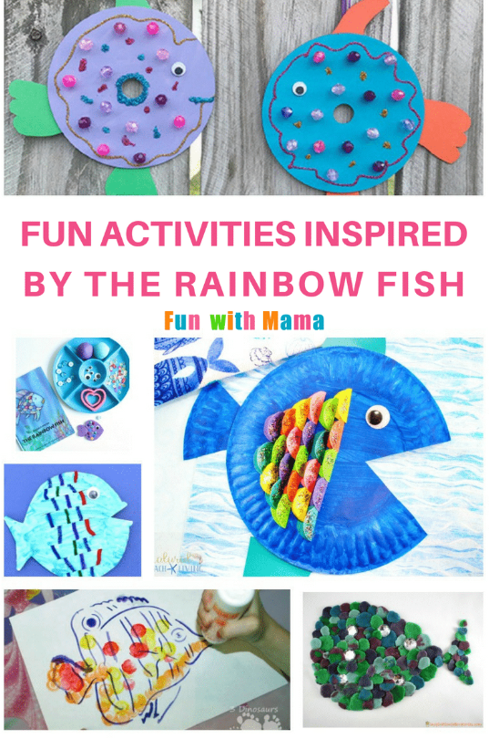

Make rainbow slime!

https://littlebinsforlittlehands.com/making-rainbows-stem-spring-science-activities/?jwsource=cl

