Complete daily | Name recognition  Find your name. Match your name. Find the letters in your name. Attempt to write your name.  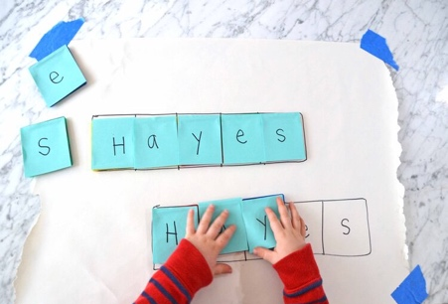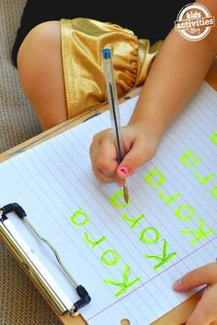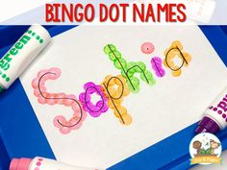
Focus tasks | 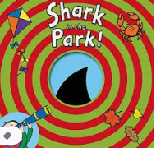  https://www.youtube.com/watch?v=nWRwBRVeGQs  Show children the book- ‘Shark in the park’ What do chn think might happen in this book? Can chn recognise the rhyming words in the story? Encourage chn to consider which part of the shark the little boy thinks he can see each time. Read through twice encouraging chn to join in with the rhyming words the second time around. Leave a space when reading and encourage chn to fill in the gaps. Which word rhymes with shark? Etc  Learning Intention: To use talk to connect ideas, explain what is happening and anticipate what might happen. To recognise initial sounds  Activity: Give each child a ‘telescope’ to look through. What can chn see through their telescope when they look around the classroom? Can we make a list of things that we can see? Can other children see those things through their telescope? Ask chn to say one thing each that they can see. What sounds can we hear in that word? Model writing a list, taking children’s suggestions as to how words are spelled and then show them the correct version.  What can you see? What sounds can you hear in that word?  Vocab- telescope, see, view, sounds  Learning Intention: To use talk to connect ideas, explain what is happening and anticipate what might happen. To recognise initial sounds  Activity: Show chn a diagram of a shark with different features hidden in small circles. ( Could drawk this and cover with cut out circles) Can chn recognise which part of the shark is hidden within the circles? Can chn help to label the shark? What sounds can we hear in the words? Can one child come out to the board and try to write a label for the part of the shark?  Which part of the shark is that? Which sounds can we hear in that word?  Vocab- feature, label, sound.

Complete daily | Watch the jolly phonics phase 2 song on Youtube. Join in with the words and actions. https://www.youtube.com/watch?v=1Qpn2839Kro  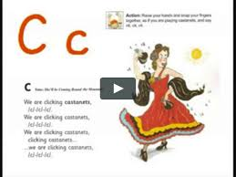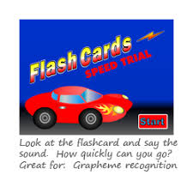  Go on Phonicsplay.co.uk or use the app Username: march20Password: home. Flashcards- speed trials- phase 2
Focus tasks | Introduce the ‘r ’sound.  Form the letter ‘’ saying, “Down the robot’s body, back up and give him an arm”. as you form the letter.  How many things around the house can you find begging with the ‘R’ sound?  Practise forming the letter ‘r’. Remember to start and finish in the correct place. Say ““Down the robots body, back up and give him an arm”, as you form the letter.  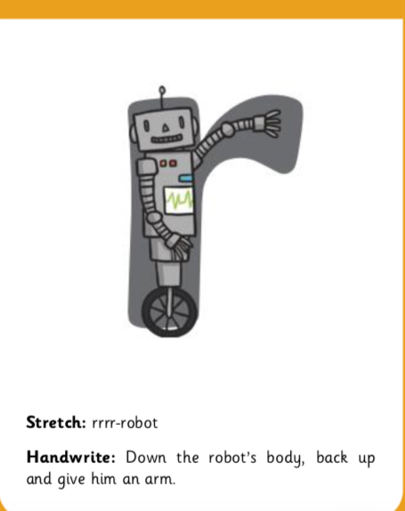  If you wish to practise a new sound the cards are available to download on the class dojo.  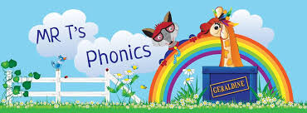  https://www.youtube.com/watch?v=0xFKC8tNdEo  Watch Mr Thorne does phonics on YouTube- episode ‘R’  Write some words with the initial sound ‘R’.  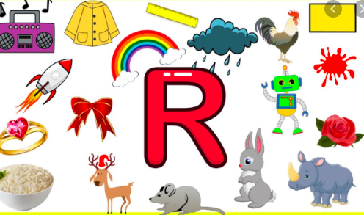  Watch the Letter R Song with bounce patrol. https://www.youtube.com/watch?v=gUSJeivdEH8

Complete daily | Watch the ‘Our favourite number songs’ video on Youtube on the Super Simple Songs channel. Sing along and remember to hold up the correct fingers when counting.  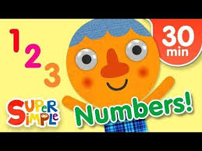
Focus tasks | Hide some sea creatures outside, different amount of different types.  The children must find all of each sea creatures. Take turns to go and look When you have them all count all, count how many we have for each sea creature. Can the children find the numeral to match the amount for each sea creature.  Resources- sea pictures different types and different amounts. numbers  Clap and count, attempt beyond ten taking turns.
Clap and count, attempt beyond ten taking turns. Give each child the fish matching activity. Can they independently match all of the cards?
Resources- sea creature matching cards, set each. numbers.
Clap and count, attempt beyond ten taking turns.
Build the number line together on the board.
Choose a number from the number line and centre it on the board.
Give each child a set of pens and a blank fish. Tell the children to make decorate the fish by adding X amount of spots. Check they all have the correct amount then ask them to match the Numicon.
Repeat for more numbers.
Resources-blank fish cut-out, pens, Numicon
Clap and count, attempt beyond ten taking turns.

Other activities.
- Go over the date and weather daily. Go outside to check the weather and discuss. What season are we in? What happens during this season? Make a weather chart or use an online one. https://www.ictgames.com/mobilePage/dateChart/index.html
Jack Hartmann on YouTube has some great days of the week and months of the year songs and dances.

- Encourage children to dress themselves. Putting on their own clothes, coats and shoes makes them more independent and ready for starting their Reception class.

Pencil control
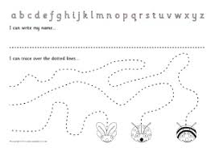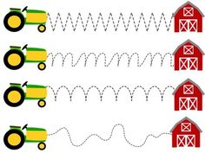
- You can make your own pencil control sheet by drawing lines for your child to follow. Make these however you like. Using , straight, circular, and zig zag lines.
- Have your child join the dots, number the dots to incorporate a bit of maths.
- Placing objects inside lines.
- Highlighter Tracing, draw a picture with a highlighter for your child to trace
See additional file for new pencil control sheets.
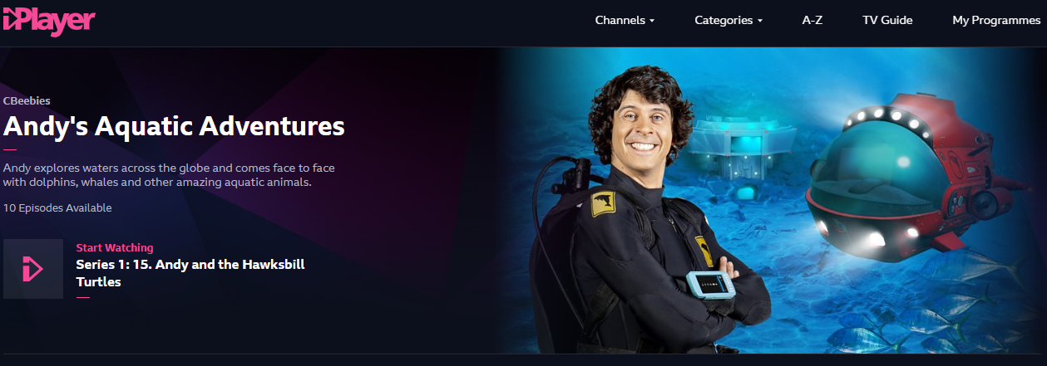
https://www.bbc.co.uk/iplayer/episodes/m000fbs2/andys-aquatic-adventures
