Complete daily | Name recognition  Find your name. Match your name. Find the letters in your name. Attempt to write your name.  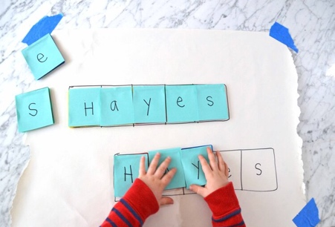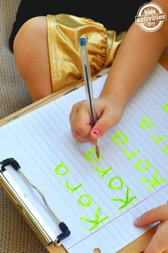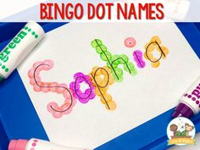
Focus tasks | Look at the PowerPoint ‘All about dinosaurs’ Go through the PowerPoint together.  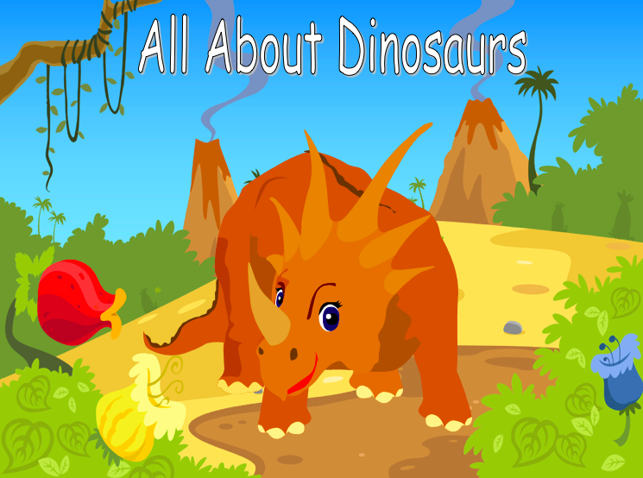  Talk about the different dinosaurs they see. Make sure the children explain the language used. What is Earth? Use a globe to show them.  Does anyone know any names of dinosaurs?  Write the names on the board, what sound does the dinosaur begin with?  Resources – Printout of PowerPoint
Describing game
Your child must describe their dinosaur whilst the you have to listen. Ask questions to help the child describe. What colour is it? Does it have spikes? Is it big or small? Try and guess which dinosaur the child was describing.
Resources – Dinosaur pictures.
Explain that you are going back in time to look for dinosaurs. Go through a bag with things we need. ( Binoculars, camera, note book, torch)
Can the children think of reasons why we might need each piece of equipment? What could they be used for? What might we find if we went back in time.
Have some printed out scenes from Jurassic times to give children ideas.
Resources – Jurassic scenes, bag of items

Complete daily | Watch the jolly phonics phase 2 song on Youtube. Join in with the words and actions. https://www.youtube.com/watch?v=1Qpn2839Kro  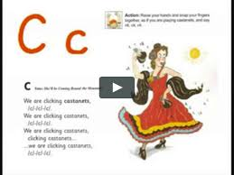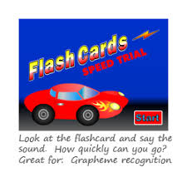  Go on Phonicsplay.co.uk or use the app Username: march20Password: home. Flashcards- speed trials- phase 2
Focus tasks | Introduce the ‘u ’sound.  Form the letter ‘’ saying, “Down and under the umbrella, back up and don’t forget the puddle”. as you form the letter.  How many things around the house can you find begging with the ‘F’ sound?  Practise forming the letter ‘f’. Remember to start and finish in the correct place. Say “Down the stem and draw the leaves” as you form the letter.  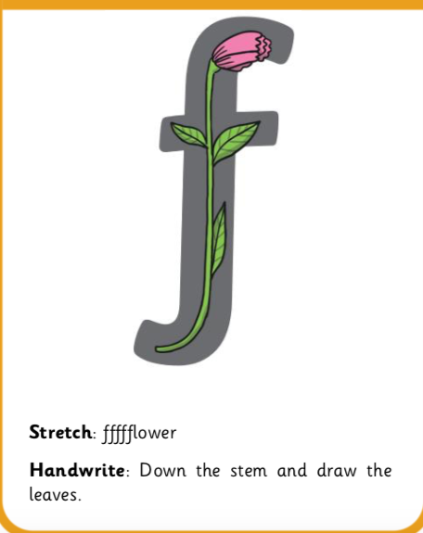  If you wish to practise a new sound the cards are available to download on the class dojo.  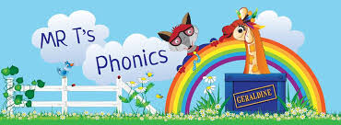  Watch Mr Thorne does phonics on YouTube- episode ‘f’. https://www.youtube.com/watch?v=T0-KNJ0yXS8  Write some words with the initial sound ‘f’.  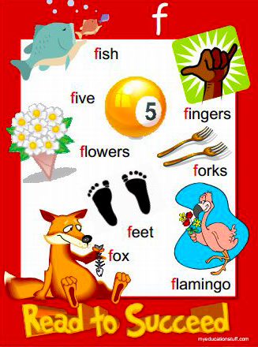  Watch the Letter F Song with bounce patrol. https://www.youtube.com/watch?v=Zrj0feSC5oo

Complete daily | Watch the ‘Our favourite number songs’ video on Youtube on the Super Simple Songs channel. Sing along and remember to hold up the correct fingers when counting.  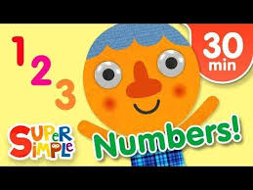
Focus tasks | Look at some pictures of dinosaurs, can they remember their names. Talk about big dinosaurs and small dinosaurs.  See if they can find a big dinosaur on the board? Which is the smallest dinosaur? Can they find a dinosaur that is bigger than this dinosaur?  Resources- different sized dinosaurs. One set
Independent
Can the children sort their dinosaurs into a pile of big and a pile of small dinosaurs.
Each child has set of dinosaurs
Extension- see if they can sort the dinosaurs in a line according to size.
Resources-Different sized dinosaurs – set each
Using playdough ask the children to make a big dinosaur and a small dinosaur.
Can they use size language when making their dinosaurs?
Examples -This one has short legs It has a long neck. This one is taller than that one.
Resources-Own playdough

Other activities.
- Go over the date and weather daily. Go outside to check the weather and discuss. What season are we in? What happens during this season? Make a weather chart or use an online one. https://www.ictgames.com/mobilePage/dateChart/index.html
Jack Hartmann on YouTube has some great days of the week and months of the year songs and dances.

- Encourage children to dress themselves. Putting on their own clothes, coats and shoes makes them more independent and ready for starting their Reception class.

Pencil control
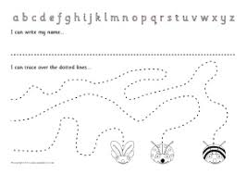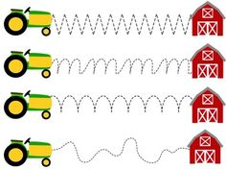
- You can make your own pencil control sheet by drawing lines for your child to follow. Make these however you like. Using , straight, circular, and zig zag lines.
- Have your child join the dots, number the dots to incorporate a bit of maths.
- Placing objects inside lines.
- Highlighter Tracing, draw a picture with a highlighter for your child to trace
See additional file for new pencil control sheets.

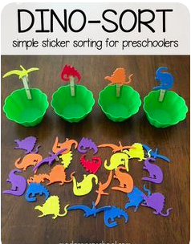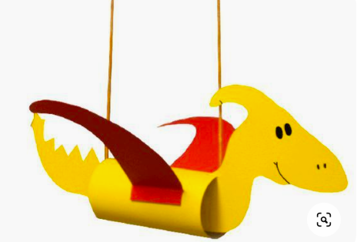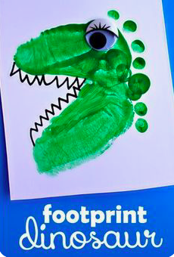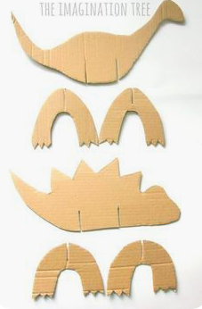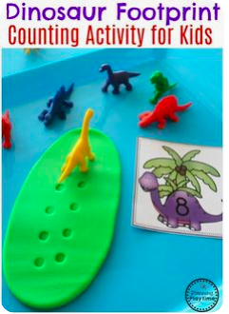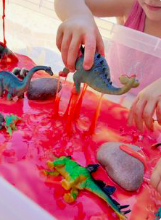

https://www.bbc.co.uk/cbeebies/games/andys-dinosaur-adventures-game
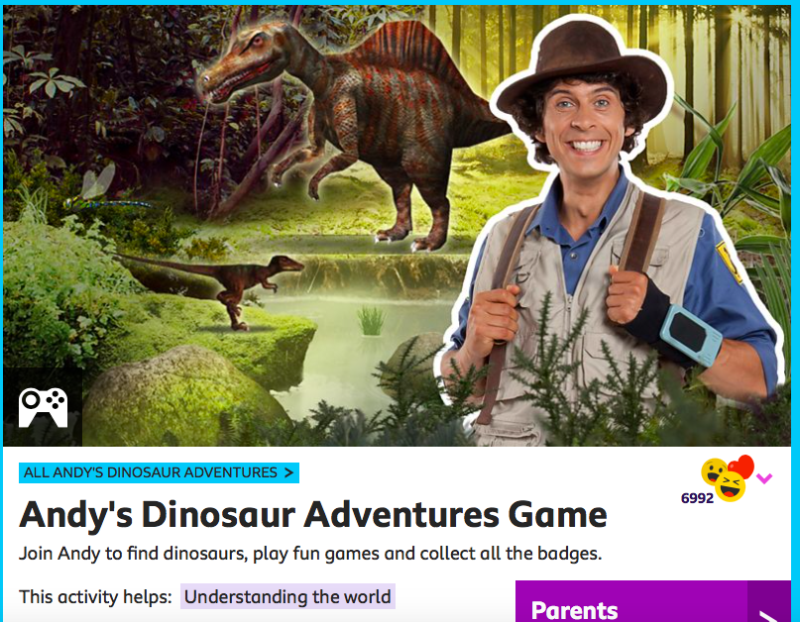

Watch Harry online. https://www.youtube.com/channel/UCoHJXadQIxxMT69kHWt0zOQ

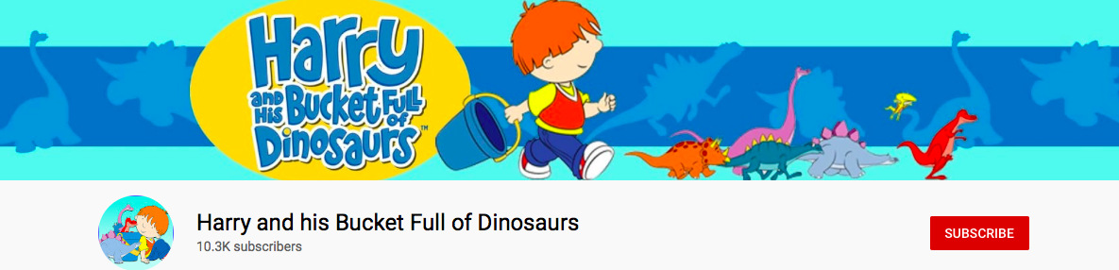

https://www.bbc.co.uk/iplayer/episodes/b03wh7vl/andys-dinosaur-adventures
