Complete daily | Name recognition  Find your name. Match your name. Find the letters in your name. Attempt to write your name.  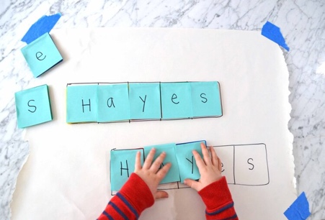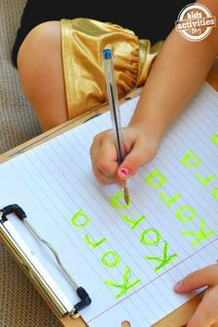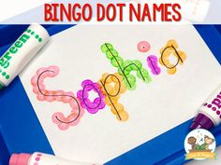
Focus tasks | Read ‘If I had a Dinosaur.’  https://www.youtube.com/watch?v=og9xn8WoyDs  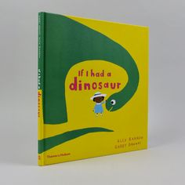  LO:  I can begin to recall and discuss the events of story.  I can think of and share my own ideas.  Ask your child if they can remember all the different things that the little girl wants to do with her dinosaur. Where does she take it? Where was there favourite place and why?  Look at the picture of the dinosaur, can your child recognise what kind of dinosaur it is?  Watch the dinosaur video and say if they can spot a similar dinosaur.  https://www.youtube.com/watch?v=W-Bg9MhSb7M  Can they recognise the initial sound in the name of their dinosaur?  Ask your child what they would do if they had a dinosaur. Which dinosaur would they want? Where would they take it? How would they make it welcome into their home? Would they need to change anything? What would it eat?  Learn some facts about the kind of dinosaur they have chosen.  Draw a picture of your dinosaur in your home and some of the activities you would do with them.

Complete daily | Watch the jolly phonics phase 2 song on Youtube. Join in with the words and actions. https://www.youtube.com/watch?v=1Qpn2839Kro  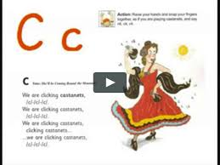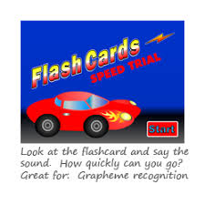  Go on Phonicsplay.co.uk or use the app Username: march20Password: home. Flashcards- speed trials- phase 2
Focus tasks | Introduce the ‘u ’sound.  Form the letter ‘’ saying, “Down and under the umbrella, back up and don’t forget the puddle”. as you form the letter.  How many things around the house can you find begging with the ‘u’ sound?  Practise forming the letter ‘u’. Remember to start and finish in the correct place. Say “Down and under the umbrella, back up and don’t forget the puddle” as you form the letter.  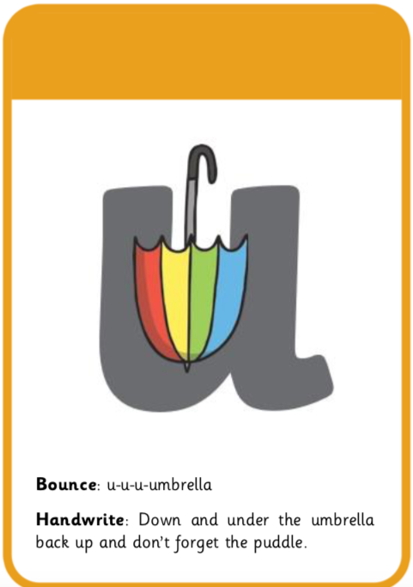  If you wish to practise a new sound the cards are available to download on the class dojo.  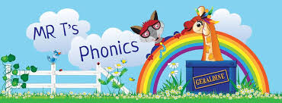  Watch Mr Thorne does phonics on YouTube- episode ‘u’. https://www.youtube.com/watch?v=kmmewEew6lM  Write some words with the initial sound ‘u’.  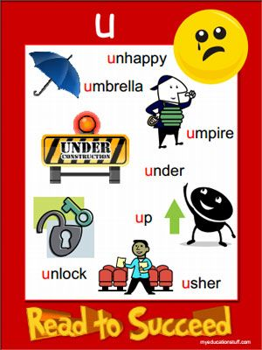  Watch the Letter U Song. https://www.youtube.com/watch?v=nPJRhEV-kF8

Complete daily | Watch the ‘Our favourite number songs’ video on Youtube on the Super Simple Songs channel. Sing along and remember to hold up the correct fingers when counting.  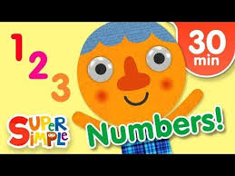
Focus tasks | Recognising and describing 2D shapes.  Cut out some simple 2D shapes in different sizes ( triangles, squares, rectangles, circles). See if your child can spot the different shapes. Ask, “Can you find the circle?” and “What shape is this?”. Once they recognise the shape discuss the parts of the shape. Look at the straight sides or curved sides. Look at long sides and short sides. Talk about corners and how many each shape has. Look at the sizes of the shapes, can they find a circle? Can they find a bigger circle? Can they find all the squares? Check all the squares have the same properties by looking at the length of the sides, corners etc. Which one is the smallest square? If you want, you can introduce new shapes. (semi-circle, diamond, oval, hexagon).  Display all of the shapes on a flat surface and explain you are going to make a dinosaur picture using the shapes.  Talk about the shapes as you are choosing them. (“This circle could be good because it has a curved side.”, “ The triangles could be good for this part because it has sharp corners.”)  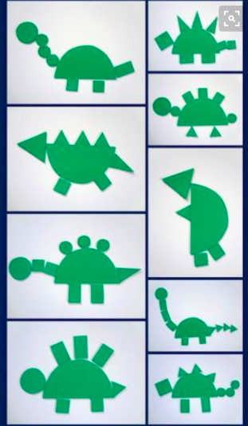

Other activities.
- Go over the date and weather daily. Go outside to check the weather and discuss. What season are we in? What happens during this season? Make a weather chart or use an online one. https://www.ictgames.com/mobilePage/dateChart/index.html
Jack Hartmann on YouTube has some great days of the week and months of the year songs and dances.

- Encourage children to dress themselves. Putting on their own clothes, coats and shoes makes them more independent and ready for starting their Reception class.

Pencil control
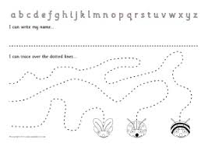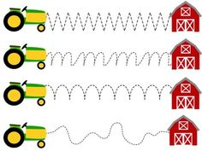
- You can make your own pencil control sheet by drawing lines for your child to follow. Make these however you like. Using , straight, circular, and zig zag lines.
- Have your child join the dots, number the dots to incorporate a bit of maths.
- Placing objects inside lines.
- Highlighter Tracing, draw a picture with a highlighter for your child to trace
See additional file for new pencil control sheets.
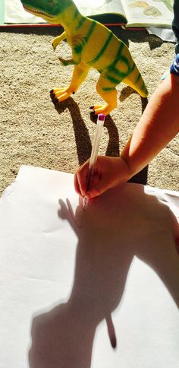

https://www.bbc.co.uk/cbeebies/games/andys-dinosaur-adventures-game
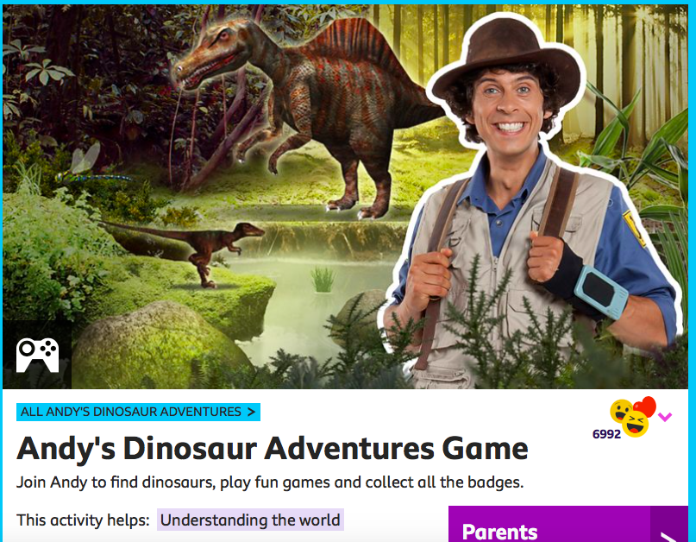

Watch Harry online. https://www.youtube.com/channel/UCoHJXadQIxxMT69kHWt0zOQ

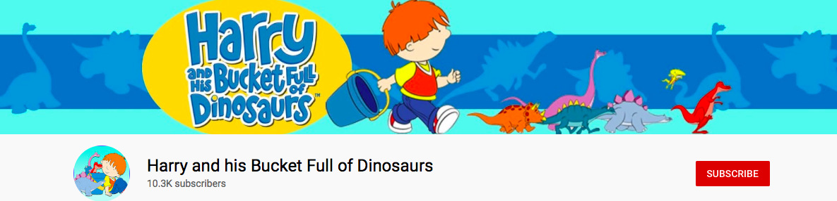

https://www.bbc.co.uk/iplayer/episodes/b03wh7vl/andys-dinosaur-adventures

