Box-it up grid | Tyrannosaurus Drip | My story
Opening
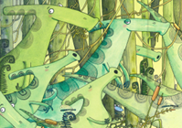
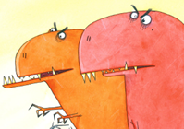
 | Words and phrases I can magpie:
Build-up
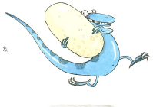
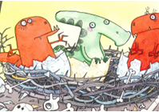
 | Words and phrases I can magpie:
Problem
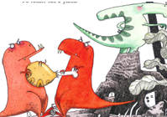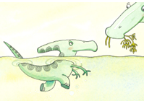
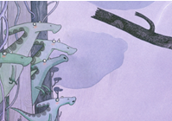
 | Words and phrases I can magpie:
Resolution
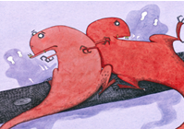
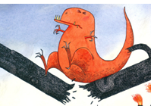
 | Words and phrases I can magpie:
Ending
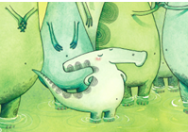
 | Words and phrases I can magpie:

