Please note- Please try to ensure you complete your daily reading via MyON. You can also complete the quiz related to the book you have been reading.
Monday | Maths- Money  Starter- Using a tens frame and some two-sided counters. Explore different number bonds to 10. Write as number sentences on a whiteboard.  Main Activity- Add by making 10.  Complete each of the tasks in turn. Adult to discuss each task before the children then have an opportunity to complete it. First two tasks complete using a tens frame. Children should have a blank tens frame and two-sided counters on their tables.  Complete the final task using number bond knowledge. Can provide numicon if needed. | Literacy  Phonics- Flash card hunt. Reading and writing given words with chalk.  Literacy- Read ‘Twinkle, Twinkle, Little Star’ and ‘Twinkle, Twinkle, Little Bat’ together. Children have the nursery rhyme and poem in front of them so they can follow along with their finger as we read them. Are the rhyming words always together? Does every line or every other line rhyme?  Children recognise the rhyming words and circle these.  Introduce Ronnie the rhyming rhino. Can we help him match the rhyming words? Go through the PowerPoint together.  Show the children the different animal poem. Which animal do you think the poem is all about? Can you spot what is missing? Discuss the fact that some of the rhyming words are missing. Can you identify the missing rhyming words and add these to the poem?  Once they have completed the poem, children read the completed poems aloud. Have they selected the correct rhyming words? How do we know? Does the poem now rhyme? | Healthy Me- Discuss looking after ourselves and keeping ourselves healthy and safe.  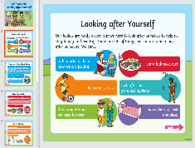  Look at the PowerPoint provided and talk about how we can keep healthy/safe. | Plastic pollution-  Look at the PowerPoint ‘Plastic in the Environment’ and discuss the harmful effects of plastic.  Talk about what we can do to help. Look at the examples shared in the PowerPoint.  Complete the ‘5 Ways I Can Help Our Earth’ task. Write simple sentences and include pictures.
Tuesday | Maths  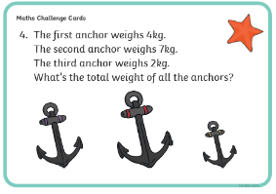  Starter- Count to 100, following numbers on interactive hundred square.  What is one more than 26? Two more? Etc.  Complete the challenge card. Children solve problem using their choice of resources. Write out number sentence on a whiteboard.  Main Activity- Subtraction crossing 10.  Complete each of the tasks in turn. Adult to discuss each question. | Literacy  Phonics- Sounds- Can you hit a sound card with a beanbag? Say the sound as you aim. Buried treasure, blending for reading. Can you find the coins hidden in the year 1 outdoor space?  Literacy- Re-read the story- Commotion in the Ocean by Giles Andreae.  https://www.youtube.com/watch?v=9pRhgZ8Jffs  Do you notice anything about the words? Look for the children who notice the rhyming words. Adult to use my turn, your turn to say different rhyming words. Explain that each page is a poem about a different sea creature. Show the children. Which poem is your favourite and why?  Look at one page together. Circle the rhyming words. Look for and pick out the matching sounds in the rhyming words. Are they all the same sound or alternative sounds? Does it matter which ‘ay/a-e/ai sound, or does it rhyme anyway?  Children should be given different poems from the story. They should identify and then circle the rhyming words. Does each line or every other line rhyme? They should then think about other related words that also rhyme with the circled words. Children write other words in the boxes provided. | Music-  Learn and perform various different ‘Under the Sea’ songs and rhymes.  See songs and rhymes within the resource booklet. Add music. Can the children sing in time to the music? Can they add their own music/beat, with a drum? | PE-  https://www.youtube.com  /user/thebodycoach1  Join in with Joe Wicks daily PE session on his YouTube- The Body Coach.
Wednesday | Maths  Starter- Number bond song- https://www.youtube.com/watch?v=lD9tjBUiXs0  Main Activity- Subtraction crossing 10.  Complete each of the tasks in turn. Adult to discuss each question. | Literacy  Phonics- Sounds- Teacher shouts a sound, children write on the yard with chalk. Word hunt- Hunt for words, read these and then sort into real or nonsense.  Literacy- Explain that we are gong to create our own poem to be added to or to replace one of the poems in the book.  Show the example poem created by Mrs Morris. Can you spot the rhyming words? Circle the rhyming words. Are the rhyming words together in this poem? Discuss and explain what a rhyming couplet is. --- A Rhyming Couplet is two line of the same length that rhyme and complete one thought.  Explain that we are all going to be creating our own poem to be added to the book ‘Commotion in the Ocean.’ Today we are going to focus on identifying and writing lots of rhyming words related to turtles that we could use when writing our poem. | Science/Geography – Can you find out about different famous deep-sea explorers?  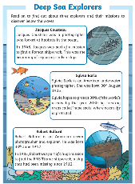  Read the information sheet about three famous deep-sea explorers together. Children then use the internet to research these people further. Children create their own PowerPoint all about one of the explorers. Present their PowerPoint and findings to others.  https://thekidshouldseethis.com/post/dr-sylvia-earle-world-renowned-oceanographer
Thursday | Maths  Starter- Count in 2’s, 5’s and 10’s on interactive hundred square. Practise your 2, 5, and 10 times tables, link to counting.  Main Activity- Compare number sentences.  Complete each of the tasks in turn. Adult to discuss each question. | Literacy  Phonics- Flash cards (Phase 3&5) Phonics play- Tricky word trucks.  Literacy- Children use the rhyming words they throughout about/identified in yesterday’s lesson to complete their own rhyming poem.  Look at the template and talk about the fact that our poem is going to have three rhyming couplets. Recap what a rhyming couplet is. **A Rhyming Couplet is two line of the same length that rhyme and complete one thought. Discuss the fact that our poem is going to be all about turtles.  Adult to model sharing some ideas together for the poem. | Art- Create your own foil fish design.  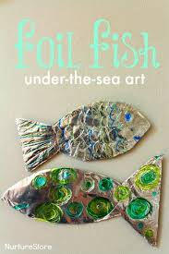  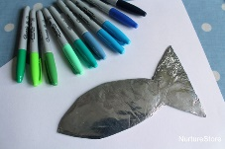 | PE- Continuation from last week.  https://www.youtube.com/watch?v=SH-7A3NVQbY  Practise learnt dance- Disney ‘Just Dance- Under the Sea’ song. Perform to others. Video and watch back. Can we improve/change the dance?  Sing along to the Little Mermaid by practising your dance moves!
Friday | Maths  Starter- Choose a random number on the hundred square. Can you add 10? Can you take away 10?  Main Activity- Challenge Friday!  Complete the ‘Under the Sea’ maths problems.  Adult to encourage the children to think carefully about how they could solve these problems.  Can you work it out using your knowledge of number bonds or doubling facts? Do you need to check whether you are correct by using some manipulatives? Could you use a number line or counters? Do you need to add or take away? | Phonics- Flash cards (Phase 3&5) Phonics play- Sentence level game.  Literacy- Edit and improve your poem.  Create illustrations ready for this to be published within the ‘Commotion in the Ocean’ book.  Read poem aloud to others. Adult to record. | 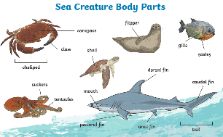  Science- Can you explore and name the different creature baby parts?  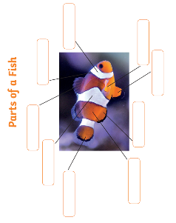  Look at the learning mat together and discuss the names of different body parts. Children then use some sea creature figures, then point out and name different body parts.  Focus on the body parts of a fish. Use the internet to find out about the different parts of a fish. Children then complete the labelling activity provided in the pack.

Useful Websites for Extra Tasks/Activities
Phonics  https://www.phonicsplay.co.uk/  Username – march20 Password – home  https://www.teachyourmonstertoread.com/games/tm1/demo  https://www.phonicsbloom.com/  https://www.topmarks.co.uk/english-gam…/…/letters-and-sounds | Maths  www.mathletics.com  www.ttrs.com  www.topmarks.co.uk  https://www.oxfordowl.co.uk/for-home/  https://www.bbc.co.uk/iplayer/episodes/b08bzfnh/numberblocks  www.whiterosemaths.com/homelearning/
English  https://www.topmarks.co.uk/…/7-11-years/spelling-and-grammar  www.sooperbooks.com  https://www.oxfordowl.co.uk/for-home/  www.spellingframe.co.uk  http://www.funenglishgames.com/games.html  https://www.eslgamesplus.com/  www.pobble365.com  www.readtheory.org  https://www.scholastic.com/…/scholastic-learn-at-home--free…# | Other  https://www.si.edu/kids - Fun lessons on geography, history and science  https://www.shaunsgameacademy.co.uk/ - Computing  https://scratch.mit.edu/ - Computing – click ‘create’  https://www.duolingo.com/register - Languages  https://mrnussbaum.com/science - Science  https://www.gonoodle.com/good-energy-at-home-kids-games-an…/ - Free exercise videos  https://www.virtualmusicalinstruments.com/ - Music

