Name:
I can choose an appropriate unit of measure.
Choose an appropriate unit of measure for each of the objects in the pictures
Choose from mm (millimetres)
cm (centimetres)
m (metres)
km (kilometres)

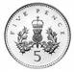  5p coin | a car | 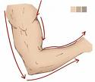  arm
length of a river | your height | 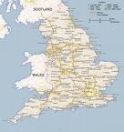  England
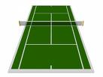  a tennis court | 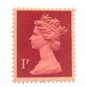  a stamp | 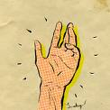  length of hand

I can convert units of measure – Length

Remember: 10mm = 1cm
100cm = 1m
1000m = 1km

For these questions you will need to convert these larger units of measure into smaller ones by multiplying by 10, 100 or 1000.

3cm = __________ mm | 5m = __________ cm
6km = __________ m | 54cm = __________ mm
5.8km = __________ m | 13.6cm = __________ mm
6.193km = __________ m | 3.4cm = __________ mm
4.56m = __________ cm | 150.953km = __________ m

For these questions you will need to convert these smaller units of measure into larger ones by dividing by 10, 100 or 1000.

30mm = _________ cm | 400cm = _________ m
9000m = __________ km | 540mm = _________ cm
5500m = _________ km | 4650m = _________ km
656cm = _________ m | 75mm = __________ cm
1122cm = _________ m | 356mm = _________ cm

Remember: 10mm = 1cm
100cm = 1m
1000m = 1km

Think carefully about whether you need to multiply or divide by 10, 100 or 1000 for each question:

3cm = __________ mm | 5m = __________ cm
6km = __________ m | 54cm = __________ mm
5.8km = __________ m | 13.6cm = __________ mm
6.193km = __________ m | 3.4cm = __________ mm
4.56m = __________ cm | 150.953km = __________ m
30mm = _________ cm | 400cm = _________ m
9000m = __________ km | 540mm = _________ cm
5500m = _________ km | 4650m = _________ km
656cm = _________ m | 75mm = __________ cm
1122cm = _________ m | 356mm = _________ cm

How many m are there in 1.459km?

How many mm are there in 1.5cm?

How many m are there in 546cm?

How many cm are there in 1.29m?

How many cm are there in 656mm?

How many km in 600m?

How many km in 15798m?

How many mm are there in 125cm?

