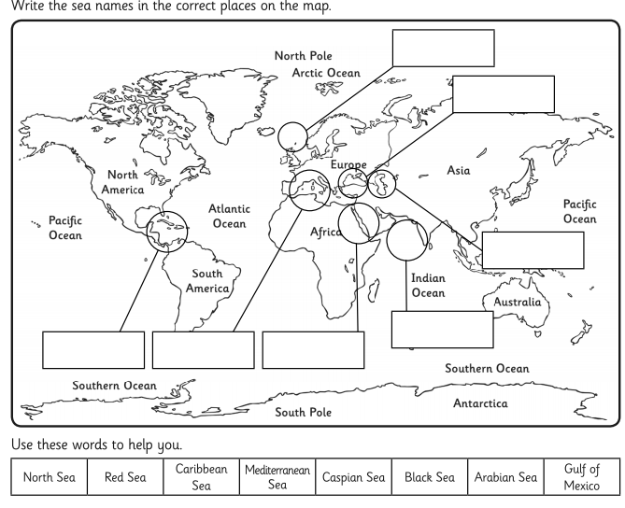

**Match up the Seas**

**Look at an Atlas or an online map to see if you can find out the location of each of the seas listed below. Match them up on the map if you can!**