Year 5 Geography Task 4/5/20

Work through the PowerPoint watching the clips by following the links. (You may need to copy and paste the link into your search).
https://www.bbc.co.uk/bitesize/clips/z8tyr82

https://www.bbc.co.uk/bitesize/clips/zj6rkqt

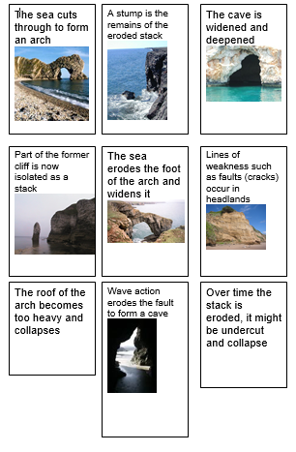
Complete the ordering activity. You can do this by printing the worksheet and cutting out or by numbering if you don’t have a printer .

Try to label the diagram. If you don’t have a printer you can add text boxes to the PowerPoint slide.
