Year 5 Geography 11/5/20
This week we are looking at the way land is formed by earthquakes. Watch the following clip on BBC bitesize.
https://www.bbc.co.uk/bitesize/topics/z849q6f/articles/zj89t39
Work through this PowerPoint to answer the following questions. 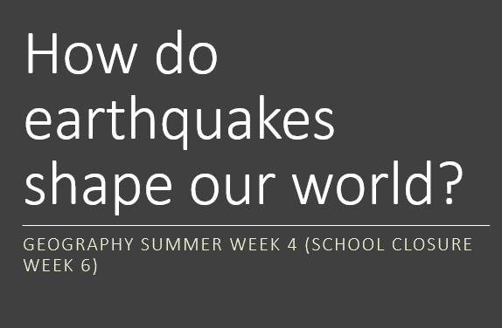

- What is a tectonic plate?
- What are the names of some of the main tectonic plates?
- What causes an earthquake?
- Describe what causes a fault line to form.
- How is the magnitude of an earthquake measured?
From your own research
- Name an example of a fault line.
- Name a region of earth which has frequent large earthquakes.
- Where did the largest earthquake ever occur?
Challenge
How might movement of tectonic plates cause a new island to be formed?
What causes a tsunami?

