**West Cornforth Primary School**

**Home/School Learning Pack**



**Summer 2 Week 1**

**WB: 1.6.20**

*Note: Remember to refer to the Year 1 weekly overview plan for further details on each task. As always the plan will be sent via class dojo and shared on the school website.*

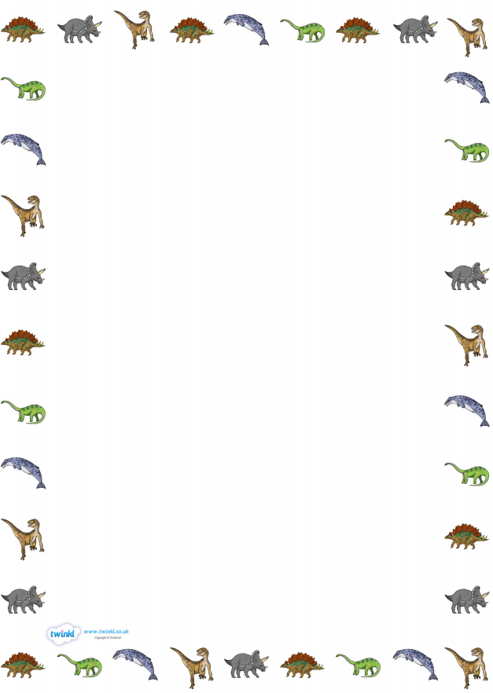**Monday English-** An introduction to the dinosaur topic.

**What do you already know about dinosaurs?**

**_____________________________________________________________________________________________________________________________________________________________________________________________________________________________________________________________________________________________________________________________________________**

**What would you like to find out about dinosaurs?**

**_________________________________________________________________________________________________________________________________________________________________________________________________________________________________________________________________________________________________________________________________________________________**

**___________________________________________________________________________________________________________________**

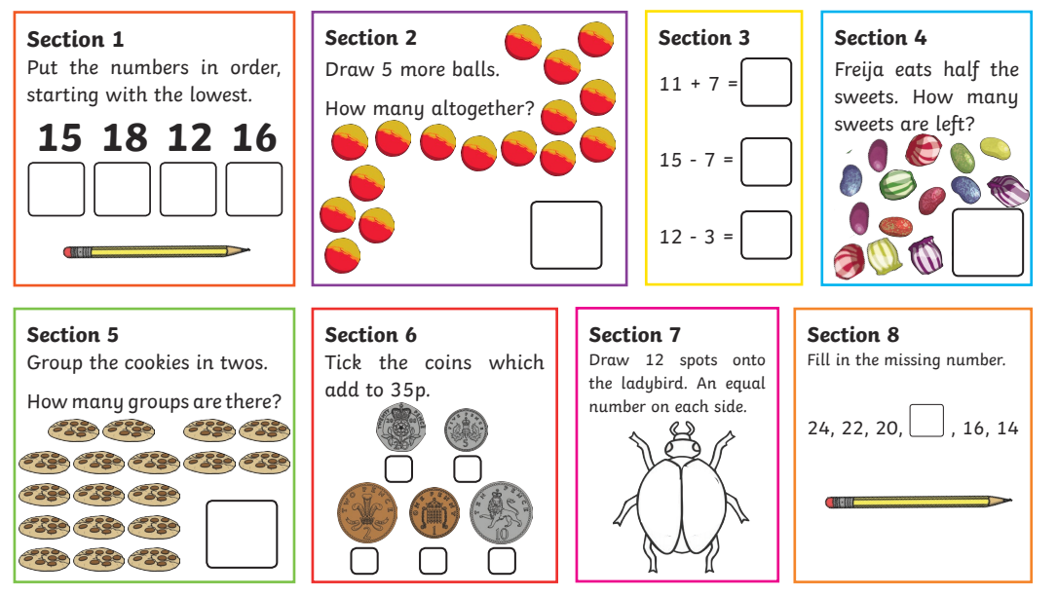**Monday Maths**

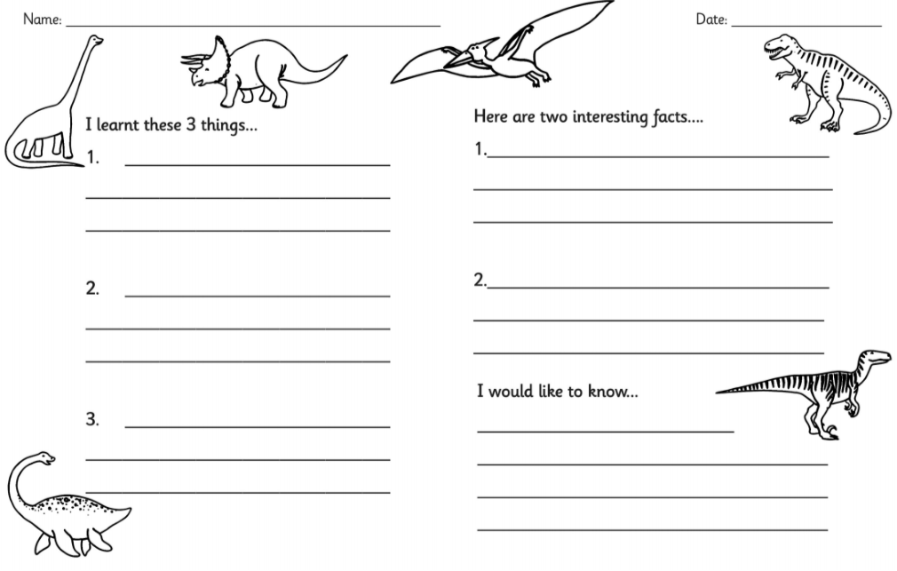**Tusday English-**

Introducing Dinosaurs!

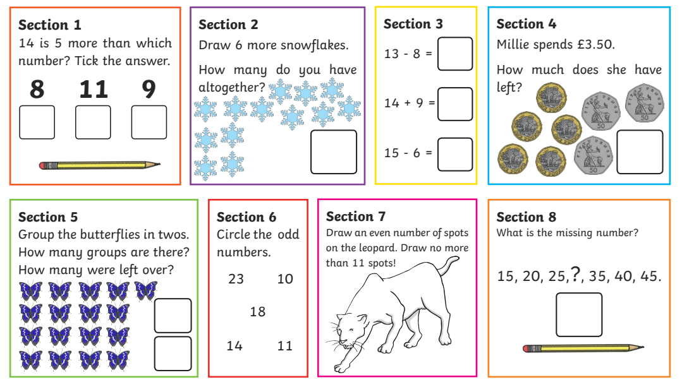**Tuesday Maths**

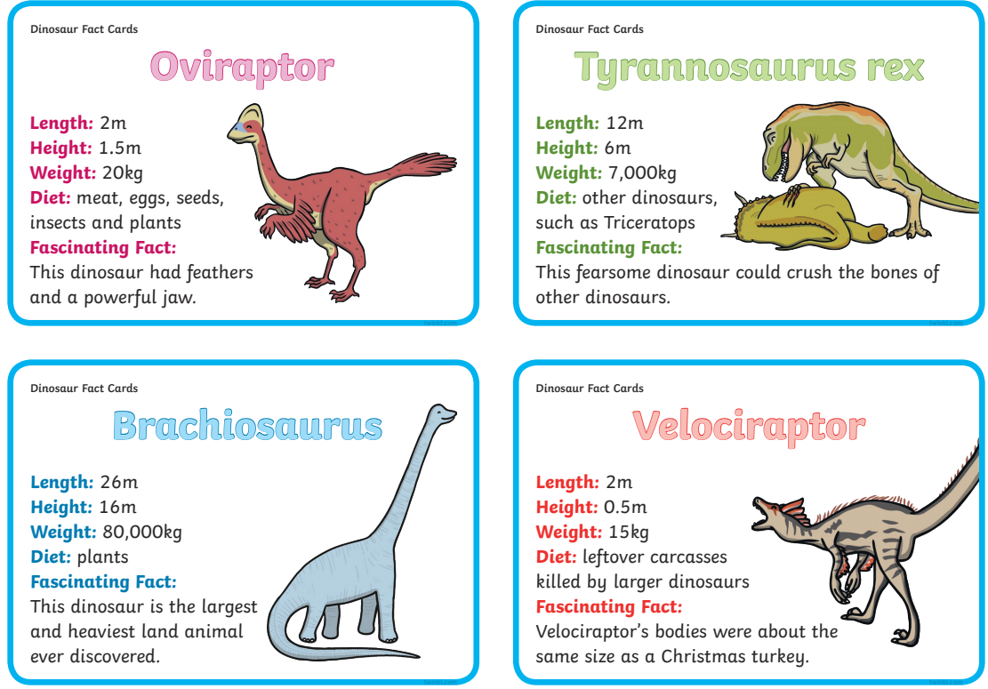**Wednesday English –** Fact cards to read.

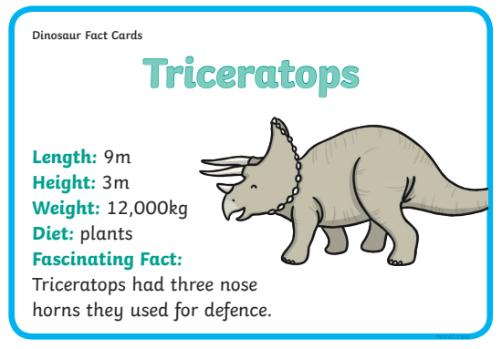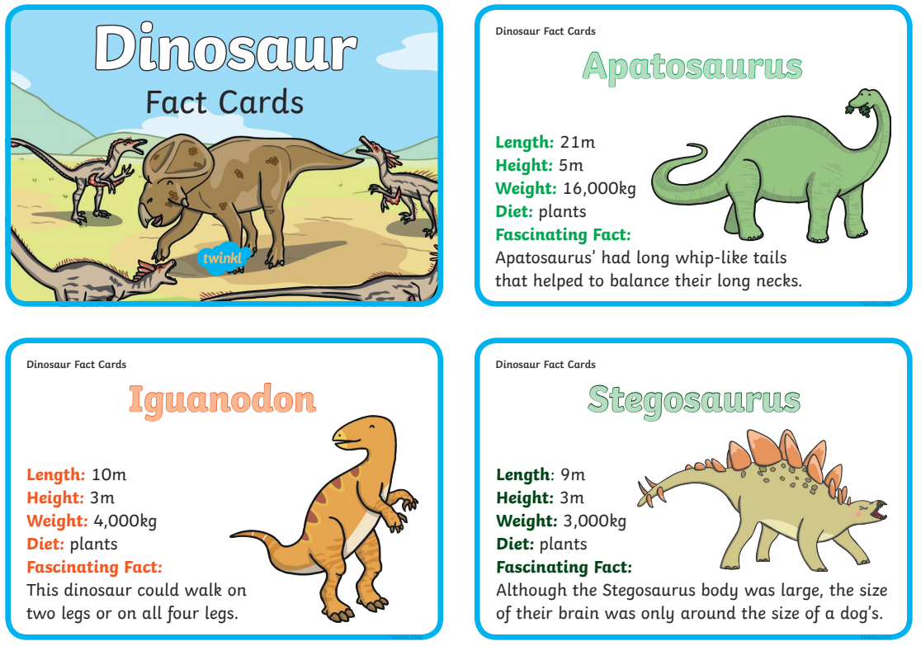

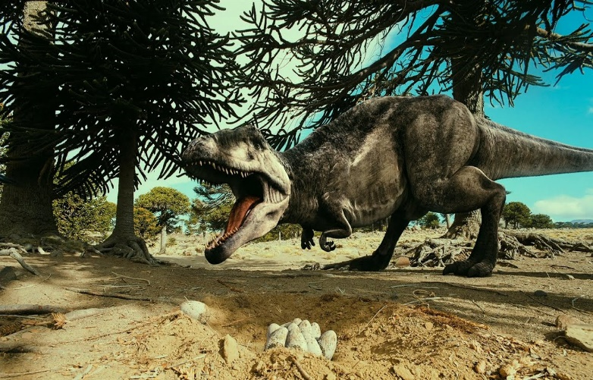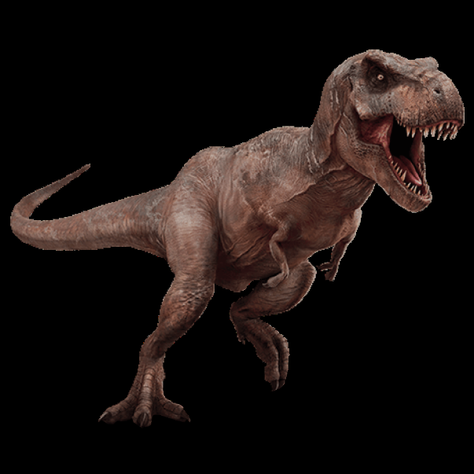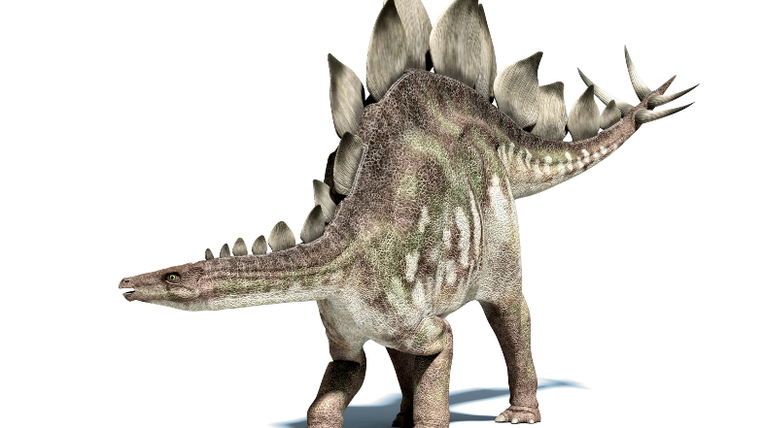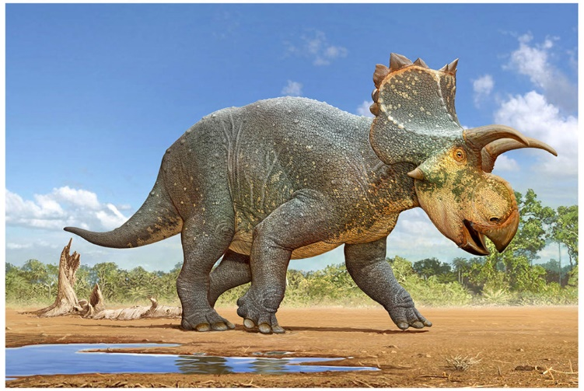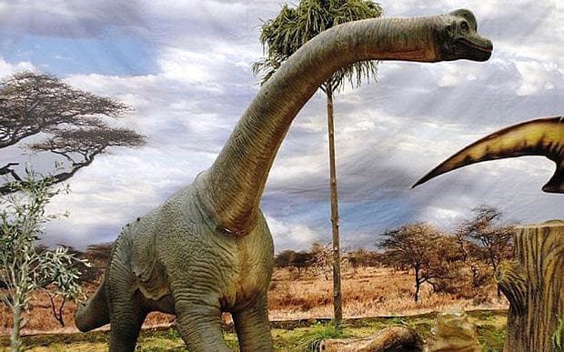**Wed** **nesday English –** Images for the dinosaur information posters.

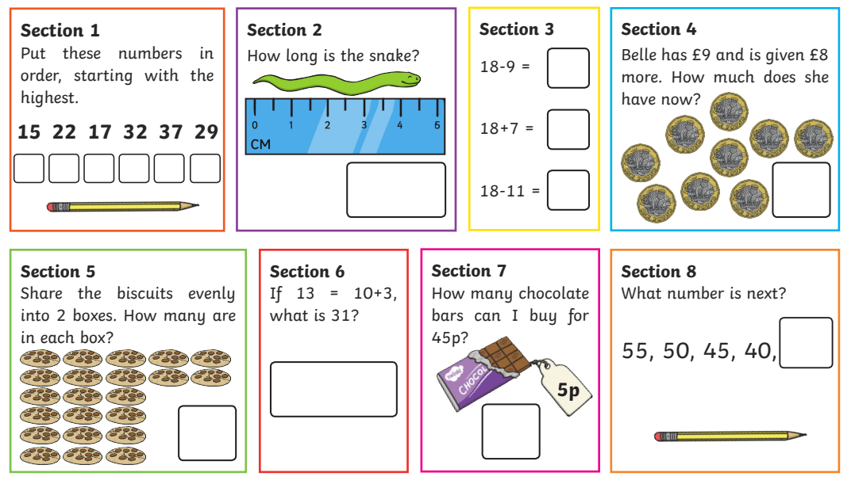**Wednesday Maths**

**Wednesday Science –** Which animal group it dinosaurs once belong it?

**What do you notice about the dinosaur? Add labels to the image.**

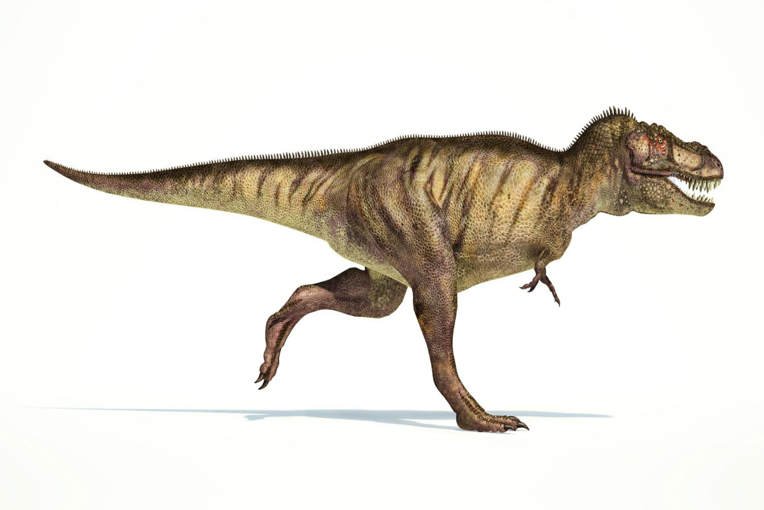**Circle the group you think dinosaurs belonged it?**

**Mammal**

**Reptile**

**Fish**

**Amphibian**

**Bird**

Explain your thinking.

______________________________________________________________________________________________________________________________________

**Thursday English –**

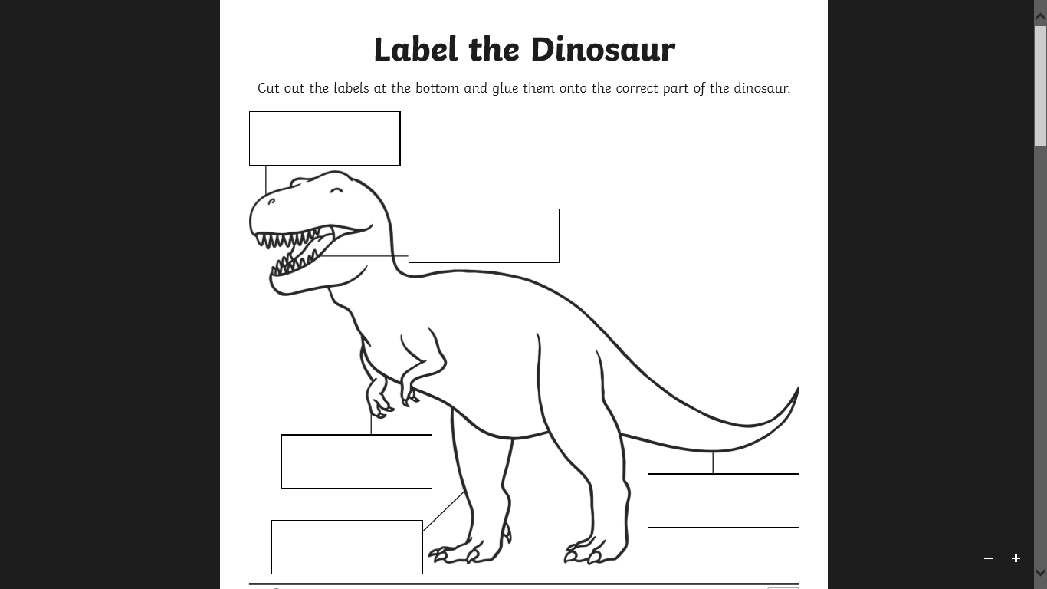

**Dinosaur Name:**

**Dinosaur Facts:**

**_______________________________________________________________________________________________________________________________________________________________________________________________________________________________________________________________________________________________________________________________________________________________________________________________________________________________________________________________________________________________________________________________________________________________________________**

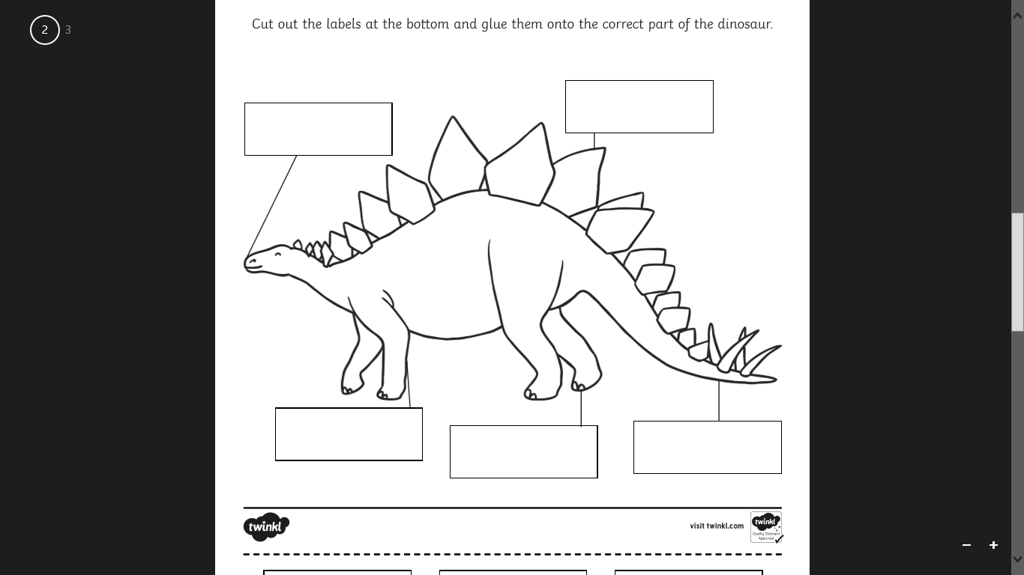

**Dinosaur Name:**

**Dinosaur Facts:**

**_______________________________________________________________________________________________________________________________________________________________________________________________________________________________________________________________________________________________________________________________________________________________________________________________________________________________________________________________________________________________________________________________________________________________________________**

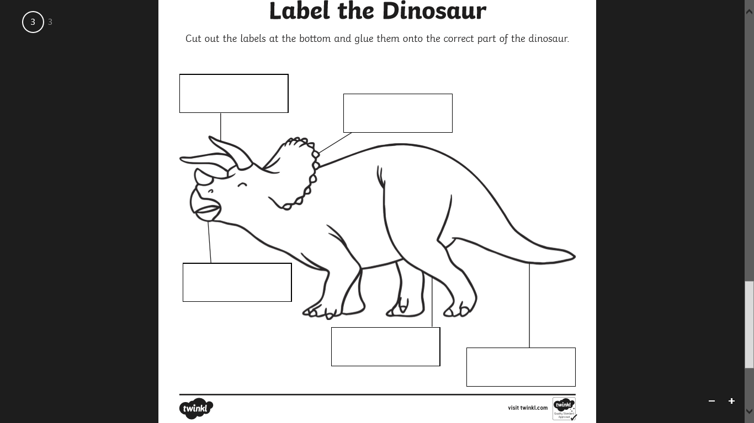

**Dinosaur Name:**

**Dinosaur Facts:**

**_______________________________________________________________________________________________________________________________________________________________________________________________________________________________________________________________________________________________________________________________________________________________________________________________________________________________________________________________________________________________________________________________________________________________________________**

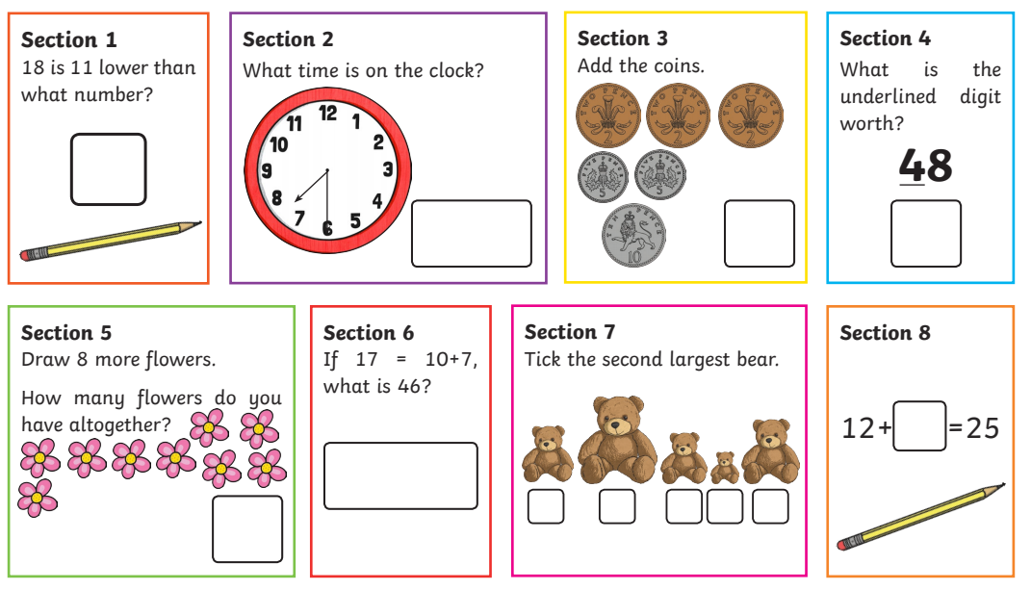**Thursday Maths-**

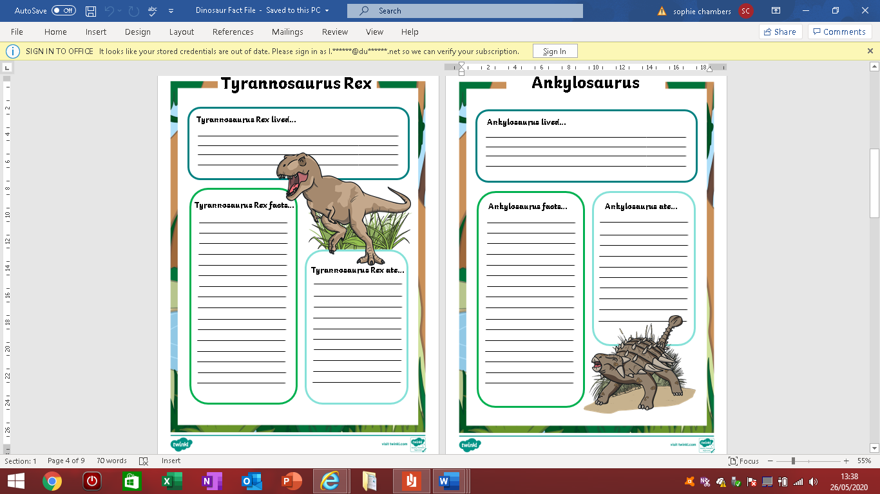**Friday English-** Dinosaur fact file.

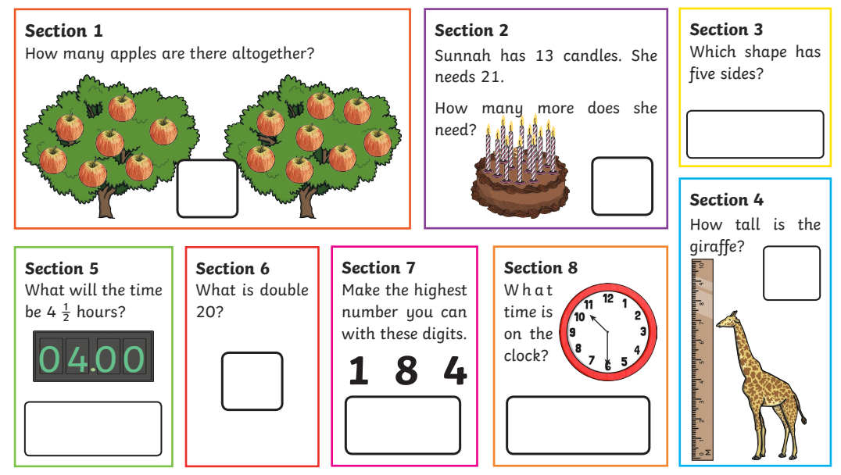**Friday Maths-**

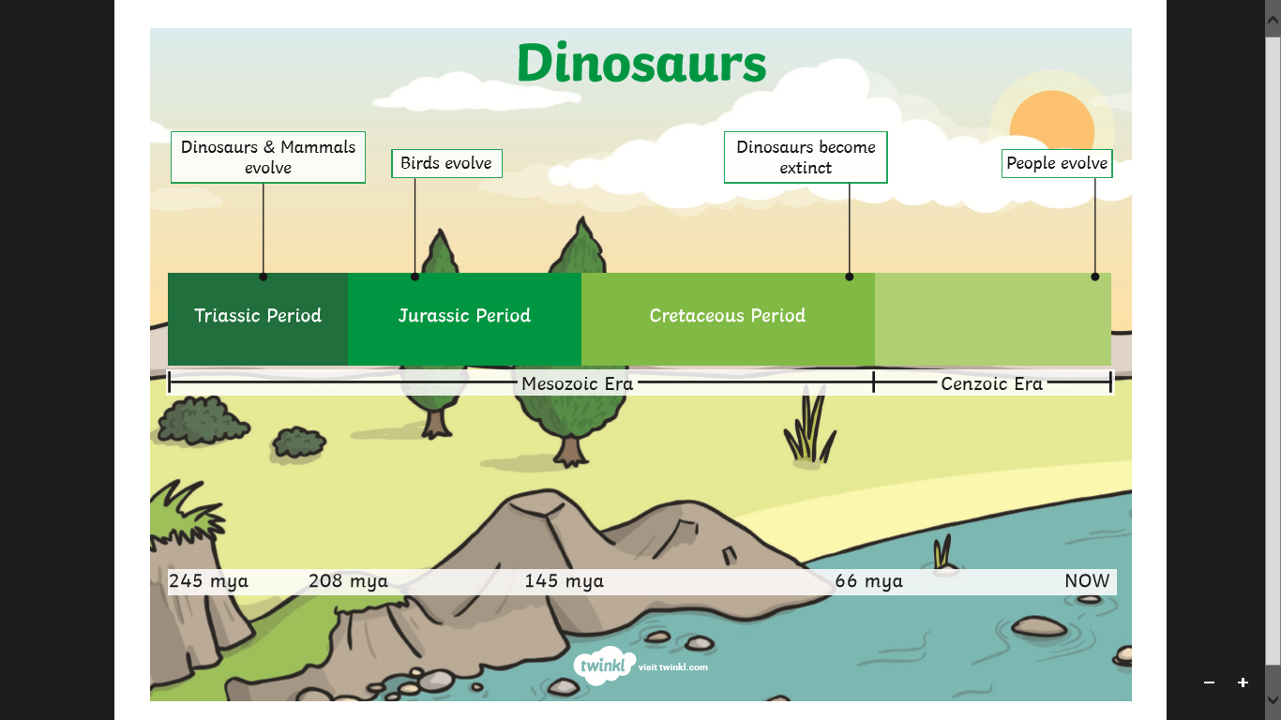**History-** Dinosaur periods timeline.

**History-** Create your own timeline.

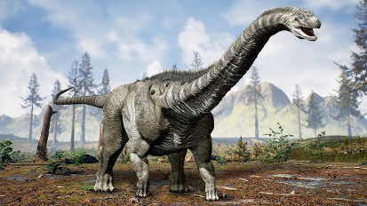**Art-** Observational drawing of a dinosaur

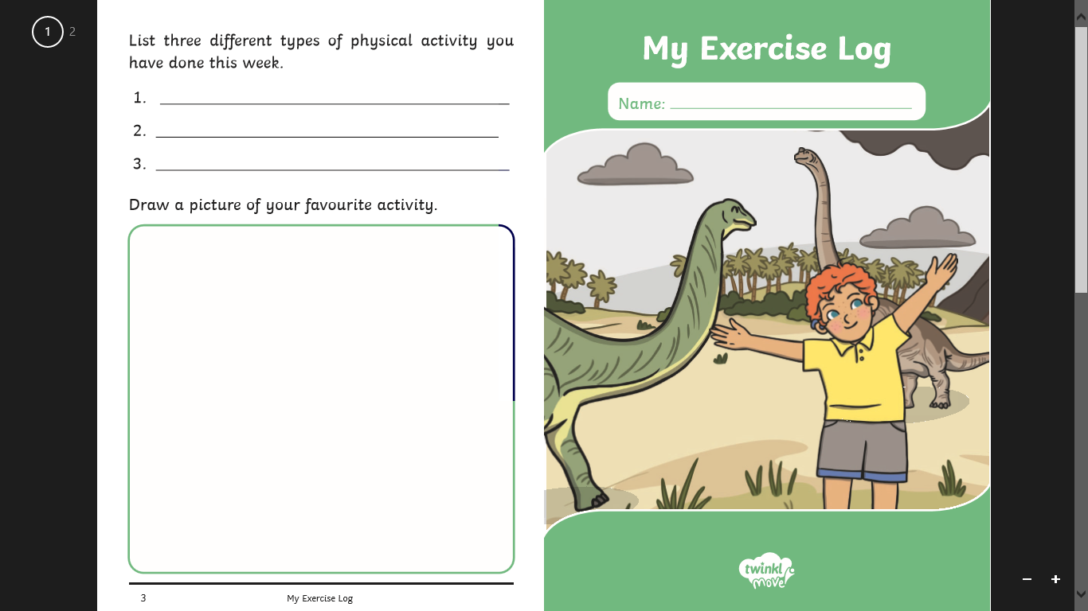

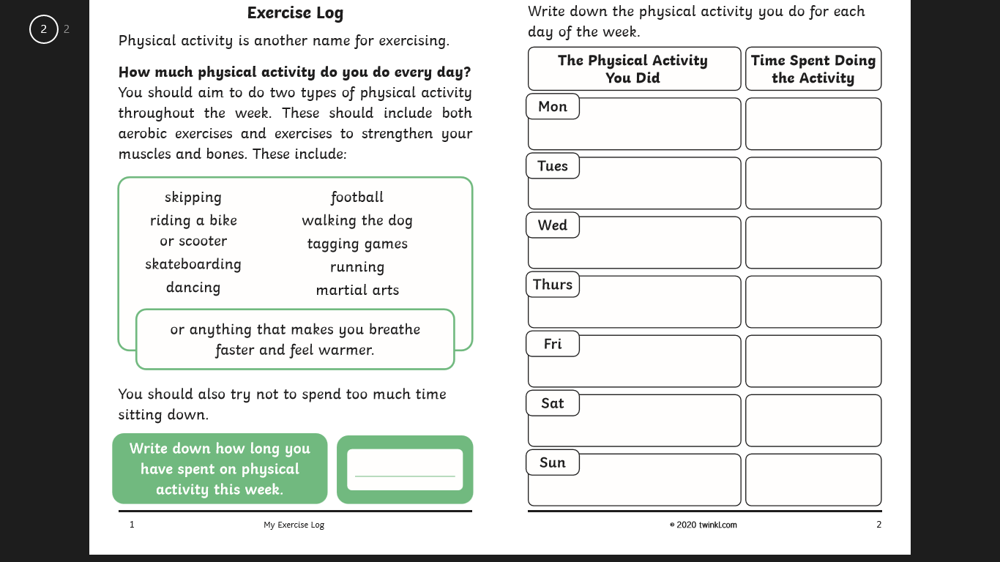

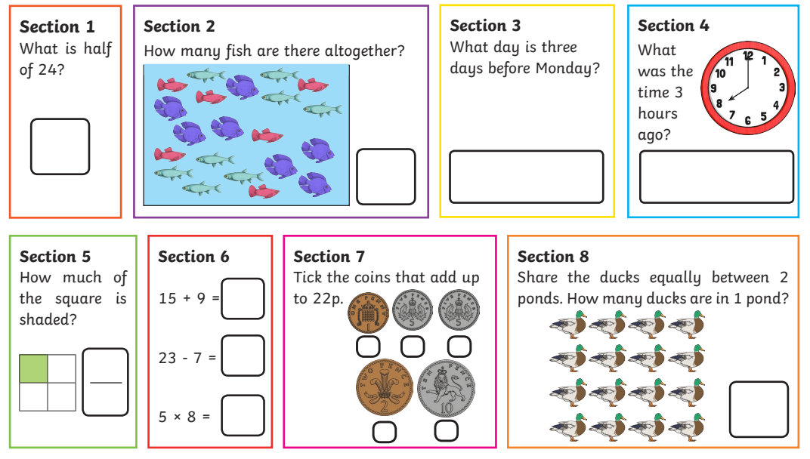**Extra Maths-**