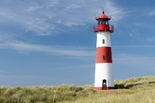
Monday English-
All about Lighthouses

What do you know? | What do you want to find out?
Monday Maths-
Monday Geography-
Find out about different important building in Durham City.

Can you write a list of different key buildings?

Can you find an image of the buildings?

Try and find the buildings by looking at an aerial image of Durham City using google earth.

Start to think about which building you would like to find out more about.

Monday RE-
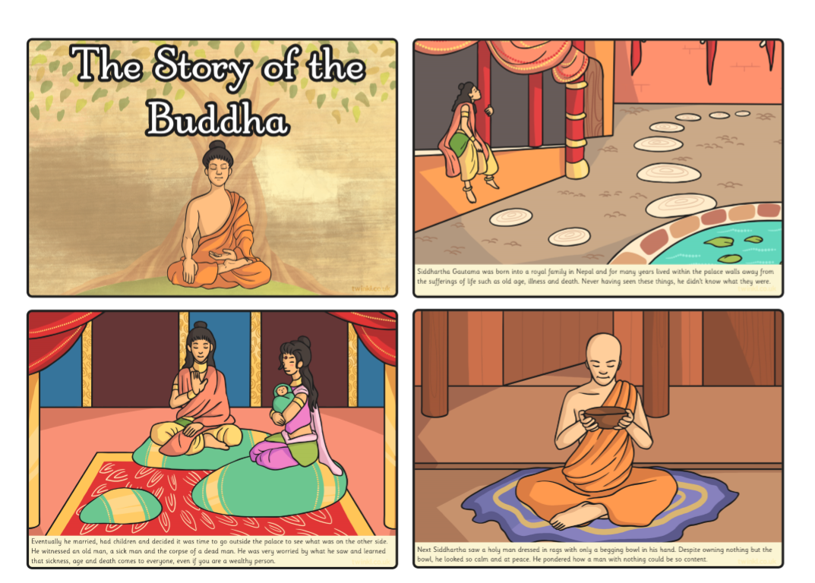
Read in detail to story of Buddha. After you have read and talked about the images and key parts of the story, cut up the cards, mix them up and see if you can place them back in the correct order.

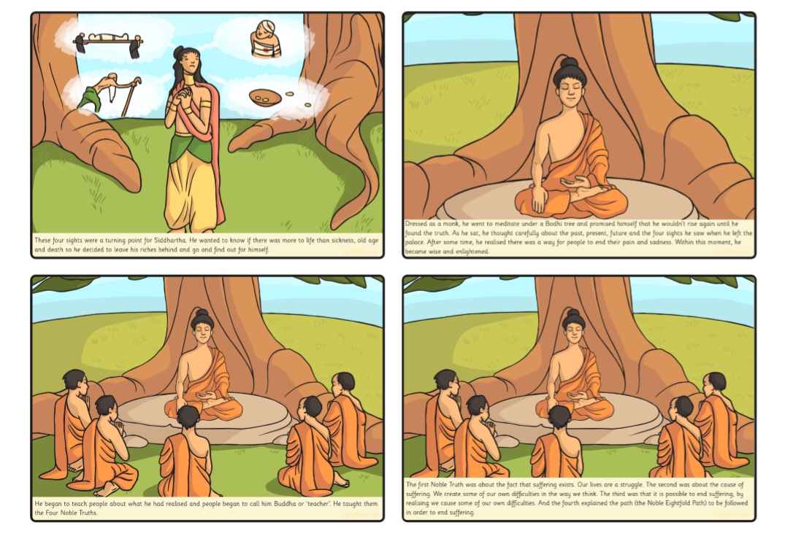

Tuesday English-
Read the PowerPoint all about lighthouses. Can you write five facts you can remember?

Fact 1
Fact 2
Fact 3
Fact 4
Fact 5

Tuesday Maths-

Wednesday English –
Complete the reading comprehension task.
Do you understand all the information you have read?
Can you tell an adult all about what you have read?
Complete the questions to show your understanding.

Can you create your own question that someone else could answer, based on the information you have read?
____________________________________________________________________________________________________________________________________________________

Wednesday Maths-
Thursday English - Can you create your own fact file, all about lighthouses? Use the information you have learnt this week.
Thursday Maths - Family challenges, complete together.

Friday English- Find out about VE day by completing the reading comprehension task.

Friday Maths – Family challenges, complete together.

c

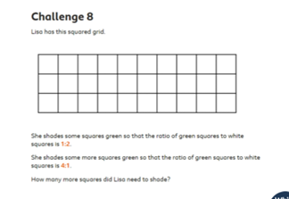

History-
What was life like for the Darling family?

Ask the children to tell you any specific things they can remember about Grace’s life from last week.
Explain that this week they are going to find out what it felt like to be a part of the Darling family and to live in the lighthouse. Look at the image of the Grace Darling Family.
Talk about life for the Darling family. Look at the information sheet provided in the pack. Read the roles and duties for the day.

1. Explain that the brothers or sisters would have had to share their bedroom as there were only three bedrooms for the 11 people in the lighthouse.

2. They would begin their day by waking up and walking down the three flights of stairs to the living area and kitchen at the bottom. They would need to pump some water into the kitchen from the tanks underground and light the stove before having breakfast.

3. After tidying up, they need to row over to the next island where they need to do some gardening, dig up some vegetables, collect the chickens eggs and feed them before rowing back to the lighthouse.

4. After this, the boys will go out fishing with their father (more rowing!), while the girls help their mother tidy the house and are taught to sew, spin and cook.

5. After lunch, all of the children are taken upstairs to the lamp room to be taught maths, geography and history, working on slate boards by candlelight.
6. After this is done, they all help their father to take care of the lamp in the lighthouse – polishing the reflectors, cleaning the windows, checking the wick, topping up the oil etc.

7. After their day of hard work, the children return to their bedroom which they share with their siblings for a well-deserved rest!

Task- Children can act out the roles. Take some pictures.
Can you write a dairy entry all about a day in the life of Grace Darling?

Art/DT
Plan and then create your own lighthouse using junk.
Discuss the steps with an adult.
