May Half Term ‘The Great Outdoor’ activities
Here are a wide selection of activities you can choose from during half term. We would love to see some photos of you completing them as well as the final products – so don’t forget to upload them to Class Dojo. I wonder how many you can complete. I wonder if you can think of any of your own too
Go on a Bug hunt. How many different types of bugs can you find? |  |  | Go on a nature walk. What different types of nature can you find?
Complete a Scavenger hunt. There are lots of different ones online you could print and follow, or you could create your own. For example can you find something red? Can you find something spiky? Can you find a smooth stone? |  |  | Find a large stone and get creative with some stone painting.  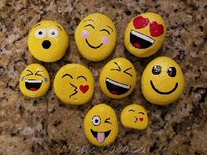  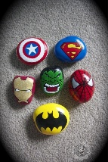  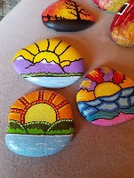
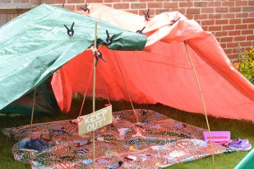  Build a den in your garden. You could use rugs, blankets, garden furniture or anything your grownups let you use. You could make it big enough for you to fit in or make it to fit a toy.  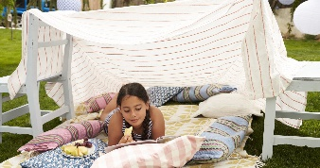 |  |  | Design a treasure hunt for someone in your family. You could write clues for them to follow or you could draw a map and write instructions, order children you could use coordinates to help find the treasure.
Camp out in your garden. You will ONLY be able to do this if your parents allow you to and you have the right equipment. |  |  | Press some flowers. Ask for permission to pick some flowers, maybe a daisy or dandelion if you do not have other flowers and find something to press them between, for example 2 large stones or 2 books. Leave the flower for 24 hours and then you will have pressed flowers that can be used to create pictures, bookmarks, collages.
Collect some natural objects and then complete some printing, you could use paints or ink. |  |  | Find some different natural objects and take rubbings using a wax crayon. Once you have collected them you might want to create a picture, create a list and write labels or even create a family quiz ‘guess the rubbing’
Find a beautiful spot in your garden, find some natural objects in your house (fruit/vegetables/house plant) and spend some time looking closely at the object to complete an observational drawing. |  |  | Make a bird feeder – there are lots of ideas if you search on the internet.  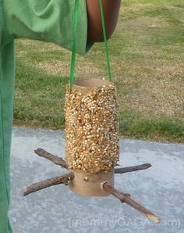  https://www.youtube.com/watch?v=A1-85wKBVRo  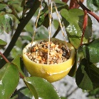  https://www.bbc.co.uk/cbeebies/makes/bird-feeder
Work with your grownups to grow some plants. This might be some flowers or even some vegetables. You could then think about what they need to grow well, keep a diary of their progress including measuring their growth and write a report about what you have found out. |  |  | 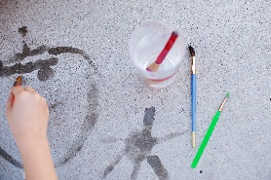  Use water to paint the pavements. You can use a bucket and paint brushes or you can fill empty bottles and use them. What can you create? Can you write your letters? Can you draw some shapes?
Create a mud kitchen and make some mud pies or potions. You will need some old pots/pans/spoons and mud and water. It WILL GET MESSY but it is also great fun! |  |  | 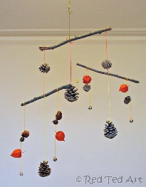  Collect some natural materials and create a mobile. You can get as creative as you want.
Play some outdoor games – football, tennis, hide and seek |  |  | Hold your own sports day – egg and spoon race, sack race, skipping race, long jump
Create an assault course. You could then time yourself and members of your family and see who completes it quickest.  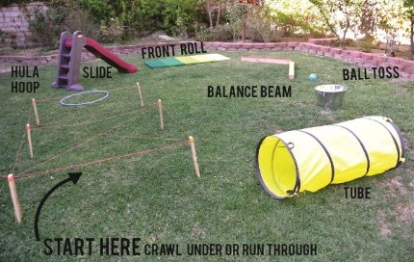  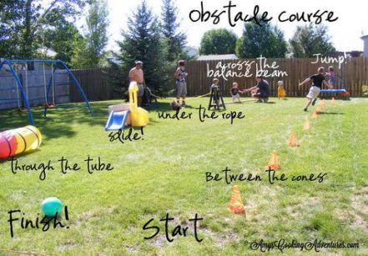 |  |  | 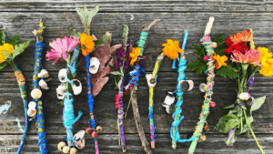  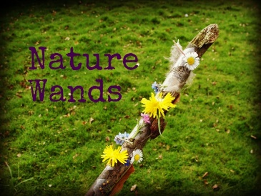  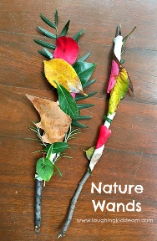  Make natural wands. You could then write a magic spell or draw picture of some of the magic you do.
Go puddle jumping (if the weather allows) |  |  | When you are out walking or playing in your garden, look at the different birds you can see. See if you can name any of them.  https://www.rspb.org.uk/fun-and-learning/for-families/family-wild-challenge/activities/go-birdwatching/
Have a family picnic. Think about which foods would be good to eat outside, create a menu and ask your grownup is you can help make the food. You might also want to make people in your family invites. |  |  | See which shapes you can spot out in nature. Think about whether objects are made up of more than one shape. Can you name them?
Go on a bike/scooter ride around your local area. |  |  | Read outside in the garden. Where is your favourite place to sit? Why?
Create a map of your garden/street/route on your daily walk. Can you name some ‘landmarks’ (street names, post box, buildings)? Can you draw them onto your map? Older children you might want to think about creating a key for your map e.g. a red square represents a post box. Could you write some instructions to get from one place to another? Could you use the points of the compass to help you make sure they go the fastest route? |  |  | 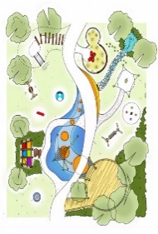  If you were in charge of the local area and had to design a new play area what you have in it? Think about the types of equipment you like, areas you would include. When you have finished you might want to write a letter to persuade someone your design is the best and why.
Chalk drawing – create a mural. Always ask an adult where you can draw. |  |  | Write fact file about an insect or animal you would find in your garden. You might want to use the internet for some research.
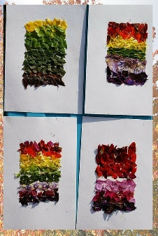  Create a natural rainbow. Collect objects from within your garden or on your daily walk that represent the different colours of the rainbow.  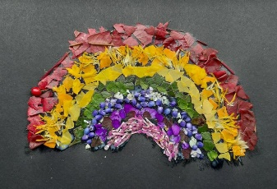 |  |  | Create a natural alphabet. Collect objects or think of objects from within your garden or on your daily walk that represent each letter of the alphabet.  e.g.  A – ant, B – buttercup, C – cone, D - daisy
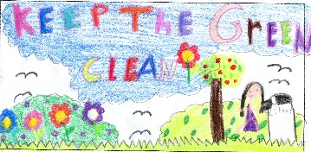  Design a poster that promotes keeping the environment tidy. You might want to think about a catchy slogan and bold pictures to make it stand out. |  |  | 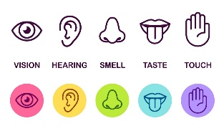  Write a poem that uses your 5 sense. Sit in your garden and think about what you can see, hear, smell, touch and taste.
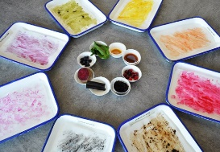  Make some natural paints and then create a master piece! Which materials make the best colours? https://artful-kids.com/2010/09/08/experimenting-with-natural-paints/ |  |  | 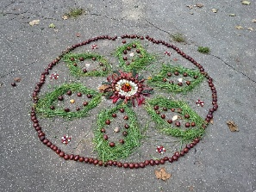  Create a natural mandala pattern. Which objects can  You use to create different colours and shapes?
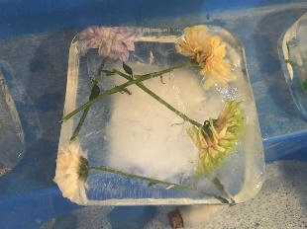  Create natural ice blocks. Use an old ice cream/butter tub and fill it with water and natural objects you have found in the garden, put it in the freezer and then explore the textures, colours and patterns it creates. This should create some lovely language that could be used to write labels, a descriptive paragraph or even a poem. |  |  | 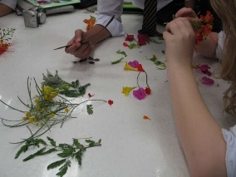  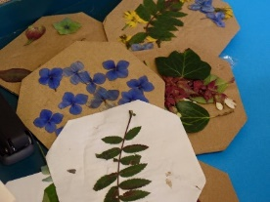  Create some natural collages. Collect some objects and either lay them out to make a picture or stick them to some card (the inside of a cereal box would work well.)

