Day | 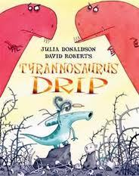  Daily English Task  Weekly Focus:  Tyrannousarus Drip – Comprehension  Week 1: Conprehension  Week 2: Ficiton writing  Week 3: Non Fiction writing – Dinosaurs. | Daily Maths Task  Weekly Focus: Division | 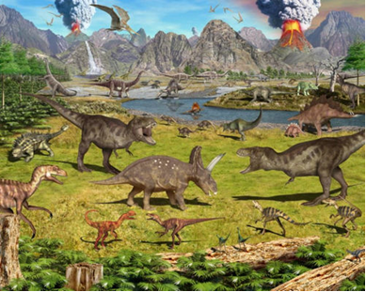  Other Subjects  Y2 Dinosaur Topic
Monday | Daily Reading. Read online and complete your Accelerated Reader quizzes https://www.myon.co.uk/login/index.html  Spellings : Week 3 spelling booklet. Days 1-5 (Spelling list is on back page.)  Look at the story Tyrannosaurus Drip by Julia Donaldson.  Listen to Tyrannosaurus Drip here!  Who is Tyrannosaurus Drip?  What could the book be about?  Do you think you will enjoy this book?  Complete Challenges 1-6 in “Challenges” PDF | TTRockstars: https://ttrockstars.com/  Topmarks:  Daily 10 Mixed Tables 2, 3, 5 and 10  Mathletics Multiplication: www.mathletics.co.uk  DIVISION WEEK 6  10 X TABLES | Watch clips from ‘Walking with Dinosaurs’  https://www.bbcearth.com/walking-with-dinosaurs/  What do you notice? Are all dinosaurs the same?  What similarities/differences do they have? Write down notes to discuss.  Focus on Dinosaur features by researching  Tyrannosaurus Rex  Brachiosaur  Stegosaurus  Eoraptopr  Make a poster and use words to describe.  Challlenge: – why do you think this dinosaur has a long neck/tail? Why has that dinosaur only got small arms? Dinosaurs are a type of animal. Can you name any other type of animal? What about humans. How are they adapted for the way they live?
Tuesday | Recap on the story  Complete Challenges 7-12 in “Challenges” PDF | TTRockstars: | Read the story ‘Stone Girl, Bone Girl’. What did Mary find? Why was this discovery so exciting?  Listen to Stone Girl Bone Girl here!  How do we know that dinosaurs existed? What is a fossil? What do you think we can find out from fossils? Imagine that we have been travelling through the Jurassic Jungle and made an amazing discovery – we found some fossils!  What did you find?  Research Lyme Regis and fossils that have been found there. http://www.lymeregis.org/fossils.aspx | PSHE  Look at the Booklet and Parent info – Making a Difference from home.  Try some activities from there and start a little project if you wish!
https://ttrockstars.com/
Topmarks:
Daily 10 Mixed Tables 2, 3, 5 and 10

Mathletics: www.mathletics.co.uk

SHARING
Wednesday | Complete Challenges 13-18 in “Challenges” PDF | TTRockstars: https://ttrockstars.com/  Topmarks:  Daily 10 Mixed Tables 2,5 and 10  Mathletics: www.mathletics.co.uk  GROUPING | 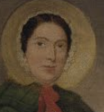  Why do we remember Mary Anning? What is she famous for? People had found fossils before - why was her discovery so important? What do you find most interesting about her life? Imagine you were telling someone about Mary Anning, what important details would you tell them?  Find out more about Mary Anning and display your information in any way you wish.  Complete the Mary Anning Sheet  Mary Anning Natural History Museum  Who was Mary Anning?  BBC Teach Mary Anning
Thursday | Complete Challenges 19-24 in “Challenges” PDF | Daily 10 Division 2,5, 10 Extension- choose 3 x tables | Computing  Think U Know Activity Pack 3  Do some of this week’s activities on the computer and upload them to Class Dojo if you can  Why don’t you type up your reports this week:  Add a picture and caption too.
Mathletics: www.mathletics.co.uk

ODD AND EVEN NUMBERS
Friday | Complete Challenges 25-30 in “Challenges” PDF | Daily 10 Division 2,3, 5, 10  Mathletics: www.mathletics.co.uk  Friday Challenge | PE/ Movement  Try some Yoga! YOGA!  See the attached Daily Live Activities sheet for ideas.

