Complete daily | Name recognition  Find your name. Match your name. Find the letters in your name. Attempt to write your name.  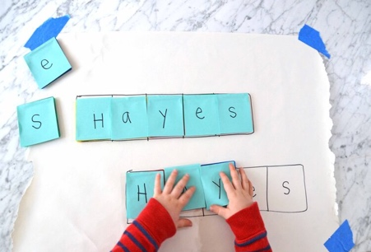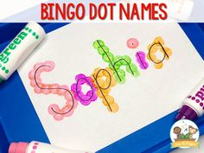
Focus tasks | Listen to the story ‘ The three little wolves and the big bad pig’  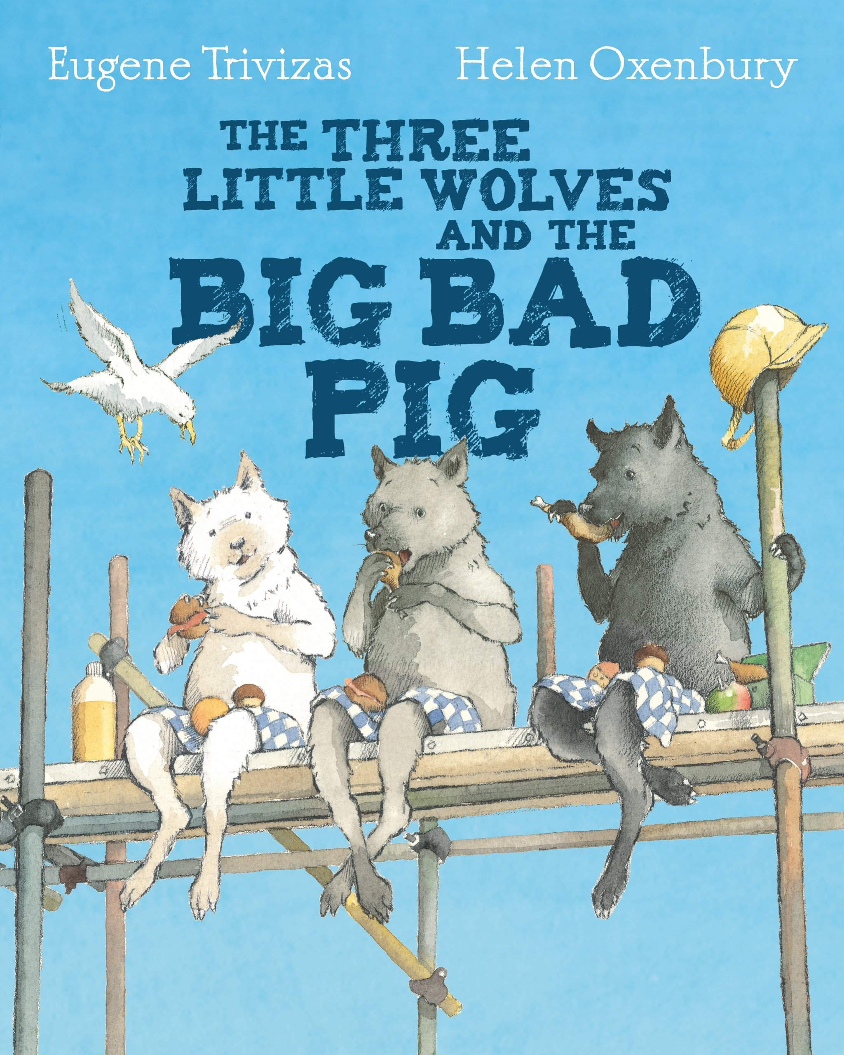  Can you retell the story? Y o could make a story map together!  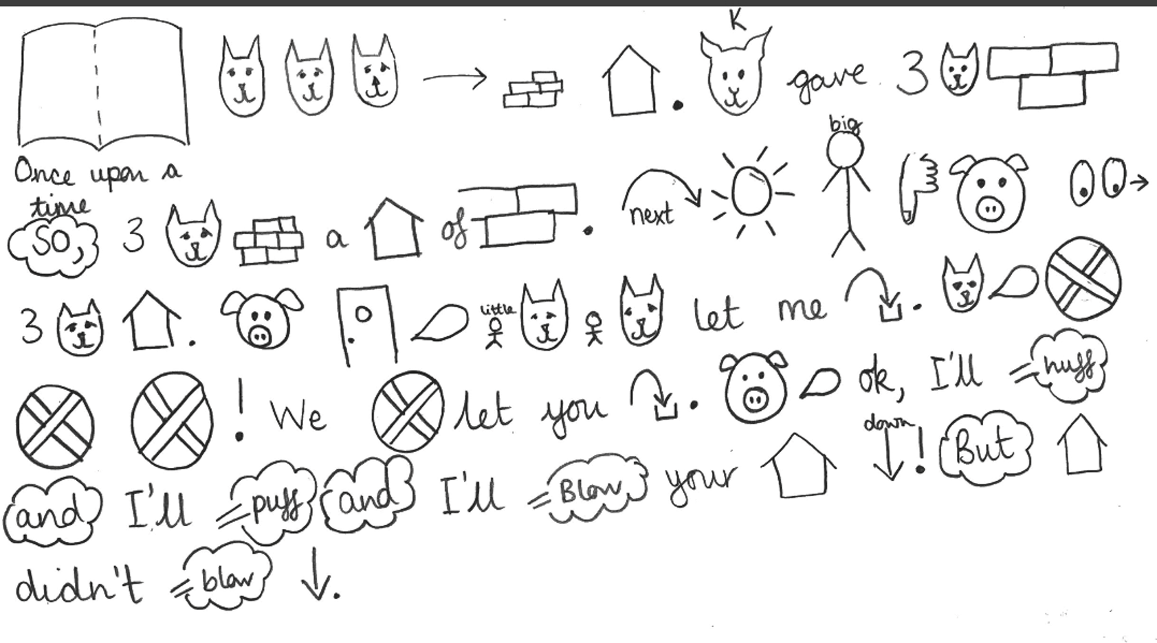  Can you act out the story?  What did you notice about the story?  What is different to the original Traditional Tale? What is the same?  What was your favourite part and why?  Describe the pink. An adult can help sound these words out, bad, pink, mean etc. ( label resource or create your own)
English

Complete daily | Watch the jolly phonics phase 2 song on Youtube. Join in with the words and actions. https://www.youtube.com/watch?v=1Qpn2839Kro  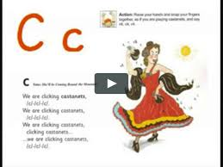  Go on Phonicsplay.co.uk or use the app Username: march20Password: home. Flashcards- speed trials- phase 2
Focus tasks | How many things around the house can you find begging with the ‘k’ sound? Practise forming the letter ‘k’. Remember to start and finish in the correct place. Say ‘Down the kangaroo’s body, back UP and around his bottom and a flick for the teail.’, as you form the letter. If you wish to practise a new sound the cards are available to download on the class dojo.  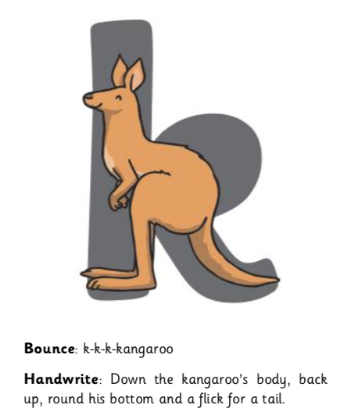  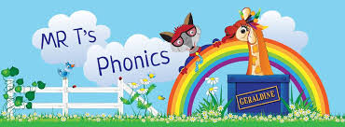  Watch Mr Thorne does phonics on YouTube- episode ‘k’. https://www.youtube.com/watch?v=WKrPdwsXuLk

Complete daily | Watch the ‘Our favourite number songs’ video on Youtube on the Super Simple Songs channel. Sing along and remember to hold up the correct fingers when counting.  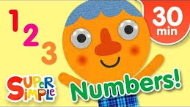
Focus tasks | Comparing groups  Give your children a pile of lego bricks or blocks. Can they compare the two groups of bricks and say which pile has more? Can chn count how many bricks they have each. Show chn a number line 1-10. Can chn find the numbers on the number line? Which number is further along the number line?  Extension- How many more bricks does larger pile have?  More things you could do with blocks.  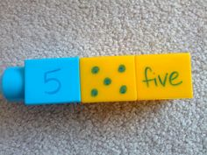  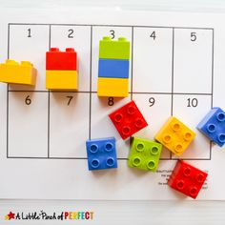

Other activities.
- Go over the date and weather daily. Go outside to check the weather and discuss. What season are we in? What happens during this season? Make a weather chart or use an online one. https://www.ictgames.com/mobilePage/dateChart/index.html
Jack Hartmann on Youtube has some great days of the week and months of the year songs and dances.

- Encourage children to dress themselves. Putting on their own clothes, coats and shoes makes them more independent and ready for starting their Reception class.

Pencil control
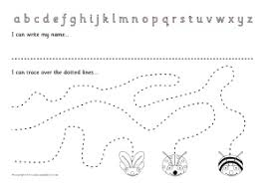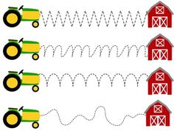
- You can make your own pencil control sheet by drawing lines for your child to follow. Make these however you like. Using , straight, circular, and zig zag lines.
- Have your child join the dots, number the dots to incorporate a bit of maths.
- Placing objects inside lines.
- Highlighter Tracing, draw a picture with a highlighter for your child to trace
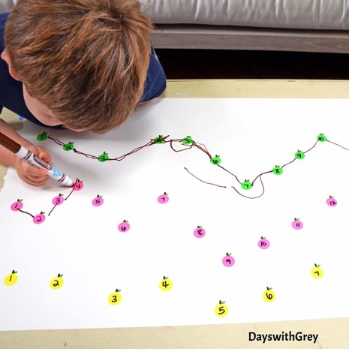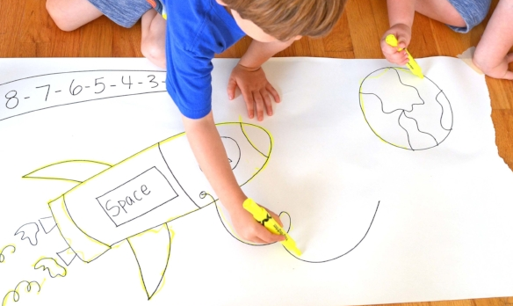

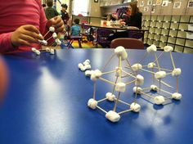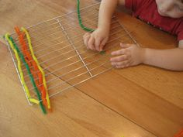

Learn some facts and research wolves.
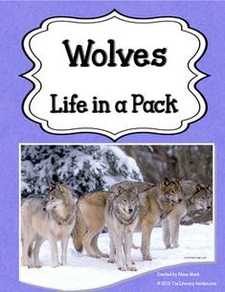

Play what’s the time Mr wolf
The wolf stands at the other end of the room, facing the rest of the group. The rest of the group ask, "What's the time, Mr Wolf?". The wolf then says a time between 1 and 12, for example, "Three o'clock."
The group would then take three steps forward. This continues until the group is very close to the wolf. Then the wolf can say "Dinner time!" and has to try and catch as many group members as they can, before they all run back to the other end of the room.

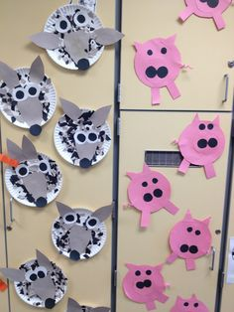
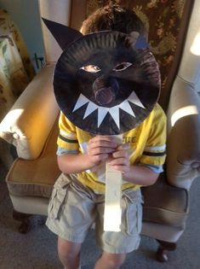

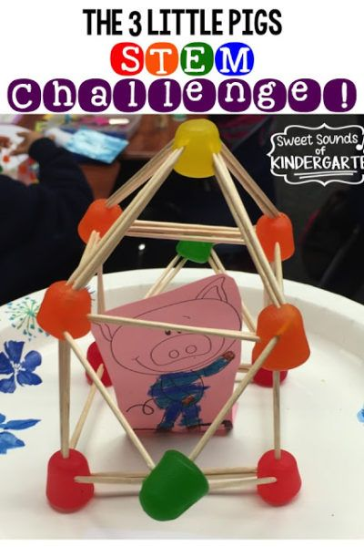
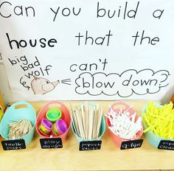

THE THREE LITTLE PIGS EXPERIMENTS
Test a stick, straw and brick roof to see which is the most windproof, we used the squeezy bottle to act like wind and placed tissue paper inside the house so we could see if the ‘wind’ reached it.
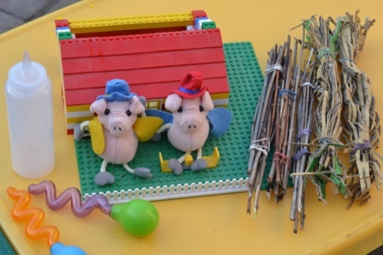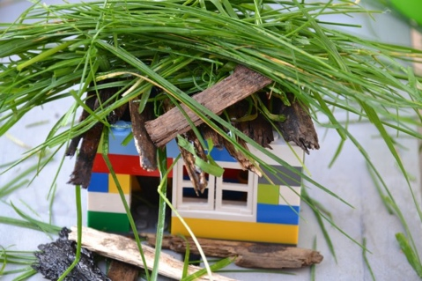
Build house for the three little pigs using sweets and straws, which sweets work the best? 