Complete daily | Name recognition  Find your name. Match your name. Find the letters in your name. Attempt to write your name.  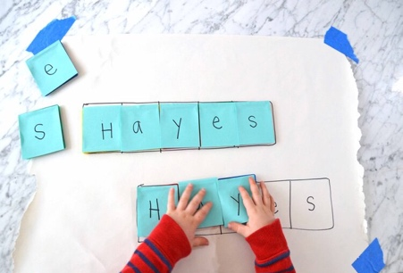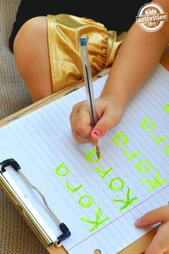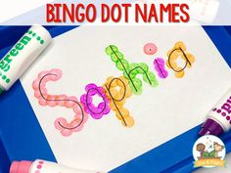
Focus tasks | Listen to the story ‘ Farmer Duck’ witten by Martin Waddle  https://www.youtube.com/watch?v=Gug6P8l1q6c  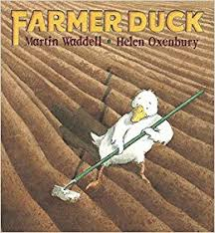Key Questions  How do you think duck is feeling?  What work did the farmer make duck do?  Do you think the animals could have handled the situation with the farmer a little better? What could they have done instead?  Activities  - As you read the story, provide a camera or mirror and encourage children to look at the story illustrations. Encourage the children to make a face to show how that illustration makes them feel.  - Play a duck-themed movement game. Children could create movements to show walking like a duck, sitting on a nest, flying or swimming on a pond. You could look at some duck photos or videos to explore how ducks move.  - Play a movement game based on the farmer running away from the farm. Give the children actions to follow, e.g. running ‘around’ a space to represent running away from the animals, ‘through’ fields, ‘over’ hills and jumping ‘over’ obstacles.  - Sequence the story pictures - see additional resources. If you cannot access these see if your child can retell the story. Can they recall all of the jobs that the duck did on the farm.  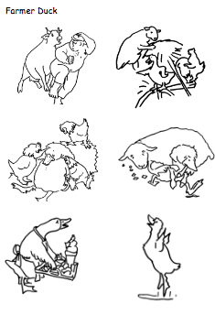  Discuss the needs of the animals. What does each animal need to survive? Do they need the same things that we need? Draw a picture of each animal and add their needs around them. Here are some examples.  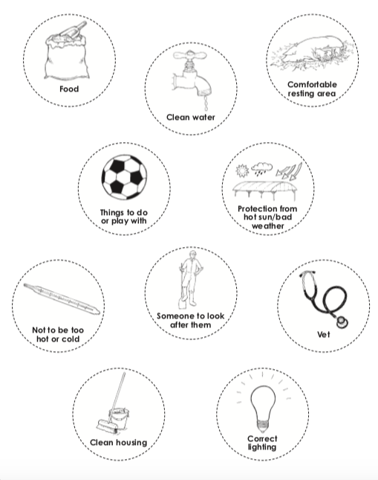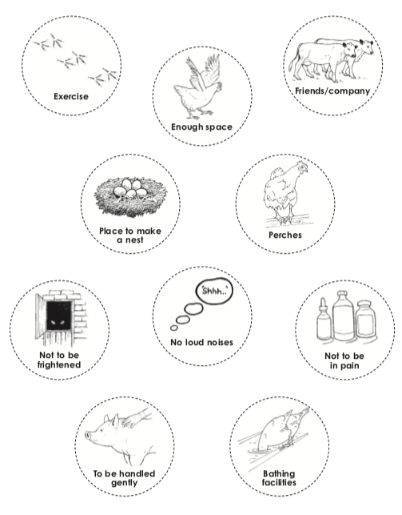  Look at the pictures from the story on the word matching resource. Can your child match the words to the correct picture?  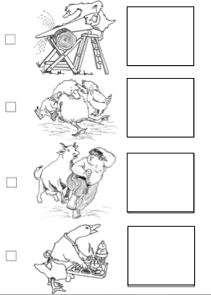\  Attempt to use the sounds to complete the speech bubbles for the animals.
English

Complete daily | Watch the jolly phonics phase 2 song on Youtube. Join in with the words and actions. https://www.youtube.com/watch?v=1Qpn2839Kro  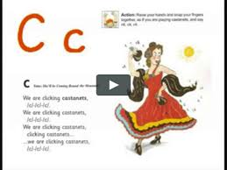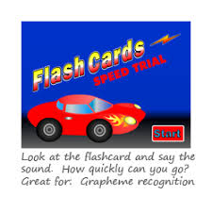  Go on Phonicsplay.co.uk or use the app Username: march20Password: home. Flashcards- speed trials- phase 2
Focus tasks | How many things around the house can you find begging with the ‘d’ sound? Practise forming the letter ‘d’. Remember to start and finish in the correct place. Say ‘Round the dinosaurs back, up his tall neck and down to his feet” , as you form the letter. If you wish to practise a new sound the cards are available to download on the class dojo.  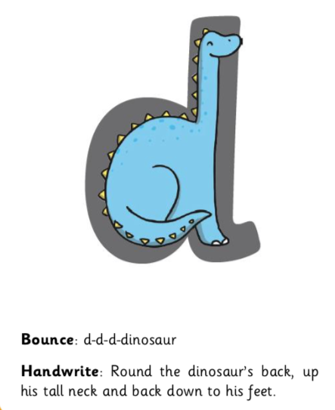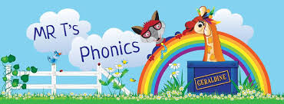  Watch Mr Thorne does phonics on YouTube- episode ‘d’. https://www.youtube.com/watch?v=PnyZD45yne0

Complete daily | Watch the ‘Our favourite number songs’ video on Youtube on the Super Simple Songs channel. Sing along and remember to hold up the correct fingers when counting.  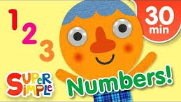
Focus tasks | I can recognise 2D shapes in the environment.  Take children on a walk around your house and garden Can they spot any circles, triangles, squares and rectangles? Encourage your child to point to what they can see. Record it on a sheet and take a photo.  Extension- How many of each shape did we find? Can we find a diamond? Can we find a semi-circle?  Try and make some nature shapes using things that you can find.  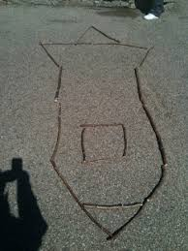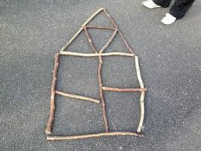  - Cut out some 2D shapes from coloured paper. Encourage children to use the shapes to make pictures of farm animals.

Other activities.
- Go over the date and weather daily. Go outside to check the weather and discuss. What season are we in? What happens during this season? Make a weather chart or use an online one. https://www.ictgames.com/mobilePage/dateChart/index.html
Jack Hartmann on Youtube has some great days of the week and months of the year songs and dances.

- Encourage children to dress themselves. Putting on their own clothes, coats and shoes makes them more independent and ready for starting their Reception class.

Pencil control
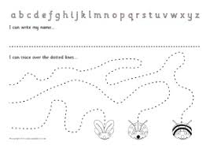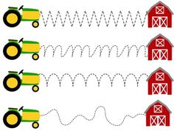
- You can make your own pencil control sheet by drawing lines for your child to follow. Make these however you like. Using , straight, circular, and zig zag lines.
- Have your child join the dots, number the dots to incorporate a bit of maths.
- Placing objects inside lines.
- Highlighter Tracing, draw a picture with a highlighter for your child to trace
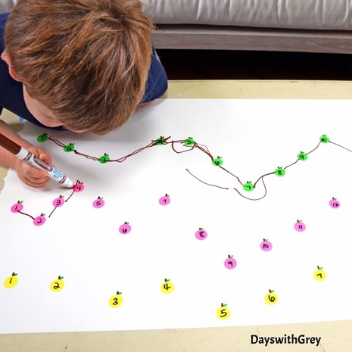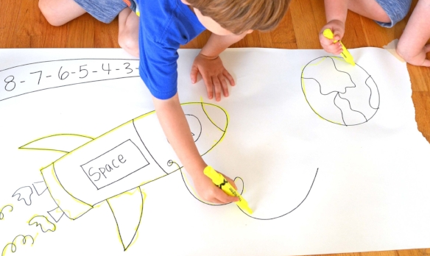

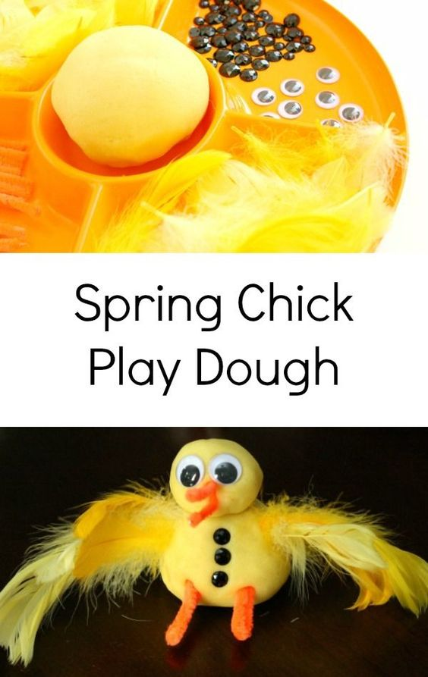
Make some playdough farm animals using a mixture of resources. Talk about what body parts the animal has as they but their farm animal together.
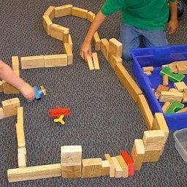
Build a farm using blocks, talk about which animals live on the farm and what they might need for their home.
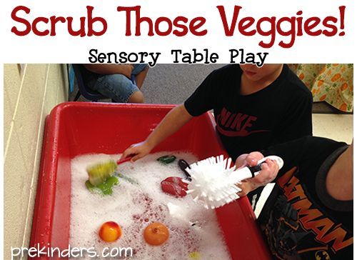

Scrub some vegetables and talk to your child about how farmers plant the seeds and the vegetables grow. When vegetables are picked, they have to be cleaned well before we can eat them since they are dirty from the soil and may have pesticides on them.

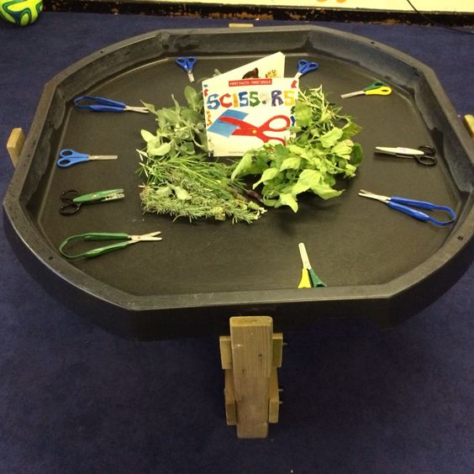
Do some leaf cutting to develop fine motor skills.

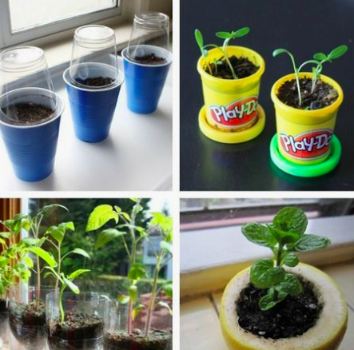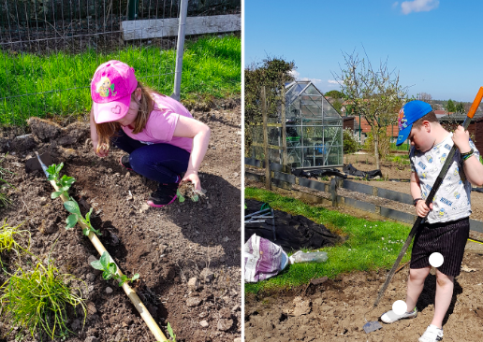

Plant some vegetables and watch them grow. Talk about what the plant will need to help it grow and how each vegetable will develop differently over time, either a root vegetable or growing above the ground.

