Complete daily | Name recognition  Find your name. Match your name. Find the letters in your name. Attempt to write your name.  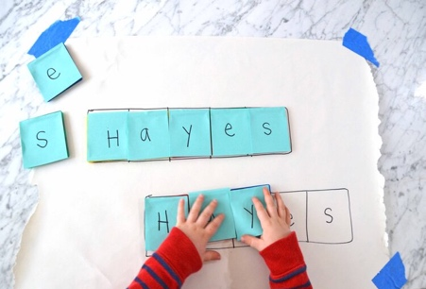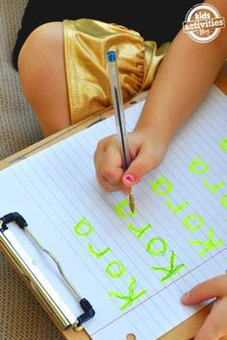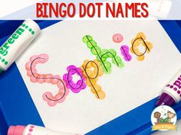
Focus tasks | Read harry and the Dinosaurs go to School  https://www.youtube.com/watch?v=gCR42DG1joU  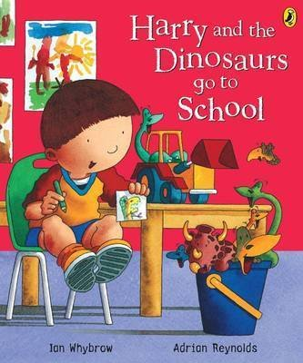  L.O To identify similarities and differences.  Read the page in the book where Harry looked sad and didn’t enjoy any of the things in his classroom. Ask them to identify similarities and differences between Harry’s classroom and our classroom. What can they see that is the same e.g role play area, trays etc. Ask your child to name the different areas in the classroom that they remember and model the list on the paper asking them for the initial sounds of each area (water area, playdough area, writing area, reading tent, creation area, role play area, construction area, outdoor area, mark making area, Lego area). Ask them to say which is their favourite area and what they like to do in there.  L.O To be able to say what makes me feel sad. Read the page where Harry’s friend the other new boy arrives at school. Ask your child to say why they think the boy will not speak. Ask them how they think he is feeling and why. What could be making the boy feel sad?  Use 2 puppets to role play Harry and the boy having a conversation about why he is sad.  Tell your child what makes you feel sad. Then, ask your child to say what makes them feel sad at school. Briefly ask them what we should do if someone is sad, how can we make them feel better?  L.0 To be able to say how I can help my friends.  Espresso clip – feelings.  Read the part of the story where Harry and the other new boy are playing together happily and the boy is no longer sad.  Ask your child to say what has made the boys feel happy. Ask them how Harry helped the boy.

Complete daily | Watch the jolly phonics phase 2 song on Youtube. Join in with the words and actions. https://www.youtube.com/watch?v=1Qpn2839Kro  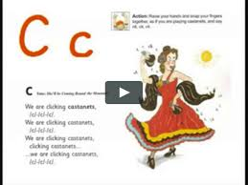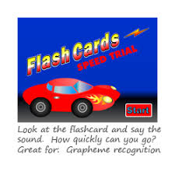  Go on Phonicsplay.co.uk or use the app Username: march20Password: home. Flashcards- speed trials- phase 2
Focus tasks | Introduce the ‘h’ sound. Form the letter ‘h’ saying, “Down the horses head to its hooves and around its back”. as you form the letter.  How many things around the house can you find begging with the ‘h’ sound?  Practise forming the letter ‘h’. Remember to start and finish in the correct place. Say ‘Down the horses head to its hooves and around its back”. as you form the letter.  If you wish to practise a new sound the cards are available to download on the class dojo.  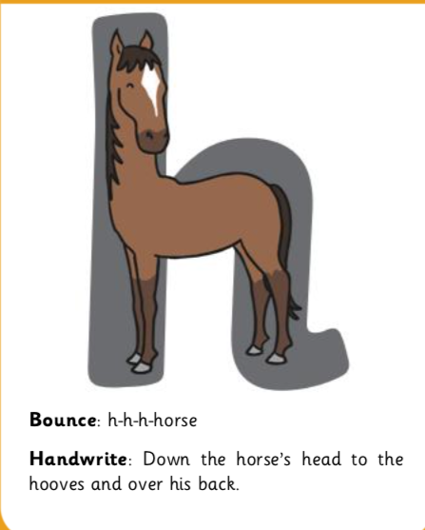  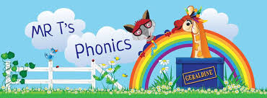  Watch Mr Thorne does phonics on YouTube- episode ‘h’. https://www.youtube.com/watch?v=C69V6GtdT7Y  Write some words with the initial sound ‘h’.  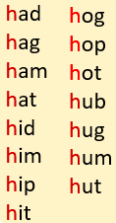  Watch the Letter H Song. https://youtu.be/NtUSMBzacQ0

Complete daily | Watch the ‘Our favourite number songs’ video on Youtube on the Super Simple Songs channel. Sing along and remember to hold up the correct fingers when counting.  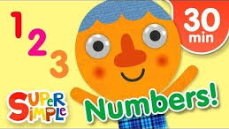
Focus tasks | Counting dinosaurs/objects.  Write out the numbers 0-10, cut them out and lay them on display. See if your child can recognise the numbers and order them. Help where needed, and then count across the number line together.  Have a bucket filled with objects. If you have some small plastic dinosaurs it would be a good idea to use these to link them to our story this week. You could use some homemade dinosaurs from the ‘Other activities’ section below.  Ask your child to count out the objects in the bucket. See if they can then match this number to the number on the number line. Do this with numerous numbers.

Other activities.
- Go over the date and weather daily. Go outside to check the weather and discuss. What season are we in? What happens during this season? Make a weather chart or use an online one. https://www.ictgames.com/mobilePage/dateChart/index.html
Jack Hartmann on YouTube has some great days of the week and months of the year songs and dances.

- Encourage children to dress themselves. Putting on their own clothes, coats and shoes makes them more independent and ready for starting their Reception class.

Pencil control
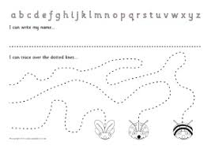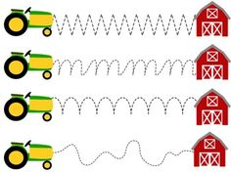
- You can make your own pencil control sheet by drawing lines for your child to follow. Make these however you like. Using , straight, circular, and zig zag lines.
- Have your child join the dots, number the dots to incorporate a bit of maths.
- Placing objects inside lines.
- Highlighter Tracing, draw a picture with a highlighter for your child to trace
See additional file for new pencil control sheets.

https://www.bbc.co.uk/cbeebies/games/andys-dinosaur-adventures-game
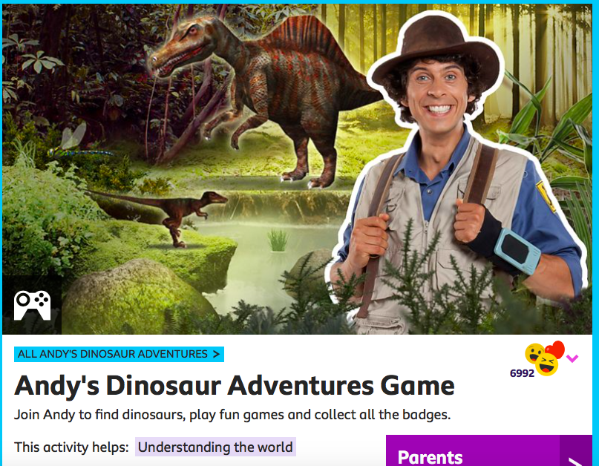
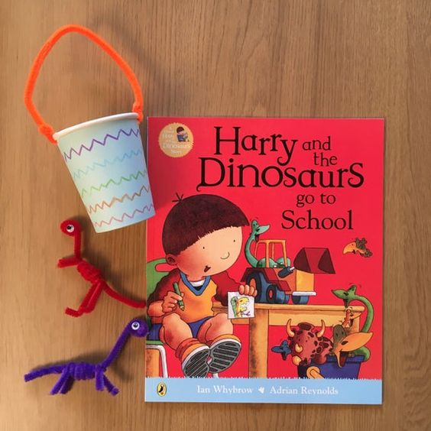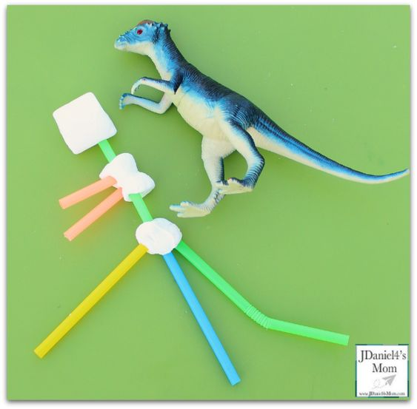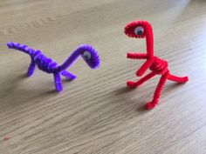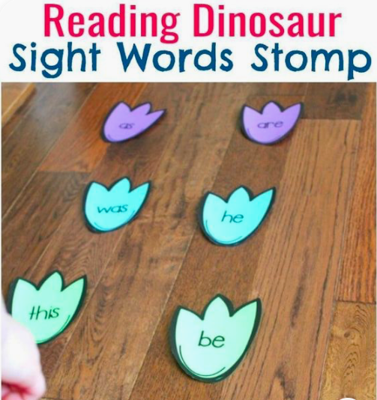

Watch Harry online. https://www.youtube.com/channel/UCoHJXadQIxxMT69kHWt0zOQ

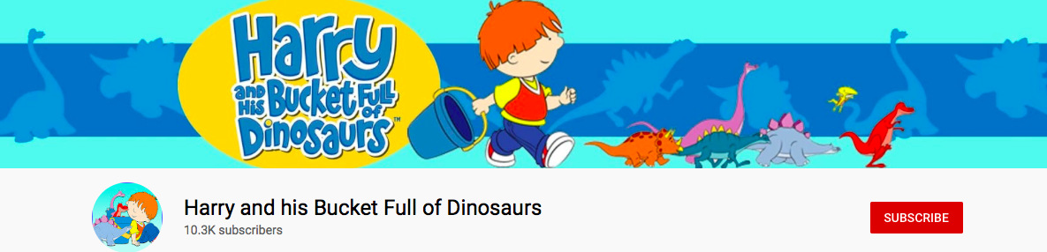

https://www.bbc.co.uk/iplayer/episodes/b03wh7vl/andys-dinosaur-adventures

