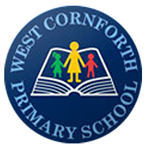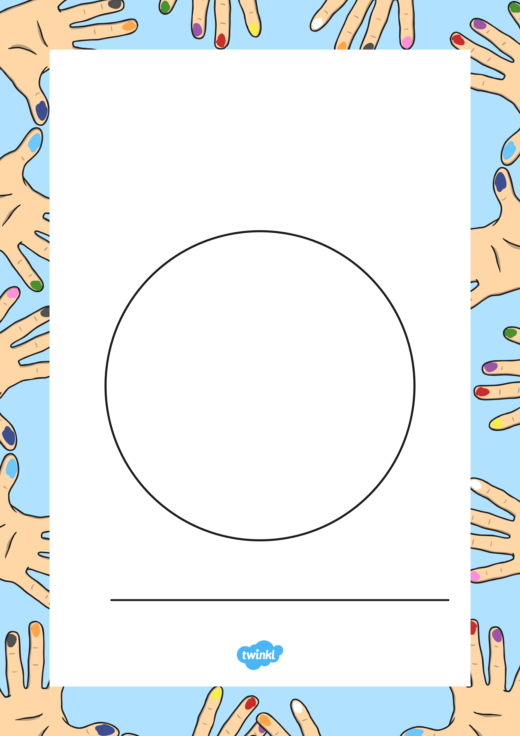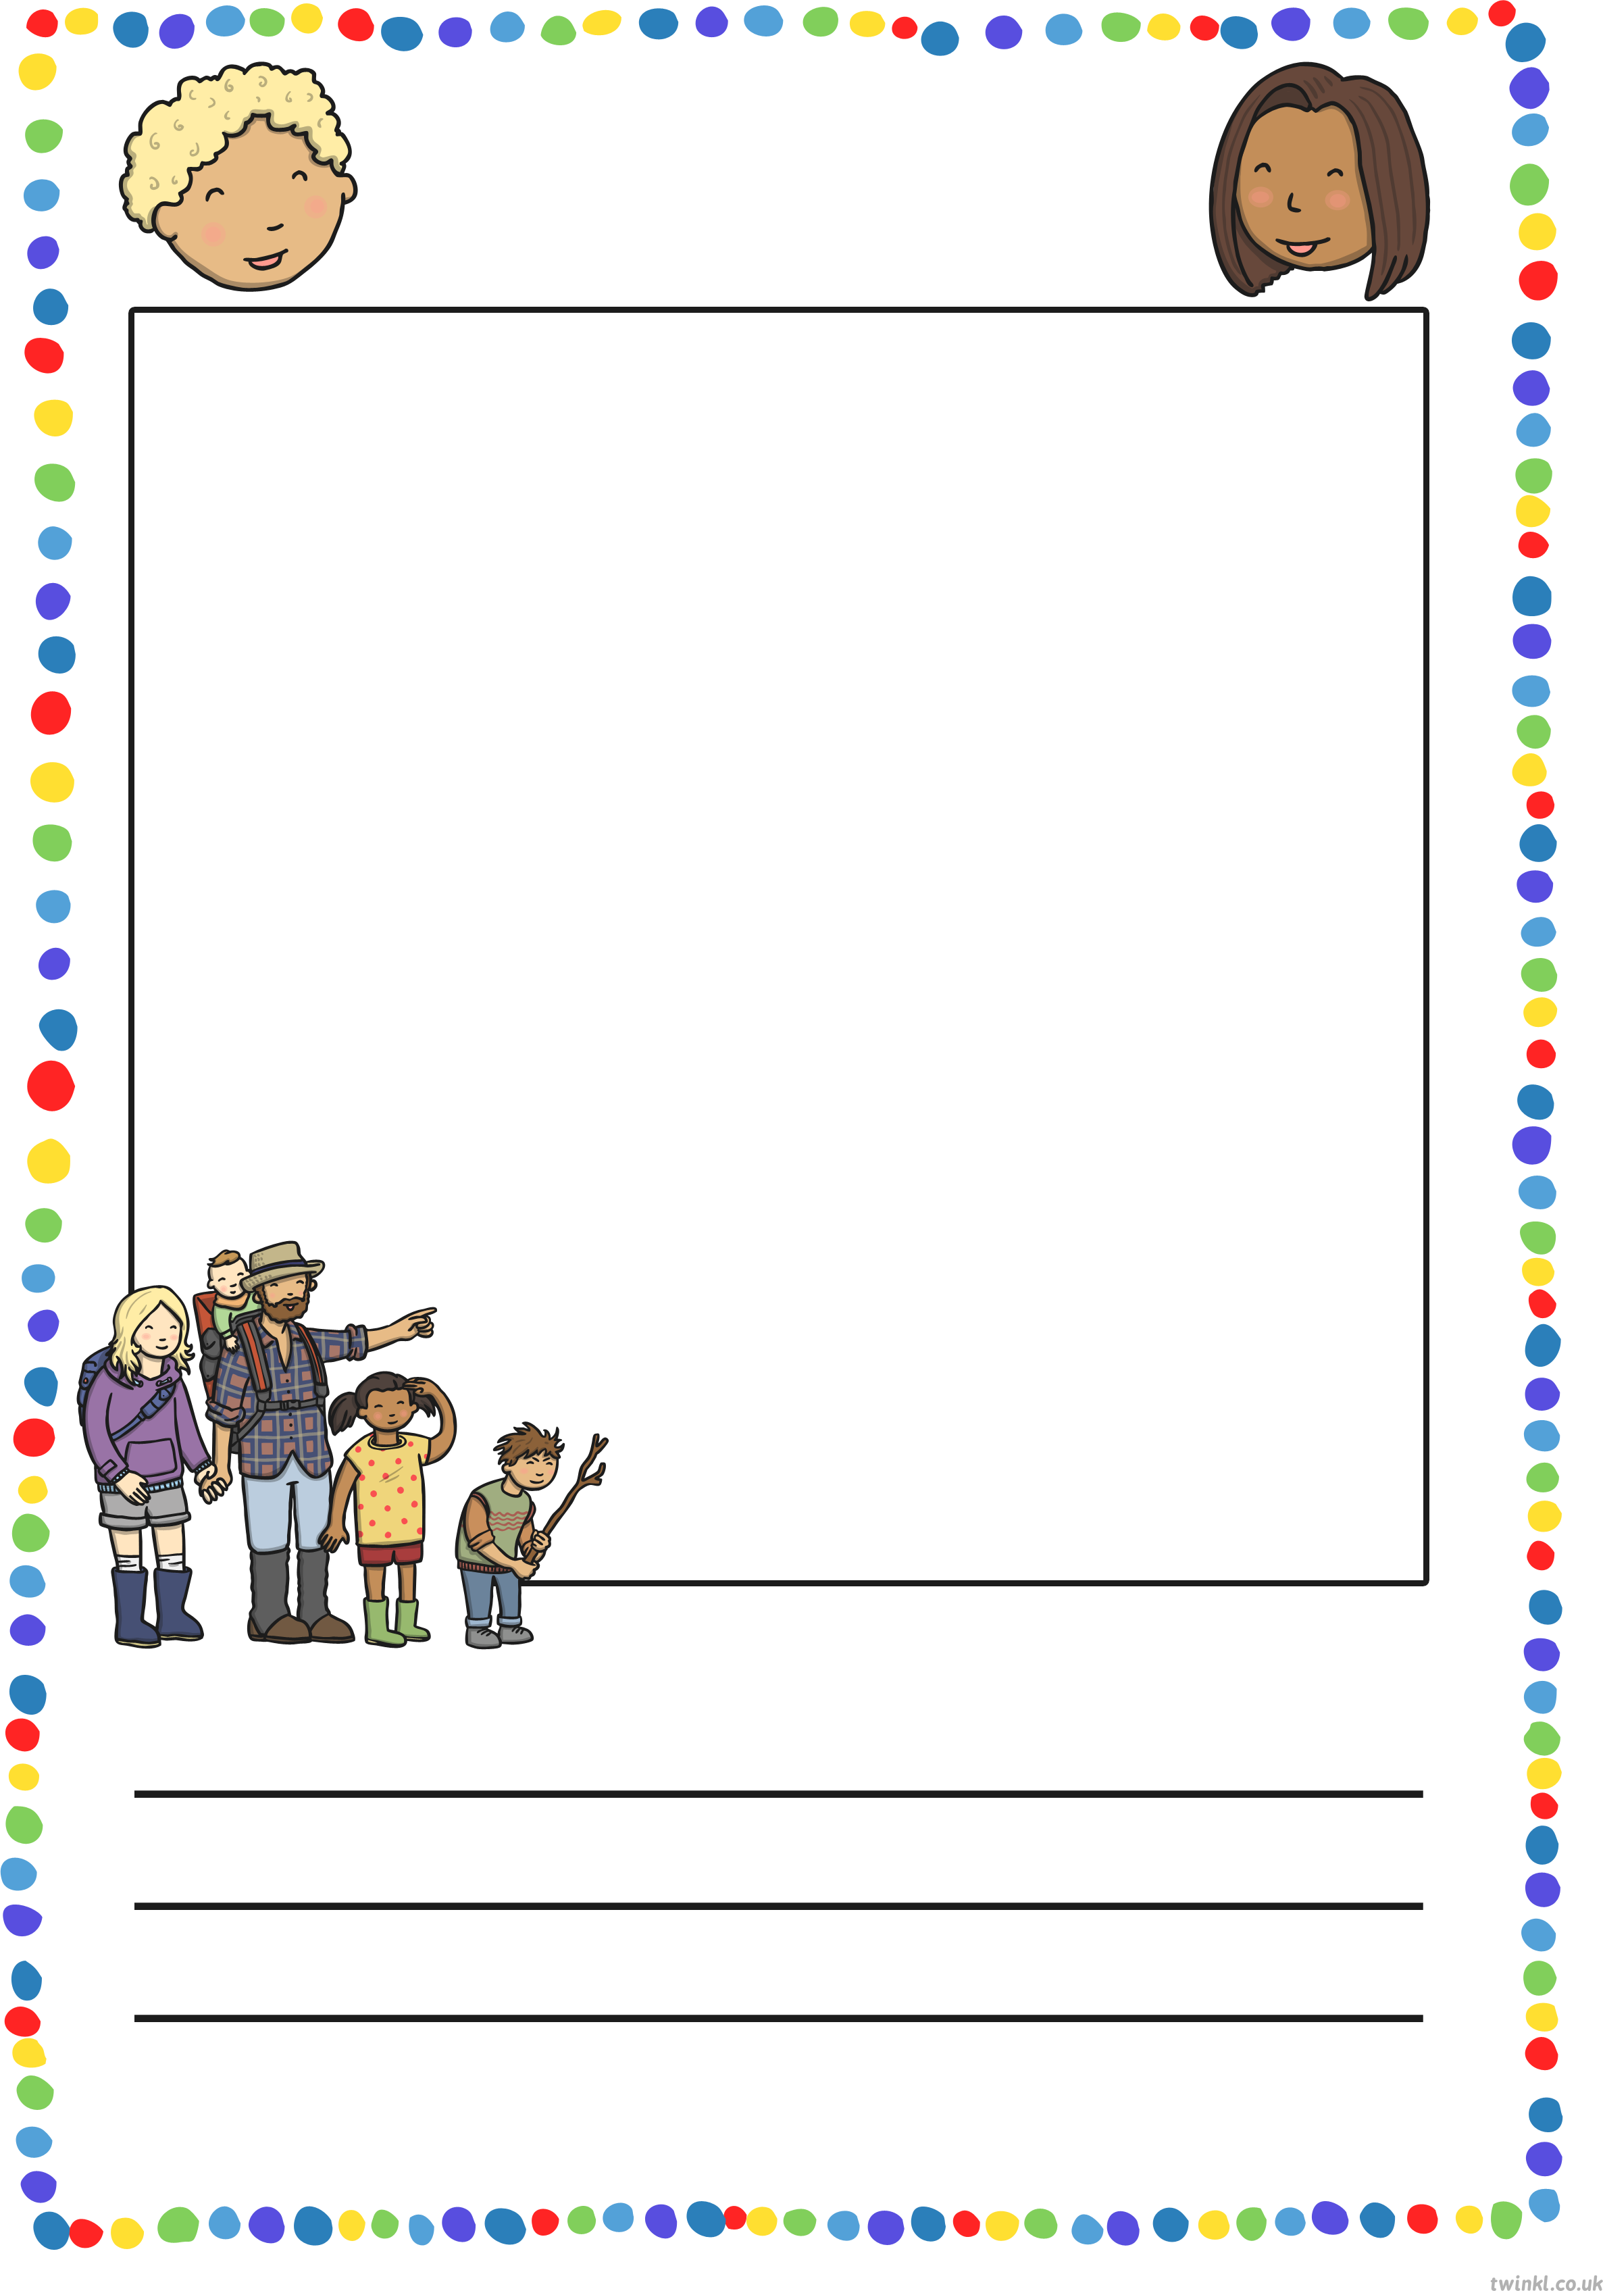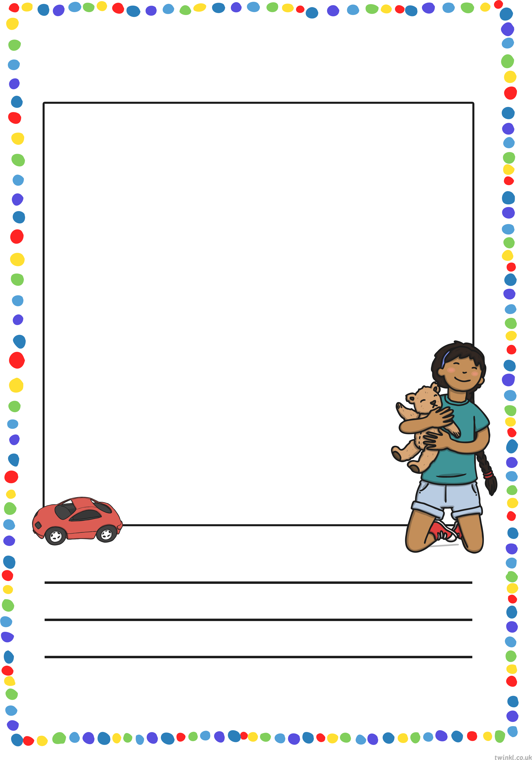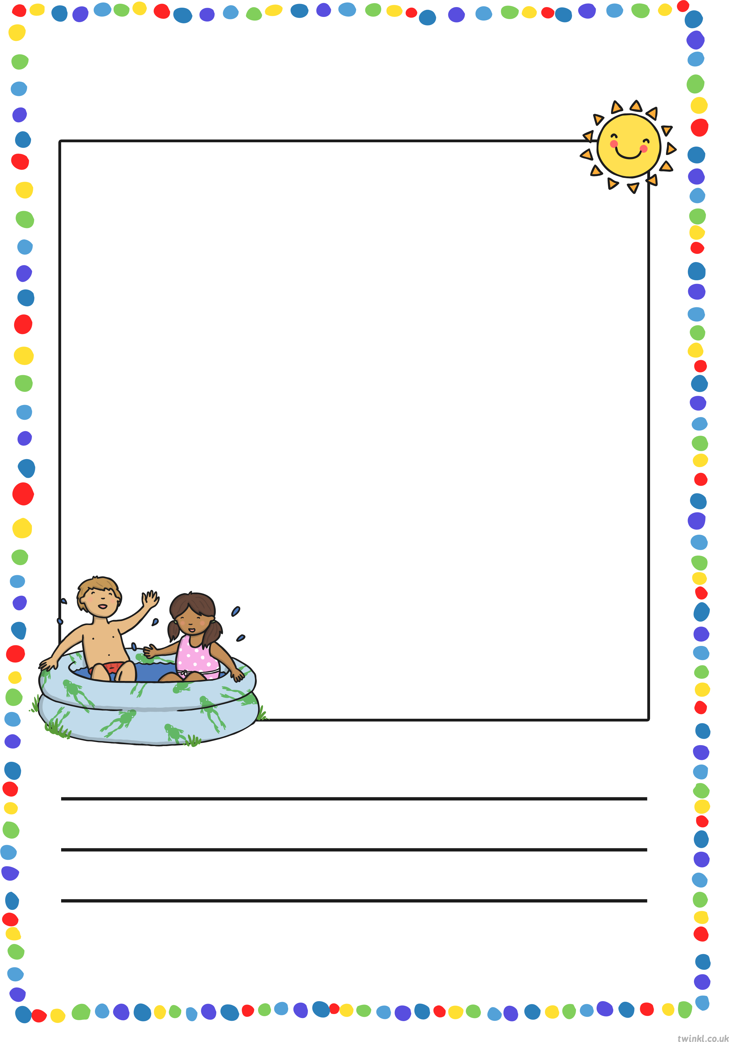

By

All About Me!

West Cornforth

Primary School

Starting Reception

Booklet

My Family

My Favourite Toy

Something Fun I Did During the Summer



My favourite food is:

My favourite book is:

My favourite movie is:

My favourite song is:

My least favourite food is:

My least favourite book is:

My least favourite film is:

My least favourite song is:



What is your favourite animal?

Do you have any pets? What are they?

What is your favourite subject?

What is your favourite drink?

What is your favourite sport?

What is your least favourite animal?

What is your least favourite subject?

What is your least favourite drink?

What is your least favourite sport?