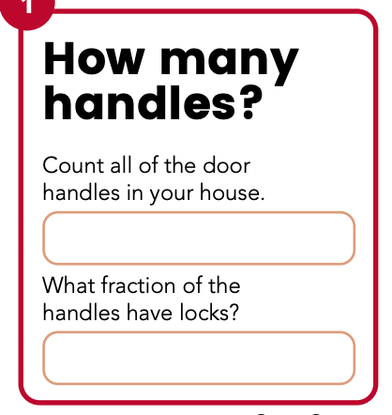

Handles
Locks

Challenge

Can you find any other fractions of amounts around your house? Write the details below:

