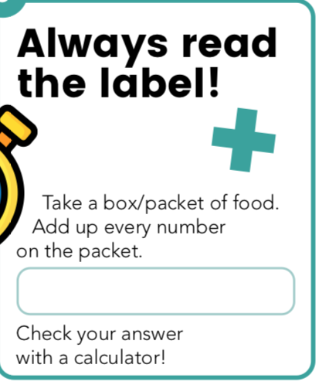

Food Type | Total Amount (on the packet or box)

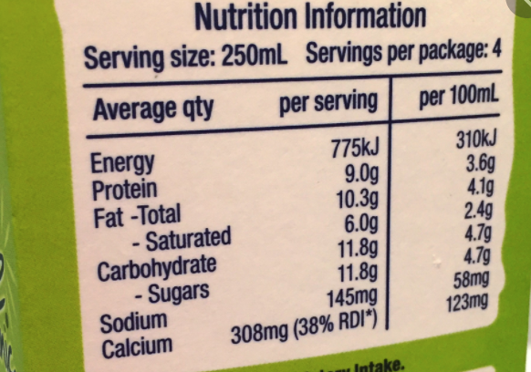

Here is an example, so you would add up all of these numbers!

