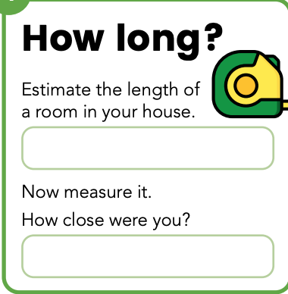

Room | Measurement

Challenge

Could you try to do this in more than one room?

Which room was the longest and which room was the shortest?

