Please note- Please try to ensure you complete your daily reading via MyON. I will be checking this daily next week and rewarding children with 5 dojo points when they complete their daily reading. You can also complete the quiz related to the book you have been reading.
Monday | Maths  Starter- Practise counting in 10’s.  Counting song- https://www.youtube.com/watch?v=7stosHbZZZg  Main Activity- Explain that this week in maths we are going to be checking our mathematical knowledge and thinking about what we may need to work on in the next few weeks. What do we still find tricky? What have we mastered?  Complete the maths tasks on the ‘Activity Mat 1’. Try and allow the children to complete these tasks independently. What were they able to complete confidently? What did they find hard? Work on any questions that they found hard and provide other similar examples.  Discuss the tasks- What maths learning did we use to help us work out the answer? Discuss. Did we use our number bonds? Did we use our knowledge of place value? Did we add? Did we divide? | Literacy  Phonics- Flash card hunt. Reading words and writing given words with chalk.  Literacy- Introduce our new whole school/home learning topic of ‘Dinosaurs’. Start the session by showing the children a range of images of different dinosaurs using google images. Show the children how to access google images. Begin to discuss dinosaurs. What do you notice about them? Do they all look the same? Can you describe any of their features? Do they look like any other animal that we are already familiar with? Which animal group do you think they once belonged to? Recap Science learning.  Give children a chance to look at different images of dinosaurs for themselves on an iPad or laptop. Feedback what they notice.  Discuss- What do we already know about dinosaurs?  What would we like to find out?  Adult to model building and writing information sentences onto the given template, that the children will then complete. Go through lots of ideas shared by the children. Focus on the basics of a good sentence when modelling. Discuss- finger spaces, capital letters, full stops, careful spelling and use of sounds and extended sentences etc. Children then complete the task sheet for Monday using modelling to help. | Computing  Using a laptop look at images of different dinosaurs using google images. Explain and model how to save images to the laptop.  Model inserting saved images into a word or PowerPoint document.  Children can then explore moving and enlarging the images. They can type a describe sentence to match with the image.  Encourage children to save and print their work if possible. | PHSCE-  Adult to read the book ‘Can’t you sleep, little bear?’ by Martin Waddell. Ask the children- Do you ever find it hard to sleep at night? Why is that? Talk about worries and the link between finding it different to sleep.  What are your worries? Discuss going back to school. Discuss the coronavirus.  Talk about the importance of sharing our worries. Use the concept of a bag of peddles being all of our worries and how hard to can be to carry them around. How does it feel when we offload a pebble/worry from the bag?
Tuesday | Maths  Starter- Number bonds to 10- https://www.youtube.com/watch?v=lD9tjBUiXs0  Main Activity- Complete the maths tasks on the ‘Activity Mat 2’. Try and allow the children to complete these tasks independently. What were they able to complete confidently? What did they find hard? Work on any questions that they found hard and provide other similar examples.  Discuss the tasks- What maths learning did we use to help us work out the answer? Discuss. Did we use our number bonds? Did we use our knowledge of place value? Did we add? Did we divide? | Literacy  Phonics- Sounds- Can you hit a sound card with a beanbag? Say the sound as you aim. Buried treasure, blending for reading. Can you find the coins hidden in the year 1 outdoor space?  Literacy- Recap- What do we already know? What do we want to find out?  Explain that today we are going to go back to basics to answer some of the simple things we wish to find out. Look at the PowerPoint- What is a dinosaur? Discuss the simple facts/information.  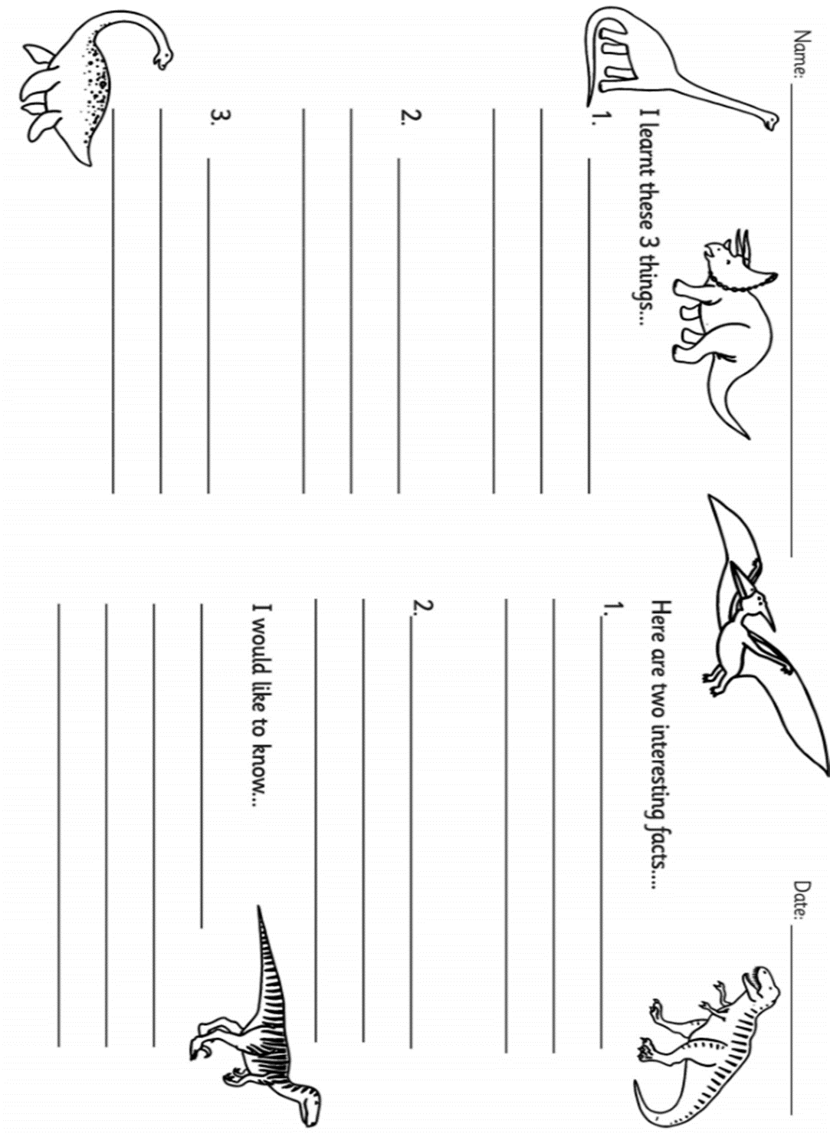  After going through the PowerPoint. Pose the question- What did we learn? Did we learn anything new? Children feedback their learning. Adult to model writing some ideas for the ‘Introducing Dinosaurs’ sheet. Adult to talk out loud about the modelling process.  Discuss each subheading. What is the purpose of these? What do they say? What kind of information are we going to write under each subheading? | Music-  https://www.youtube.com/watch?v=W0FOZ0-VpcU  Learn the words to the dinosaur song.  Sing in tune to the music.  Add body percussion to different key parts. | PE- Let’s get moving!  Discuss the dinosaur exercise log book. Why is exercise important?  Write a list of the different forms of exercise that we could complete in short 10 minutes sessions throughout the week.  Children complete their exercise log books. Record the time spent completing each task, even if this is more or less than 10 minutes.  Children use stop watches to measure their time.
Wednesday | Maths  Starter- Count to 100 using interactive hundred square. Count in 2’s, 5’s and 10’s to music. Follow numbers on interactive hundred square when counting.  Main Activity- Complete the maths tasks on the ‘Activity Mat 3’. Try and allow the children to complete these tasks independently. What were they able to complete confidently? What did they find hard? Work on any questions that they found hard and provide other similar examples.  Discuss the tasks- What maths learning did we use to help us work out the answer? Discuss. Did we use our number bonds? Did we use our knowledge of place value? Did we add? Did we divide? | Literacy  Phonics- Sounds- Teacher shouts a sound, children write on the yard with chalk. Word hunt- Hunt for words, read these and then sort into real or nonsense.  Literacy- What more can we find out about dinosaurs? Show the children the simple fact cards about the various dinosaurs. Can you name them? Do you already know any facts about any of these dinosaurs? Talk about what a fact is. Do we know for a fact that it is true?  Children read the fact cards and feedback information. Can parents or siblings guess which dinosaur they are talking about by using the information they have picked up from the fact cards?  Chidlren should be provided with a large sheet of paper, dinosaur images and coloured pencils etc. They should make dinosaur information posters using the information they have learnt from reading the fact cards. Talk about making their posters as attractive as possible. Use some images/drawing and clear writing. Think about the layout of the poster. | Science –Which animal group did dinosaurs belong to?  Recap previous learning from in school all about different animals groups. Go through the animal groups PowerPoint, recap the group names and the different features of different animals that allow us to classify them into the different groups.  Complete the quiz about different animal groups at the end of the PowerPoint.  Using the information learnt and recapped about different animals groups, pose the key question to the children. Which animal group do you think dinosaurs belonged to?  Children think carefully about the dinosaurs. Label the image of the T-rex found in the resource booklet. Does it have scales? Does it lay eggs? Which animal group would it have belonged to?
Thursday | Maths  Starter- Count in 2’s, 5’s and 10’s on interactive hundred square. Practise your 2, 5, and 10 times tables link to counting.  Main Activity- Complete the maths tasks on the ‘Activity Mat 4’. Try and allow the children to complete these tasks independently. What were they able to complete confidently? What did they find hard? Work on any questions that they found hard and provide other similar examples.  Discuss the tasks- What maths learning did we use to help us work out the answer? Discuss. Did we use our number bonds? Did we use our knowledge of place value? Did we add? Did we divide? | Literacy  Phonics- Flash cards (Phase 3&5) Phonics play- Tricky word trucks.  Literacy- Pose the question- Are we becoming dinosaur experts? What have we learnt?  Explain that on Friday we will be completing a fact file about a chosen dinosaur, using all the information that we have learnt this week. Look at the three dinosaurs we will be focusing on. Use non-fiction books (link to e-book to be sent via class dojo and shared on the website) and online research to learn more information about the three dinosaurs.  Can we name and then label the key parts of each?  Chidlren should then have a try at naming and labelling the dinosaurs and writing some facts about each. Share expectations for some more complex sentences. | Art/DT- Children complete an observational drawing of a dinosaur from a still image.  Explain what an observational drawing is- Observational drawing is drawing what you see. It's as simple and as complicated as that. It can be a flower, a person, a still life, a landscape, whatever. But it's drawing what you see in front of you as realistically and as true to life as possible.  Provide children with a range of images of different dinosaurs. These can be images from the internet or from with non-fiction books, that the children can find for themselves.  Adult to model using a chosen image. | PE- Discuss the dinosaur exercise logbook. Why is exercise important?  Write a list of the different forms of exercise that we could complete, in short 10 minutes sessions, throughout the week.  Children complete their exercise log books. Record the time spent completing each task, even if this is more or less than 10 minutes.  Children use stop watches to measure their time. Recap previous maths learning.
Friday | Maths  Starter- Write numbers 1 – 10 as numbers and words. Can you add 1 more to each number? Can you add 2 more?  Main Activity- Complete the maths tasks on the ‘Activity Mat 5’. Try and allow the children to complete these tasks independently. What were they able to complete confidently? What did they find hard? Work on any questions that they found hard and provide other similar examples.  Discuss the tasks- What maths learning did we use to help us work out the answer? Discuss. Did we use our number bonds? Did we use our knowledge of place value? Did we add? Did we divide? | Phonics- Flash cards (Phase 3&5) Phonics play- Sentence level game.  Literacy- Children draw upon all the facts and information they have learnt about dinosaurs over the course of the week. What do we now know? Can we complete a fact file about a given dinosaur?  Look at the fact file template and talk about which dinosaur it is going to be focused on. Adult to discuss each part carefully, talk about what they could write in each part. Give ideas. Children draw upon knowledge and carry out further research if needed. | History- When were dinosaurs alive?  Find about how long ago it was when dinosaurs roamed the earth. Were humans around? What were the different time periods known as?  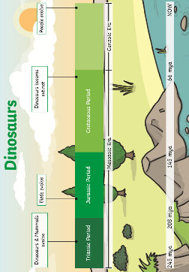  Watch the video clip to find out about the dinosaur timeline- https://www.youtube.com/watch?v=OzetCEYYABo  Look at the completed dinosaur period timeline. Which period came first? Which period came after that? Talk about the amount of time between each period.  Can the children draw their own dinosaur period timeline? Keep this safe as we will be using it next week.

Useful Websites for Extra Tasks/Activities
Phonics  https://www.phonicsplay.co.uk/  Username – march20 Password – home  https://www.teachyourmonstertoread.com/games/tm1/demo  https://www.phonicsbloom.com/  https://www.topmarks.co.uk/english-gam…/…/letters-and-sounds | Maths  www.mathletics.com  www.ttrs.com  www.topmarks.co.uk  https://www.oxfordowl.co.uk/for-home/  https://www.bbc.co.uk/iplayer/episodes/b08bzfnh/numberblocks  www.whiterosemaths.com/homelearning/
English  https://www.topmarks.co.uk/…/7-11-years/spelling-and-grammar  www.sooperbooks.com  https://www.oxfordowl.co.uk/for-home/  www.spellingframe.co.uk  http://www.funenglishgames.com/games.html  https://www.eslgamesplus.com/  www.pobble365.com  www.readtheory.org  https://www.scholastic.com/…/scholastic-learn-at-home--free…# | Other  https://www.si.edu/kids - Fun lessons on geography, history and science  https://www.shaunsgameacademy.co.uk/ - Computing  https://scratch.mit.edu/ - Computing – click ‘create’  https://www.duolingo.com/register - Languages  https://mrnussbaum.com/science - Science  https://www.gonoodle.com/good-energy-at-home-kids-games-an…/ - Free exercise videos  https://www.virtualmusicalinstruments.com/ - Music

