Please note- When using the whiterose maths resources please ensure you use the video clip and resources identified in the plan and shared as part of the resource pack each week. Try not to move onto anything else, as we will be using these in the coming weeks. If you would like to compete extra maths tasks, then please use your Mathletics log in. Thank you.

Please try to ensure you complete your daily reading via MyON. I will be checking this daily next week and rewarding children with 5 dojo points when they complete their daily reading. You can also complete the quiz related to the book you have been reading.
Monday | Maths  Starter- Complete flash back 4 as a recap.  Main Activity- https://whiterosemaths.com/homelearning/year-1/  Use white rose home learning resources-  Look at Year 1- Summer Term – Week 2 – Lesson 1- Find a half.  Watch the video provided and discuss the key questions and learning points. Work with your child to answer the questions and pause the video as needed to give thinking and discussion time.  Following the completion of the video complete the independent task, see resources. - Monday Maths Task. | Literacy  Phonics- Phonics play- Flash cards. Buried Treasure.  Daily reading- Myon- https://www.myon.co.uk/login/index.html  Username and password sent via class dojo.  Literacy- Children complete the Year 1 SPaG tasks. Go through the questions and examples carefully. Discuss each task.  If children struggle with a question, try to spend more time talking about this. Maybe create another example, similar to that used on the task sheet. | Geography  Discuss the key building you talked about last week.  Using the internet to find out about Durham Cathedral.  Look at some of the amazing pictures of this building on Google Images.  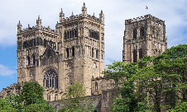  Using the template provided, write down 5 facts you have discovered about this building. | RE  Recap the story of Buddha. Look back at the cards you sorted last week.  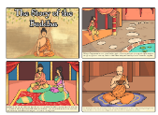  Use the blank story board and your knowledge of the story, to complete a simple story board of your own.  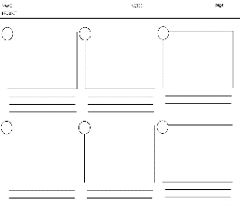
Tuesday | Maths  Starter- Complete flash back 4 as a recap.  Main Activity- https://whiterosemaths.com/homelearning/year-1/  Use white rose home learning resources- Look at- Year 1- Summer Term – Week 2 – Lesson 2- Find a quarter.  Watch the video provided and discuss the key questions and learning points. Work with your child to answer the questions and pause the video as needed to give thinking and discussion time.  Following the completion of the video complete the independent task, see resources marked as Tuesday Maths Task. | Literacy  Phonics- Phonics Play- Flash cards (Phase 3&5) Dragons Den.  Daily reading- Myon- https://www.myon.co.uk/login/index.html  Username and password sent via class dojo.  Literacy- All about Grace Darling, linked to our History. Watch the video clip up to 53 seconds. https://www.youtube.com/watch?v=xCL1x7wHQLY  Watch the beginning of the clip to recap the information we have already learnt about the early life of Grace Darling. Where did she live? When we she born? How many siblings did she have?  Using the template provided in the resource pack, complete a spider diagram to highlight the things you already know about the early life of Grace Darling. | Music  Watch and join in with ‘Durham Music’ online clips.  Wednesday Incy Wincy | Rhyme of the Week Episode 3  https://www.youtube.com/watch?v=6V_XIEMeXF0 | PE  - https://www.youtube.com  /user/thebodycoach1. Join in with Joe Wicks daily PE session on his YouTube- The Body Coach.  - Go into your garden or own outdoor space and make an obstacle course to complete.
Wednesday | Maths  Starter- Complete flash back 4 as a recap.  Main Activity- https://whiterosemaths.com/homelearning/year-1/  Use white rose home learning resources- Look at- Year 1- Summer Term – Week 2 – Lesson 3- Find a quarter.  Watch the video provided and discuss the key questions and learning points. Work with your child to answer the questions and pause the video as needed to give thinking and discussion time.  Following the completion of the video complete the independent task, see resources marked as Wednesday Maths Task. | Literacy  Phonics- Phonics Play- Flash cards (Phase 3&5) Choose a game, sentence level.  Daily reading- Myon- https://www.myon.co.uk/login/index.html  Username and password sent via class dojo.  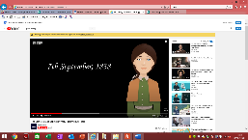  Literacy- What made Grace Darling Famous? What happened on the night of 7th September 1838?  Watch the remainder of the clip you looked at yesterday. Write some simple facts about what happened. | 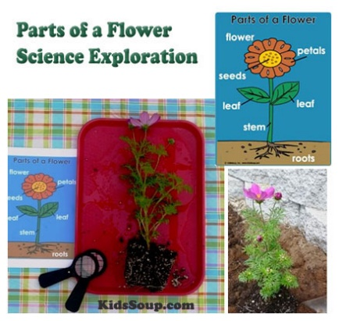  Science – Plants  Parts of a plant-  Explore parts of a plant. Find a plant in your garden or while out for your daily exercise.  Look closely at the different parts. Name these and talk about the similarities and differences between each part.
Thursday | Maths  Starter- https://www.cgpbooks.co.uk/info/times-table-tester  Practise your 2, 5, and 10 times tables using the link above.  Main Activity- https://whiterosemaths.com/homelearning/year-1/  Use white rose home learning resources- Look at- Year 1- Summer Term – Week 2 – Lesson 4- Find a quarter.  Watch the video provided and discuss the key questions and learning points. Work with your child to answer the questions and pause the video as needed to give thinking and discussion time.  Following the completion of the video complete the independent task, see resources marked as Wednesday Maths Task. | Literacy  Phonics- Flash cards (Phase 3&5) Phonics play- Tricky word trucks.  Daily reading- Myon- https://www.myon.co.uk/login/index.html  Username and password sent via class dojo.  Literacy- Cut out and order the images that show the events of the 7th September 1838.  Stick the images onto the template provided. Add numbers to clearly show the order of key events. Write about each image. Try to include some extended sentences. | Art/DT  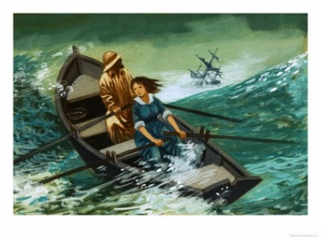  Paint a picture of the night of 7th September 1838. Draw your outline and then add paint or colour with pencils.  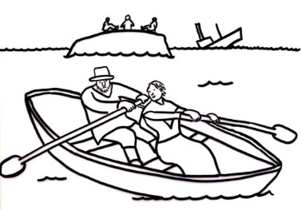 | PE  - https://www.youtube.com  /user/thebodycoach1. Join in with Joe Wicks daily PE session on his YouTube- The Body Coach.  - Go into your garden or own outdoor space and make an obstacle course to complete.
Friday | Maths  Starter- Continue to practise writing number from 1-20 as numerals and words.  Main Activity-  Family Maths Challenges!  https://whiterosemaths.com/homelearning/year-1/  Use white rose home learning resources- Look at- Year 1- Summer Term – Week 2 – Family challenges.  Please complete challenges. Work as a family and take your time to think about all the maths you need to use to solve the maths challenges. | Phonics- Flash cards (Phase 3&5) Phonics play- Sentence level game.  Daily reading- Myon- https://www.myon.co.uk/login/index.html  Username and password sent via class dojo.  Literacy-Write a recount all about the events that took place on the night of 7th September 1838.  Use the recount template provided. Discuss the key time conjunctions. Draw your own pictures into the boxes provided. You could use the images your ordered yesterday to help.  Remember as many details about the night as you can. | History- What made Grace Darling famous?  Discuss our learning as part of the English tasks throughout this week.  Talk to an adult about what made Grace Darling famous?  What do you think Grace Darling was thinking on the night of the rescue?  Using the template provided complete the thought bubbles to show what you think Grace Darling and her farther were thinking during the rescue.

Useful Websites for Extra Tasks/Activities
Phonics  https://www.phonicsplay.co.uk/  Username – march20 Password – home  https://www.teachyourmonstertoread.com/games/tm1/demo  https://www.phonicsbloom.com/  https://www.topmarks.co.uk/english-gam…/…/letters-and-sounds | Maths  www.mathletics.com  www.ttrs.com  www.topmarks.co.uk  https://www.oxfordowl.co.uk/for-home/  https://www.bbc.co.uk/iplayer/episodes/b08bzfnh/numberblocks  www.whiterosemaths.com/homelearning/
English  https://www.topmarks.co.uk/…/7-11-years/spelling-and-grammar  www.sooperbooks.com  https://www.oxfordowl.co.uk/for-home/  www.spellingframe.co.uk  http://www.funenglishgames.com/games.html  https://www.eslgamesplus.com/  www.pobble365.com  www.readtheory.org  https://www.scholastic.com/…/scholastic-learn-at-home--free…# | Other  https://www.si.edu/kids - Fun lessons on geography, history and science  https://www.shaunsgameacademy.co.uk/ - Computing  https://scratch.mit.edu/ - Computing – click ‘create’  https://www.duolingo.com/register - Languages  https://mrnussbaum.com/science - Science  https://www.gonoodle.com/good-energy-at-home-kids-games-an…/ - Free exercise videos  https://www.virtualmusicalinstruments.com/ - Music

