The roof of the arch becomes too heavy and collapses

Wave action erodes the fault to form a cave

[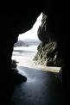](http://images.google.co.uk/imgres?imgurl=http://www.firstlighttours.com/PHOTOS/or07_cave.JPG&imgrefurl=http://www.firstlighttours.com/oregoncoast.html&h=370&w=247&sz=38&hl=en&start=12&um=1&usg=__Kgjbhqic503pnDsnRdYmcLixtaM=&tbnid=yMboNKhwul4z3M:&tbnh=122&tbnw=81&prev=/images%3Fq%3Dcoast%2Bcave%26um%3D1%26hl%3Den%26sa%3DG)

Over time the stack is eroded, it might be undercut and collapse

Lines of weakness such as faults (cracks) occur in headlands

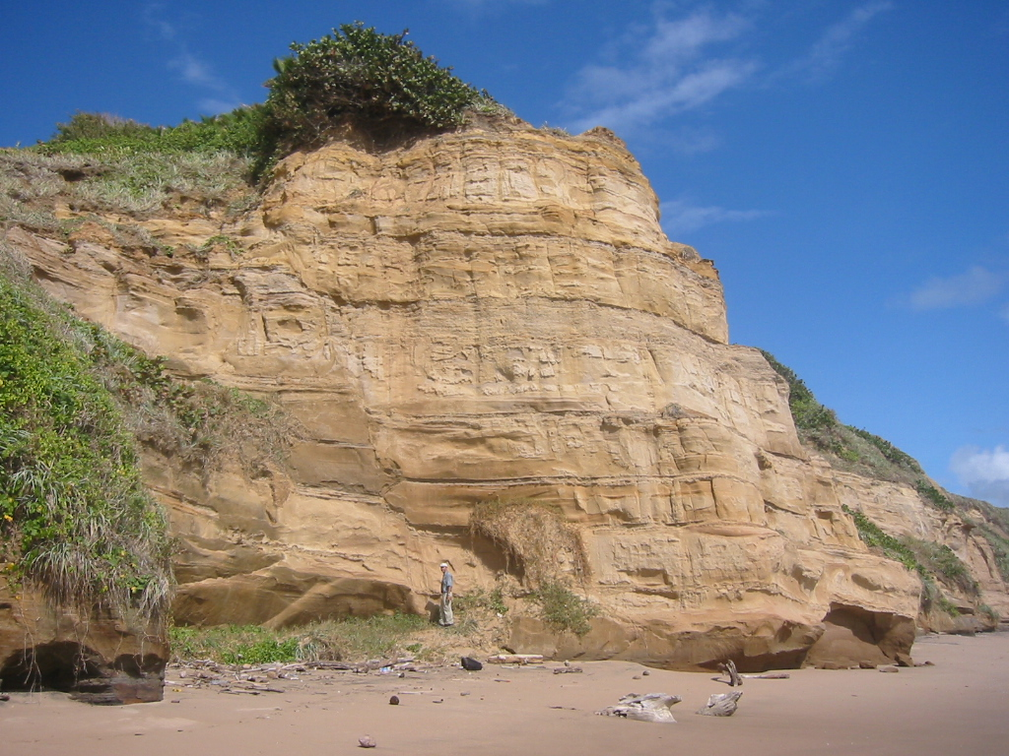

The sea erodes the foot of the arch and widens it

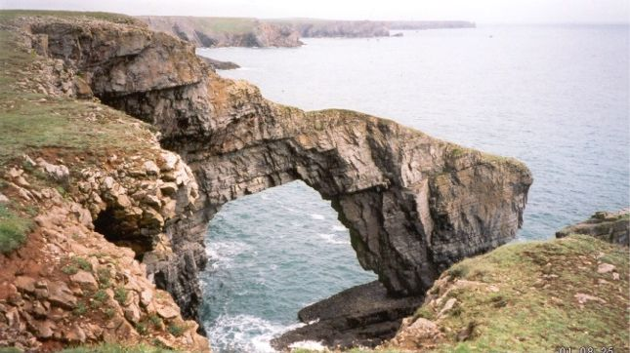

Part of the former cliff is now isolated as a stack

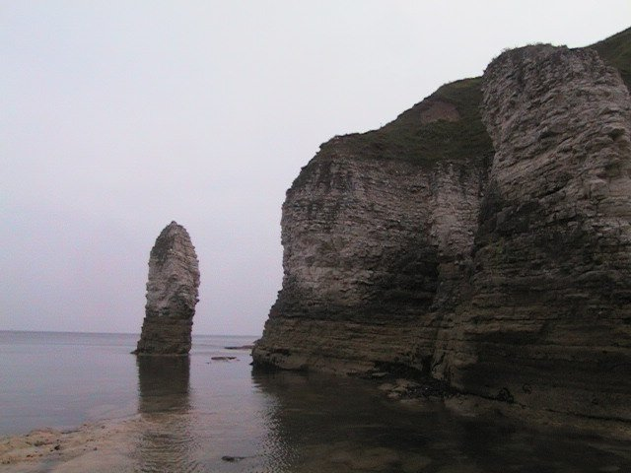

The cave is widened and deepened

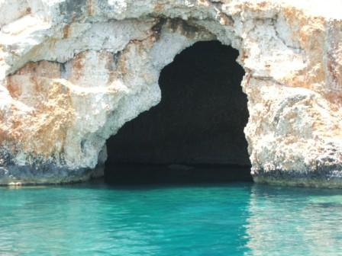

A stump is the remains of the eroded stack

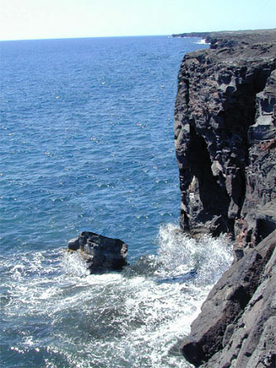

The sea cuts through to form an arch

