Complete daily | Name recognition  Find your name. Match your name. Find the letters in your name. Attempt to write your name.  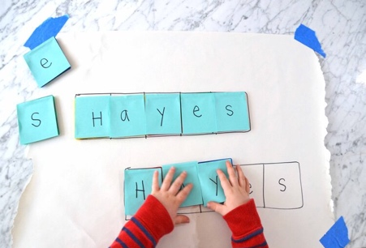
Focus tasks | Watch the animated story of the three little pigs - The Three Little Pigs - Animated Fairy Tales for Children ( by Oxbridge baby) https://youtu.be/QLR2pLUsl-Y  - Discuss the character of the Big Bad Wolf. What was his behaviour like? Why? Are there any other reasons why he might be trying to blow the little pigs’ houses down?  - Make a ‘Wanted Poster’ for the big bad wolf.  - Can the children say what kind of home they would like to live in? Encourage them to use their imagination – a fairy castle, a rocket ship, a house with its own football pitch!  - Provide a sorting activity with pictures of objects starting with ‘p’ and some pictures of objects starting with ‘w’ as well as a large image of a pig and a wolf. Can the children sort all of the ‘p’ objects onto the pig and the ‘w’ objects onto the wolf?  - Explore building with different materials. Can the children work out which ones would be best for building a house and why? Build some homes and test them out by blowing them with a hairdryer!  - Model writing simple letters with the children. This could be from the Big Bad Wolf, saying ‘Sorry’ and explaining that he just wanted to be friends, or from The Three Little Pigs to the Big Bad Wolf, telling him how they felt when he banged on the door and chased them.  - Re-enact the story with the children and encourage them to experiment with different ways of moving during each part of the story. Discuss the characters.  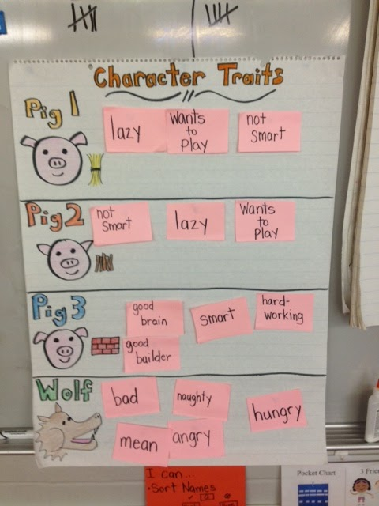
English

Complete daily | Watch the jolly phonics phase 2 song on Youtube. Join in with the words and actions. https://www.youtube.com/watch?v=1Qpn2839Kro  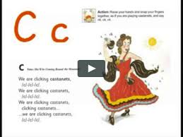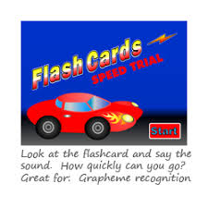  Go on Phonicsplay.co.uk or use the app Username: march20Password: home. Flashcards- speed trials- phase 2
Focus tasks | 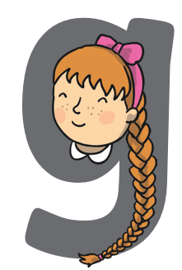  How many things around the house can you find begging with the ‘n’ sound? Practise forming the letter ‘n’. Remember to start and finish in the correct place. Say ‘Round the girls face, down her hair and give her a curl.’, as you form the letter. If you wish to practise a new sound the cards are available to download on the class dojo.  Bounce: g-g-g-girl  Handwrite: Round the girls face, down her hair and give her a curl.  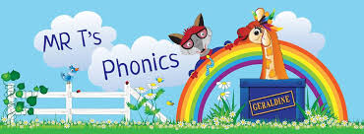  Watch Mr Thorne does phonics on YouTube- episode ‘g’’ https://www.youtube.com/watch?v=bzXDzhDI4Q0

Complete daily | Watch the ‘Our favourite number songs’ video on Youtube on the Super Simple Songs channel. Sing along and remember to hold up the correct fingers when counting.  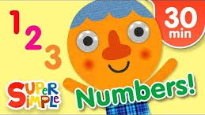
Focus tasks | Hide the numbers 0 to 10 around your room, house or garden. See if your child can find all 10 and place them in order. They could ask someone which number to find. Can you remember what the number looks like and find it? Once they have been found, try and count objects to match each number.  Collect 10 leaves from the garden or a local park. Help your child write the numbers 0-10, one on each leaf, using a thick marker pen. Use a hole punch to make a hole in either end of the leaves and then thread them onto a piece of string. Don’t forget to put them in the correct order! You could then put up your homemade number line in your bedroom to help you

Other activities.
- Go over the date and weather daily. Go outside to check the weather and discuss. What season are we in? What happens during this season? Make a weather chart or use an online one. https://www.ictgames.com/mobilePage/dateChart/index.html
Jack Hartmann on Youtube has some great days of the week and months of the year songs and dances.

- Encourage children to dress themselves. Putting on their own clothes, coats and shoes makes them more independent and ready for starting their Reception class.

Pencil control
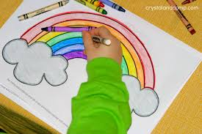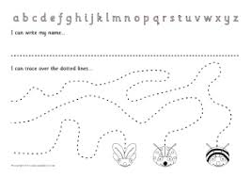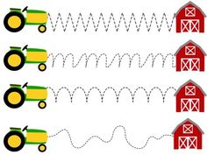
- You can make your own pencil control sheet by drawing lines for your child to follow. Make these however you like. Using , straight, circular, and zig zag lines.
- Have your child join the dots, number the dots to incorporate a bit of maths.
- Placing objects inside lines.
- Highlighter Tracing, draw a picture with a highlighter for your child to trace
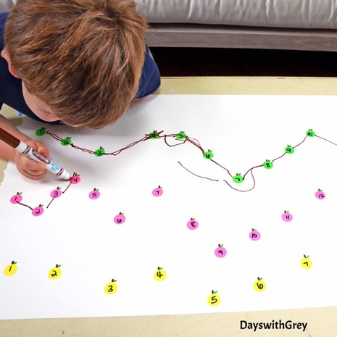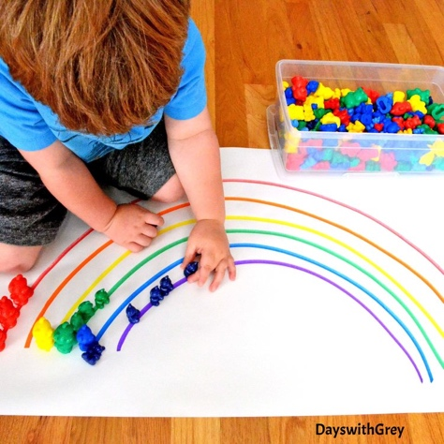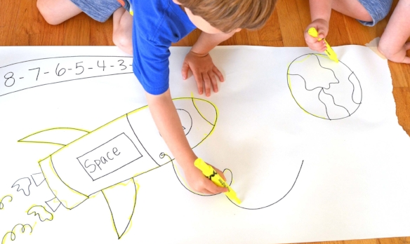
ine Motor skills
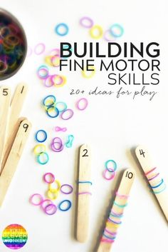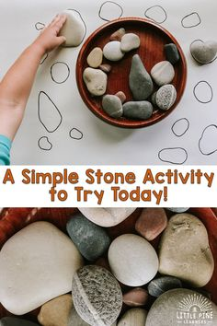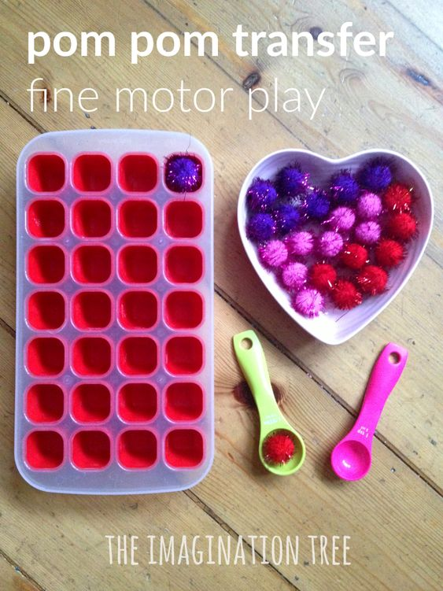

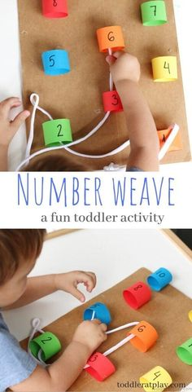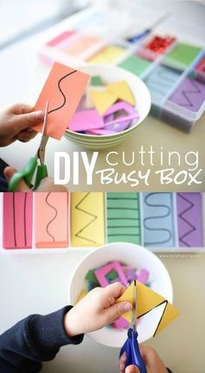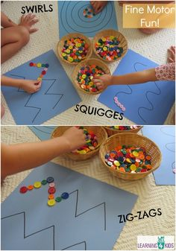

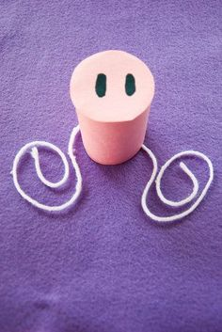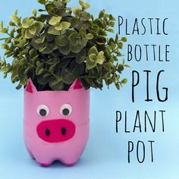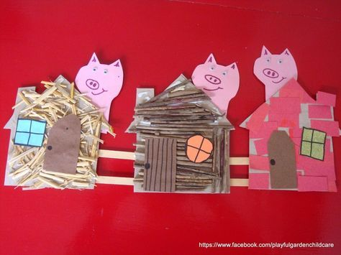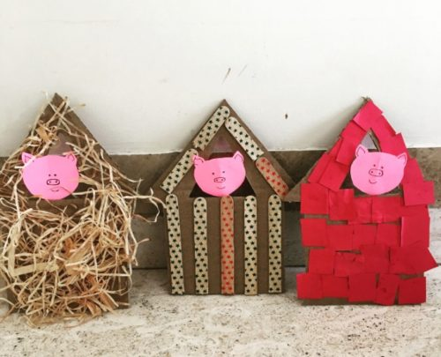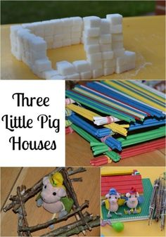

THE THREE LITTLE PIGS EXPERIMENTS
Test a stick, straw and brick roof to see which is the most windproof, we used the squeezy bottle to act like wind and placed tissue paper inside the house so we could see if the ‘wind’ reached it.
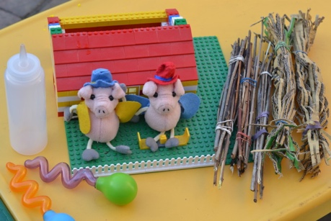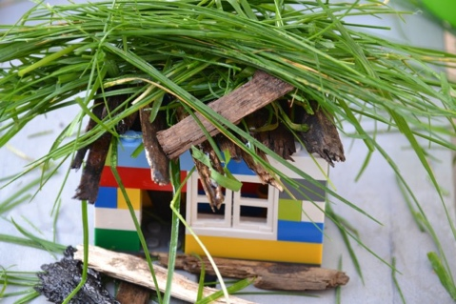
Build house for the three little pigs using sweets and straws, which sweets work the best? 