Complete daily | Name recognition  Find your name. Match your name. Find the letters in your name. Attempt to write your name.  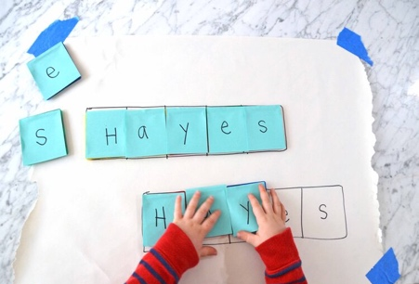
Focus tasks | Listen to the story ‘What the Ladybird Heard” written by Julia Donaldson  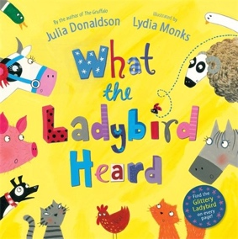https://www.youtube.com/watch?v=Eu9mPX7DuLA  - Look at the words used to describe how the thieves are planning to steal the cow. What other direction words can you think of?  - The ladybird whispered into each animal's ear. Think of other words that describe how we can communicate with others (e.g. shouted, screamed, hissed, chattered) Try and communicate in different ways.  - The thieves 'crept' into the farm. Think of words that describe how people can move. Can you demonstrate each one (e.g. sprint, crawled, paced).  - Try and recall all the animals on the farm.  - Create a 'Wanted Poster' to tell people about the criminals and their crimes.  - Look at the pictures of the farm at the start and end of the book. Can you describe how they are different?
English

Complete daily | Watch the ‘Our favourite number songs’ video on Youtube on the Super Simple Songs channel. Sing along and remember to hold up the correct fingers when counting.  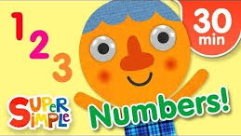
Focus tasks | Topmarks website https://www.topmarks.co.uk/learning-to-count/ladybird-spots  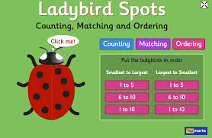Play the various counting, matching and ordering Ladybird spots game on the Topmarks website.  Draw some lady birds for your child to add spots to (if they can, they could draw or paint their own ladybird). Ask them to add a number of spots between 1-10, or if you have a dice, roll the dice and ask your child to count the spots on the dice and then them to the ladybird.  Cut out some numbers for your child to then match the numeral to the correct lady bird with that number of spots.  Continue to do so for different numbers 0-5, then 0-10.
Maths
Phonics
Complete daily | Watch the jolly phonics phase 2 song on Youtube. Join in with the words and actions. https://www.youtube.com/watch?v=1Qpn2839Kro  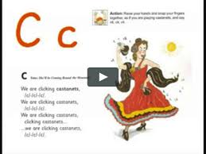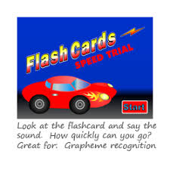  Go on Phonicsplay.co.uk or use the app Username: march20Password: home. Flashcards- speed trials- phase 2
Focus tasks | 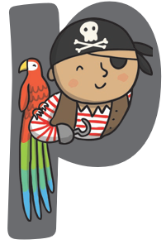  How many things around the house can you find begging with the ‘p’ sound?  Practise forming the letter ‘p’. Remember to start and finish in the correct place. Say ‘Down the pirates plat, back up and around his face”, as you form the letter.  Bounce: p-p-p-pirate  Handwrite: Down the pirates plat, back up and around his face.  Watch Mr Thorne does phonics on YouTube- episode ‘p’ https://www.youtube.com/watch?v=8_NmgZWvWG4

Other activities.
- Go over the date and weather daily. Go outside to check the weather and discuss. What season are we in? What happens during this season? Make a weather chart or use an online one. https://www.ictgames.com/mobilePage/dateChart/index.html
Jack Hartmann on Youtube has some great days of the week and months of the year songs and dances.

- Encourage children to dress themselves. Putting on their own clothes, coats and shoes makes them more independent and ready for starting their Reception class.

- Watch Alpha blocks- learning to read, writing made easy episode on Youtube.
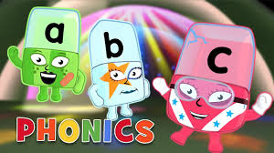
https://www.youtube.com/watch?v=xJSVrq-6-jc
- Complete the farm exercise on YouTube. https://www.youtube.com/watch?v=iHJ2fW3iJVE
- Pencil control
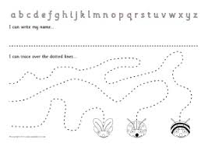

- Fine motor skills

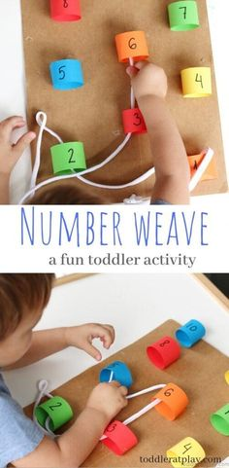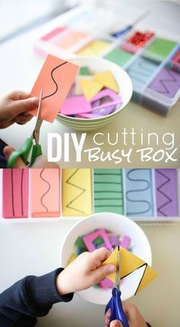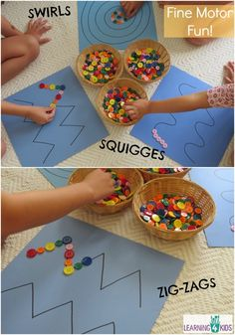

- Lady bird crafts

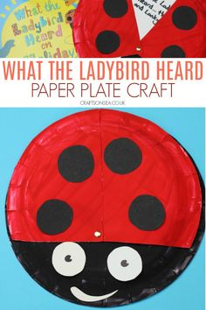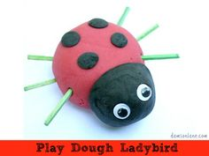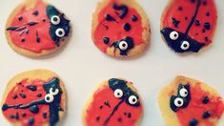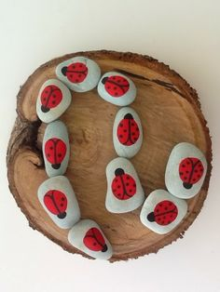
- Go on a lady bird hunt
