[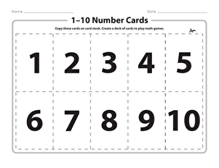](https://www.google.com/url?sa=i&url=https%3A%2F%2Fwww.education.com%2Fworksheet%2Farticle%2F1-10-number-cards%2F&psig=AOvVaw1R-fNnZYQbWbT1_Tqho4w0&ust=1588345064276000&source=images&cd=vfe&ved=0CAIQjRxqFwoTCPjZ1c20kOkCFQAAAAAdAAAAABAI)