Science Week beginning 20/4/20- Tasks
Our new science topic is Forces. Our first task is to look at the force of gravity.
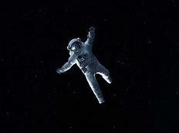

- If you can try the learner guide https://www.bbc.co.uk/bitesize/topics/zf66fg8 then complete the quiz.
There are also five class clips which are quite interesting to watch.

- If you can open the PowerPoint at home work through the slides and complete the home learning links and the quiz.

- Read the gravity explanation text and complete the questions from this.

