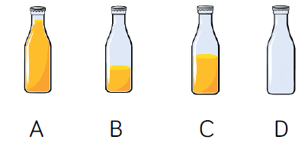

**Problem solving**

Match the statement to the correct picture.

This glass has the largest volume of water.

This glass of water has twice the amount as glass A.

This glass of water is more than half full but less than nearly full.

This glass has the least volume of water.

This glass of water has half the volume of water as glass C.

This glass is nearly full.

**Problem solving**

Match the statement to the correct picture.

The volume of orange is 0 cups.

The volume of orange is the same as the capacity of the bottle.

The volume of the orange is about 2 cups.

The volume of orange is more than 2 cups.



A B C D E