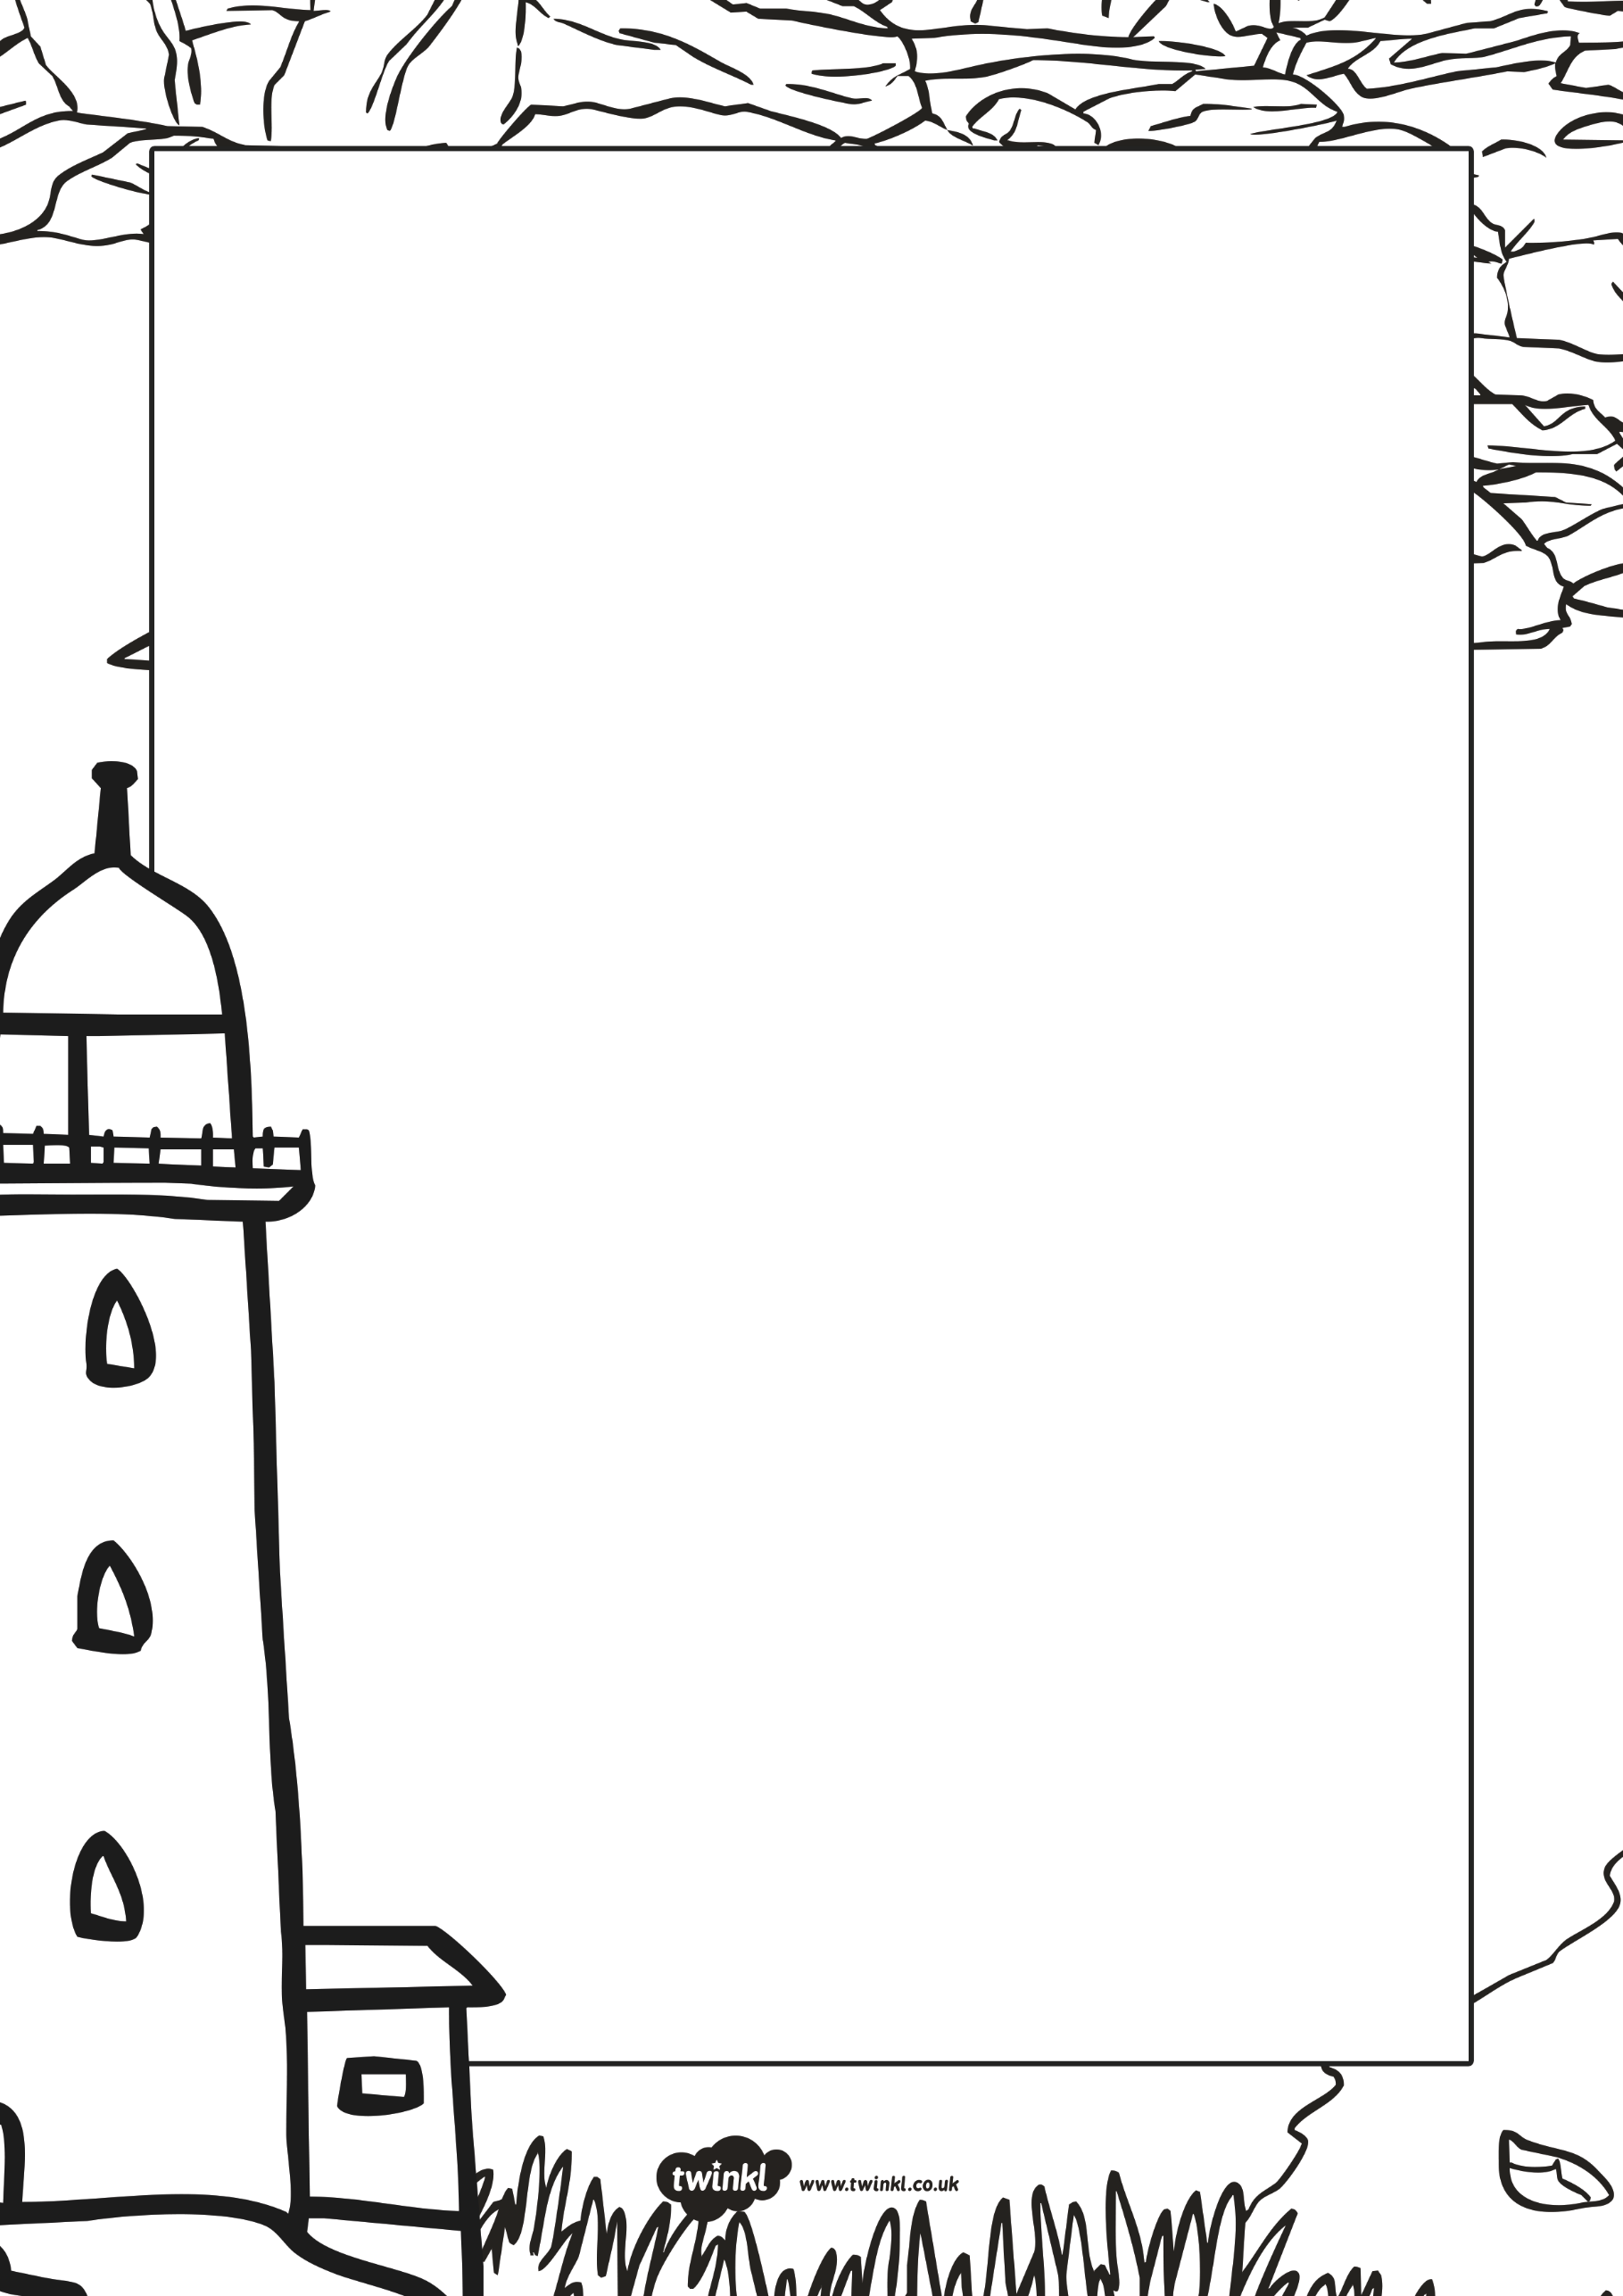

**Hello children,**

My name is Marcel and I am a lighthouse keeper. I live in a very tall lighthouse at the seaside. My lighthouse helps to keep ships and boats safe, especially during the night-time. At the top of my lighthouse is a big light which shines brightly and shows sailors where any rocks are.

However, I have a bit of a problem and I’m hoping you can help me. My lighthouse is very old and is starting to fall down. I need to build a new lighthouse but I’m not sure what it should look like. It needs to be tall and have a light at the top. Bright colours would be good too so that it can be easily seen.

Please can you help me? I need some ideas about what my new lighthouse should look like. Maybe you could make some model lighthouses for me to look at? I’ve sent you some photos of lighthouses to give you some ideas.

Thank you for your help. I look forward to seeing your lighthouse models and pictures!

**From Marcel**

